Name, Group: Date:

1 Experimental setup


2 Measurements
2.1 Measurements on the photocoupler with feedback
- I/V characteristic for different values of R₁, R₂ and R₃


- I/V characteristic for different values of Rv

2.2 Optically addressable memory
- I/V characteristic for constant values of R₁, R₂ and R₃ with illumination of PD and LDR

- At which voltage is the switching process measured?
V_{AB} = __V

- The memory is set by illuminating …
… ___, as in this case [the voltage drop across the resistor __ ] [the current] in the circuit is [increased] [decreased].

- The memory is cleared by illuminating...
… ___, as in this case [the voltage drop across the resistor __ ] [the current] in the circuit is [increased] [decreased].

2.3 Optical Schmitt trigger
- Experimental setup circuit

- At which values of the resistors can the hysteresis-like characteristic curve be observed?
R₁ = __%, R₂ = __%, R₃ = __%, R_{V} = __%

- Photo of the oscilloscope (hysteresis characteristic: triangular voltage, 50 Hz)

- Photo of the oscilloscope (characteristic curve: square-wave voltage, 50 Hz)

- Photo of the oscilloscope (characteristic curve: square-wave voltage, 2 kHz)

- What can be seen? Interpretation of the characteristic curve from e):

2.4 Optical RS-Flip-Flop
- Experimental setup circuit

- Characteristic curve for different values of the resistors R₁ and Rv

- Selected resistor values for
twin hysteresis (I as a function of V_{AB})
R1 | R2 | R3 | R_{V}
___% | ___% | ___% | 0%

s-shaped characteristic curve (I as a function of illumination)
R1 | R2 | R3 | R_{V} | U_{AB}
__% | __% | __% | ___% | ___%

- Truth table of the RS flip-flop
 |  | Theory |  | Experiment
$$R$$ | $$S$$ | $$\overline{Q}$$ | $$Q$$ | $$\overline{Q} (LED_{1})$$ | $$Q (LED_{2})$$
0 | 0 | Q̄ₙ (hold) | Qₙ (hold)
1 | 0 | 1 | 0
0 | 1 | 0 | 1
1 | 1 | forbidden | forbidden

3 Simulations
Simulated with LTspice 26.1.1 using the models of the course files (PC817 subcircuit with Igain = 1m, QTLP690C LED); the curves were exported from the LTspice .raw results.
3.1 Simulation of the photocoupler with feedback
- I/V characteristics [x: 0…16V, y: 0…12mA] for different resistor values of
  - R₁ 1.3k, 1.5k, 1.7k
  - R₂ 0.8k, 1k, 1.2k
  - R₃ 6k, 7k, 9k

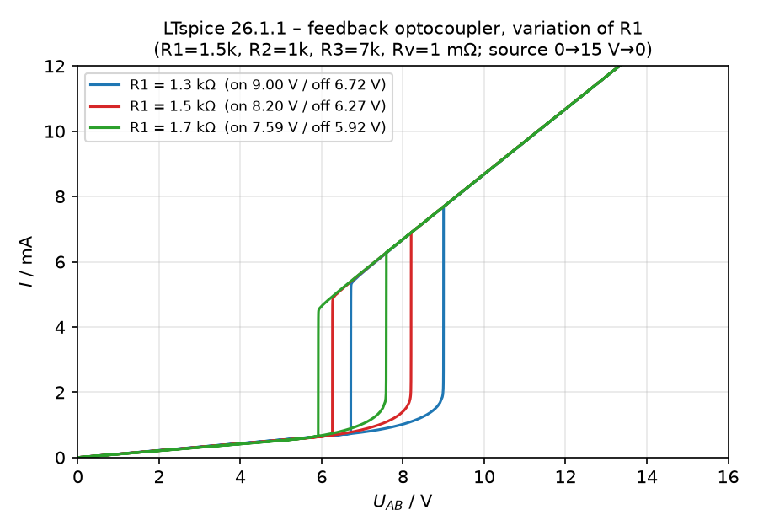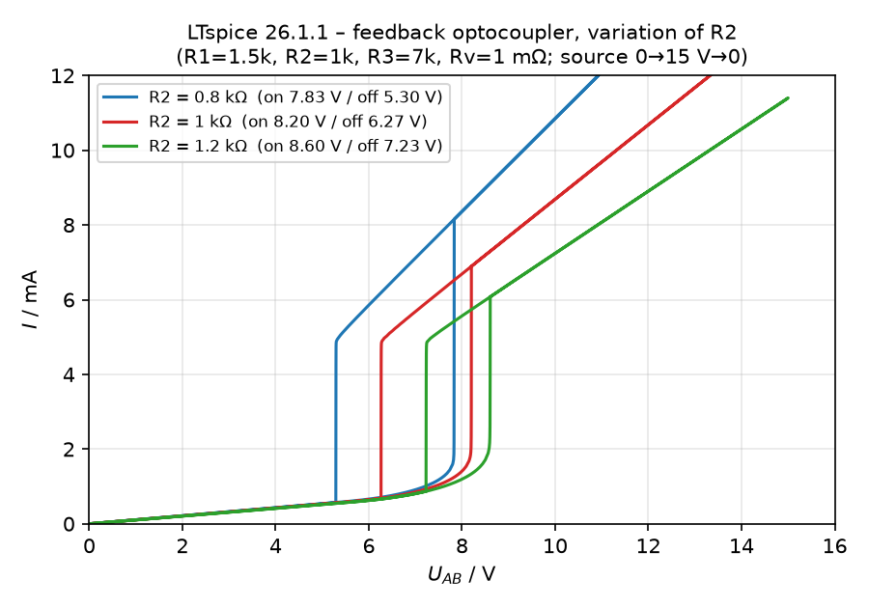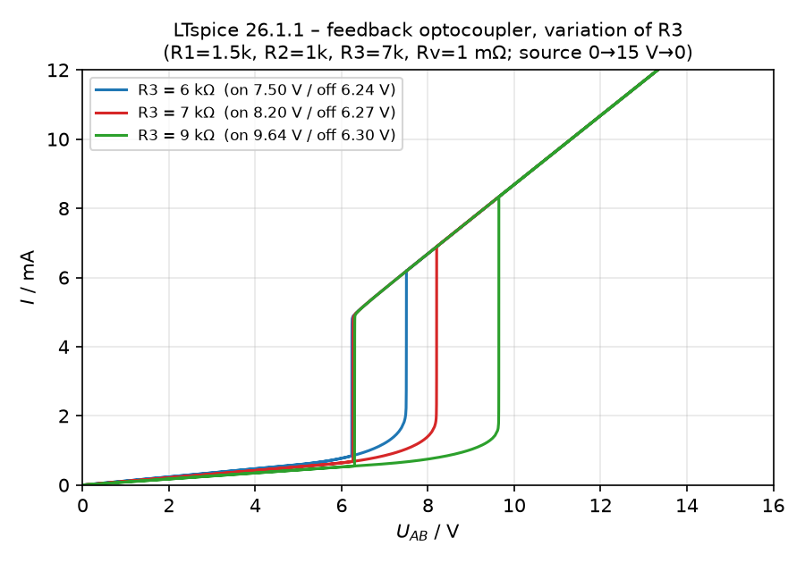
Switch-on / switch-off voltages U_AB (Rv ≈ 0): R1 = 1.3k/1.5k/1.7k → 9.00/8.20/7.59 V and 6.72/6.27/5.92 V; R2 = 0.8k/1k/1.2k → 7.83/8.20/8.60 V and 5.30/6.27/7.23 V; R3 = 6k/7k/9k → 7.50/8.20/9.64 V and 6.24/6.27/6.30 V. R1↑ lowers both thresholds (the LED reaches U_F at a lower current); R2↑ raises both thresholds, flattens the ON branch and narrows the hysteresis (1.93 V → 1.37 V); R3↑ raises only the switch-on voltage, so the hysteresis widens (1.26 V → 3.34 V).

- I/V characteristics [x: 0…16V, y: 0…12mA] for different resistor values of
  - Rv 0.1, 1k
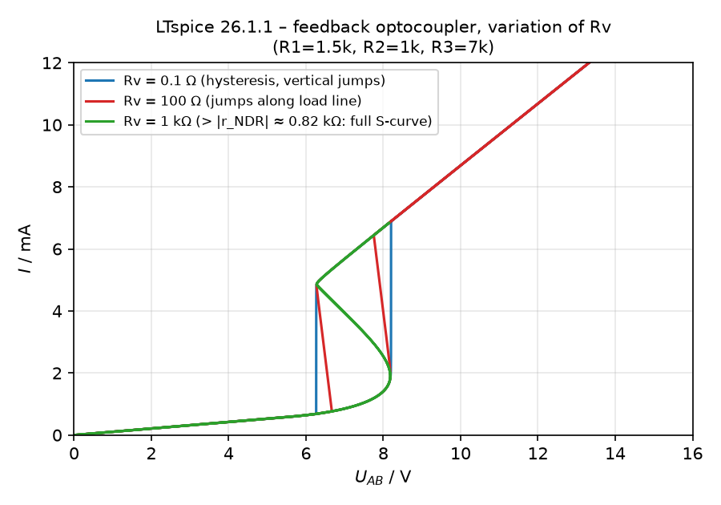
Rv = 0.1 Ω: vertical jumps at U_AB = 8.20 V / 6.27 V. Rv = 100 Ω: the jumps follow the load line (slope −1/Rv) and occur at U_source = 8.40 V / 6.75 V. Rv = 1 kΩ is larger than the largest negative differential resistance (≈ 0.82 kΩ), so the hysteresis disappears and the complete S-shaped curve including the unstable branch (3) of Fig. 5 is traced.

3.2 Simulation of the Schmitt trigger
- I_{out}/I_{in} characteristics [x: 0…2.5mA, y: 0…5mA] for matched resistor value of Rv
  - R1 = 800 Ω; R2 = 400 Ω; R3 = 5 kΩ; Rv = 0.1 Ω

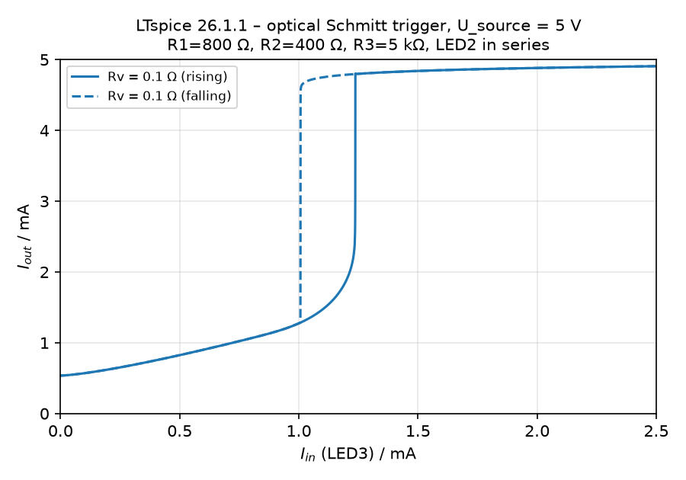
Rv = 0.1 Ω: switches ON at I_in ≈ 1.24 mA and OFF at I_in ≈ 1.01 mA; I_out jumps between ≈ 1.3 mA and 4.8 mA and returns to 0.54 mA in the dark → Schmitt-trigger hysteresis. Remark: with R1 = 400 Ω / R2 = 800 Ω as printed in the template, no hysteresis occurs at U_source = 5 V for any Rv (I_out rises continuously to ≈ 2.6 mA); the values of R1 and R2 appear to be swapped (simulation file: R1 = 800 Ω, R2 = 400 Ω).
R1 = 800 Ω; R2 = 400 Ω; R3 = 5 kΩ; Rv = 100 Ω
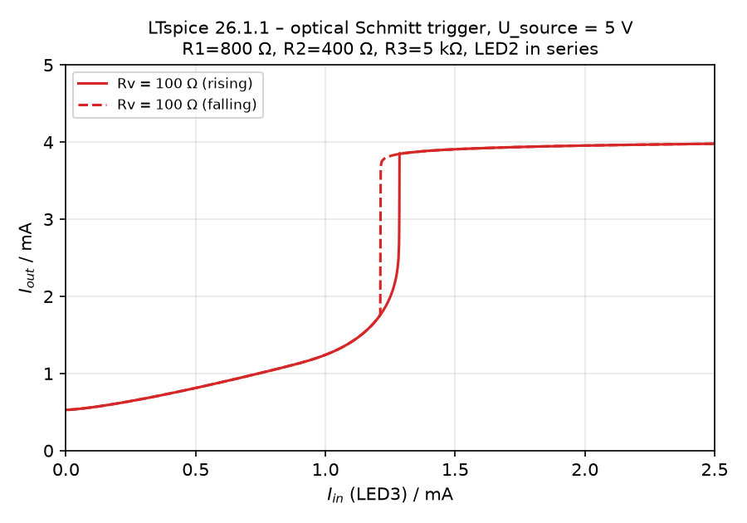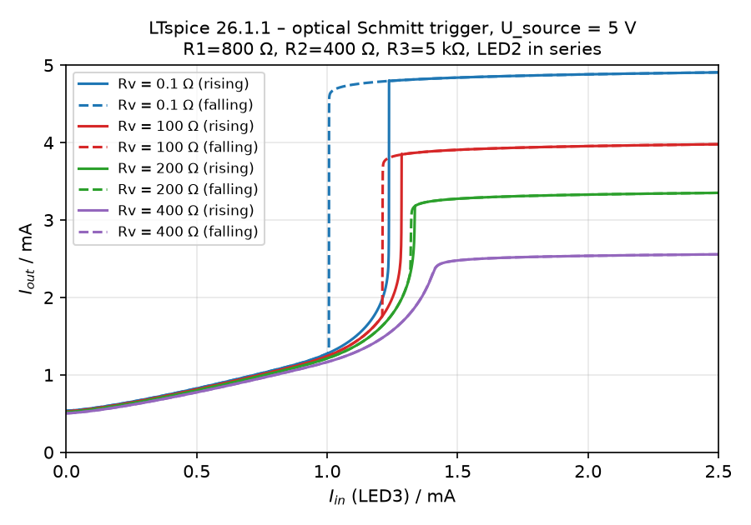
Rv = 100 Ω: ON at I_in ≈ 1.29 mA, OFF at ≈ 1.21 mA (narrower hysteresis, I_out,max ≈ 4.0 mA). Rv = 200 Ω: 1.33 / 1.32 mA. Rv ≳ 300 Ω: no hysteresis any more. The hysteresis width is therefore set by Rv.
3.2 Simulation des RS-Flip-Flops
- I/V characteristics [x: 0…16V, y: 0…24mA] for different resistor values of
  - R₁ 1.0k; R₄ 2k; Rv 0.1
  - R₁ 1.5k; R₄ 1.5k; Rv 0.1
  - R₁ 1.5k; R₄ 1.5k; Rv 450
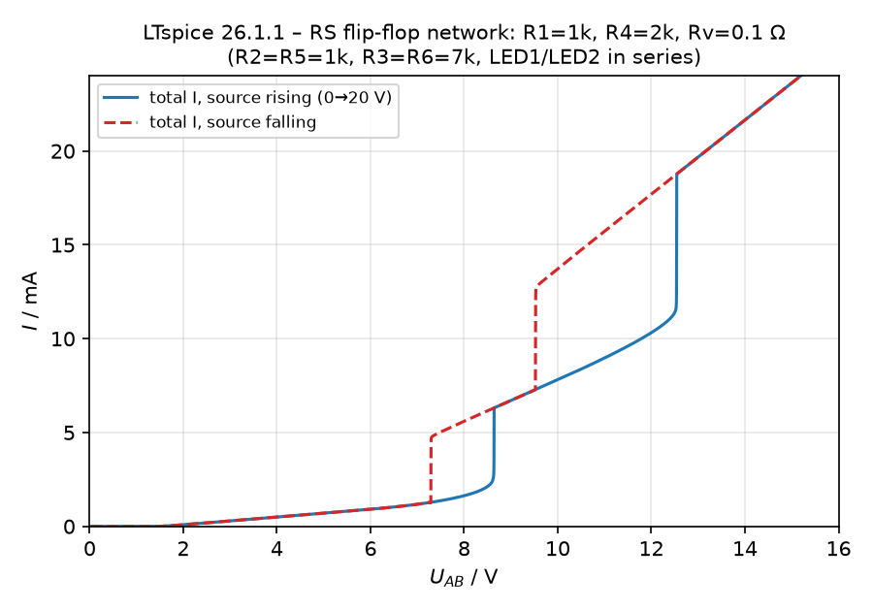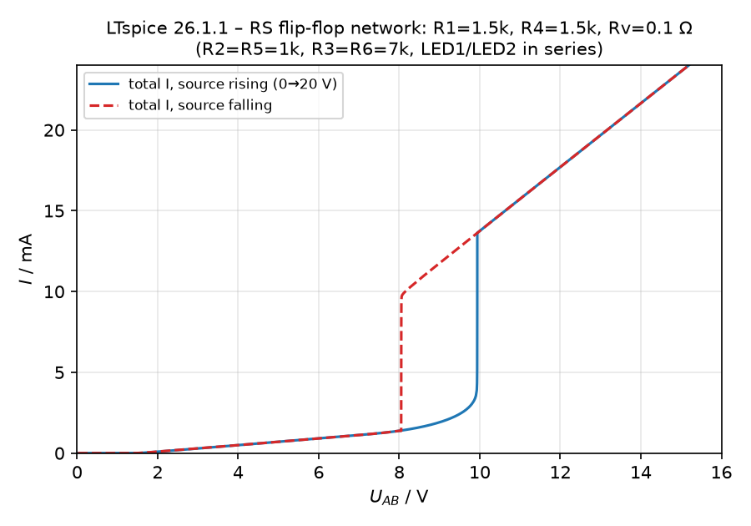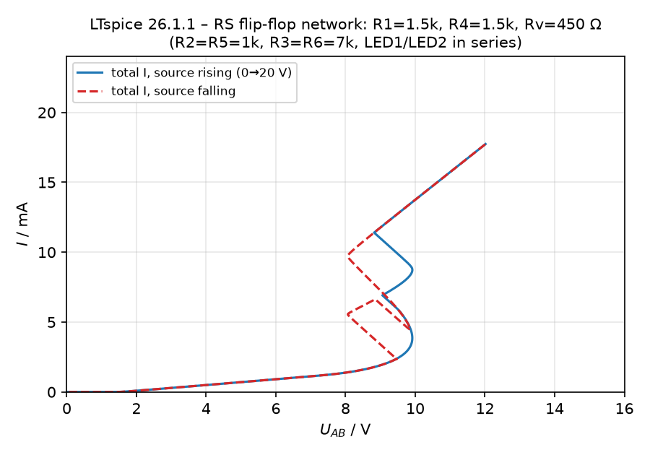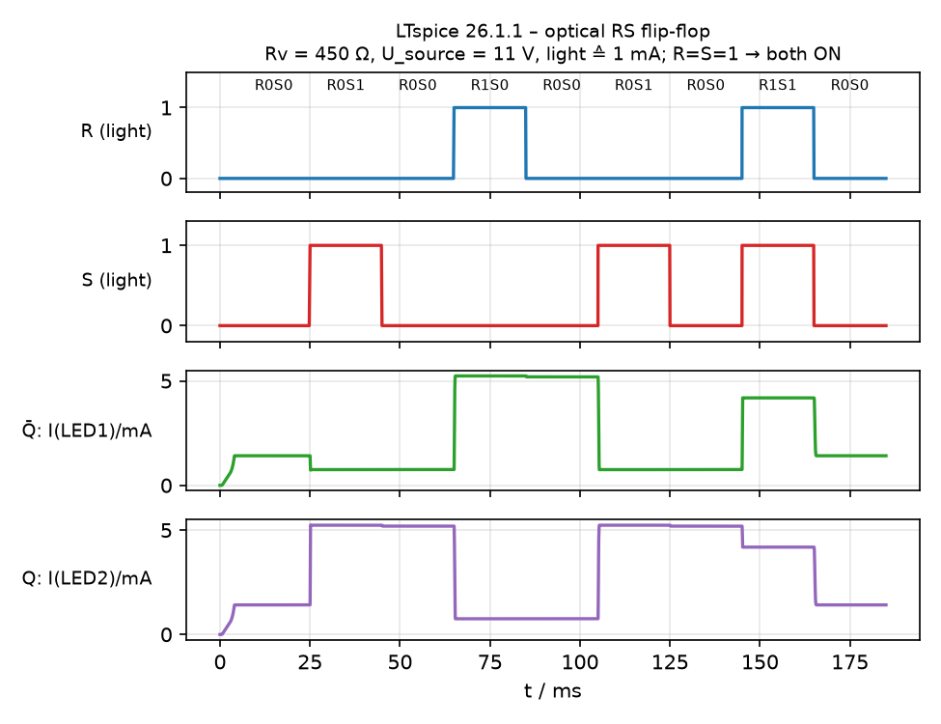
a) R1 = 1k, R4 = 2k, Rv = 0.1 Ω: twin hysteresis – element 2 switches ON at 8.64 V (OFF 7.29 V), element 1 at 12.54 V (OFF 9.53 V); both can be ON → no flip-flop. b) identical elements, Rv = 0.1 Ω: both switch together at 9.94 V (OFF at 8.05 V). c) Rv = 450 Ω: when the first element switches ON (U_source ≈ 12.2 V), U_AB drops and the second element stays OFF up to ≈ 13.9 V. Falling: both-ON → one-ON at 11.9 V, one-ON → OFF at 10.5 V. With a fixed U_source ≈ 10.6–11.6 V the network works as an RS flip-flop (truth table verified with light pulses ≙ 1 mA input-LED current; 0.3 mA is not sufficient). With Rv = 0.1 Ω both LEDs remain ON after S and R → Rv is essential.

LT-Spice settings


