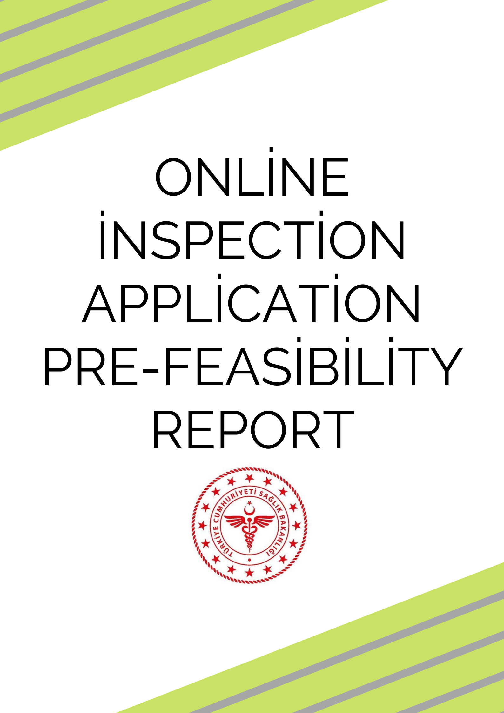

**INTRODUCTION**

**The application for people to spend less time in the hospital is the subject of this study. This**

**In this context, a pre-feasibility report has been prepared within the scope and conditions stated below.**

**PURPOSE**

**The system aims to make the patient spend less time in the hospital by determining the stages such as test and x-ray that can help diagnose the patients before coming to the physicians and by making an appointment.**

**CONTENT**

**The online examination allows the patient to spend less time in the hospital by setting up appointments and determining the stages such as assay,X-ray, which can help the diagnosis of the patients before they come to the doctors. An artificial intelligence uses this data as training data to predict disease by reading patient complaints, assays and doctor responses.**

**MARKET ASPECT**

**Demand Analysis**

**The demand is determined by the prospective enrollees composed of those who signified their interest in the aplication.**

**In the image, you see the number of cases in our country and in other countries.**

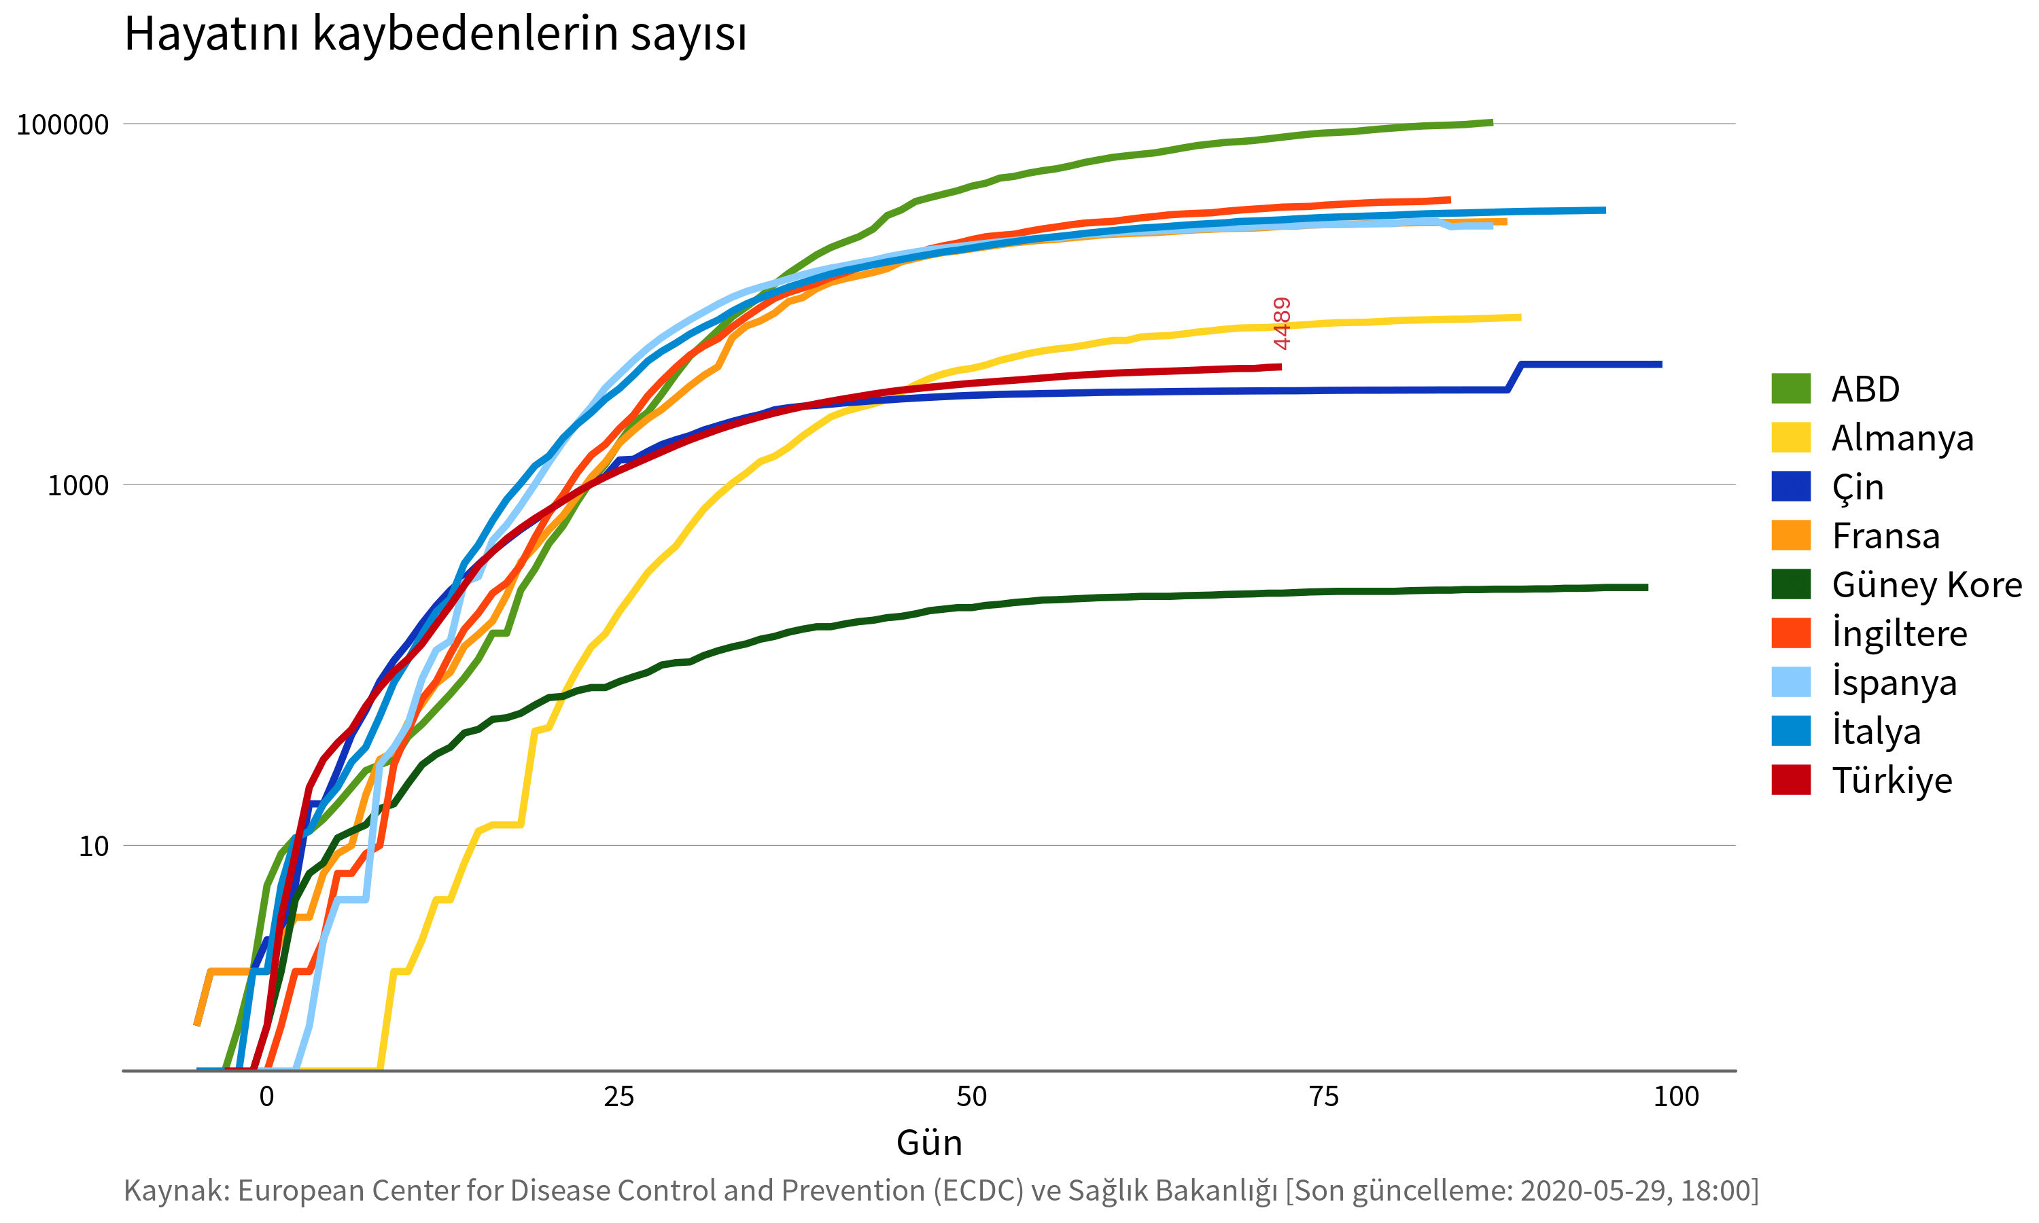

**That's why people are afraid to go to the hospital.Thanks to this practice, the time spent in the hospital is reduced.**

**FINANCIAL ANALYSIS**

**For online inspection application, the necessary physical infrastructure has been identified and related as the cost calculations were put forward.**

**TECHNICAL REVIEW**

**It is defined as the practice that allows people to be pre-examined without going to the hospital. By analyzing the questions asked by the doctors according to the incoming complaint , it provides diagnosis, identification, assistance.**

**Feasibility Result**

**With this project, he obtained the feasibility and cost analysis of the online inspection application needed by the health sector. Built**

**time and work studies required for online inspection application with feasibility study,physical infrastructure, legal status, economic conditions, applicability, security level and get concrete data on issues such as the level of need for members ' online inspection has been.**