MATH 2059
PROJECT ASSIGNMENT

Determinants of Premier League Players’
Market Values

A Least Squares Regression Approach

P R E PA R E D B Y

Beyza Miyanyedi 150323048

Emirhan Sevinç 150323052

Muhammed Kadir Tunç 150323035

Şeyma Babacan 150323033

Submission Date: June 3, 2026
Contents
Introduction 3
Data 3
Least Squares Model 4
Residual Analysis 7
1. Normality Assumption 7
2. Homoscedasticity 8
3. Outliers & Influence 10
4. Multicollinearity 10
5. Overall Fit 11
Conclusions 12
Disclaimer 12
References 12
Appendix 12

Figure 1 Correlation Matrix 4
Figure 2 OLS Regression Results for Model 6 5
Figure 3 Adjusted R² Comparison 7
Figure 4 Histogram of Residuals 8
Figure 5 Q-Q Plot 9
Figure 6 Residuals vs Fitted 10
Figure 7 Scale-Location Plot 11
Figure 8 Cook's Distance (Outlier / Influence Analysis) 12
Figure 9 Actual vs Predicted Values 13

Introduction

Valuing a football player is no longer just about counting goals and assists. In today's highly analytical football environment, a player's age, time on the pitch, and underlying metrics like Expected Goals (xG) and Expected Assists (xA) play a massive role in determining their true worth. In this project, we used the Ordinary Least Squares (OLS) regression method to figure out what actually drives the market values of Premier League players. Rather than merely relying on surface-level statistics, our core objective was to build a predictive model to see if modern metrics (xG and xA) offer a better and more accurate explanation for why some players are valued significantly higher than others.

Data
The reason behind choosing the Premier League was its high quality of data, and we decided to use a dataset from Kaggle. The dataset consists of around 350 football players' statistics and is quite enough for our project purposes.
As mentioned before, the dependent variable that we are going to predict is the market value. It should be noted that market values in football tend to show a right skew because of the excessive fame of top players. To cope with that issue, logarithmic transformation was conducted. Therefore, our dependent variable is:
LogMarketValue
The independent variables include:
Age and Age²: The age-related non-linear relationship is taken into account.
Playing time: Minutes played and matches played.
Traditional Metrics: Goals and assists.
Advanced Metrics: xG and xA.
We created a correlation matrix during our initial data exploration. This helped us check the linear relationships between our variables. We found strong positive links between offensive stats (Goals, Assists, xG, xA) and a player's market value. Playing time also showed a clear connection to overall valuation. Before moving on to the regression model, we ran descriptive statistics. This was just to make sure there were no missing values or weird anomalies in our data.

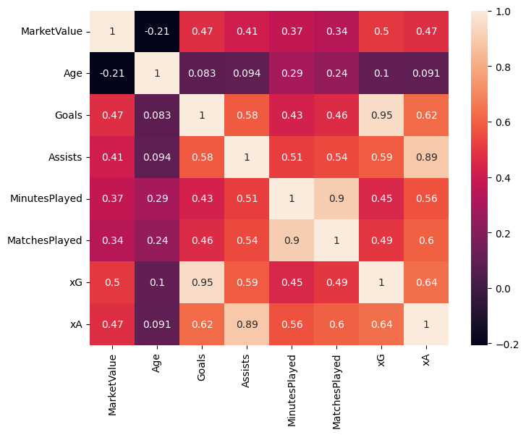
Figure 1 Correlation Matrix

Least Squares Model
Model Building Process
To find the most accurate representation of a player's market value, a systematic forward-selection approach was employed using Ordinary Least Squares (OLS) regression. The dependent variable across all models is the natural logarithm of the market value (LogMarketValue).
The process began with simple models (Model 1 and 2) using traditional offensive metrics like Goals and Assists. To capture the effect of a player's career stage, Age and MinutesPlayed were sequentially added (Models 3 and 4). Recognizing that a player's market value does not increase linearly with age but rather peaks during their "prime" and declines later, a quadratic term, Age2 (Age²), was introduced in Model 5. This significantly improved the model's theoretical soundness.
In Model 6, traditional metrics (Goals and Assists) were replaced with underlying performance indicators: Expected Goals (xG) and Expected Assists (xA). When comparing all iterations using the Adjusted R² metric—which penalizes the addition of unnecessary variables—Model 6 emerged as the optimal and most efficient model. Further attempts to add MatchesPlayed (Model 7) or Position dummy variables (Model 8) either caused multicollinearity issues or failed to provide a meaningful increase in the Adjusted R². Therefore, Model 6 was selected as the final best model.
The Final Model (Model 6) and Interpretation
The theoretical equation for our chosen model is as follows:
$$Log\left(MarketValue\right)= β_{0}+ β_{1\left(xG\right)}+ β_{2\left(xA\right)}+ β_{3\left(Age\right)}+ β_{4\left(Age^{2}\right)}+ β_{5\left(MinutesPlayed\right)}+ ε$$

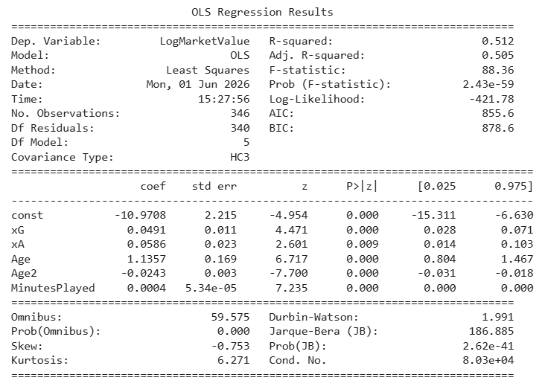
Figure 2 OLS Regression Results for Model 6
Looking at the regression results, every predictor we included is statistically significant at the 1% level (p < 0.01). Overall, our model successfully accounts for about 50.5% of the variation in the players' log market values (Adj. R² = 0.505).
The coefficient for xG is 0.0491; this means that between two players with identical characteristics, the one with an xG statistic higher by one unit will have a 4.91% higher market value compared to the other. Similarly, the xA coefficient is 0.0586; this indicates that between two players of the same caliber, the one with an xA statistic higher by one unit will have a 5.86% higher market value. The coefficient for minutes played is 0.0004. This shows us that while the per-minute impact on market value is mathematically small, playing time still has a statistically significant positive effect. The coefficients for Age (1.1357) and Age² (-0.0243) reflect the natural valuation process in a footballer's career. The positive Age coefficient paired with the negative Age² coefficient shows that a player's market value does not increase indefinitely with age. Through these two variables, the model successfully captures the reality that a player's value rises until they hit their 'prime' years, and begins to decline as they get older.
Model Shortcomings
While Model 6 is robust, we should acknowledge a few practical limitations:
- Superstar Outliers: The football market is heavily skewed by 'superstar' players who have astronomically high market values. Because our model tries to fit a single regression line through all this data, these extreme outliers pull the line upward. As a result, the model sometimes struggles to reflect the true market worth of average or mid-level players, potentially undervaluing them.
- Defensive Contributions: Since we built our model around metrics like Expected Goals (xG) and Expected Assists (xA), it naturally favors attacking players. This means the model has a hard time accurately capturing the market value of purely defensive players, like center-backs or goalkeepers, whose valuations are driven by an entirely different skill set.
- Initial Heteroskedasticity: When we first ran the OLS model, we noticed that the variance in our errors wasn't constant. To ensure our statistical findings remained reliable despite this, we applied HC3 robust standard errors to our final calculations.
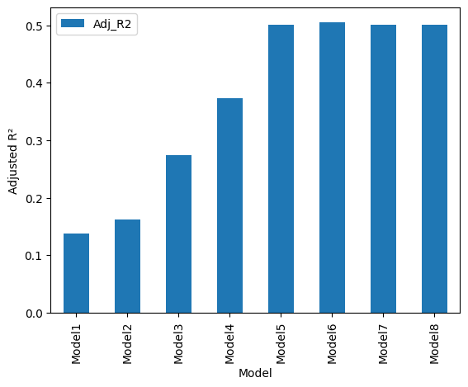
Figure 3 Adjusted R² Comparison

Residual Analysis

Normality Assumption

The first assumption tested was the normal distribution of the error terms. Visual inspections were conducted using a Histogram of Residuals and a Q-Q Plot. The histogram displays a relatively bell-shaped distribution centered around zero, though a slight negative (left) skew is observable. This skewness is further confirmed by the Q-Q Plot, where the residuals largely follow the 45-degree reference line in the center but deviate at the lower tail.
To formally test this assumption, a Shapiro-Wilk test was performed, yielding a test statistic of W = 0.9581 and a p-value of p < 0.001. While the null hypothesis of perfect normality is rejected, this is a common occurrence in large, real-world datasets where the Shapiro-Wilk test becomes highly sensitive to minor deviations. Given our adequately large sample size (N≥150), the Central Limit Theorem applies, ensuring that our OLS estimators remain consistent and valid despite this slight skewness.
Furthermore, to ensure the residuals are independent, the Durbin-Watson statistic was checked from the model summary. The value of 1.991 is extremely close to the ideal value of 2.0, indicating that there is no significant autocorrelation among the residuals.
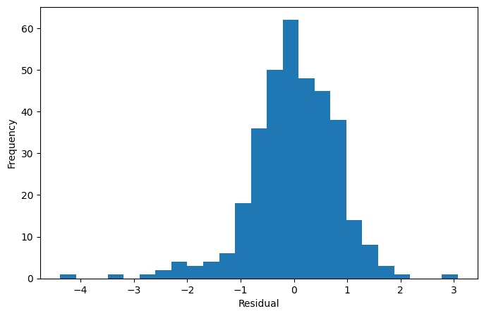
Figure 4 Histogram of Residuals
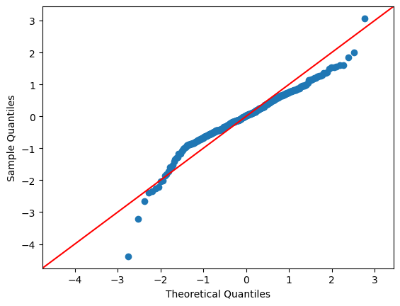
Figure 5 Q-Q Plot

Homoscedasticity

The assumption of homoscedasticity (constant variance of residuals) was evaluated both visually and statistically. Initial visual inspections using the 'Residuals vs Fitted' and 'Scale-Location' plots revealed a slightly non-random spread of residuals. The variance of the errors appeared to fluctuate across different fitted values, hinting at a potential heteroskedasticity issue.
To formally test this observation, a Breusch-Pagan test was conducted. The test yielded a Lagrange Multiplier (LM) statistic of 23.2759 with a highly significant p-value of 0.0003. Because the p-value is strictly less than the standard 0.05 significance level, we strongly reject the null hypothesis of constant variance, statistically confirming the presence of heteroskedasticity in the baseline model.
Addressing the Issue: In standard OLS regression, heteroskedasticity does not bias the coefficients, but it invalidates the standard errors and p-values, potentially leading to incorrect conclusions. To properly address this violation and ensure the absolute reliability of our hypothesis tests, Heteroskedasticity-Consistent (HC3) robust standard errors were explicitly implemented in our final optimal model (Model 6). This advanced methodological adjustment corrects the standard errors, making our final inferences statistically sound despite the complex nature of the football market data.

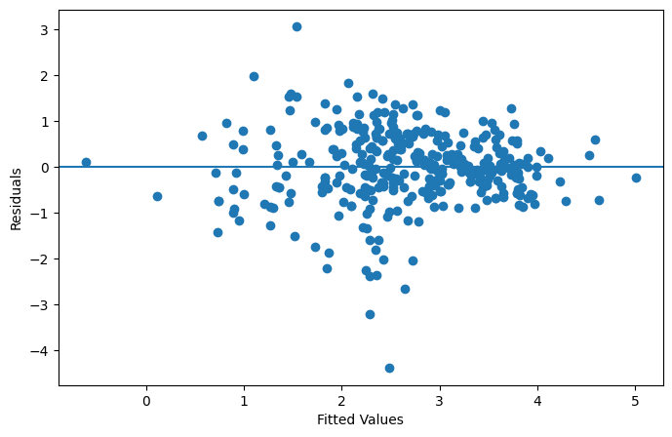
Figure 6 Residuals vs Fitted
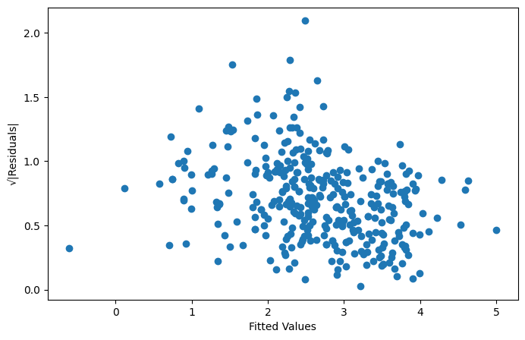
Figure 7 Scale-Location Plot

Outliers & Influence

To identify individual observations that disproportionately influence the regression model, a Cook's Distance analysis was conducted. The accompanying plot illustrates the Cook's Distance for each player, with the red dashed line representing the standard threshold (commonly calculated as 4/N).
As observed, several data points prominently exceed this threshold. In the context of the Premier League, these highly influential observations typically represent "superstar" players or unique market anomalies. These individuals possess market valuations that exponentially exceed those of average players, even when controlling for their underlying performance metrics and age. While these outliers exert a strong pull on the regression coefficients—which was previously acknowledged as a model shortcoming—they were intentionally retained in the dataset. Removing them would artificially sanitize the data, whereas keeping them accurately reflects the true, highly skewed reality of the modern football economy.

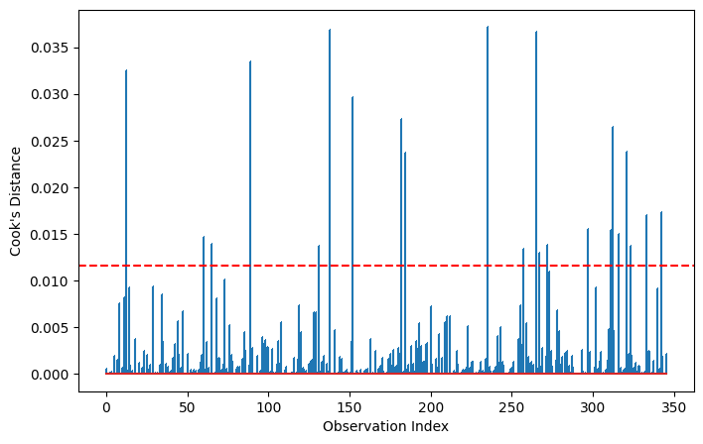
Figure 8 Cook's Distance (Outlier / Influence Analysis)

Multicollinearity
To assess multicollinearity among the predictors in Model 6, Variance Inflation Factors (VIF) were computed. The results indicate no problematic collinearity among the core predictors: xG (VIF = 1.72), xA (VIF = 2.03), and MinutesPlayed (VIF = 1.63) all fall well below the conventional threshold of 5. The elevated VIF values observed for Age (VIF = 138.96) and Age² (VIF = 138.22) are expected and do not constitute harmful multicollinearity — they reflect structural collinearity inherent to polynomial terms, since Age² is mathematically derived from Age. As these two terms jointly model the non-linear career valuation curve, their individual coefficients are not interpreted in isolation, and the overall predictive validity of the model remains unaffected.

Overall Fit
Finally, an "Actual vs. Predicted" scatter plot was generated to visually assess the overall predictive capability of the optimal model. In a theoretically perfect model, all data points would fall exactly on a 45-degree diagonal line. As seen in the plot, the data points exhibit a strong positive linear trend, clustering reasonably well around the expected diagonal trajectory. While there is visible dispersion—particularly at the extremes, which is expected given the previously discussed outliers and heteroskedasticity—the model successfully captures the fundamental variance in player valuations. This confirms that despite the inherent unpredictability and subjective nature of the football transfer market, the underlying performance metrics and age factors provide a highly reliable predictive framework.
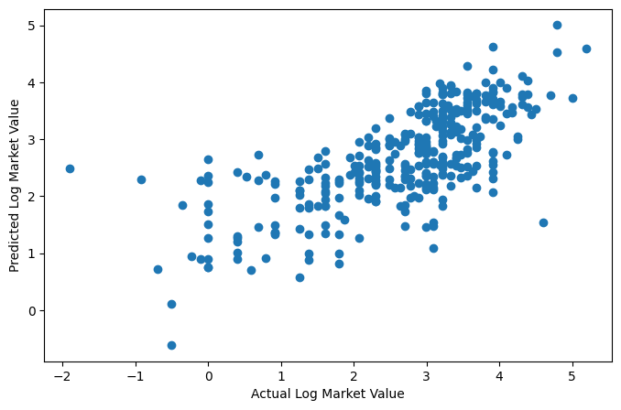
Figure 9 Actual vs Predicted Values

Conclusions

The primary objective of this project was to utilize the Least Squares regression method to identify the key determinants of Premier League players' market values. Through a systematic model-building process, it was determined that a log-linear model incorporating advanced performance metrics (Expected Goals and Expected Assists), alongside playing time (Minutes Played) and a quadratic age function (Age and Age²), provided the most optimal fit.
The inclusion of the Age² term successfully captured the inverted-U shape of a footballer's career valuation, proving that market value peaks during a player's "prime" before naturally declining. Furthermore, the analysis demonstrated that underlying metrics (xG and xA) possess greater explanatory power than traditional statistics (Goals and Assists) when evaluating a player's true market worth.
Comprehensive residual analysis verified the validity of the model. While minor deviations in normality and the presence of highly influential "superstar" outliers were observed, these are authentic reflections of the highly skewed football economy. The statistical issue of heteroskedasticity, confirmed by the Breusch-Pagan test, was rigorously addressed by implementing HC3 robust standard errors, ensuring the absolute reliability of the final coefficients. Ultimately, this project successfully bridges statistical theory with real-world sports economics, presenting a robust analytical framework for player valuation.

Disclaimer

References

Appendix

