OutBreak Detector



Computer Engineering - Senior Project Report

Advisor : Zeynep F. EREN DOGU, PhD

Student : Beyzanur Akın

Date : 24/06/20

Outbreak Detector

Beyzanur Akın
Computer Engineer
Muğla Sıtkı Koçman University
24/06/20

Summary
In this project, we supposed to make a detector application that detects outbreaks in advance. Throughout history, outbreaks have been classified as disasters, such as wars, which lead to collective deaths, therefore social, political, cultural, scientific, and economic changes. Although it is not possible to detect outbreaks in advance, the main purpose of our outbreak detector is to determine the disease and take precautions before the disease becomes pandemic.
In recent years, improvements in the storage and transmission of electronic health data have changed the ways of prevention of diseases and treatment in a good way. Many public health agencies have real-time access to large volumes of data from clinical and other settings. While this big data provides a great opportunity to identify emerging public health threats, it presents new challenges to analyze large volumes and non-specific structures. Many algorithms have been developed to process and analyze this health data. Algorithms scan large data and create new rules based on the severity of the disease. The method we will use in this project will be the outbreak curve. Our detector aims to direct the suspicion of the epidemic by interpreting the changes in the data of the year we found by developing methods by making use of the epidemic curves of the previous years correctly.

Contents
1. Introduction 4
2.Methods 5
2.1 Epidemic Curve 5
2.2 ARIMA Model 5
2.3 Cusum Control Charts 6
2.3 Residual Plots 6
3. Results 6
4. Conclusion 6
4.References 7

1. Introduction
In epidemiology, Outbreak is the event of a rapid increase of disease and spread of it more than expected at a certain time in a given population. While the outbreak may occur in a small region, it can also spread across the world. According to the world health organization(WHO), outbreaks cause the death of millions of people every year. Governments must be able to identify and prevent these outbreaks in advance. Failure to detect outbreaks in a timely manner leads to many negative consequences for effective outbreak control.

Increased incidence, laboratory confirmation and public health threat are the reasons for declaring the outbreak. It must be interpreted and controlled first to protect the public.

In recent years, progressions in the storage and transmission of electronic health data have changed the ways of prevention from the diseases. Many public health agencies have real-time access to large volumes of data from clinical and other settings. While these data provide a great opportunity to identify emerging public health threats, they pose new challenges for analyzing large volumes and nonspecific structures. Many algorithms have been developed to process and analyze these health data. Algorithms scan large data and generate new rules based on the severity of the disease. The method we will use in this project will be the epidemic curve.

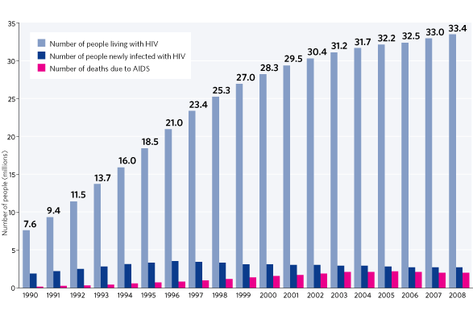

2.Methods
We have used some analysis techniques and modeling to implement our outbreak detector application.
- Epidemic Curve
- ARIMA Model
- Cusum Control Charts
- Residual Plot

2.1 Epidemic Curve
An epidemiological curve is a graphical or a visual representation of unsaid of illness of cases in an outbreak. Thence, Y-axis is the number of cases and the X-axis is the time intervals during which the outbreak occurs.
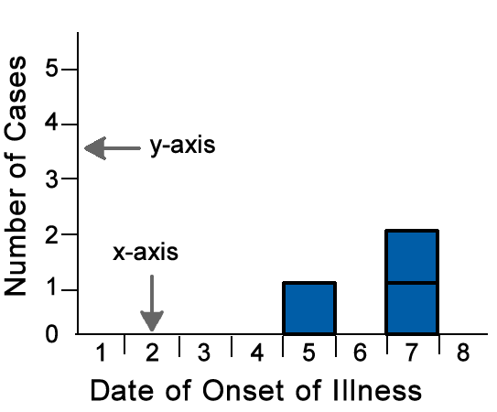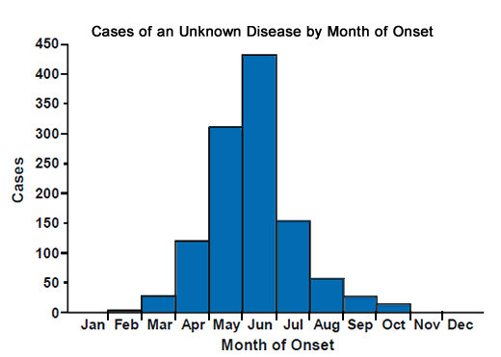
You can learn a lot about an outbreak from an epidemic curve, such as
- The outbreak's time trend, which is the distribution of cases over time
- Outliers, that is, cases that stand apart from the overall pattern
- The general sense of the illness magnitude
- Inferences about the outbreak's mode of spread
- The most likely period of exposure
On the other hand, We use the epidemic curve for the detection of the outbreak. We are going divide data into two-part, one for test data one for train data. The tools and standard deviations in the basic data are based on the observed values with days of the week, holidays, post-holiday periods, seasonal and trend adjustments. If we put this test data into the table and deduce a relationship, we will find the epidemic curve. Our detector makes a stimulating decision for each day in the time series by comparing a test statistic with a calculated historical average of the underlying data. When two models are compared and epidemic curves are mixed, signalling will be given at these points, as sudden increases disrupt the epidemic curve.

2.2 ARIMA Model
Arima model (autoregressive integrated moving average) is the time series estimation and forecasting method and is the method applied in the time series data observed at equal time intervals. [1]

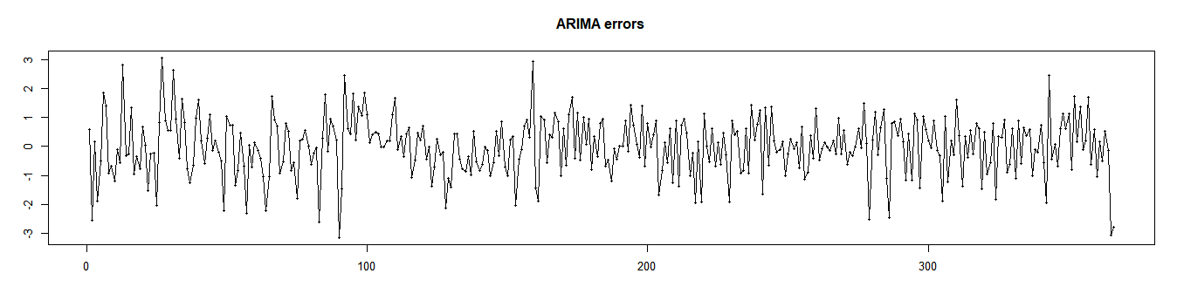
Figure A : Arima model of train data after adding Transformed count

2.3 Cusum Control Charts
Cusum (cumulative sum) control chart is one of the four chart types developed as an alternative to these charts due to the insensitivity of Shewart control charts to small but continuous shifts in the sample averages. [2]
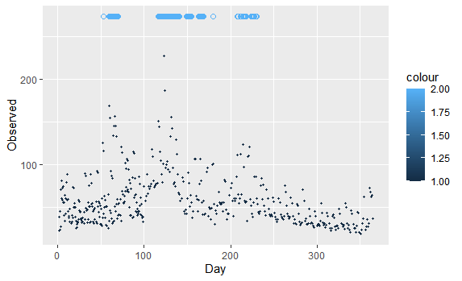
Figure B: Plot that show cusum results with signals that may be outbreak suspicions

2.3 Residual Plots
A residual plot is a graph that shows the residuals on the vertical axis and the independent variable on the horizontal axis. If the points in a residual plot are randomly dispersed around the horizontal axis, a linear regression model is appropriate for the data; otherwise, a nonlinear model is more appropriate.[3]
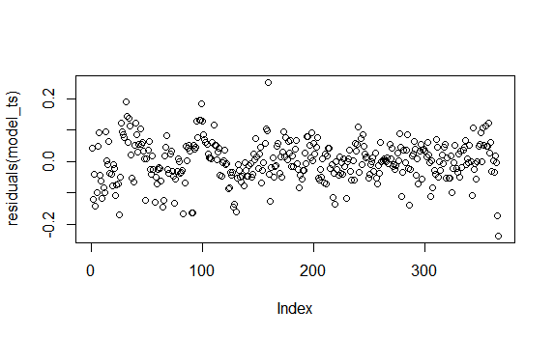
Figure C :Residual plot of 1-year train data

3. Results
In the first semester, we have completed some initial steps for the progression of the project. We encountered and solved some technical problems in almost every step. It was decided which language and which library would be suitable for the detector.

Firstly, We coordinate the code that makes the necessary arrangements to process the data. In this way, we have guaranteed to be able to process whatever data we receive in our detector.

Secondly, The interface for the homepage was designed by the shiny library, run and tested with sample data. Sample data has 3 columns , count, date and holidays.
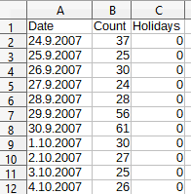

Thirdly, We obtained the necessary statistical data for the start. We made translations for months and days. Start and end dates were determined for test and training data. Some additional and helper methods were merged into the detector such as Arima, Cusum etc.

4. Conclusion
With the increase in technology in recent years, the projects that computer scientists can do with big data and the benefits to humanity have shown a great improvement. Controlling new outbreaks with information from past data of outbreaks is one of these great benefits. Unfortunately, there are not many methods to estimate and prevent outbreaks before it started. Otherwise controlling it with our outbreak detector and minimizing the the number of people affected by the outbreak and the number of people who died by epidemic will make a great contribution to us.

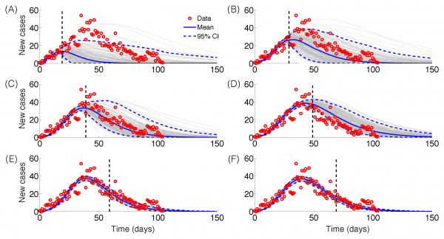

4.References
[1] https://en.wikipedia.org/wiki/Autoregressive_integrated_moving_average
[2]http://acikerisim.pau.edu.tr/xmlui/bitstream/handle/11499/2696/Abdullah%20Özçil.pdf?sequence=1&isAllowed=y
[3] https://en.wikipedia.org/wiki/Autoregressive_integrated_moving_average

https://www.youtube.com/watch?v=xqoaGhxrIfY
https://www.ncbi.nlm.nih.gov/pmc/articles/PMC2656053/

https://www.youtube.com/watch?v=7SM4PN7Yg1s&t=202s/

https://www.youtube.com/watch?v=dn84ezAzV4k/
https://www.klimik.org.tr/wp-content/uploads/2012/02/1282011143636-15Mart2008_F_Akdas.pdf/
http://currents.plos.org/outbreaks/index.html%3Fp=68353.html/

https://www.who.int/hiv/data/global_data_slideshow.html/

