|  |  |
| --- | --- |
| **Topic** | Hazelcast |
| **Document Name** | HAZELCAST-EX-02 |
|  |  |

|  |  |  |  |
| --- | --- | --- | --- |
| **Document Difficulty Level** | | | |
| **Beginner** | **Junior** | **Senior** | **Expert** |
| □ | ■ | □ | □ |

# Document History

|  |  |  |  |
| --- | --- | --- | --- |
| Date | Author | Ver | Comments |
| 05.03.2025 | Mennan Tekbir | 1.0 | Initial Draft |
| 05.03.2025 | Mehmet Erdem Önal | 1.1 | Revisions |

# Hazelcast

## Exercise HAZELCAST-EX-02:

**Definiton:** Please pull & run hazelcast and man-center conatiners in your local machine. You may use the following Docker commands:

docker pull hazelcast/hazelcast:latest

docker run hazelcast/hazelcast:latest

docker pull hazelcast/management-center:latest

docker run --rm -p 8080:8080 hazelcast/management-center:latest

**Docker Hub Repo for Hazelcast:** <https://hub.docker.com/r/hazelcast/hazelcast>

**Docker Hub Repo for Hazelcast Management Center:** <https://hub.docker.com/r/hazelcast/management-center>

Please provide screenshots to show your work once the installation is complete.

## HAZELCAST -EX-02 Solution:

**Your Answer:**

You may provide screenshots here to show your work…

In this assignment, I used Docker to install and run **Hazelcast** and **Hazelcast Management Center** services on my local machine.  
First, I pulled the Docker images hazelcast/hazelcast and hazelcast/management-center. Then, I created and started two separate containers using these images. I ran the Hazelcast container in the background, and I exposed the Management Center container on port 8080 to access its web interface from my browser.  
Finally, I took screenshots of the terminal output and the Management Center UI to document that the setup was successful.

Bu ödevde Docker kullanarak **Hazelcast** ve **Hazelcast Management Center** servislerini kurup çalıştırdım.  
İlk olarak Docker üzerinden hazelcast/hazelcast ve hazelcast/management-center imajlarını çektim. Ardından bu imajlarla iki farklı container oluşturdum. Hazelcast container’ı arka planda çalıştırdım, Management Center container’ını ise 8080 portu üzerinden çalıştırarak arayüzüne tarayıcıdan erişim sağladım.  
Son olarak terminal çıktısı ve Management Center arayüzünün ekran görüntülerini alarak kurulumu belgeledim

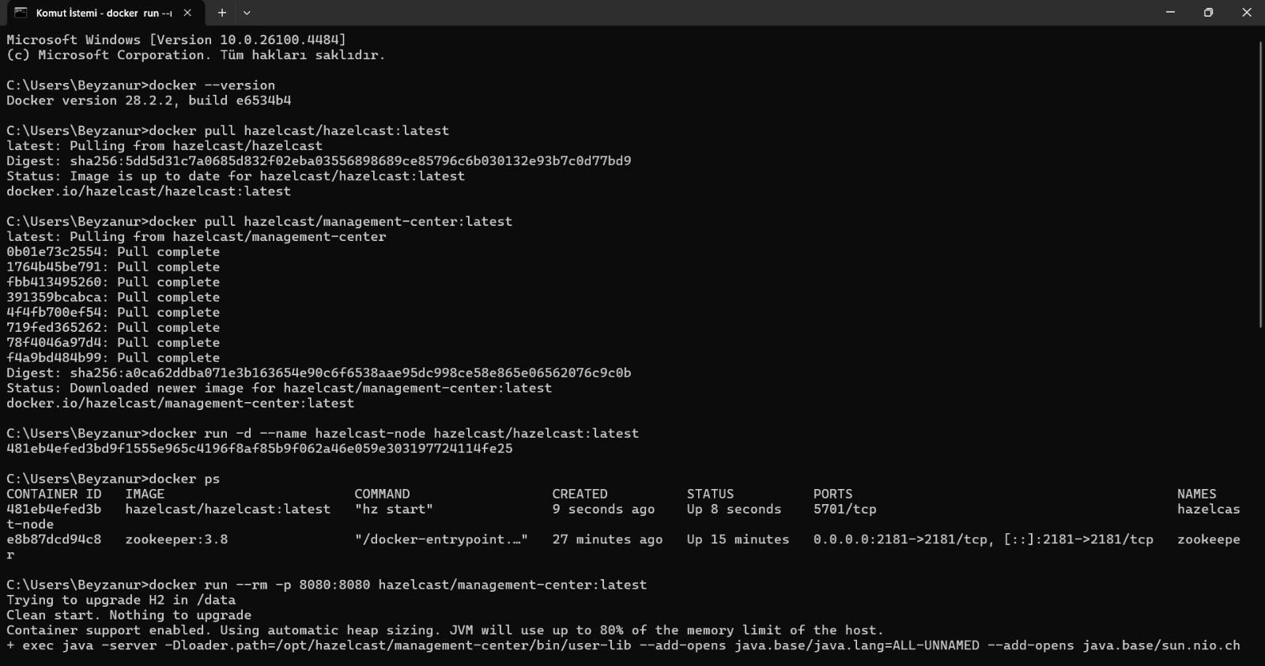

metin, ekran görüntüsü, yazılım, multimedya yazılımı içeren bir resim

Yapay zeka tarafından oluşturulmuş içerik yanlış olabilir.

