|  |  |
| --- | --- |
| **Topic** | SQL Language Fundamentals I |
| **Document Name** | PLSQL01-EX-08 |
|  |  |

|  |  |  |  |
| --- | --- | --- | --- |
| **Document Difficulty Level** | | | |
| **Beginner** | **Junior** | **Senior** | **Expert** |
| □ | ■ | □ | □ |

# Document History

|  |  |  |  |
| --- | --- | --- | --- |
| Date | Author | Ver | Comments |
| 20.09.2013  03.10.2013 | Onur Bayram  Erman İbrişim | 1.0  1.1 | Initial Draft  Sample Outputs and Rules Added |

# SQL Language Fundamentals I

## Exercise PLSQL01-EX-08:

**Definiton :** Write a PL/SQL program that prints out string in xml format.

Input String : “acbbcadefghkkhgfed”

Input String: “abbcddfggfca”

**Rules:** -Maximum string length is 30.

-No duplicate characters in string like ‘abbcddfaafca’ or ‘defgddgfed’.

-String can’t have space character or any numeric characters.

**Sample Output :**

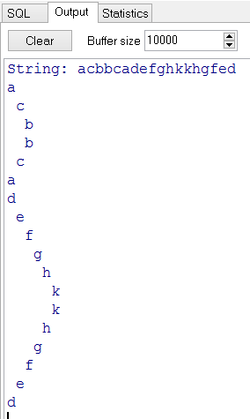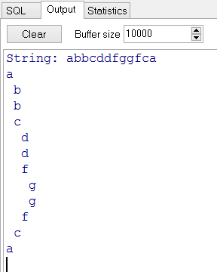

**Objectives** : To learn SQL string functions and conditional claueses(IF THEN ELSE), loops(FOR, WHILE)

## Solution of PLSQL01-EX-08:

For solution of example, please send your answer to your supervisor.

metin, ekran görüntüsü, yazılım, çizgi içeren bir resim

Yapay zeka tarafından oluşturulmuş içerik yanlış olabilir.

**DECLARE**

input_str **VARCHAR2**(30) := 'abcdaefgjfg';

**TYPE** indent_table **IS** **TABLE** **OF** **NUMBER** **INDEX** **BY** **VARCHAR2**(1);

indent_map indent_table; -- karakterin indenti

xml_output **CLOB** := '';

current_char **CHAR**(1);

indent **NUMBER**;

**BEGIN**

**IF** **LENGTH**(input_str) > 30 **THEN**

DBMS_OUTPUT.PUT_LINE('Hata: String uzunluğu 30 karakteri geçemez.');

**RETURN**;

**END** **IF**;

-- indent map oluştur

**FOR** i **IN** 1..**LENGTH**(input_str) **LOOP**

current_char := **SUBSTR**(input_str, i, 1);

**IF** **NOT** indent_map.**EXISTS**(current_char) **THEN**

indent_map(current_char) := i - 1;

**END** **IF**;

**END** **LOOP**;

-- Her karakteri alt alta indent ile yaz

**FOR** i **IN** 1..**LENGTH**(input_str) **LOOP**

current_char := **SUBSTR**(input_str, i, 1);

indent := indent_map(current_char);

xml_output := xml_output || **LPAD**(' ', indent) || current_char || **CHR**(10);

**END** **LOOP**;

DBMS_OUTPUT.PUT_LINE('Çıktı:');

DBMS_OUTPUT.PUT_LINE(xml_output);

**END**;