|  |  |
| --- | --- |
| **Topic** | SWAGGER |
| **Document Name** | SWAGGER |
|  |  |

|  |  |  |  |
| --- | --- | --- | --- |
| **Document Difficulty Level** | | | |
| **Beginner** | **Junior** | **Senior** | **Expert** |
| □ | ■ | □ | □ |

# Document History

|  |  |  |  |
| --- | --- | --- | --- |
| Date | Author | Ver | Comments |
| 05.03.2025 | Murat Kağan Temel | 1.0 | Initial Draft |

# SWAGGER

## Exercise SWAGGER:

**Definiton:** Create a layered Spring Boot RESTful application that provides basic CRUD operations for managing Customer data. The application should include OpenAPI-compliant API documentation using the springdoc-openapi-starter-webmvc-ui dependency. This dependency also enables Swagger UI, so no additional configuration is required.

You may choose to simulate database operations using in-memory data structures such as Map or List. Using a real database is not mandatory.

The application should expose endpoints for the following operations:

* **Create a new customer**
* **Retrieve a customer by ID**
* **Retrieve all customers**
* **Update an existing customer**
* **Delete a customer**

After completing the implementation, open the Swagger UI in your browser and share screenshots of the generated API documentation and the available endpoints. A sample CustomerDTO (DTO refers to Data Transfer Object) is shared in the next page.

public class CustomerDTO {

@Schema(description = "Unique ID of the customer", example = "1")

private Long id;

@NotBlank

@Schema(description = "Full name of the customer", example = "John Doe")

private String name;

@Email

@Schema(description = "Email address", example = "john.doe@example.com")

private String email;

}

## SWAGGER:

**Your Answer:**

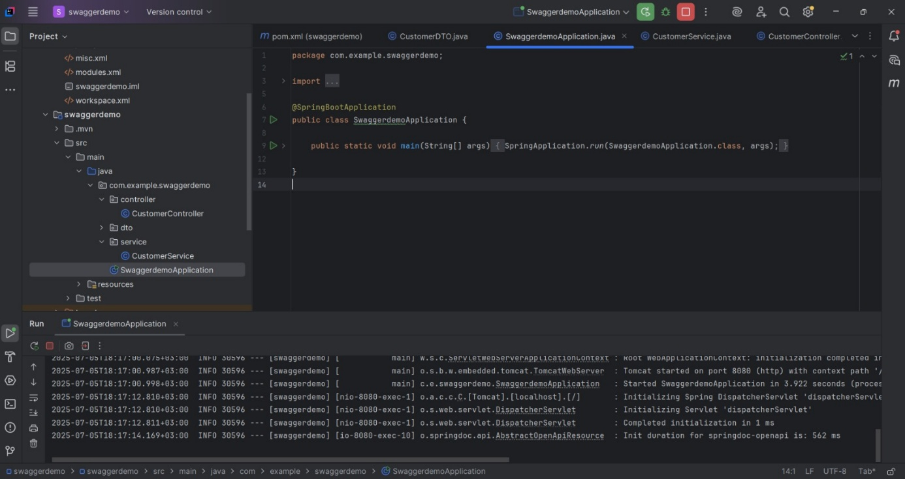

**I write the codes and go here http://localhost:8080/swagger-ui/index.html**

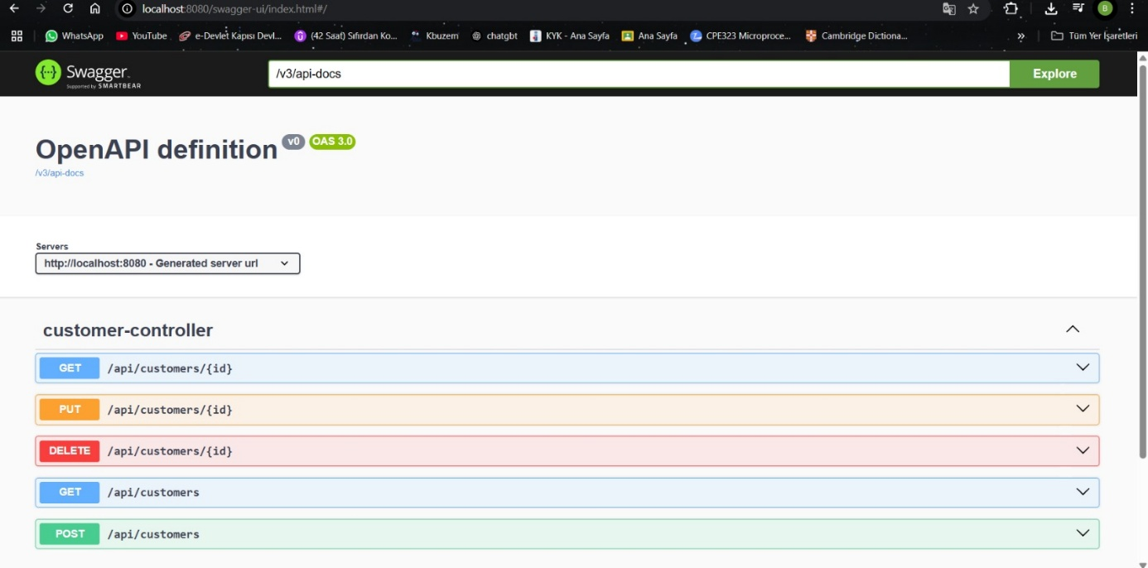

**\* Swagger UI açıldı**

**\* Tüm CRUD endpoint’ler (GET, POST, PUT, DELETE) eksiksiz görünüyor**

**\* DTO yapın da kullanılmış**

**\* Spring Boot uygulamam çalışıyor.**

**I wrote this to test on the post screen**

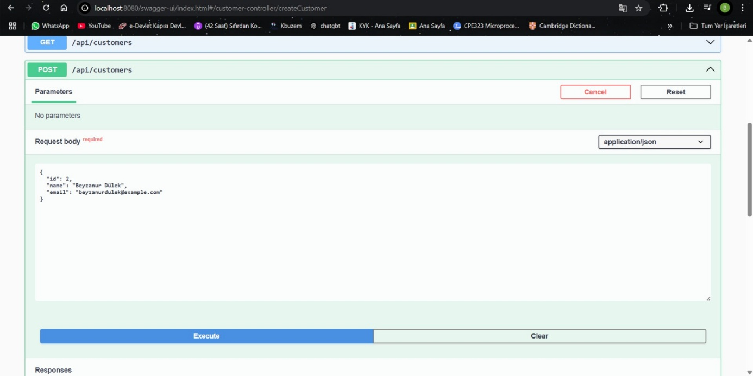

**When I go to this page http://localhost:8080/api/customers I get this result.**

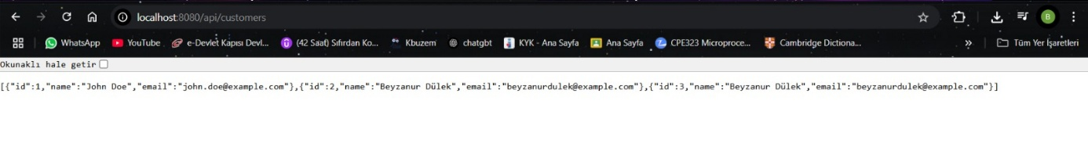

**To delete, I deleted the one with id 3.**

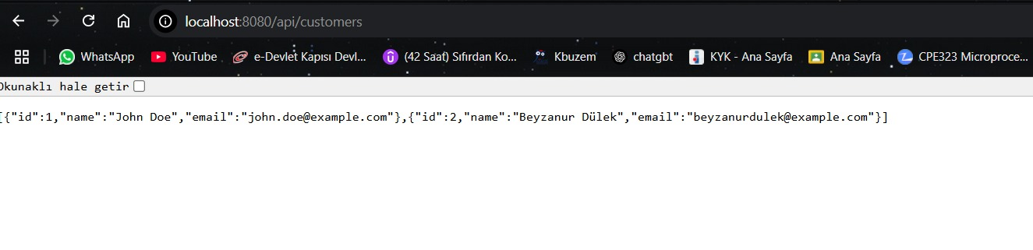

**Summary: I developed a Spring Boot RESTful application that performs basic CRUD operations on Customer data using in-memory data structures (Map). The API is documented using springdoc-openapi and can be tested via Swagger UI. It supports operations to create, retrieve, update, and delete customer records.**