Spring Boot Homework

First of all, I set the settings from this site and downloaded it by producing 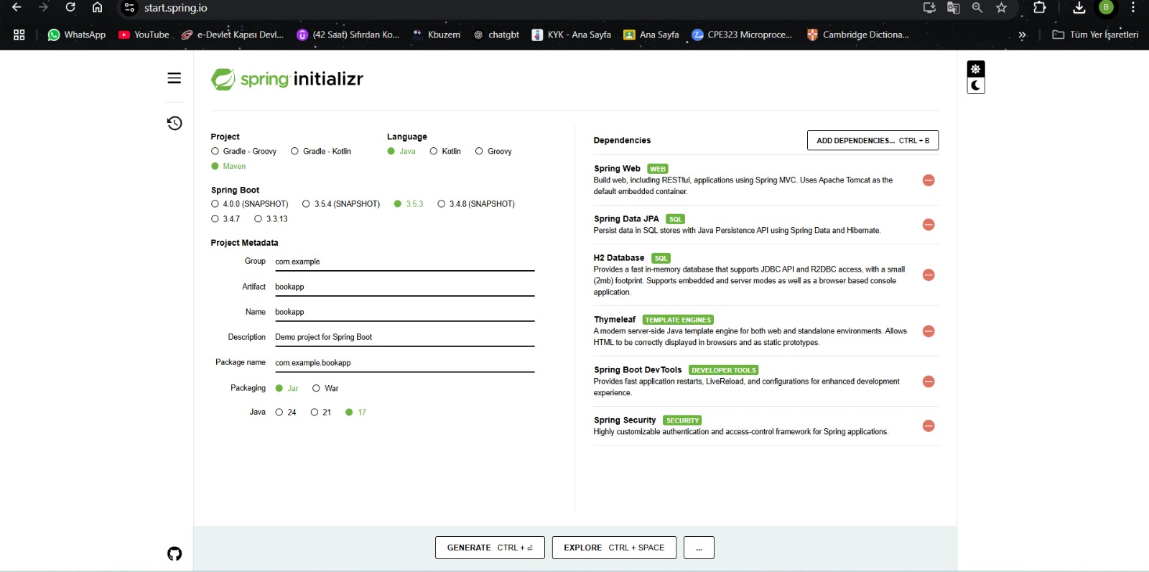

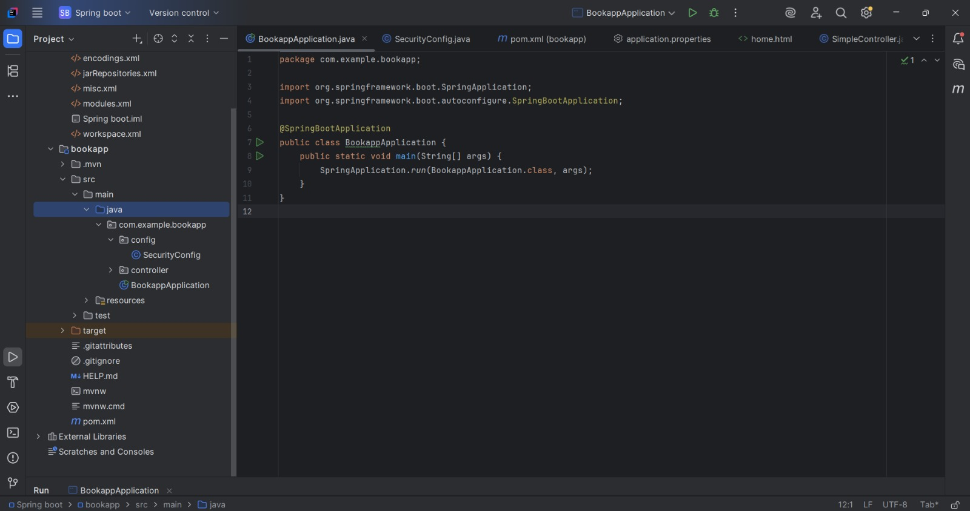I wrote the code for the main class.

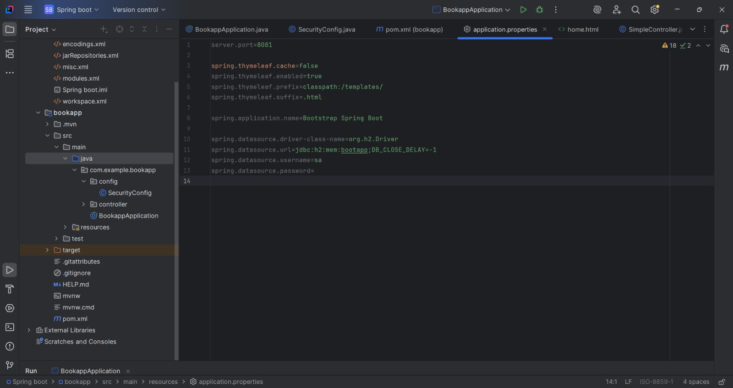

I set up the properties file.

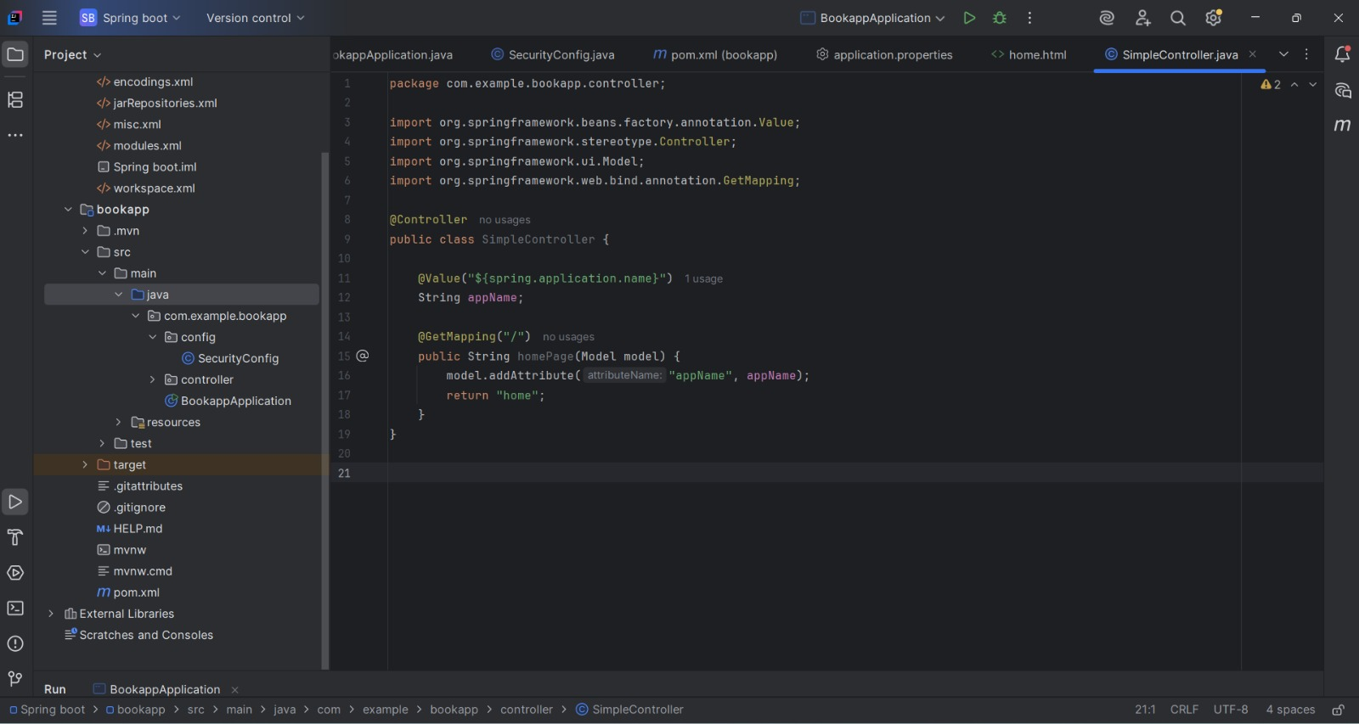

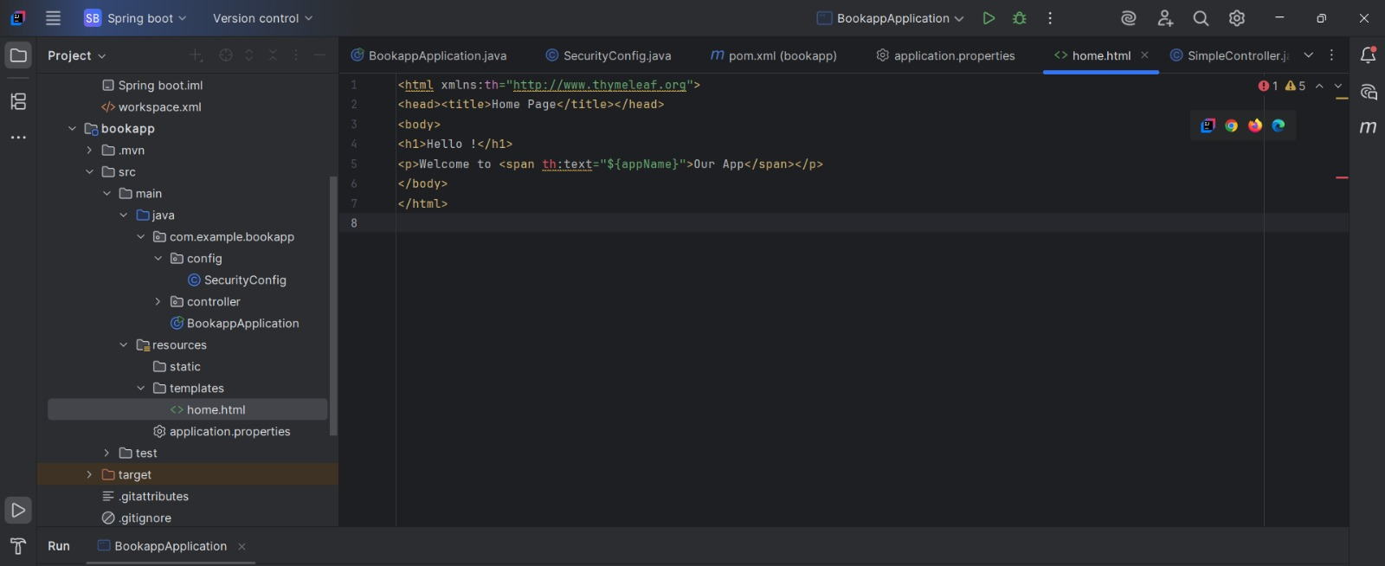  
I created a controller and html page, an error occurred in a word originating from the IDE (th). I added xmlns:th="http://www.thymeleaf.org"> to the beginning of the code, but the error persisted. Since my project was working without any errors, I did not pay much attention to it because it was just an IDE error.

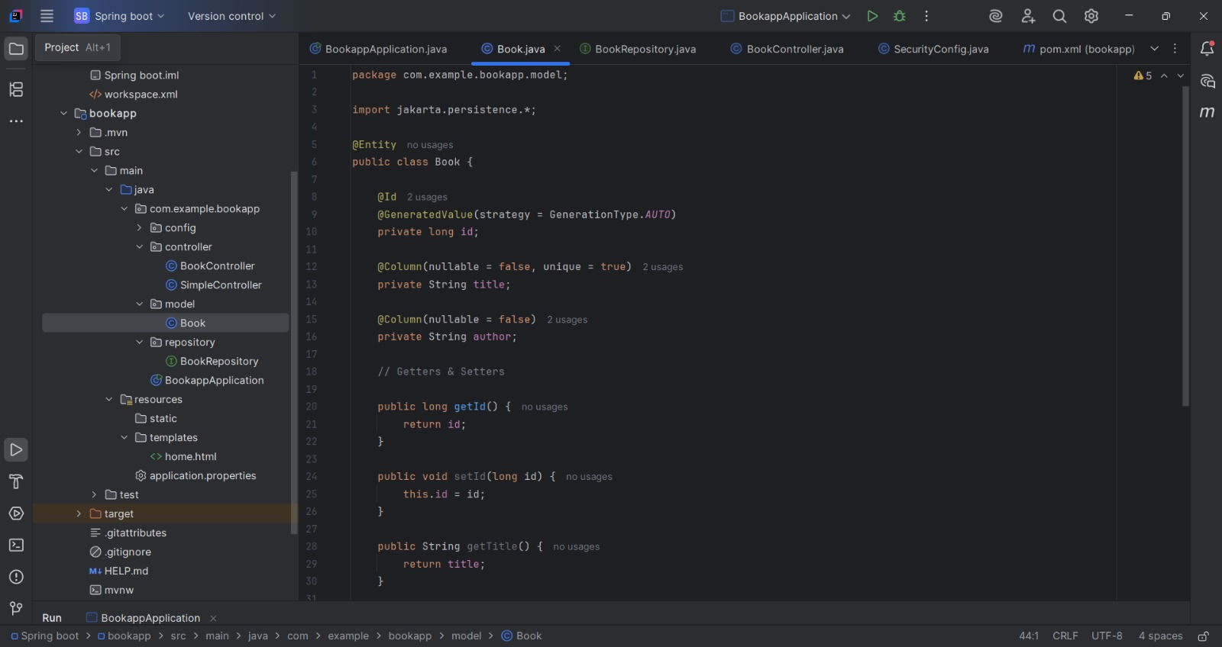

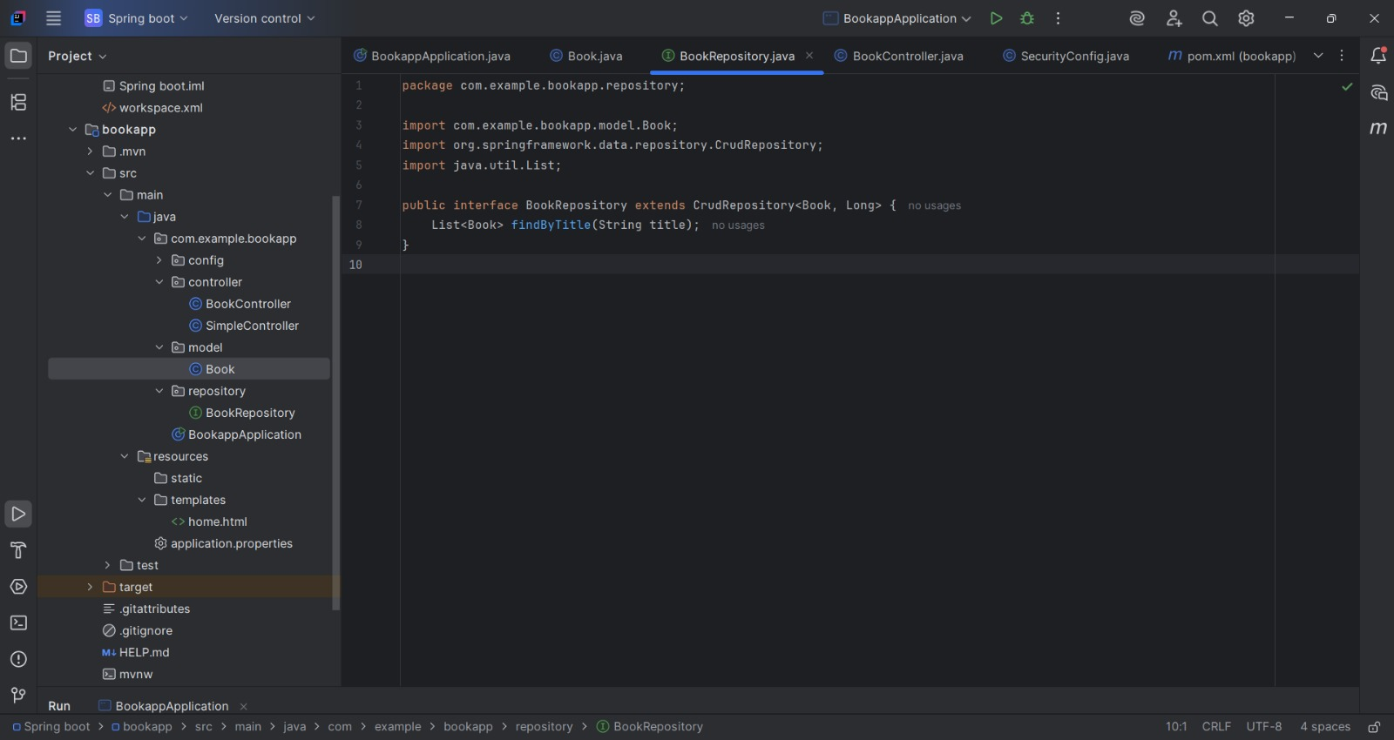

I wrote my book.java and bookrepository.java codes

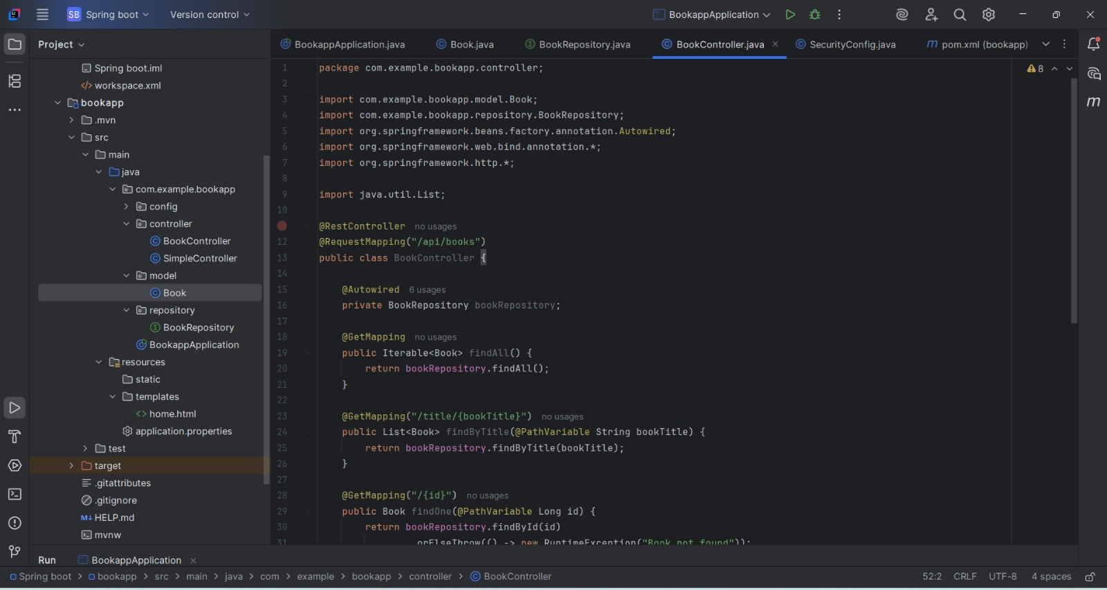

I wrote the BookController.java code

I will run my project in application.java and control it from http://localhost:8081/ → Home page

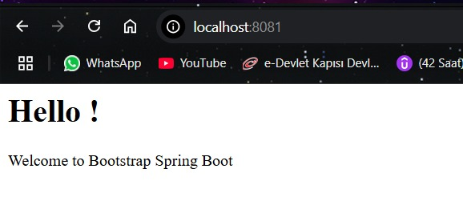

When I go to http://localhost:8081/api/books page, I see this page because there are no books yet but tables have been created.

