Software Requirements Specification
(SRS)

Project Name | HEALTH AI Co-Creation & Innovation Platform
Course | SENG384
Group No / Name | MediConnect
Group Members | Beyza Nur Özdemir 202228402  Betül Özdemir 202328405  Buğra Güngör 202228022
Submission Date | 18/04/2026
Version | 1.0
Revision History
Date | Version | Change Description | Author
18/04/2026 | 1.0 | Initial version | Both

Table of Contents
Table of Contents 2
1. Introduction 3
1.1 Purpose 3
1.2 Scope 3
1.3 Definitions and Abbreviations 3
1.4 Intended Audience 3
2. Overall Description 3
2.1 Product Perspective 3
2.2 User Roles 3
2.3 Assumptions and Dependencies 4
2.4 Constraints 4
3. Functional Requirements 4
3.1 User Registration & Access Control 4
3.2 Post Management 4
3.3 Search Functionality 5
3.4 Meeting Request Workflow 5
3.5 User Interface & Interaction 5
3.6 Future Requirements 5
3.7 Activity Logging & Audit Trail 6
3.8 Administrative Dashboard 6
4. Non-Functional Requirements 6
5. Use Cases 6
5.1 UC-01: Engineer Creates a Post 6
5.2 UC-02: User Logs In 7
5.3 UC-03: User Publishes a Post 7
5.4 UC-04: User Deletes a Post 7
5.5 UC-05: User Searches Posts 8
6. Data Model 8
7. Interface Requirements 9
7.1 User Interface (UI) 9
7.2 External System Interfaces 9
8. Requirements Traceability Matrix 9
9. Appendices 10

1. Introduction

1.1 Purpose
The purpose of this document is to describe the functional and non-functional requirements of the Health AI Platform.
This system is designed to provide a simple and user-friendly web interface where users with academic (.edu) email addresses can log in, create, manage, and search posts related to healthcare and artificial intelligence collaboration. This document is intended to guide the development and evaluation of the system.

1.2 Scope

The system supports user registration, post management, search functionality, and meeting request workflows.

The current version represents a frontend prototype and may not include full backend integration.

1.3 Definitions and Abbreviations
SRS: Software Requirements Specification
UI: User Interface
UX: User Experience
RBAC: Role-Based Access Control
GDPR: General Data Protection Regulation
NDA: Non-Disclosure Agreement
HTML: HyperText Markup Language
CSS: Cascading Style Sheets
JS: JavaScript

1.4 Intended Audience
This document is intended for the course instructor, students, and developers who are involved in the design, implementation, and evaluation of the Health AI Platform.

2. Overall Description

2.1 Product Perspective
The Health AI Platform is designed to make it easier for healthcare professionals and engineers to find collaboration opportunities. Currently, people usually rely on informal methods such as social media or personal contacts, which makes it difficult to find suitable partners and share project ideas.
This system provides a simple web platform where users can create and view posts in a more organized and accessible way.

2.2 User Roles
Role | Description | Key Permissions
Engineer | A user with a technical background who is interested in collaborating on healthcare-related projects. | - Log in to the system  - Create posts  - Publish posts  - Delete posts  - Search posts
Healthcare Professional | A user from the healthcare field who wants to collaborate on AI-based solutions. | - Log in to the system  - Create posts  - Publish posts  - Delete posts  - Search posts
Admin | A system-level role responsible for managing the platform. (Not implemented in this version) | - Manage users and posts (future scope)

2.3 Assumptions and Dependencies
It is assumed that users have a valid .edu email and access the system via a web browser. The system depends on HTML, CSS, and JavaScript and does not include backend or database support.

2.4 Constraints
The system is limited to a frontend implementation and does not include backend services. No database is used, and all data is stored temporarily in the browser. The system does not support file uploads, real-time communication, or meeting features. No sensitive data such as patient information is stored in the system.

3. Functional Requirements

3.1 User Registration & Access Control
ID | Requirement Description | Priority | Source
FR-01 | The system shall only allow access with institutional .edu email addresses. | High | Project Brief
FR-02 | The system shall validate the email format before allowing access. | High | Project Brief
FR-03 | The user shall be able to select a role (Engineer / Healthcare Professional) during login. | High | Project Brief
FR-04 | The system shall display an error message for invalid email input. | Medium | Design
FR-05 | The system shall allow users to log out of the system. | Low | Design

3.2 Post Management
ID | Requirement Description | Priority | Source
FR-06 | The system shall allow users to create a post including title, domain, and city information. | High | Project Brief
FR-07 | The system shall allow users to publish a post by changing its status from Draft to Active. | Medium | Project Brief
FR-08 | The system shall allow users to delete a post. | Medium | Design
FR-09 | The system shall display posts in a card-based layout. | Low | Design
FR-10 | The system shall support post lifecycle states:  Draft, Active, Meeting Scheduled, Partner Found, Expired | Low | Project Brief

3.3 Search Functionality
ID | Requirement Description | Priority | Source
FR-11 | The system shall allow users to search posts by city. | High | Project Brief
FR-12 | The system shall display filtered results based on the search input. | Medium | Design
FR-13 | The system shall update the displayed posts dynamically as the user types. | Low | Design

3.4 Meeting Request Workflow
ID | Requirement Description | Priority | Source
FR-14 | The system shall allow users to send meeting requests. | High | Project Brief
FR-15 | The system shall allow users to accept or reject meeting requests. | High | Project Brief
FR-16 | The system shall allow users to propose meeting time slots. | Medium | Project Brief

3.5 User Interface & Interaction
ID | Requirement Description | Priority | Source
FR-17 | The system shall provide a simple and user-friendly interface. | High | Design
FR-18 | The system shall display posts in a structured card-based layout. | Medium | Design
FR-19 | The system shall provide clear visual feedback for user actions (e.g., status changes, error messages). | Medium | Design
FR-20 | The system shall allow users to interact with the system using buttons and input fields. | Low | Design

3.6 Future Requirements
ID | Requirement Description | Priority | Source
FR-21 | The system shall support additional post lifecycle states such as Meeting Scheduled, Partner Found, and Expired in future versions. | Low | Project Brief
FR-22 | The system shall support persistent data storage using a database in future versions. | Low | Design
FR-23 | The system shall support backend integration for user authentication and data management. | Low | Design
FR-24 | The system shall support communication features between users in future versions. | Low | Design

3.7 Activity Logging & Audit Trail
ID | Requirement Description | Priority | Source
FR-25 | The system shall record basic user actions such as post creation, publishing, and deletion for tracking purposes (future implementation). | Low | Brief 4.6
FR-26 | The system shall provide an activity log to monitor user actions within the system (future implementation). | Low | Brief 4.6

3.8 Administrative Dashboard
ID | Requirement Description | Priority | Source
FR-27 | The system shall allow admin users to view all posts. | Medium | Project Brief
FR-28 | The system shall allow admin users to delete inappropriate posts. | Medium | Project Brief
FR-29 | The system shall allow admin users to view registered users. | Low | Project Brief

4. Non-Functional Requirements
Define the requirements from section 5 of the brief with concrete and measurable metrics.
ID | Requirement | Metric / Target | Category
NFR-01 | Search results shall be returned within a specified time. | < 1.5 seconds | Performance
NFR-02 | Page load time shall be limited. | < 3 seconds | Performance
NFR-03 | The system shall validate user input to prevent invalid data entry. | 100% validation for required fields | Usability
NFR-04 | The system shall restrict access to users with .edu email addresses. | Only .edu domains allowed | Security
NFR-05 | The system shall not store any personal or sensitive user data. | No data persistence in system | GDPR/Privacy

5. Use Cases

5.1 UC-01: Engineer Creates a Post
Name | UC-01: Engineer Creates a Post
Actor(s) | Engineer
Precondition | The engineer must be logged in.
Main Flow | 1. The engineer clicks the “New Post” button.  2. Fills in the required fields (domain, description, required expertise, etc.).  3. Clicks the “Publish” button.  4. The system publishes the post with “Active” status.
Postcondition | The post is saved and visible to other users.
Alternative Flow | 2a. If a required field is left blank, the system displays an error message.

5.2 UC-02: User Logs In
Name | UC-02: User Logs In
Actor(s) | User (Engineer / Healthcare Professional)
Precondition | The user must have a valid .edu email address.
Main Flow | 1. The user enters their email.  2. The user selects a role.  3. The user clicks the “Login” button.  4. The system validates the email.  5. The user is redirected to the dashboard.
Postcondition | The user is successfully logged into the system.
Alternative Flow | 4a. If the email is invalid, the system displays an error message.

5.3 UC-03: User Publishes a Post
Name | UC-03: User Publishes a Post
Actor(s) | User
Precondition | The user must be logged in and have at least one draft post.
Main Flow | 1. The user views a draft post.  2. The user clicks the “Publish” button.  3. The system updates the post status to “Active”.
Postcondition | The post becomes visible as an active post.
Alternative Flow | 2a. If the post is already published, no action is taken.

5.4 UC-04: User Deletes a Post
Name | UC-04: User Deletes a Post
Actor(s) | User
Precondition | The user must be logged in and have existing posts.
Main Flow | 1. The user selects a post.  2. The user clicks the “Delete” button.  3. The system asks for confirmation.  4. The user confirms deletion.  5. The system removes the post.
Postcondition | The post is removed from the system.
Alternative Flow | 3a. If the user cancels, the post is not deleted.

5.5 UC-05: User Searches Posts
Name | UC-05: User Searches Posts
Actor(s) | User
Precondition | The user must be logged in.
Main Flow | 1. The user enters a city in the search bar.  2. The system filters posts based on the input.  3. Matching posts are displayed.
Postcondition | The user sees filtered results.
Alternative Flow | 2a. If no match is found, no posts are displayed.

6. Data Model

Entity | Key Fields | Relationships
User | id, email, role | A user can create multiple posts
Post | id, title, domain, city, status | A post belongs to one user
MeetingRequest | id, postId, requesterId, status | Linked to a post and a user (future implementation)
ActivityLog | id, action, timestamp, userId | Records actions performed by users (future implementation)

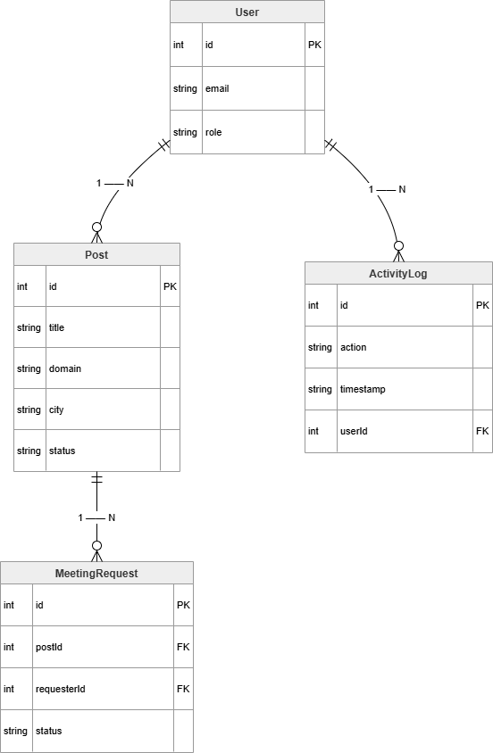
Figure 1: Entity Relationship Diagram
This diagram shows the main entities of the system and their relationships.
A user can create multiple posts, each post can have multiple meeting requests,
and user actions are recorded in the activity log.

7. Interface Requirements

7.1 User Interface (UI)
The system consists of two main screens: the login page and the dashboard. The login page allows users to enter their email and select a role. It also provides validation and error messages for incorrect input. The dashboard includes a post creation form where users can enter title, domain, and city information. It also displays all posts in a card-based layout, along with their status (Draft / Active). The dashboard also includes a search bar that allows users to filter posts by city, and buttons for publishing and deleting posts.

7.2 External System Interfaces

The current system does not interact with any external services. All functionalities are handled on the client side using HTML, CSS, and JavaScript. In future versions, the system may integrate with external services such as email verification systems or communication platforms.

8. Requirements Traceability Matrix

Req. ID | Requirement Summary | Source (Brief) | Related Use Case
FR-01 | .edu email restriction | Project Brief | UC-02
FR-02 | Email format validation | Project Brief | UC-02
FR-03 | Role selection | Project Brief | UC-02
FR-04 | Error message display | Design | UC-02
FR-05 | Logout functionality | Design | UC-02
FR-06 | Create post | Project Brief | UC-01
FR-07 | Publish post | Project Brief | UC-03
FR-08 | Delete post | Design | UC-04
FR-09 | Display posts (card layout) | Design | UC-01
FR-10 | Display post status | Project Brief | UC-03
FR-11 | Search posts by city | Project Brief | UC-05
FR-12 | Filtered results display | Design | UC-05
FR-13 | Dynamic search update | Design | UC-05
FR-14 | Send meeting request | Project Brief | UC-01
FR-15 | Accept / reject request | Project Brief | UC-02
FR-16 | Propose meeting time | Project Brief | UC-02
FR-17 | User-friendly interface | Design | UC-01, UC-02
FR-18 | Structured post layout | Design | UC-01
FR-19 | Visual feedback (status/errors) | Design | UC-02, UC-03
FR-20 | User interaction (buttons/inputs) | Design | UC-01
FR-21 | Future lifecycle states | Project Brief | Future
FR-22 | Database support (future) | Design | Future
FR-23 | Backend integration (future) | Design | Future
FR-24 | User communication (future) | Design | Future
FR-25 | Activity logging (future) | Brief 4.6 | Future
FR-26 | Audit trail (future) | Brief 4.6 | Future
FR-27 | Admin view posts | Project Brief | Future
FR-28 | Admin delete posts | Project Brief | Future
FR-29 | Admin view users | Project Brief | Future

9. Appendices
• Use Case Diagram

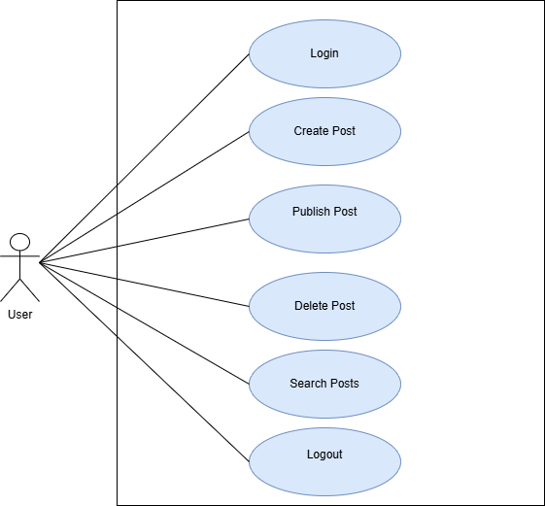

• Wireframe / Mockup images
Figure B1: Login Page
This screen allows users to enter their email and select a role.
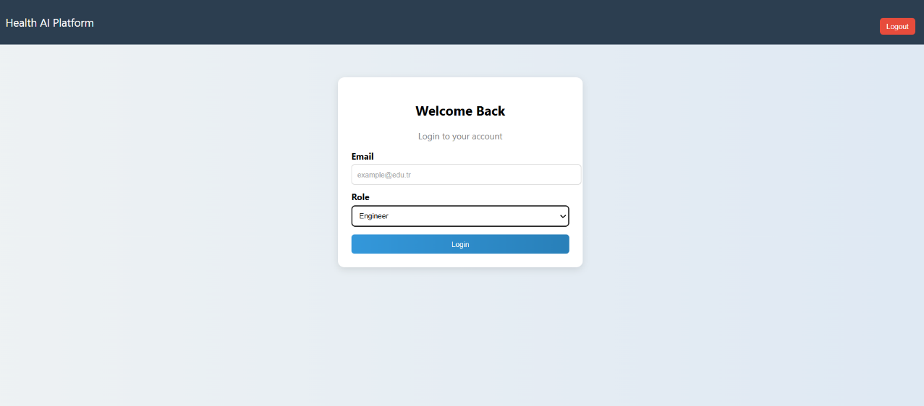

Figure B2: Invalid Login

This screen shows the error message for invalid email input.
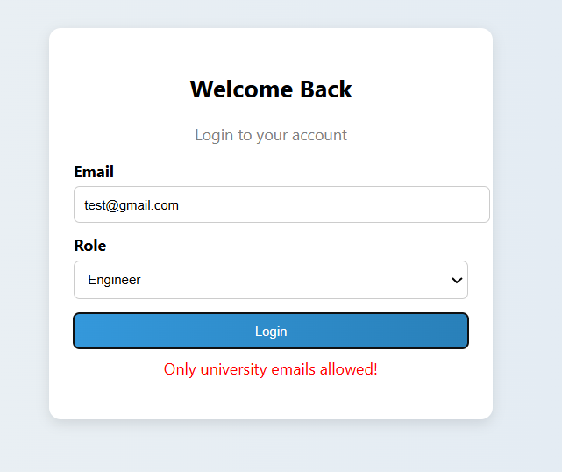

Figure B3: Dashboard
This screen shows the main interface of the system.
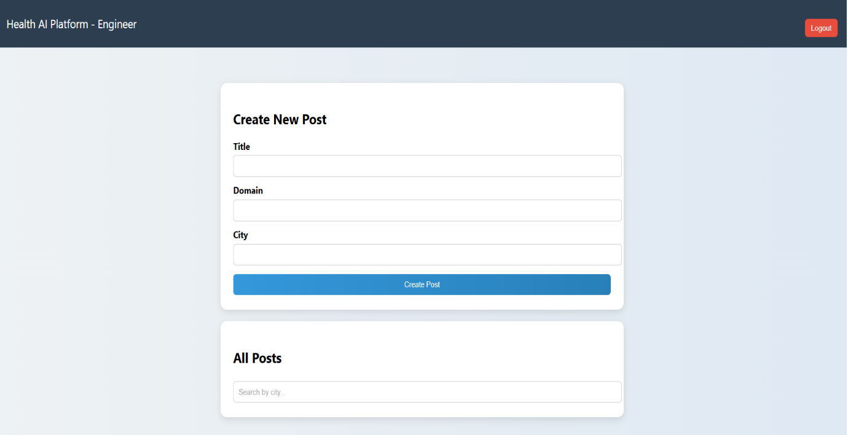

Figure B4: Post Creation
Users can create and manage posts.
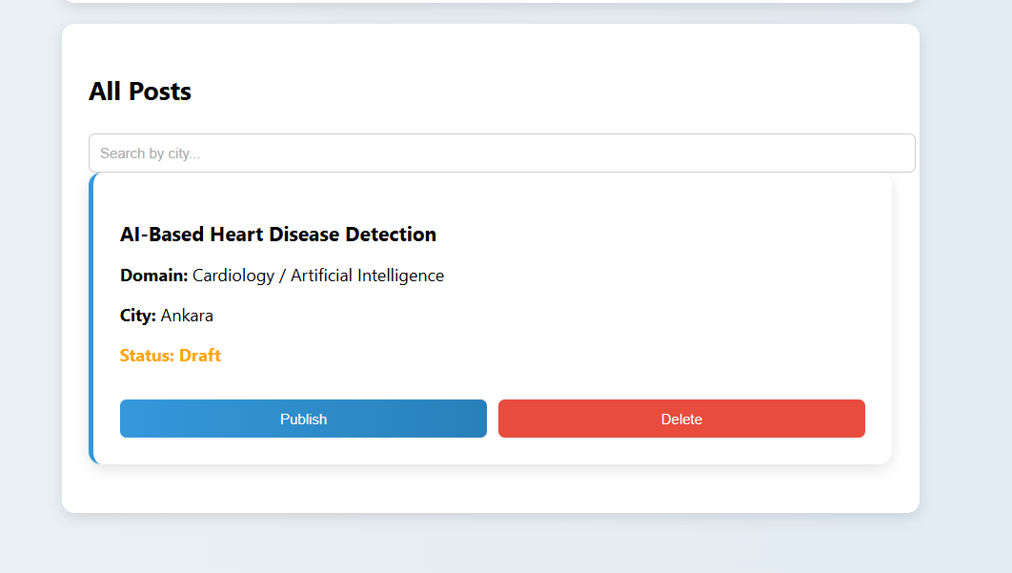

Figure B5: Post List
Posts are displayed with their status and actions.
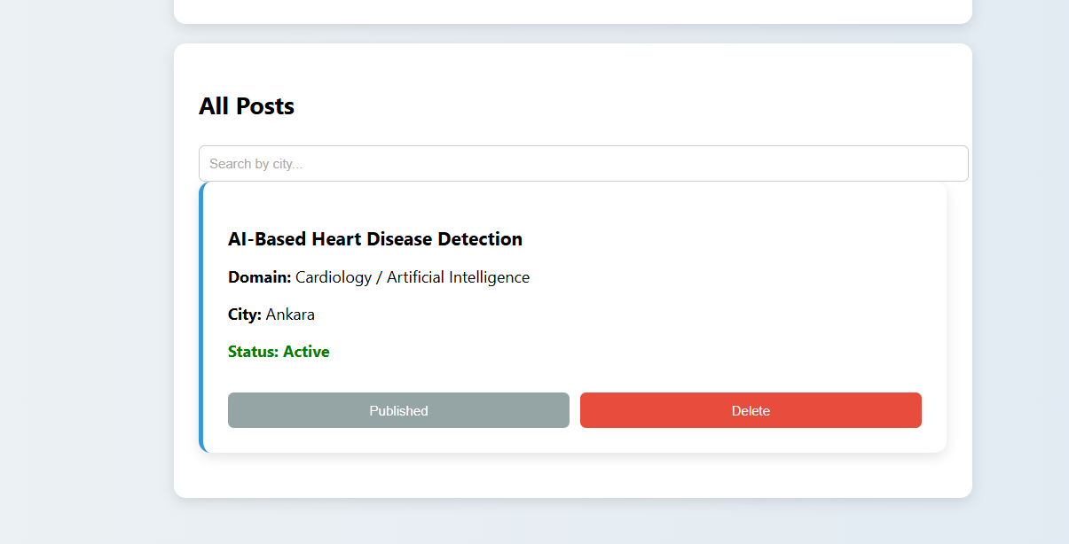

Figure B6: Search Function
Users can filter posts by city.
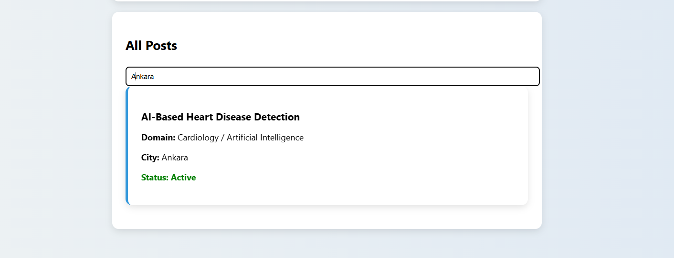

• ER Diagram
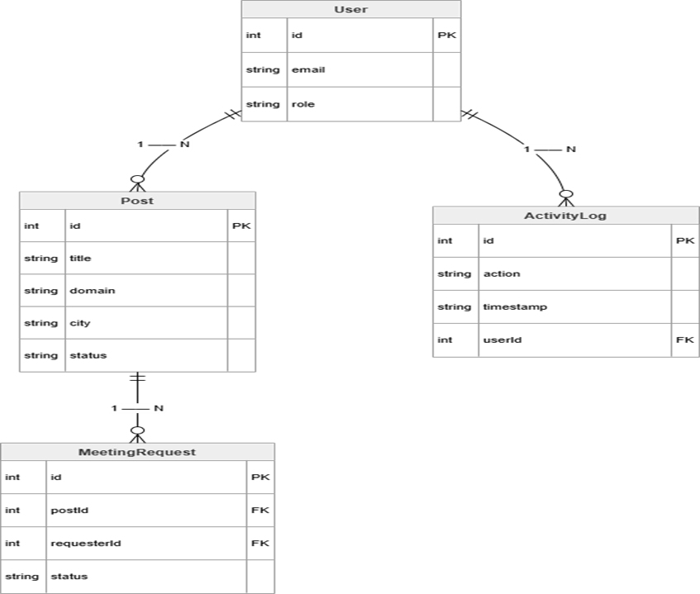
Figure C1: Entity Relationship Diagram
This diagram shows the main entities of the system and their relationships.
A user can create multiple posts, each post can have multiple meeting requests,
and user actions are recorded in the activity log.

