

BAHÇEŞEHİR UNIVERSİTY

2017-2018 SPRING

CMP 1001 Introduction to Programming (C++)

**Term Project Report**

PROJECT PURPOSE

Our aim is to create maze game.The game consists of two parts.Each section contains two levels.The first part is that car is moving randomly.The game has the aim to get bonuses(do not have to) and reach the finish point before time is up. The bonuses affect to increase, decrease score and change the car type.When the time is over, the second level is not passed but score can be seen.If the car finishes the first level, it goes to the second level.If the car finishes the second level before the time is up, the game will be completed.The second part has differences from the first part.In the second part, user controls car and the bonuses have different random value.

MINIMUM CRITERIA

**Game Board:**

int firstlvl[10][10];

for (int i = 0; i<10; i++){

for (int j = 0; j<10; j++){

firstlvl[i][j] = 1;

}

}

firstlvl[0][7] = 3;

for (int i = 1; i<5; i++){

firstlvl[i][7] = 2;

}

for (int i = 2; i<7; i++){

firstlvl[4][i] = 2;

}

for (int i = 5; i<10; i++){

firstlvl[i][2] = 2;

}

firstlvl[9][2] = 4;

1 represents random coordinates.2 represents main road.3 represents entry.4 represents exit.

We use the two-dimensional array and for loops to create the 2-dimensional matrix.We use the pointer and function to display the game board on the screen.The first position was transferred to the function via the pointer.This function reached the other position of the arrays by using the first position.We displayed game board on the screen.

arraystart1 = &firstlvl[0][0];(first position)

gameboard1(arraystart1, row1, column1, randomcoord1, randombonus1)(function)

If position’s value is 3, this represents x.If position’s value is 7, this represents f(car type).If position’s value is 8, this represents b(car type).If position’s value is 4, this represents space.If position’s value is 1, this represents random position.If random value is 1 ,it represents char(219).

for (int i = 0; i < row1*column1; i++){

if (*(arraystart1 + i) == 1)

randomcoord1[i] = rand() % 2;

else

randomcoord1[i] = 0;

}

We have transferred these array information the function(gameboard1).Therefore, we have different game board shape every game.

**Control Statement:**

We produce random number 1,2,3,4.

int move1 = (rand() % 4) + 1;

‘1’ represents up. ‘2’ represents left. ‘3’ represents down. ‘4’ represents right.

else if (*(coord1 - column1) == 1 && randomcoord1[i1 - column1] == 0 || *(coord1 - column1) == 2){

temp = *(coord1 - column1);

*(coord1 - column1) = *coord1;

*coord1 = temp;

coord1 = coord1 - column1;

i1 = i1 - column1;

finish1 = time(NULL);

if (difftime(finish1, start1) > time1){

if (score1 < 0){

score1 = 0;

}

cout << endl << "TIME IS UP!" << endl << "SCORE=" << score1;

game1 = false;

game2 = false;

}

}

}

We use the pointer to move the car and change the value of that location.We use temp to change location.We write proper control code statement.End of the code the new location is our last location.

**Creating Bonuses Randomly:**

int randombonus1[100];

for (int i = 0; i < row1*column1; i++){

if (*(arraystart1 + i) == 2 || randomcoord1[i] == 0 && *(arraystart1 + i) != 4){

randombonus1[i] = (rand() % 35) + 1;

}

}

We send this array to the game board functions to see this bonuses on the screen.We produce a random number to create bonus. If the random number is 5, it displays ‘t’ bonuses.If the random number is 6, it displays ‘$’.If the random number is 7, it displays ‘#’.

if (y[i] == 5)

cout << "t";

else if (y[i] == 6)

cout << "$";

else if (y[i] == 7)

cout << "#";

**Bonuses Value:**

‘t’ bonuses increase score 100 points. (score1 = score1 + 100 in movement part)

‘$’ bonuses increase score 100 points and change the car type. (score1 = score1 + 100 in movement part)

‘#’ bonuses decrease score 100 points. (score1 = score1 - 100 in movement part)

**Car Type:**

if ((i1 - column1) % 2 == 0){

cartypef1(arraystart1, i1 - column1);

}

else

{

cartypeb1(arraystart1, i1 - column1);

}

void cartypef1(int* f, int j){

int g = 7;

*(f + j) = g;

}

void cartypeb1(int* n, int j){

int k = 8;

*(n + j) = k;

}

When the randombonus1 value is 6, it means that it changes car type.

We used functions and pointer to change car type. i represents array number.When i divisible by 2, car type changes and the new car type is ‘f’.Otherwise, the new car type is ‘b’. We transferred arraystart1 position and i’s value to the function. We showed f and b on the screen.

else if (coordvalue == 7)

cout << "f";

else if (coordvalue == 8)

cout << "b"; (in gameboard1 function)

**High Score and Time:**

if (difftime(finish1, start1) > time1){

(score1 < 0){

score1 = 0;

}

cout << endl << "TIME IS UP!" << endl << "SCORE=" << score1;

game1 = false;

game2 = false;

}

}

srand(time(NULL));

time_t start1, finish1;

start1 = time(NULL);

finish1 = time(NULL);

We use time library. We use difftime to calculate the time interval between start and end points.When the time is up or the game ends, score is shown on the screen.

BONUS:

**Alternative control:**

move1 = _getch();

‘w’ represents up. ‘a’ represents left. ‘s’ represents down. ‘d’ represents right.Other part is same structure with first part.

**Different Random Values:**

score1 = score1 + (rand() % 100) + 1;(When bonus is ‘t’)

score1 = score1 + (rand() % 100) + 1;(When bonus is ‘$’)

score1 = score1 - (rand() % 100) + 1; (When bonus is ‘#’)

SCREENSHOTS:

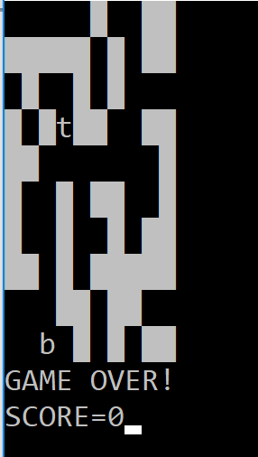 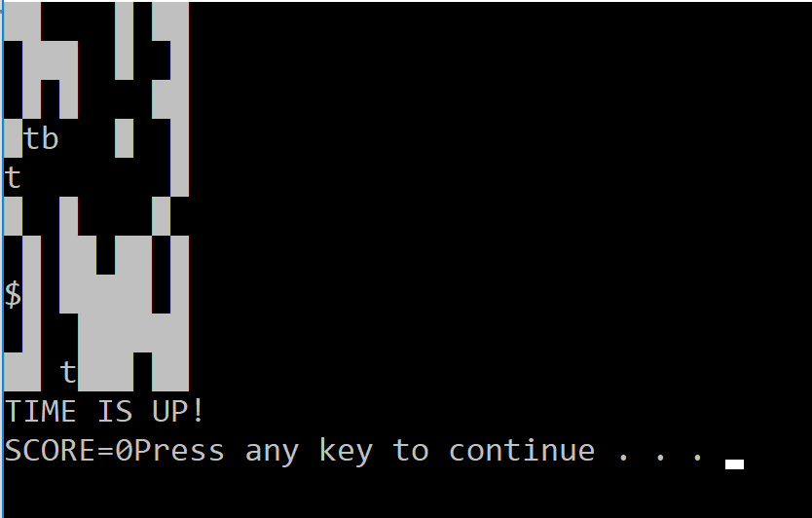

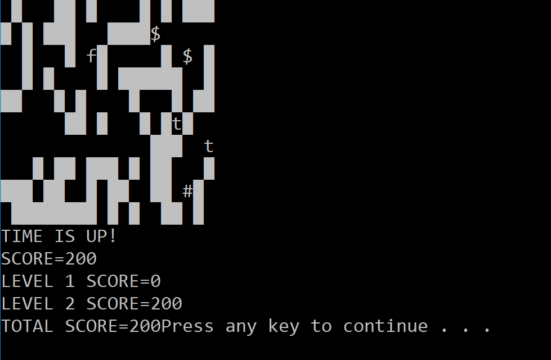

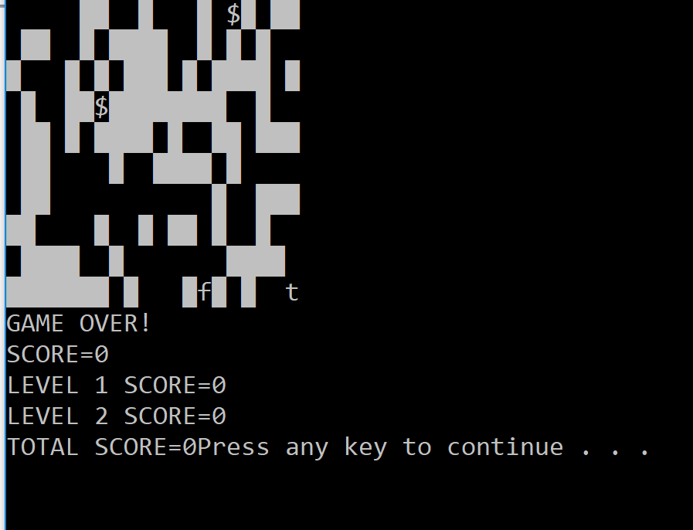

EXTRA INFORMATION:

#include <cstdlib> (for random number)

#include <Windows.h>(for sleep)

#include <ctime>(for random number)

#include <stdio.h> (for difftime)

#include <time.h> (for difftime)

#include <conio.h>(for _getch())