**RESUME BUILDER USING JAVA**

**INTRODUCTION -**

This is a basic Resume maker. It is divided into three sections - personal details, education, experience. And final resume is made by combining all the three sections.

**IMPLEMENTATION -**

Basic functionalities used in this project are -

1. **Login Page -**

Registered users can login to their account to use this resume builder.

1. **Sign-up Page -**

New users can register in this section and get their account created.

1. **Personal Details -**

User have to fill the fields like name, father’s name, DOB, nationality, phone number and email id.

1. **Educational Details -**

User have to fill the fields for school, college and university and their respective joining and passing years. One more field of Languages known.

1. **Experience -**

Users have to fill their internship details.

1. **Final Resume Output -**

Final output of resume comes out after combining personal, education and experience sections.

**PROGRAM -**

**Landing Page:**

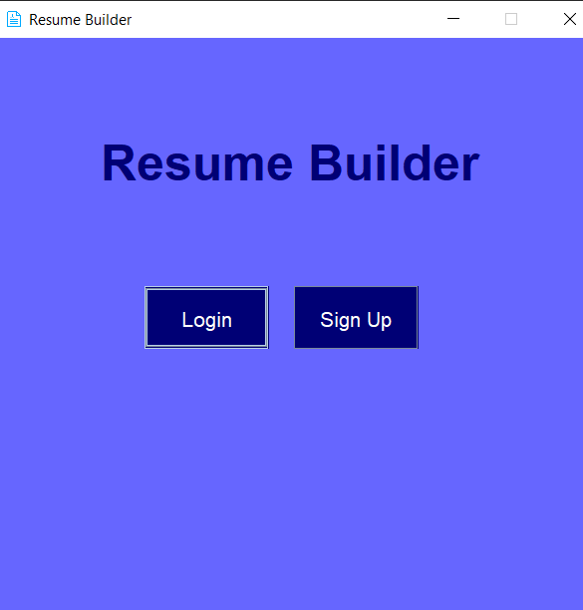

**Sign-up Page:**

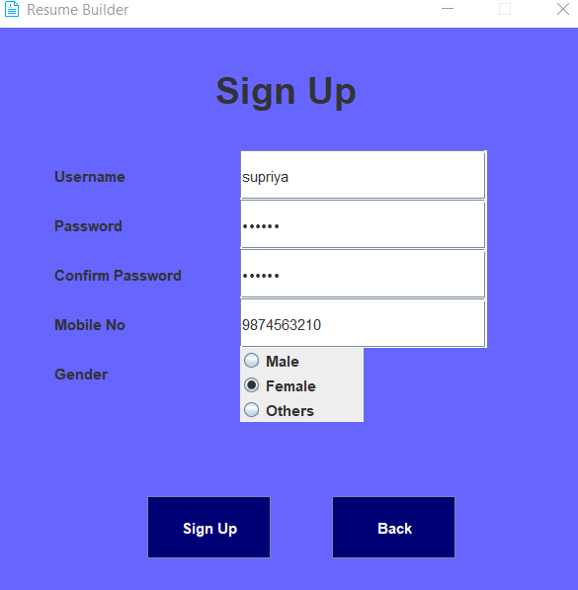

**Login Page:**

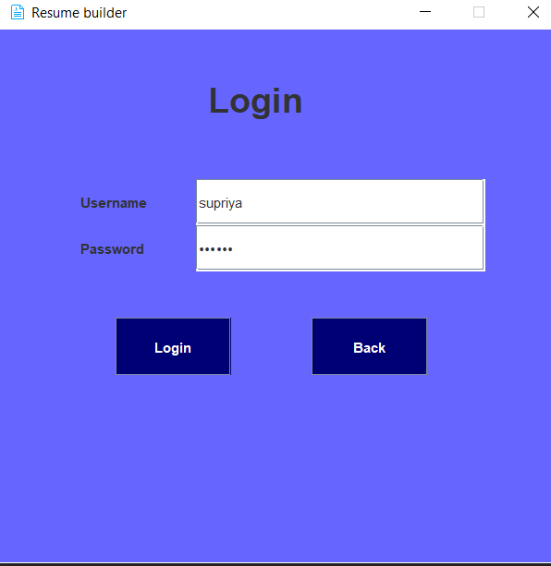

**Personal detail page:**

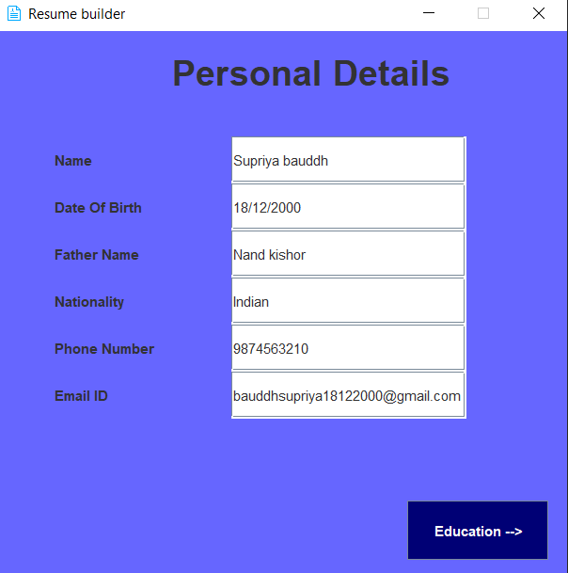

**Educational details page:**

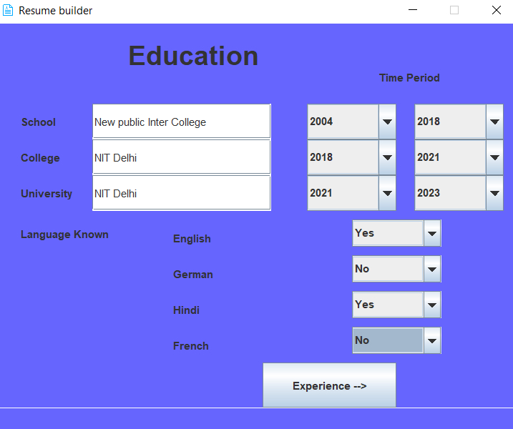

**Experience details page:**

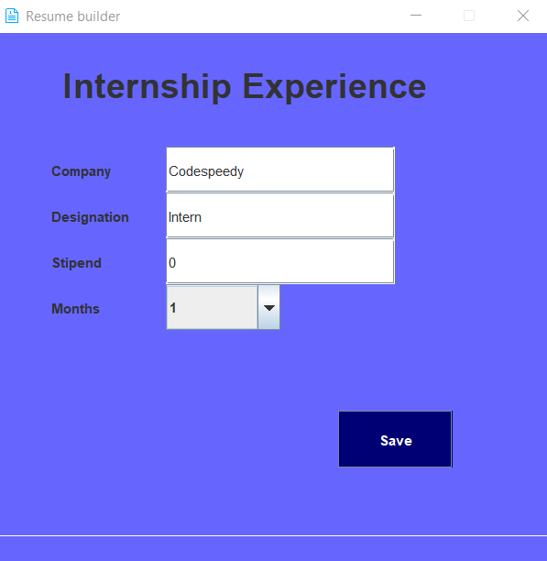

**Final Resume builder:**

