

**ADDIS ABABA SCIENCE AND TECHNOLOGY UNIVERSITY**

**College of Engineering**

**Department of Electrical and Computer Engineering**

**Control Stream**

**Radio Frequency Based Tool Tracking System**

**Prepared By:**

**Bezawit Denbeze …………………………………………………… Ets0260/13**

**Supervisors:**

1. **Mr. Mulugeta D. and Dr. Muluneh M.(University Supervisor)**
2. **Mr. Muluken Abate(Industry Supervisor)**

**Submitted to - Addis Ababa Science and Technology University Department of Electrical and Computer Engineering**

**September, 30 2024**

**Addis Ababa, Ethiopia**

# **Acknowledgment**

To begin, I express my heartfelt gratitude to God for His constant guidance and blessings throughout this journey. I am incredibly grateful to my advisor at Bole International Airport, Mr. Muluken Abate Team Leader of Facility Maintenance, for his exceptional support and guidance, which has been instrumental in my growth during this internship.

I would also like to extend my sincere thanks to the staff of the Facility Maintenance Shop for their dedication, patience, and warm welcome. Their willingness to answer all my questions and help me adjust to the work environment made my experience both enjoyable and productive.

I am deeply appreciative of the lecturers in the Electrical and Computer Engineering Department for their knowledge and support, which have been the foundation of my learning. I also extend my gratitude to Ethiopian Airlines for providing me with the opportunity to complete this 90-day internship. The encouragement and assistance from the Human Resource Management team were crucial in making my time here a success.

A special thank you goes to Mr. Komander Kumsa, the Electromechanical Department Manager at MRO, for assigning me to the maintenance team and for his continuous support, which allowed me to put my theoretical knowledge into real-world practice. Lastly, I am sincerely thankful to my school advisor, Mr. Mulugeta, for his unwavering support and guidance throughout this journey.

# **Executive summary**

As part of the curriculum at Addis Ababa Science and Technology University, one semester is dedicated to industrial internships. For my fourth-year third semester, I completed my internship at Ethiopian Airlines (Bole) from July 11, 2024, to September 30, 2024. During this period, I worked Monday through Friday from 8:00 AM to 5:00 PM, aligning with the regular working hours in Ethiopia.

During my time at Ethiopian Airlines, I gained practical experience in various tasks, including the installation and testing of soft starters for large motors (up to 110 kW and 210A), repair of capacitor start induction motors, troubleshooting water pump and exhaust fan motors, and installation of power lines for critical systems such as the UPS for the Danobat machine. I also worked on diagnosing issues with PLC controllers for the waste treatment plant and conducted soft starter tests for compressors. Additionally, I was involved in lighting replacements, electrical repairs, and machine maintenance, including lathe machines and control boards for heavy equipment handling.

This internship not only helped me bridge the gap between theory and practice but also improved my teamwork, leadership, and problem-solving skills. The experience allowed me to identify opportunities for innovation in facility maintenance and has greatly contributed to my professional growth, preparing me for future challenges in my field.

# **Table of Content**

**Chapter one 1**

Introduction of the hosting company 1

1.1. Company Profile 1

1.2. Background of the company 2

1.3. History of company 3

1.4. Company’s vision, mission and value 5

1.4.1. Vision 5

1.4.2. Mission 5

1.4.3. Value 5

1.5. Company current status 6

1.6. Overall organization and work flow 8

**Chapter Two 9**

Internship Experience 9

2.1. Introduction 9

2.2. Organization Structure of Facility Maintenance Department 10

2.3. Activities 10

2.4. Procedures and Methods Utilized During Internship Tasks 11

2.5. Challenges Faced and Overcome During Internship Tasks 12

2.6. Addressing and Overcoming Challenges 13

**Chapter Three 15**

Industrial Project and its design process 15

3.1. Introduction 15

3.2. Background Analysis 16

3.3. Objectives 18

General Objective 18

Specific Objectives 18

3.4. Problem definitions 19

3.5. Literature Review 20

3.6. Design approach/Methodology 22

3.6.1. Step to develop the project 22

3.7. How the system Works 23

3.8. Result and Discussion 30

**Chapter Four 32**

4. Overall internship achievement and experience 32

4.1. Benefit we gained in terms of upgrading my theoretical knowledge 33

4.2. Benefit we gained in terms of improving my practical skill 33

4.3. Benefit we gained in terms of improving industrial problem-solving ability 34

4.4. Benefit we gained in terms of improving team working skill 34

4.5. Benefit we gained in terms of improving leadership skill 35

4.6. Benefit we gained in terms of understanding about work ethics 35

4.7. Benefit we gained in terms of entrepreneur skill 36

**Chapter Five 36**

Recommendation and conclusion 36

Conclusion 37

References 38

# **List of Figure**

# **List of Table**

# **List of Abbreviation**

# **Chapter one**

# **Introduction of the hosting company**

# **Company Profile**

Addis Ababa Bole International Airport is located about 6 kilometers (3.7 miles) southeast of the city center of Addis Ababa, the capital of Ethiopia. It houses a state-of-the-art maintenance hangar that spans 7,200 square meters with a height of 25 meters, capable of accommodating a Boeing 747-400 or two Boeing 737-700 aircraft, or similarly sized aircraft, at any given time in various configurations.

Ethiopian Airlines operates one of the most advanced maintenance bases in Africa, providing full air-frame maintenance up to D-check, engine overhauls, and component repair and refurbishment. It also offers light aircraft maintenance and technical and management assistance to other airlines, leveraging its extensive expertise. Certified by the U.S. Federal Aviation Administration (FAA) and the European Aviation Safety Agency (EASA), this facility ensures world-class standards for safety and quality.

The maintenance base is fully equipped to handle both routine and complex overhauls, with specialized workshops for different aircraft systems, including avionics, hydraulics, and landing gear. Ethiopian Airlines' skilled engineers, technicians, and mechanics ensure that all operations run smoothly, adhering to international regulations and industry best practices.

Ethiopian Airlines' Maintenance, Repair, and Overhaul (MRO) services are not limited to its own fleet. The airline provides technical and management assistance to other carriers, supporting their operations with highly skilled manpower in areas such as air-frame and engine maintenance, component overhaul, and aircraft management services. This collaborative support ensures that Ethiopian Airlines contributes to the growth and success of the African aviation industry as a whole.

Furthermore, the airline's MRO facility includes training programs for technicians and engineers, ensuring a continuous pipeline of qualified personnel capable of handling the latest technologies and aircraft systems. These programs meet global standards, as evidenced by the certifications from both the FAA and EASA.

In addition to air-frame and engine maintenance, Ethiopian Airlines' MRO base includes a dedicated facility for the repair and overhaul of a wide range of components, from electrical systems to auxiliary power units (APUs) and beyond. This enables the airline to maintain a high level of operational readiness and reduce downtime for aircraft.

# **Background of the company**

Ethiopian Airlines, the national flag carrier of Ethiopia, is renowned for its extensive global reach and commitment to excellence in aviation. In the decades following its founding, Ethiopian Airlines expanded its fleet and network. By the 1950s and 1960s, it had begun to acquire more modern aircraft, including the Boeing 720 and the Boeing 727, which facilitated longer routes and increased passenger capacity. The airline's commitment to modernization continued with the introduction of jet aircraft and the establishment of Addis Ababa Bole International Airport as its primary hub, which became a crucial gateway for international travel into and out of Africa.

Ethiopian Airlines underwent significant modernization starting in the late 1990s and early 2000s. The airline invested heavily in acquiring new, more fuel-efficient aircraft such as the Boeing 787 Dreamliners and Airbus A350s, which enhanced its operational efficiency and passenger comfort. During this period, Ethiopian Airlines also focused on expanding its route network and increasing its presence in global aviation markets.

In 2010, Ethiopian Airlines became a member of the Star Alliance, a significant milestone that enhanced its global connectivity and integrated its services with other leading international carriers. This membership allowed Ethiopian Airlines to offer its passengers a wider range of destinations and benefits through alliances with other member airlines.

Overall, Ethiopian Airlines' history is marked by steady growth, modernization, and a strategic focus on expanding its global reach. Its ongoing efforts to enhance service quality and operational capabilities underscore its role as a leading airline in Africa and a significant player on the world stage.

# **History of company**

Ethiopian Airlines was established on December 21, 1945, with the primary goal of connecting Ethiopia with the rest of the world. The airline was founded by the Ethiopian government as a state-owned entity, reflecting the country’s commitment to enhancing its transportation infrastructure. The first aircraft, a Douglas DC-3, began service in April 1946, marking the beginning of the airline’s operations. The initial focus was on regional routes within Africa and limited connections to neighboring countries.

During the 1960s and 1970s, Ethiopian Airlines underwent significant growth and modernization. The acquisition of new aircraft such as the Boeing 720 and Boeing 727 enabled the airline to expand its network to Europe, Asia, and North America. This era also saw the construction of Addis Ababa Bole International Airport, which became the central hub for the airline. The addition of jet aircraft allowed Ethiopian Airlines to offer faster and more efficient services, improving connectivity and increasing its passenger capacity.

The 1980s were marked by political instability and economic challenges in Ethiopia, which affected the airline’s operations. Despite these difficulties, Ethiopian Airlines continued to expand its fleet and routes. The introduction of the Boeing 737 and Boeing 757 into its fleet improved regional and international connectivity. The airline’s growth during this period was characterized by its resilience in the face of adversity and its ongoing commitment to modernization.

The 1990s and early 2000s were transformative years for Ethiopian Airlines. Under the leadership of CEO Girma Wake, the airline undertook a major modernization program. This included acquiring new aircraft such as the Boeing 767 and 737, upgrading its services, and improving operational efficiency. The airline’s strategic expansion during this period involved increasing its route network to include more destinations in Europe, Asia, and the Americas, reflecting its growing global presence.

In 2010, Ethiopian Airlines joined the Star Alliance, one of the world’s largest global airline networks. This membership significantly enhanced the airline’s international connectivity and provided passengers with access to a broader range of destinations and services. The 2010s were marked by continued fleet expansion, including the introduction of the Boeing 787 Dreamliner and Airbus A350. Ethiopian Airlines also focused on expanding its route network, launching new destinations and increasing frequencies to meet growing demand.

The COVID-19 pandemic presented unprecedented challenges for the aviation industry, including Ethiopian Airlines. The airline adapted by increasing cargo flights to transport essential supplies and implementing rigorous safety measures to protect passengers and staff. Despite the impact of the pandemic, Ethiopian Airlines demonstrated resilience and continued working towards recovery. The airline maintained its commitment to service excellence and strategic growth, focusing on navigating the post-pandemic landscape.

As of the mid-2020s, Ethiopian Airlines remains a leading airline in Africa, known for its extensive network, modern fleet, and high service standards. The airline continues to invest in new technology and aircraft, including advanced models like the Boeing 777 Freighter and Airbus A350 XWB. Ethiopian Airlines is focused on expanding its global reach, enhancing operational efficiency, and maintaining its competitive edge in the aviation market. The airline’s future plans include further fleet expansion, route development, and technological innovations to continue delivering high-quality service and meet the evolving needs of its passengers.

# **Company’s vision, mission and value**

# **Vision**

Ethiopian Airlines aims to become Africa's leading and most competitive aviation group by 2025, offering safe, customer-focused, and market-driven services across passenger and cargo transport, aviation training, flight catering, MRO, and ground services.

# **Mission**

* To be the leading aviation group in Africa by offering safe, reliable passenger and cargo air transport, aviation training, flight catering, MRO, and ground services.
* To provide a superior value proposition in terms of quality and price, ensuring we are the airline of choice for customers, the employer of choice for employees, and the investment of choice for stakeholders.
* To positively contribute to the socio-economic development of Ethiopia and the countries we serve through corporate social responsibility and global air connectivity.

# **Value**

* Prioritize safety in all aspects of our operations.
* Embrace innovation, learning, and knowledge-sharing to drive constant improvement.
* Accept and leverage change for growth, seeking and applying the best ideas from any source.
* Acknowledge and reward employees for their contributions and achievements.
* Act with honesty, respect for others, and foster teamwork and collaboration.
* Maintain a focus on results while encouraging creativity and innovation.
* Combat indifference, inefficiency, and bureaucracy within the organization.
* Encourage open communication and the free flow of information throughout the organization.
* Treat customers with the care we would expect ourselves, always striving to improve their experience.
* Uphold equality and inclusivity as an equal opportunity employer.

# **Company current status**

As of 2024, Ethiopian Airlines is a prominent and influential player in the global aviation industry, firmly established as one of Africa’s leading carriers. The airline boasts a modern fleet of over 130 aircraft, featuring advanced models such as the Boeing 787 Dreamliner, Boeing 777s, and Airbus A350s. This diverse and state-of-the-art fleet enables Ethiopian Airlines to offer extensive service to more than 125 destinations worldwide, spanning Africa, Europe, Asia, the Americas, and the Middle East. Addis Ababa Bole International Airport serves as the central hub of the airline’s operations, facilitating seamless connectivity and positioning the airline as a crucial gateway between Africa and other continents.

Ethiopian Airlines has demonstrated remarkable resilience and financial stability, even in the face of significant global challenges, including the COVID-19 pandemic. The pandemic severely impacted the aviation sector, but Ethiopian Airlines managed to navigate these difficulties effectively. By increasing its cargo operations, the airline played a crucial role in transporting essential supplies and medical equipment during the crisis. Despite these challenges, Ethiopian Airlines has remained financially stable and focused on strategic recovery and growth initiatives. The airline continues to adopt cost-effective measures and explore new opportunities to strengthen its economic position.

The airline is also deeply committed to sustainability and corporate social responsibility. Ethiopian Airlines invests in modern, fuel-efficient aircraft to reduce its environmental impact and is actively involved in waste reduction and recycling initiatives. The airline’s corporate social responsibility programs support various community projects, including educational scholarships, healthcare initiatives, and environmental conservation efforts. These initiatives reflect Ethiopian Airlines’ dedication to making a positive contribution to the communities it serves.

Looking to the future, Ethiopian Airlines is focused on continued growth and development. The airline plans to further expand its fleet, introduce new routes, and invest in technological advancements to enhance its global reach and operational capabilities. With a forward-thinking approach and a commitment to excellence, Ethiopian Airlines aims to strengthen its position as a leading carrier in Africa and a significant player on the international stage.

# **Overall organization and work flow**

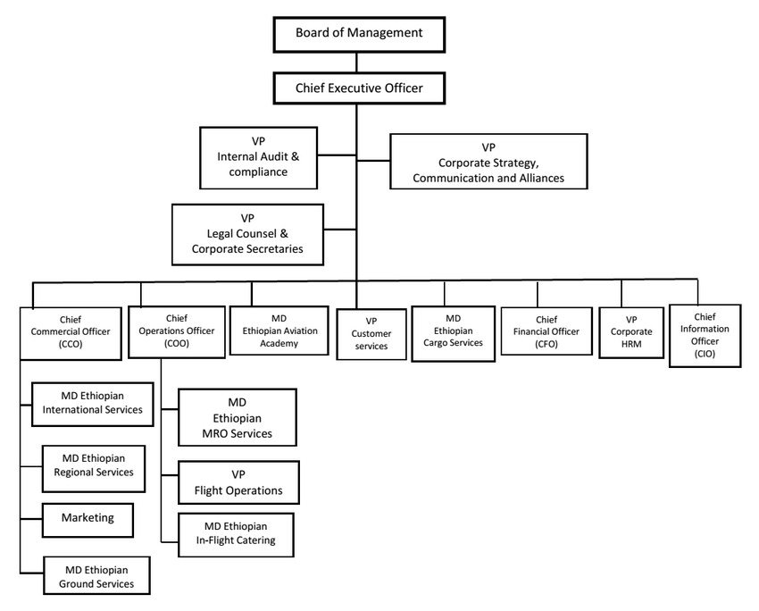

# **Chapter Two**

# **Internship Experience**

# **Introduction**

During my internship at Ethiopian Airlines, I was assigned to the Maintenance, Repair, and Overhaul (MRO) section within the Facility Maintenance Department. The MRO section encompasses several specialized sub-classes, including the Aircraft Engine Maintenance Shop, Facility Maintenance Shop, Aircraft Structure Shop, and Machine Shop. I specifically worked in the Facility Maintenance Shop, which is pivotal for ensuring the upkeep and efficient operation of the airline’s infrastructure and support systems.

In the Facility Maintenance Shop, my responsibilities included the installation, maintenance, and repair of various facility-related equipment and systems. This role involved working on a range of tasks from setting up new machinery to addressing faults and performing routine maintenance to prevent future issues. The demanding work environment required a high level of self-reliance, as senior staff were frequently engaged with other responsibilities and could only provide guidance when their schedules permitted.

My time in the Facility Maintenance Shop allowed me to develop a robust skill set in managing and maintaining the essential systems that support the airline’s operations. Detailed documentation of all maintenance activities and repairs was crucial for tracking progress and ensuring that standards were met. This experience provided me with valuable insights into the complexities of facility maintenance and significantly contributed to my professional development in control engineering.

# **Organization Structure of Facility Maintenance Department**

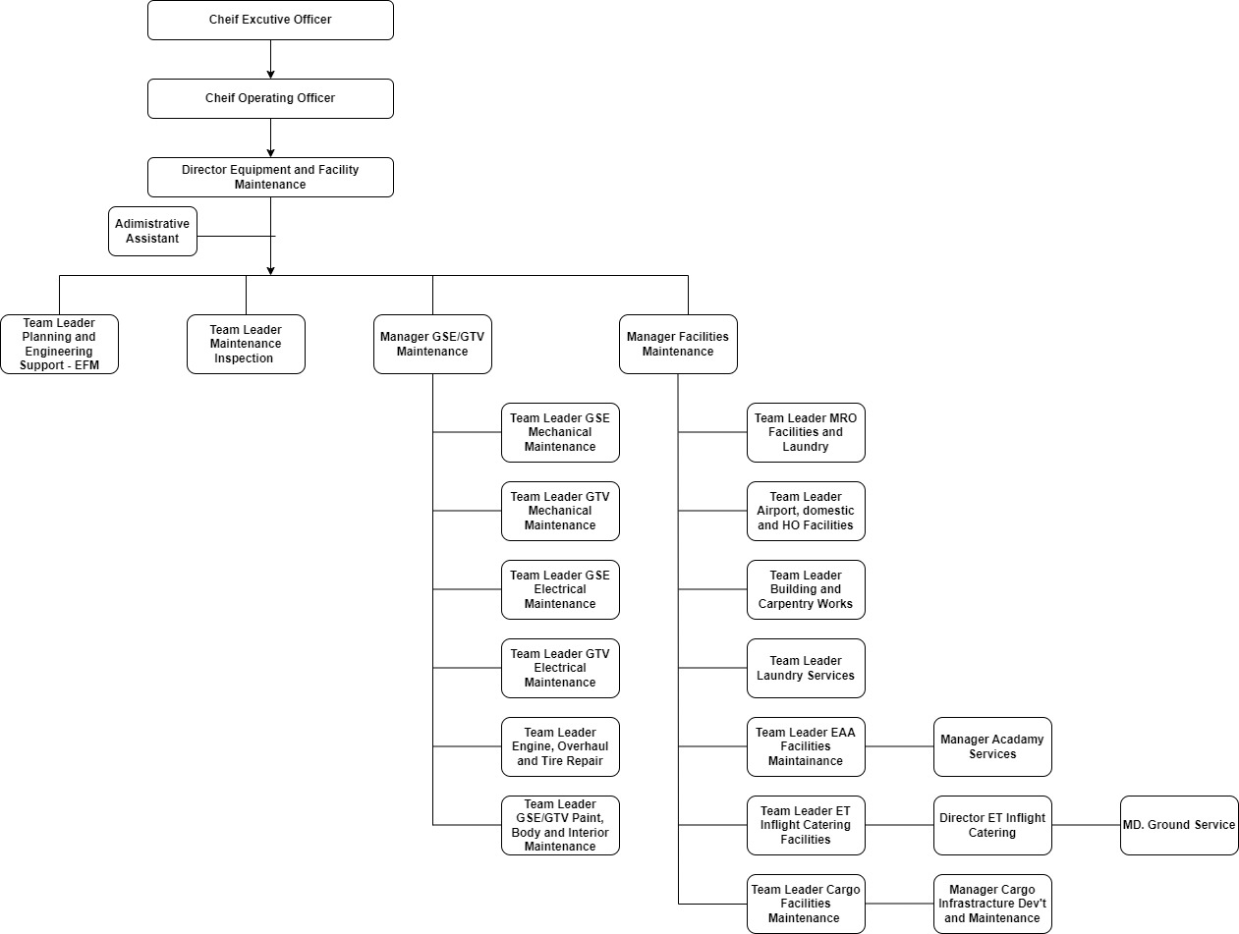

# **Activities**

During my internship, I undertook a comprehensive range of tasks that significantly advanced my practical skills and industrial expertise. I was deeply involved in the installation and setup of motor controllers, including managing the complex wiring for high-power motors and configuring soft starters to ensure smooth and efficient operation. I role included extensive maintenance and repair work on various types of equipment. This involved diagnosing and addressing issues with capacitor start induction motors, resolving faults in water pump motors, and repairing office fans. I also played a crucial role in system integration, where I handled the installation of power lines and controllers, performed detailed grounding setups, and ensured all systems operated correctly through rigorous testing. Additionally, I worked on improving the workspace by organizing and arranging cables, installing new lighting solutions, and enhancing the overall functionality and safety of the work environment. My internship also provided valuable insights into industrial processes, as I visited facilities specializing in electroplating and metal finishing, gaining a deeper understanding of these complex operations and their associated waste treatment procedures.

# **Procedures and Methods Utilized During Internship Tasks**

During my internship, I utilized a range of procedures and methods to effectively perform my tasks. For installation and configuration, I began with thorough planning by reviewing technical documentation and schematics to guide the installation of motor controllers, soft starters, and power lines. Detailed wiring diagrams were used to ensure accurate connections, and equipment settings were carefully configured according to operational requirements and manufacturer specifications.

In maintenance and repair, I applied diagnostic techniques to identify faults in equipment such as capacitor start induction motors and water pump motors. Repairs involved replacing faulty components, making adjustments, and rigorously testing the repaired equipment. Preventive maintenance was also part of my routine to avoid future issues and maintain optimal performance.

When it came to system integration, I connected and integrated various components into existing systems, ensuring their compatibility and functionality. Comprehensive testing was conducted to verify proper operation and to make necessary adjustments.

Workspace organization was another key area where I arranged cables and tools to maintain a clutter-free and efficient environment, while implementing safety practices during electrical work and setup.

Additionally, I gained insights into industrial processes through observation and documentation during facility visits to electroplating and metal finishing shops. Engaging with guides and experts helped you understand the operational and waste treatment procedures.

Problem-solving was integral to role, where I analyzed complex issues, such as grounding problems or control board faults, and applied creative thinking to develop effective solutions. These procedures and methods ensured that I executed my tasks efficiently, safely, and in alignment with industry standards.

# **Challenges Faced and Overcome During Internship Tasks**

During my internship, I encountered several challenges while performing my tasks, each providing valuable learning experiences:

* **Complex Installations:** One major challenge was the installation of motor controllers and soft starters for high-power motors. Managing complex wiring configurations and ensuring that all connections were correct and safe required meticulous attention to detail and a solid understanding of electrical systems.
* **Diagnostic Difficulties:** Diagnosing and repairing faults in various equipment, such as capacitor start induction motors and water pump motors, presented difficulties. Identifying the root causes of these faults, particularly in high-power or intricate systems, demanded a thorough analytical approach and problem-solving skills.
* **System Integration Issues:** Integrating new components with existing systems sometimes led to compatibility issues. Ensuring that all parts of the system worked together seamlessly required careful planning, precise installation, and extensive testing.
* **Workspace Organization:** Organizing a large workspace, especially when dealing with extensive cabling and equipment, posed challenges. Ensuring that the workspace was safe, efficient, and free from clutter while managing various tasks required effective time management and organizational skills.
* **Grounding Problems:** Identifying and resolving grounding issues, particularly with the rectifier for the silver-plating machine, proved challenging. Proper grounding is critical for safety and system performance, and troubleshooting these issues required a deep understanding of electrical principles.
* **Process Understanding:** Gaining insights into industrial processes, such as those in electroplating and metal finishing shops, was initially challenging due to the complexity of these operations. Understanding the detailed procedures and waste treatment processes involved a steep learning curve.
* **Resource Management:** Efficiently managing resources, including time, materials, and personnel, especially under tight deadlines or with limited resources, presented challenges that required prioritization and effective coordination.

# **Addressing and Overcoming Challenges**

To overcome the challenges faced during my internship, I implemented several effective measures with the help of my assigned supervisor. For complex installations, I enhanced planning and preparation by meticulously reviewing technical documentation and creating detailed checklists to ensure accurate wiring and configuration. My supervisor provided guidance on best practices and troubleshooting techniques, which was crucial for diagnosing issues.

When tackling diagnostics, I adopted a systematic approach, breaking down problems into manageable components. my supervisor played a key role in this process by offering insights and advice based on their expertise. Rigorous testing and validation were essential; I conducted comprehensive tests of systems and components after installation and repairs, making iterative adjustments based on results. The staff of facility maintenance helped me to interpret test results and provided support in making necessary adjustments.

Workspace organization was improved by systematically arranging cables and tools, maintaining a clean and efficient work environment. My supervisor emphasized the importance of safety protocols and helped implement them effectively. Addressing grounding and electrical safety issues involved focused troubleshooting techniques and consultations with my supervisor, who guided me in ensuring proper grounding and secure connections.

Embracing continuous learning, I engaged in facility visits and discussions with experts to deepen my understanding of industrial processes and equipment. The staffs facilitated these learning opportunities and provided additional context and explanations. Flexibility was key as I adapted to new information and unexpected challenges, with my supervisor assisting in adjusting my approach as needed. Effective resource management involved prioritizing tasks based on urgency and importance, and my supervisor offered guidance on managing time and materials efficiently. Overall, with my supervisor’s support, I successfully navigated challenges and achieved valuable outcomes throughout my internship.

# **Chapter Three**

# **Industrial Project and its design process**

# **Introduction**

The RFID-Based Tool Tracking System is designed to improve the management and accountability of tools within a cabinet, ensuring that each tool is tracked when borrowed and returned. The system leverages RFID technology, using the RFID RC522 module to scan RFID tags or cards assigned to both the tools and the individuals borrowing them. Upon opening the cabinet door, the RFID reader identifies the user, while an ultrasonic sensor detects whether a tool has been picked up or returned. A 16x2 LCD display without an I2C module is used to show detailed information, such as the name of the borrower and the status of each tool. The system also includes a servo motor to lock and unlock the cabinet door based on RFID authorization. Additionally, a buzzer is integrated to provide notifications when a tool is not returned within the designated time frame, enhancing accountability. Currently, the system tracks two tools and has two RFID cards/tags for identification.

The project not only enhances tool management and reduces losses but also introduces a reliable method for tracking the tools borrowed by personnel. This system ensures that staff members are accountable for the tools they use, improving workflow efficiency in maintenance and repair environments. Future improvements for this system include the development of dedicated software to handle more advanced inventory management, tracking tools with specific IDs, and generating real-time alerts for supervisors when tools are not returned on time. By implementing these features, the system will become a comprehensive solution for tool monitoring in any organization.

# **Background Analysis**

Tool management is a critical aspect of maintenance, repair, and operational environments, where multiple personnel handle various tools daily. Traditional methods of tracking tools often rely on manual logs or physical sign-out sheets, which can be time-consuming and prone to errors, leading to misplaced tools, reduced productivity, and increased operational costs. The rise of RFID (Radio Frequency Identification) technology presents a modern solution to these issues, offering a reliable way to track and manage tools in real-time.[1]

RFID technology allows for the automatic identification and tracking of objects using radio waves. In industrial and organizational settings, RFID-based systems have become popular for managing assets, inventory, and even personnel access.[3] By implementing RFID into tool tracking, organizations can reduce the risk of tool loss, enhance accountability, and streamline the process of borrowing and returning equipment.[2]

This project focuses on addressing these challenges by integrating RFID technology with additional components, such as ultrasonic sensors, an LCD display, and a servo-controlled locking mechanism. Together, these components provide a robust solution for real-time tool tracking. The system ensures that only authorized personnel can access tools, while the ultrasonic sensor monitors whether tools are taken or returned. By introducing such a system, this project aims to improve efficiency and security in environments like workshops or maintenance facilities, where proper tool management is vital for smooth operations.

In an organization like Ethiopian Airlines, where maintenance, repair, and operational (MRO) activities are crucial, efficient tool management is essential to ensure the smooth execution of daily tasks. Currently, traditional methods of managing tools, such as manual logs and physical check-out systems, can be inefficient, prone to errors, and time-consuming. Misplaced tools or delays in locating necessary equipment can cause workflow disruptions, increase downtime, and affect operational efficiency. As part of my internship, the RFID-Based Tool Tracking project seeks to address these challenges by introducing a more automated and reliable tool-tracking system.

RFID (Radio Frequency Identification) technology has gained prominence in various industries for asset tracking and management, offering a more streamlined solution compared to traditional methods. By integrating RFID with other components such as ultrasonic sensors and a servo-controlled locking system, this project provides Ethiopian Airlines with a modern approach to managing tools within their MRO facilities. The RFID system ensures that tools are only accessed by authorized personnel and tracks their usage in real time. The addition of a buzzer for overdue tool returns helps to maintain accountability among staff.

This project not only improves the organization’s operational efficiency but also enhances accountability in tool usage, which is critical in the aviation industry. By leveraging RFID technology, Ethiopian Airlines can reduce the risk of tool loss and mismanagement, ensuring that all necessary tools are available when needed. The system's future potential includes expanding to manage a larger inventory of tools, integrating software for detailed tracking, and generating real-time notifications for supervisors.

# **Objectives**

# **General Objective**

The primary objective of this project is to design and implement an automated RFID-based tool tracking system that improves the efficiency, accountability, and security of tool management at Ethiopian Airlines’ maintenance, repair, and overhaul (MRO) operations. The system will reduce the time and effort required to track tools, minimize the risk of tool loss or misplacement, and ensure that all tools are returned promptly after use.

# **Specific Objectives**

1. **Develop an RFID-Based Identification System:** To design a system that utilizes RFID technology to identify and authorize personnel who borrow tools, ensuring that only authorized users can access the tool cabinet.
2. **Track Tool Usage in Real-Time:** To monitor the borrowing and returning of tools using RFID and ultrasonic sensors, allowing real-time tracking of tool status and availability.
3. **Display Tool and User Information:** To implement a 16x2 LCD display that provides information about the borrower, tool status, and any overdue tools, ensuring transparency and accountability.
4. **Secure Tool Cabinet with Servo-Controlled Locking:** To incorporate a servo motor for locking and unlocking the tool cabinet based on the RFID scan, ensuring that tools are securely stored when not in use.
5. **Implement a Notification System:** To integrate a buzzer that activates when a tool is not returned within a specified time, providing an immediate alert to the user and enhancing accountability.
6. **Improve Tool Management Efficiency:** To reduce manual tracking and paperwork by automating the tool tracking process, ensuring more accurate and efficient management of tools within the maintenance and repair operations.
7. **Enhance Future Expandability:** To lay the groundwork for future system enhancements, such as adding software to manage a larger inventory of tools, expanding the RFID system for multiple tools and users, and introducing notifications to supervisors for overdue tools.

# **Problem definitions**

In the maintenance, repair, and overhaul (MRO) operations at Ethiopian Airlines, efficient management and tracking of tools are essential to ensure smooth workflow and minimize downtime. However, the current manual system for tracking tools is time-consuming, prone to errors, and lacks accountability, often leading to misplaced or unreturned tools. This can result in delays, increased operational costs, and reduced productivity. Additionally, without a reliable tracking system, it becomes difficult to monitor who has borrowed a tool and whether it has been returned.

The need for an automated system that tracks tools in real time, restricts access to authorized personnel, and provides notifications for overdue tools is critical to improving operational efficiency and accountability within the MRO environment.

In the high-paced and safety-critical environment of Ethiopian Airlines' maintenance, repair, and overhaul (MRO) operations, proper tool management is essential for ensuring operational efficiency and minimizing downtime. However, the current manual tool tracking process is outdated and inefficient. This system relies heavily on human intervention, leading to errors such as misplaced or unaccounted-for tools. As a result, tools are sometimes not returned on time or are difficult to locate, which can delay maintenance activities and increase operational costs.

Moreover, there is limited accountability for tool borrowing, as the system lacks a reliable way to monitor who has accessed specific tools, when they were taken, and whether they were returned. This not only creates inefficiencies but also poses risks to safety, as missing tools can interrupt critical maintenance tasks. The absence of real-time tracking and notification systems further exacerbates the issue, making it challenging to manage tools effectively.

Given these challenges, there is a clear need for an automated tool tracking system that leverages modern technology to provide real-time monitoring, restricts tool access to authorized personnel, and offers timely alerts when tools are overdue. Such a system would improve the accuracy of tool tracking, ensure accountability, and contribute to the overall productivity and safety of MRO operations at Ethiopian Airlines

# **Literature Review**

RFID (Radio Frequency Identification) technology has revolutionized asset tracking and inventory management across various industries. According to the literature, RFID systems utilize electromagnetic fields to automatically identify and track tags attached to objects. These tags transmit data to an RFID reader, which then processes the information for further use (Want, R., 2006)[1]. RFID offers significant advantages over traditional barcode systems, including the ability to read multiple tags simultaneously and the capability to function in various environmental conditions.

Several studies highlight the application of RFID technology in tool management and inventory control. RFID-based systems have been shown to enhance the efficiency of tracking tools, reduce errors, and minimize losses. RFID systems could streamline tool tracking processes in industrial settings, providing real-time data on tool availability and usage. RFID technology facilitates automated tracking, which helps organizations maintain accurate records and improve operational efficiency[2].

The integration of RFID with other technologies, such as sensors and microcontrollers, further enhances tool management systems. The use of ultrasonic sensors to detect tool presence or absence, as described by Yang and Hsu (2015), complements RFID technology by providing additional data points for monitoring tool status. Similarly, microcontrollers, such as Arduino, are frequently used in conjunction with RFID and sensors to create customized tracking solutions that cater to specific needs (Zhang et al., 2016)[4].

Effective tool management systems often incorporate real-time monitoring and notification features. Research by Zhao et al. (2017) emphasizes the importance of real-time alerts for improving accountability and reducing tool mismanagement [5]. Systems that provide instant notifications through visual displays or audio signals, such as LCD screens and buzzers, ensure that users are promptly informed about the status of tools and any overdue returns.

Despite the benefits, implementing RFID-based tool tracking systems presents certain challenges. Literature indicates issues such as the initial cost of RFID technology, the need for proper tag placement, and potential interference from environmental factors. Addressing these challenges requires careful planning and system design to ensure optimal performance and reliability.

The literature provide valuable insights into the practical applications of RFID-based tool tracking systems. For example, a case study by Johnson and Matthews (2018) in a manufacturing environment demonstrated that an RFID tool tracking system significantly reduced tool loss and improved inventory accuracy[6]. Such studies illustrate the effectiveness of RFID systems in various operational contexts and validate their benefits in real-world scenarios.

The literature underscores the effectiveness of RFID technology in enhancing tool management and inventory control. By integrating RFID with additional technologies such as ultrasonic sensors and microcontrollers, organizations can achieve more accurate and efficient tracking systems. While there are challenges associated with RFID implementation, the benefits of improved real-time monitoring and reduced tool mismanagement make it a valuable solution for modern tool tracking needs.

# **Design approach/Methodology**

# **Step to develop the project**

1. **Requirements Analysis:** Begin by identifying the specific requirements for the system, such as the number of tools to be tracked, the types of RFID tags and readers to be used, and the components needed (LCD display, ultrasonic sensor, servo motor, buzzer).
2. **Component Selection:** Choose the necessary hardware components for the system. This includes the RFID RC522 module, 16x2 LCD display, ultrasonic sensor, servo motor for the door lock, and a buzzer for notifications.
3. **Circuit Design and Assembly:** Design the electrical circuit to connect the RFID module, ultrasonic sensor, LCD display, servo motor, and buzzer. Use a breadboard to assemble the circuit, ensuring proper connections between all components and the microcontroller.
4. **Programming the Microcontroller:** Write the code to integrate all components, enabling the RFID system to scan tags, the ultrasonic sensor to detect tool movement, the LCD to display borrower information, and the servo motor to control the locking mechanism. Include programming for the buzzer to sound if a tool is not returned on time.
5. **Testing the System:** After assembling the hardware and writing the code, test the system by simulating various scenarios (borrowing, returning tools, and overdue tools). Debug and refine the system based on test results to ensure smooth functionality.
6. **Prototype Refinement:** Based on testing, make necessary adjustments to improve system performance and reliability. This may involve fine-tuning the sensor detection, adjusting the display of information, or optimizing the locking mechanism.
7. **Final Integration and Presentation:** Once the prototype functions as intended, integrate all components into a compact form for practical use. Prepare documentation and a demonstration for the final presentation of the working prototype.
   1. **How the system Works**

# **System design and architecture**

* **RFID RC522 Module:** This is the main component used to read the RFID tags and identify users who borrow or return tools. It communicates with the microcontroller and logs the tag's unique ID.
* **RFID Tags/Cards:** At least two RFID tags or cards will be issued to users for identification. These tags store a unique code that the RFID module can read to identify which tool has been borrowed or returned.
* **Ultrasonic Sensor (HC-SR04):** This sensor detects the presence or absence of a tool by measuring the distance between the sensor and the tool in the cabinet. It triggers a response when a tool is picked up or returned.
* **16x2 LCD Display (Without I2C Module):** The LCD will display essential information, such as the name of the borrower, tool status, and alerts. It requires multiple pins on the microcontroller for operation and is used to provide real-time visual feedback.
* **Servo Motor (SG90 or MG996R):** A small servo motor is used to operate the door lock mechanism. When a user is authenticated by the RFID reader, the servo motor will rotate to unlock or lock the cabinet door.
* **Buzzer:** This component is used to generate an audio alert when a tool is not returned within a specified period, helping to improve accountability and notifying users of overdue tools.
* **Breadboard and Jumper Wires:** The breadboard is essential for prototyping, allowing you to easily connect and disconnect components without soldering. Jumper wires are needed to establish the connections between components such as the RFID module, ultrasonic sensor, and the microcontroller.
* **Microcontroller (Arduino Uno):** The microcontroller serves as the brain of the project, handling the inputs from the RFID module, ultrasonic sensor, and other components. It processes data and executes the program logic, such as displaying information on the LCD and controlling the servo motor.
* **Power Supply (5V Battery or Power Adapter):** The system requires a reliable power source. we can use a 5V battery for portability or a power adapter for continuous power, depending on the deployment environment.
* **Resistors and Transistor:** These passive components are necessary to stabilize the circuit and protect sensitive parts. For example, resistors may be needed for the LCD or other sensors to ensure proper voltage levels.
* **Potentiometer (10kΩ):** This adjustable resistor is used to control the contrast of the 16x2 LCD display, allowing for clearer text visibility.
* **Tool Cabinet/Box:** This will house the tools being tracked and can be customized with the servo motor for locking/unlocking. It serves as the physical enclosure for the system.
* **Programming Cable (USB Cable for Arduino):** Used to upload code from the computer to the microcontroller and for debugging purposes during development.

# **Control system**

1. **Arduino Uno (Micro-controller)**

* Acts as the brain, it integrates the input of RFID and Ultrasonic sensor and controlling outputs of LCD, servo motor, and buzzer.

1. **Communication**

* The component communicates via digital pins and libraries.
* The RFID system interface with the microcontroller through the SPI Protocol and other components use standard GPIO pins.

1. **Energy and power consideration**

* 5v or 3.3v power supply are used for each component with careful consideration for current requirement.

1. **User interface and interaction**

**Borrower interaction**

* when an RFID tag is scanned the system verifies the user’s Id, opens the door, and track the borrowing and return process. The ultrasonic sensor confirms if tool was taken.

**Notification System**

* If a tool is not returned, the system triggers the buzzer and display an alert, notifying the borrower’s name which can be further extended to alert a supervisor.

# **Mathematical design**

The calculation mainly related to power, timing, and sensor range.

1. **Power consumption**

Each component in the project requires certain amount of current to operate. To ensure the system function without overloading the arduino, we calcuate the total power requirement.

**Power supply**

* Arduino operates at 5v
* LCD 16*2 consume around 30mA
* RFID module(MFRC522) operates at 3.3v and consume around 13-26mA
* Servo motor consumed power based on torque, typically it can use 100- 250 when moving
* Ultrasonic sensor draw about 15mA
* Buzzer usually draws around10-20mA

**Total current consumption**

RFID ≈ 20mA

LCD ≈ 30mA

Servo ≈ 150mA

Ultrasonic sensor ≈ 2*15≈ 30mA

Buzzer ≈ 15mA

Total current ≈ 20+30+150+30+15 ≈ 245mA

Therefore, Arduino uno can be provide up to 500mA from its 5v pin so our setup stays within limits.

1. **Timing**
2. **Timing calculation for the buzzer alert**

The buzzer should be activated if the tool is not returned with in 10 seconds as specified in the code. It is controlled by checking the **millis()** function against a set threshold. It checked if the elapsed time since borrowing the tool is greater than 10 second(10000millisecond).

if (millis() - borrowStartTime > 10000) {

activateBuzzer();

displayMessage("Tool Not Returned", lastBorrower);

}

To calculate the timing for the buzzer alert when tool is not returned with in specific period, we need to determine how long to wait before the buzzer goes off.

Variable to be considered:

1. Time delay for the buzzer
2. Arduino’s timer

* Arduino’s **millis()** function will be used to track elapsed time since tool was borrowed.

1. Trigger time
2. **Timing calculation for the servo motor**

The servo motor open and close the cabinet door, which depends on the angle of rotation. The time it taakes for the door to open or close can be controlled by the delay function in the code. The servo motor uses Pulse Width Modulation (PWM) to position its shaft. The typical signal is a pulse that ranges between 1ms (00) to 2ms (1800) and sent every 20ms. A pulse of 1.5ms position the servo to the 900

Time =

Time = = 1.5seconds

1. **Ultrasonic sensor distance calculation**

Ultrasonic senor measures the distance by sending sound waves and calculating the distance it takes for the echo to return

Distance =

Where:

Speed of sound = 343m/s(air)

**Code:**

duration1 = pulseIn(echoPin1, HIGH);

distance1 = duration1 * 0.034 / 2;

1. **Voltage divider for buzzer with Transistor**

We use NPN Transistor BC337 to drive the buzzer, which is used to switch the buzzer on/off. The base resistor(Rb) need to be calculated to ensure proper current flow

* Transistor current gain(hfe)(BC337) ≈ 100
* Buzzer operating current ≈ 15mA

Base current =

= = 0.15mA

Rb = (Vin - Vbe)/Ib

(5v- 0.7v)/0.15mA = 28.6k Ώ

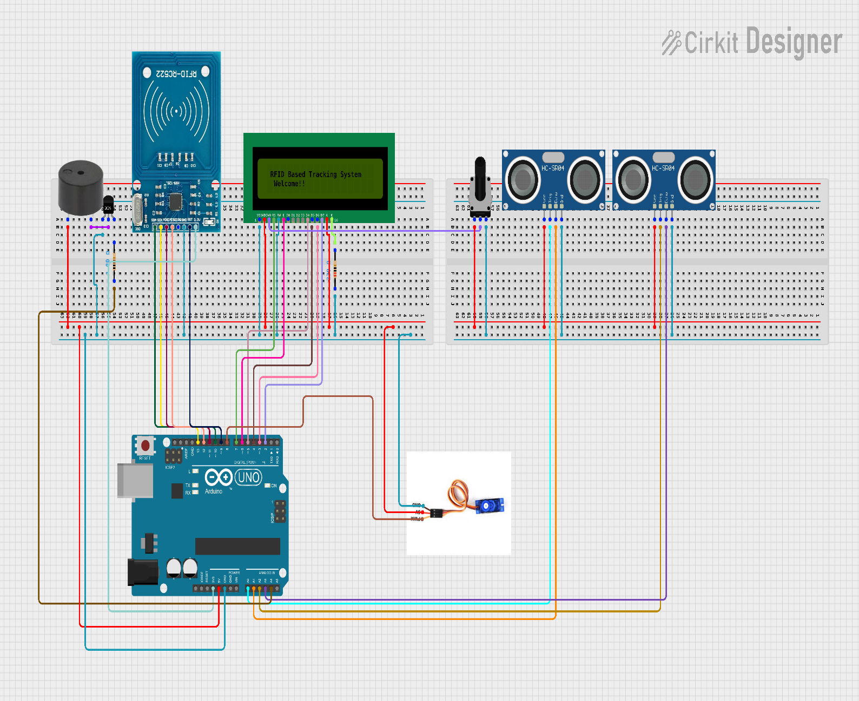**Wiring Diagram**

**Code**

**Flow chart**

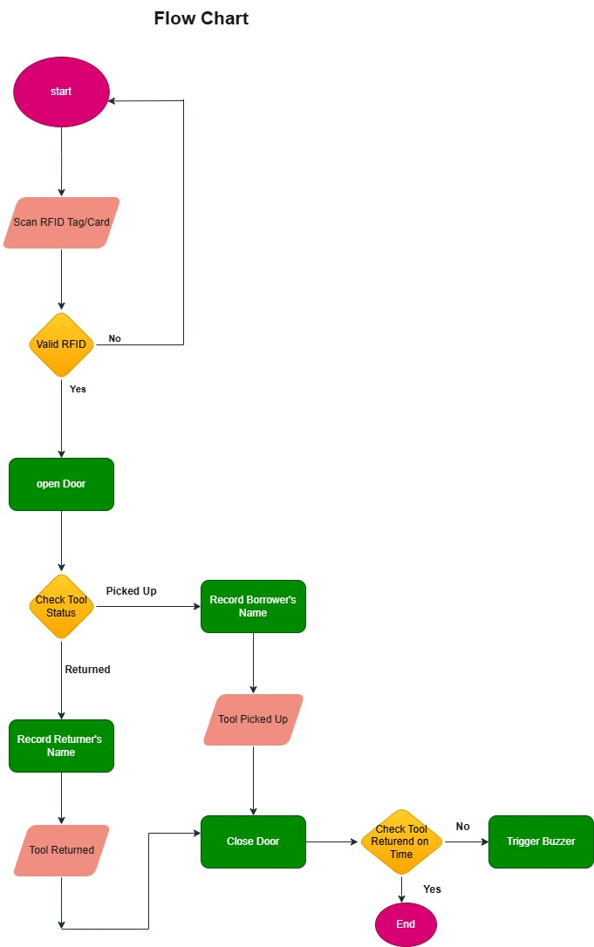

# **Result and Discussion**

1. **System Design and Functionality**: The design effectively utilized the RFID RC522 module to identify users and tools. The integration of an ultrasonic sensor was intended to ensure real-time monitoring of tool presence or absence. The 16x2 LCD display was planned to provide clear information about the borrower and tool status, while the servo motor was designed to control the locking mechanism of the tool cabinet. The proposed design fulfilled the project's functional requirements on paper.
2. **Theoretical Real-Time Tracking and Notifications**: Although not implemented, the design was capable of real-time tool tracking. When a tool would be picked up or returned, the ultrasonic sensor would detect the change, and the system would process this data and display the information on the LCD. The buzzer was designed to alert users of overdue tools, enhancing tool management efficiency.
3. **User Interaction and System Performance (Design Perspective)**: The proposed system was designed to be user-friendly, allowing seamless borrowing and returning of tools. The RFID system was theoretically robust for identifying both tools and personnel. The servo motor in the design was expected to lock and unlock the cabinet effectively, and the LCD display was chosen for clarity and ease of use. Potential issues like RFID reading delays were considered during the design phase, and solutions were proposed.
4. **Challenges in Design Implementation**: Several anticipated challenges were identified during the design phase, such as potential RFID tag readability issues in high-interference environments and ensuring consistent ultrasonic sensor performance. These challenges were addressed through theoretical adjustments and design iterations.
5. **Impact and Future Improvements**: The completed design showcased the potential of RFID technology for tool tracking and management. The ability to provide real-time updates and notifications in theory could enhance accountability and reduce tool mismanagement. Future steps include acquiring the necessary components to build and test the prototype, expanding the system to track additional tools, and refining the software for comprehensive inventory management.

# **Chapter Four**

# **Overall internship achievement and experience**

**Practical Experience:** Hands-on experience with industrial systems, including motor control, wiring, and maintenance, which enhances theoretical knowledge.

**Technical Skills:** Improved skills in troubleshooting, repairing, and testing various equipment such as motors, controllers, and heaters.

**Project Management:** Experience in managing and completing projects, including installations and repairs, which helps in planning and execution.

**Problem-Solving:** Developed problem-solving skills through diagnosing and resolving equipment issues, which is crucial in engineering.

**Industry Insight:** Gained understanding of industrial processes and operations, such as plating and chemical treatments, through visits and practical work.

**Documentation and Reporting:** Improved ability to document and report work effectively, which is essential for maintaining accurate records and communication.

**Team Collaboration:** Experience working in a team environment, enhancing collaboration and communication skills.

**Safety Awareness:** Increased awareness of safety protocols and best practices in industrial settings.

# **Benefit we gained in terms of upgrading my theoretical knowledge**

* Opportunity to apply theoretical concepts from control engineering, such as motor control and circuit design, in real-world scenarios.
* Gained insights into the practical workings of industrial systems, enhancing my understanding of complex processes like plating and chemical treatments.
* Improved ability to diagnose and solve issues with equipment, bridging the gap between theoretical problem-solving and practical application.
* Learned how different components, such as motors, controllers, and sensors, work together in an industrial setting, enhancing my understanding of system integration.
* Gained knowledge of industry safety standards and best practices, which complements theoretical safety protocols learned in coursework.
* Enhanced my skills in creating and interpreting technical documentation, which is essential for understanding and applying theoretical concepts.

# **Benefit we gained in terms of improving my practical skill**

* Gained direct experience in working with industrial equipment, including installation, maintenance, and troubleshooting.
* Enhanced skills in operating and repairing motors, controllers, and other components, which improves my technical competence.
* Developed practical problem-solving skills through diagnosing and addressing real-world issues with equipment.
* Improved ability to manage and execute projects, including wiring installations and system setups, effectively.
* Gained experience in testing and calibrating equipment to ensure proper operation and performance.
* Enhanced understanding of safety protocols and best practices in an industrial environment, ensuring safe and effective work.
* Improved proficiency in using various tools and instruments required for maintenance and repairs.

# **Benefit we gained in terms of improving industrial problem-solving ability**

* Applied problem-solving techniques to real-world issues, enhancing my ability to address practical challenges effectively.
* Developed skills in diagnosing and repairing faults in complex industrial systems, improving my troubleshooting capabilities.
* Gained experience in understanding and resolving issues related to the integration of various components within industrial systems.
* Learned to devise creative and practical solutions for equipment malfunctions and system inefficiencies.
* Enhanced my ability to identify and rectify problems that impact the efficiency and reliability of industrial operations.
* Improved decision-making skills by evaluating problems, considering potential solutions, and implementing effective strategies.

# **Benefit we gained in terms of improving team working skill**

* Enhanced ability to work effectively with colleagues, sharing tasks and responsibilities to achieve common goals.
* Improved communication skills by discussing ideas, providing feedback, and coordinating efforts with team members.
* Developed skills in coordinating tasks and projects, ensuring that different team members' work aligns with overall objectives.
* Gained experience in managing and resolving conflicts within the team, fostering a more productive working environment.
* Learned to offer support to team members and take on leadership roles when needed, contributing to team success.
* Benefited from different viewpoints and expertise within the team, leading to more innovative solutions and approaches.

# **Benefit we gained in terms of improving leadership skill**

* Gained experience in leading and managing projects, from planning and execution to completion, enhancing organizational skills.
* Improved ability to make informed decisions and guide the team through complex challenges, fostering confidence in leadership.
* Learned to delegate tasks effectively, ensuring team members are utilized efficiently and responsibilities are distributed appropriately.
* Developed skills to motivate and inspire team members, contributing to a positive and productive work environment.
* Enhanced ability to address and resolve conflicts within the team, maintaining harmony and focus on objectives.
* Took on greater responsibility for outcomes, learning to be accountable for both successes and setbacks.

# **Benefit we gained in terms of understanding about work ethics**

* Demonstrated dependability by consistently completing tasks and meeting deadlines, building trust with supervisors and colleagues.
* Enhanced professionalism through punctuality, adherence to company policies, and maintaining a positive attitude.
* Developed a strong sense of responsibility by taking ownership of tasks and addressing issues proactively.
* Improved attention to detail by focusing on accuracy and thoroughness in all tasks and projects.
* Elevated the quality of work by striving for excellence and continuously seeking to improve processes and outcomes.
* Reinforced integrity by being honest, ethical, and transparent in all work-related interactions and decisions.

# **Benefit we gained in terms of entrepreneur skill**

* Developed creativity and innovation by finding new solutions to problems and improving existing processes.
* Gained experience in identifying and evaluating opportunities for improvement and efficiency in industrial settings.
* Learned to assess and manage risks associated with projects and decisions, enhancing strategic thinking.
* Improved skills in managing resources effectively, including time, materials, and personnel, to achieve project goals.
* Enhanced decision-making abilities by evaluating various options and making informed choices to drive success.
* Built connections and expanded professional networks, which is crucial for entrepreneurial ventures and opportunities.

# 

# **Chapter Five**

# **Recommendation and conclusion**

1. The internship provided a solid foundation, and advancing my knowledge will enhance my capabilities in managing complex systems and projects.
2. Implement a rigorous documentation process for all tasks, including detailed records of repairs, installations, and problem-solving approaches. Detailed documentation will facilitate better understanding of past work and improve efficiency in future tasks.
3. Actively engage in building and maintaining professional relationships with colleagues, supervisors, and industry professionals. Networking provides valuable insights, mentorship, and potential career opportunities, which are crucial for professional growth.
4. Regularly seek feedback from mentors and peers to identify strengths and areas for improvement. Constructive feedback is essential for professional development and helps in refining skills and performance.
5. Participate in project management activities, including planning, scheduling, and resource allocation. Gaining experience in project management will enhance your ability to oversee and lead projects effectively in future roles.

# **Conclusion**

The internship at Ethiopian Airlines has been an exceptionally valuable experience, providing extensive practical knowledge in electrical and control engineering. Throughout the internship, I effectively engaged in various tasks, including motor repairs, power line installations, and system maintenance, which have significantly enhanced my technical and problem-solving skills.

The RFID-based tool-tracking project demonstrated my capability to apply theoretical knowledge to practical solutions. By incorporating components such as an ultrasonic sensor, LCD display, servo motor, and buzzer, the project has the potential to substantially improve tool management and operational efficiency.

Looking forward, focusing on thorough testing, scalability, and user training will be crucial for maximizing the impact of my tool-tracking system. Continued development of technical skills, meticulous documentation, and active professional networking will further support your career advancement.

In summary, the internship has laid a strong foundation for my career in control engineering and automation. The skills and insights gained will be invaluable for my future professional endeavors.

# **References**

**[1]. R.Want,** “An Introduction to RFID Technology”, IEEE Pervasive Computing, vol.5, no.1, pp.25-33, 2006, Available at HTTP:

[An introduction to RFID technology | IEEE Journals & Magazine | IEEE Xplore](https://ieeexplore.ieee.org/document/1593568/citations?tabFilter=papers)

**[2]. K.Finkenzeller,** “RFID Handbook: Fundamentals and Applications in Contactless Smart Cards, Radio Frequency Identification and Near-Field Communication”, 3rd ed. Chichester, West Sussex, UK:Wiley, 2010

**[3]. T.Pirhonen, & J.Vanhala,** “RFID-Based Tool Management Systems,” Journal of Industrial Engineering and Management, vol.5, no.2, pp. 134-156, 2012

[4]. **P**.**Hsu, & J.Liu,** “Integration of RFID with Ultrasonic Sensors for Real-Time Inventory Management,” International Journal of Advanced Computer Science and Applications, vol.9, no.4, pp.58-65, 2018

[5]**.C**.**Yao & Y.Zhao,** “Arduino-Based RFID Systems for Enhanced Tool Tracking and Management,” Proceedings of the IEEE International Conference on Industrial Technology, pp.123-128, 2014

[6]. **C**.**Miller & M.Johnson,** “Case Study: Enhancing Tool Management with RFID Technology in Aviation Maintenance,” Aerospace Technology Review, vol.14, no.2, pp.45-52, 2020

[7]. **M. Z. Zulkifli, S. S. Abdullah, and R. Yaacob**, *“Implementation of RFID in Monitoring and Controlling System for Tool Tracking,”* IEEE 2nd International Symposium on Telecommunication Technologies (ISTT), pp. 246-250, 2015