NAME

# Problem 1

Discuss how you determined the reference frequency and all scale / chord frequencies for this project.

I did it in Matlab with the help of the makingtables script, a modified version of what I used to generate frequencies throughout the assignment. For equal intonation I ran it once at A4 and then copied and pasted because its all the same everywhere. Very easy.

Just intonation was a lot more annoying. I interpreted the question as asking me to find all notes to the key of C4, D4 , E4, etc. This meant that A4 and B4 where actually very off from the rest of the keys by a lot because they’re really in a whole other octave. Perhaps I misunderstood this part. Regardless, I used this script and copied and pasted into excel.

# Problem 4

Insert plots and describe. 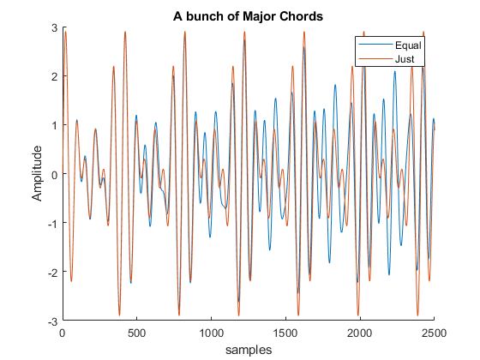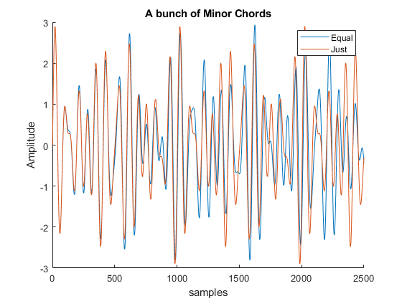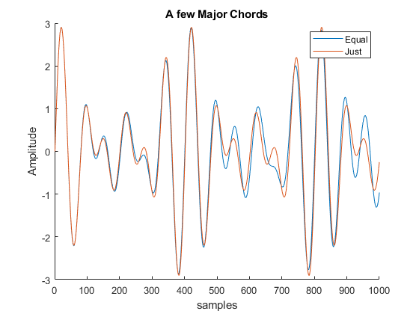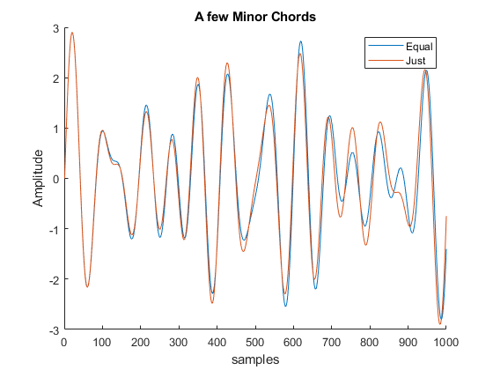

Over a short time span they seem to match almost perfectly. But upon expanding one finds that the equal temperament increases and decreases in amplitude with a beat.

# Problem 5

1. Can you hear the difference between the just tempered Major scale and the equal tempered Major scale?

Yeah. It’s not much but there is a definite difference.

1. Which one sounds better? - Why (explain)

I know you want me to say equal is better but honestly, without any context of song or progression of chords, I can’t tell. I don’t think an individual chord can sound so much “better” than another out of context.

1. Can you hear the difference between the just tempered Minor scale and the equal tempered Minor scale?

Yeah. It’s not much but there is a definite difference.

1. Which one sounds better? - Why (explain)

I know you want me to say equal is better but honestly, without any context of song or progression of chords, I can’t tell. I don’t think an individual chord can sound so much “better” than another out of context.

1. Can you hear the difference between the just tempered Major chord and the equal tempered Major chord?

Yeah. It’s not much but there is a definite difference.

1. Which one sounds better? - Why (explain)

I know you want me to say equal is better but honestly, without any context of song or progression of chords, I can’t tell. I don’t think an individual chord can sound so much “better” than another out of context.

1. Can you hear the difference between the just tempered Minor chord and the equal tempered Minor chord?

Yeah. It’s not much but there is a definite difference.

1. Which one sounds better? - Why (explain)

I know you want me to say equal is better but honestly, without any context of song or progression of chords, I can’t tell. I don’t think an individual chord can sound so much “better” than another out of context.

# Other Comments