Phase 2: Data Modeling

Entity are an object with physical existence or with a conceptual existence

The entities in the diagram are PERSON,BRANCH,STOCK,EMPLOYEE.

Relation In any business processing one object may be associated with another object due to some event.

The Relationship in this diagram is WORKES WITH, DONATION, WORKES WITH, DELIVERS.

Attribute the items of information which characterize and describe these entities.

The Attributes in the entity PERSON is p_id, p_name ,p_ gender,p_ blood group, p_date of birth,p_ phone no , p_address, p_medical issue.

The Attributes in the entity EMPLOYEE is e_id, name ,e_ gender,e_date of birth,e_ phone no , e_address,b_id.

The Attributes in the entity BRANCH is b_id, m_id, b_id.

The Attributes in the entity STOCK is s_blood_group, s_quantity, b_id.

**THE ER DIAGRAM**

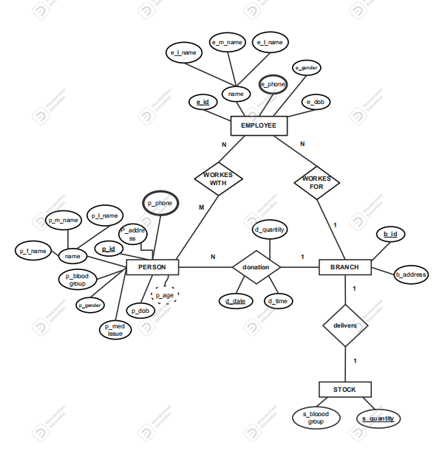

Phase 3: Logical Design

The Relational schema is

Person(**p_id**,name, p_gender,p_age,p_dob,p_address,p_b_group,p_med_issues**,b_id** )

Person_phone(**p_id**, **p_phone**)

Employee(**e_id**,name,e_gender,e_phone,e_dob,**b_id**)

Branch(**b_id**,b_adress)

Stock(**s_blood_group**, s_quantity,**b_id**)

Table person

|  |  |  |  |  |
| --- | --- | --- | --- | --- |
| Field name | Data type | Field size | Constraint | Validation |
| p_id | int | 4 bytes | PK | NOT NULL |
| p_f_name | varchar | 8 bytes |  | NOT NULL |
| p_m_name | varchar | 8 bytes |  | NOT NULL |
| p_l_name | varchar | 8 bytes |  | NOT NULL |
| p_gender | char | 1 bytes |  | NOT NULL |
| p_age | int | 4 bytes |  | NOT NULL |
| p_phone | int | 4 bytes |  | NOT NULL |
| p_dob | date | 7 bytes |  | NOT NULL |
| p_address | varchar | 8 bytes |  | DEFAULT NULL |
| p_b_group | varchar | 8 bytes |  | NOT NULL |
| p_med_issues | varchar | 8 bytes |  | DEFAULT NULL |

Table employee

|  |  |  |  |  |
| --- | --- | --- | --- | --- |
| Field name | Data type | Field size | Constraint | Validation |
| e_id | int | 4 bytes | PK | NOT NULL |
| e_f_name | varchar | 8 bytes |  | NOT NULL |
| e_m_name | varchar | 8 bytes |  | NOT NULL |
| e_l_name | varchar | 8 bytes |  | NOT NULL |
| e_gender | char | 1 bytes |  | NOT NULL |
| e_phone | int | 4 bytes |  | NOT NULL |
| e_dob | date | 7 bytes |  | NOT NULL |
| b_id | int | 4 bytes | FK |  |

|  |  |  |  |  |
| --- | --- | --- | --- | --- |
| Field name | Data type | Field size | Constraint | Validation |
| p_id | int | 4 bytes | PK,FK |  |
| d_date | date | 7 bytes |  | NOT NULL |
| d_time | time | 3 bytes |  | NOT NULL |
| d_quantity | int | 4 bytes |  | NOT NULL |
| b_id | int | 4 bytes | PK,FK |  |

Table donation

Table branch

|  |  |  |  |  |
| --- | --- | --- | --- | --- |
| Field name | Data type | Field size | Constraint | Validation |
| b_id | int | 4 bytes | PK | NOT NULL |
| b_address | varchar | 8 bytes |  | DEFAULTNULL |

Table stock

|  |  |  |  |  |
| --- | --- | --- | --- | --- |
| Field name | Data type | Field size | Constraint | Validation |
| s_blood_group | varchar | 8 bytes | PK | NOT NULL |
| s_quantity | int | 4 bytes |  | NOT NULL |

**The Relational Model**

**Diagram**

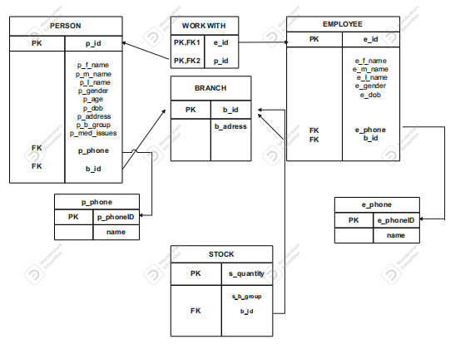

**The Code**

CREATE DATABASE blood_doner;

USE blood_doner;

CREATE TABLE employee (

e_id int NOT NULL,

e_f_name varchar(25) NOT NULL,

e_m_name varchar(25) NOT NULL,

e_l_name varchar(25) NOT NULL,

e_gender char(1) NOT NULL,

e_phone char(10) NOT NULL,

e_dob date NOT NULL,

b_id int,

PRIMARY KEY(e_id)

);

alter table employee

add foreign key (b_id) references branch(b_id) on delete set null;

CREATE TABLE branch (

b_id int PRIMARY KEY NOT NULL,

b_adress varchar(40) NOT NULL

);

CREATE TABLE person (

p_id int NOT NULL,

p_f_name varchar(25) NOT NULL,

p_m_name varchar(25) NOT NULL,

p_l_name varchar(25) NOT NULL,

p_gender char(1) NOT NULL,

p_age int NOT NULL,

p_phone char(10) NOT NULL,

p_dob date NOT NULL,

p_address varchar(100) DEFAULT NULL,

p_b_group varchar(3) NOT NULL,

p_med_issues varchar(100) DEFAULT NULL,

PRIMARY KEY(p_id)

);

CREATE TABLE donation (

p_id int ,

d_date date NOT NULL,

d_time time NOT NULL,

d_quantity int NOT NULL,

b_id int

);

ALTER TABLE donation

ADD PRIMARY KEY (p_id,b_id),

ADD FOREIGN KEY (p_id) REFERENCES person (p_id) on delete cascade,

ADD FOREIGN KEY (b_id) REFERENCES branch (b_id) on delete cascade;

CREATE TABLE stock (

s_blood_group varchar(3) PRIMARY KEY NOT NULL,

s_quantity int NOT NULL,

b_id int

);

alter table stock

add foreign key (b_id) references branch(b_id) on delete set null;

select * from stock;

INSERT INTO stock(s_blood_group,s_quantity) VALUES

('A+', 200),('A-', 100),('AB+', 100),('AB-', 0),('B+', 0),('B-', 0),('O+', 100),('O-', 100);

select * from employee;

insert into employee value(100,'samuel','alebachew','kebede','M','0911111211','1981-5-3',1),

(101,'gebre','biru','alemu','M','0911111411','1990-2-13',3),

(102,'mahlet','alemu','kebede','F','091211111','1975-2-3',3),

(103,'habetamu','alemu','kebede','M','0913111111','1980-7-3',2),

(104,'tesfaye','alemu','kebede','M','0914111111','1986-12-3',1),

(105,'yordanos','alelegn','kebede','F','0915111111','1974-2-15',2),

(106,'mekedes','fekadu','alemu','F','0916111111','1984-12-13',3),

(107,'endris','alemu','kebede','M','0916111111','1980-4-6',2),

(108,'helen','zewedu','gemechu','F','0916111111','1985-2-3',1),

(109,'elias','gezaw','kebede','M','0917111111','1989-10-3',2);

select * from branch;

insert into branch value(1,'kera branch');

insert into branch value(2,'gerji branch');

insert into branch value(3,'semit branch');

select * from person;

insert into person value(1,'abebe','alemu','kebede','M',34,'0911111111','1980-2-3','kilinto','A+','nothing'),

(2,'tadios','geremew','akalu','M',24,'0912111111','1990-7-21','bole','O+','nothing'),

(3,'tinsia','getachew','kebede','M',19,'0911111113','1995-2-3','semit','A-','nothing'),

(4,'dagim','habetamu','kebede','M',28,'0911111141','1986-2-3','gerji','A+','nothing'),

(5,'ruth','tadesse','kebede','F',20,'0911115111','1994-2-3','tulu dimtu','B+','heart diesase'),

(6,'abdela','wasihun','kebede','M',40,'0911111161','1974-2-3','4 kilo','B-','Hematuria'),

(7,'tigist','','kebede','F',47,'0911171111','1968-2-3','mexico','O-','Hepatitis A'),

(8,'elsa','alemu','kebede','F',50,'0911181111','1964-2-3','megenagna','AB+','nothing'),

(9,'getahun','alemu','kebede','M',24,'0911119111','1990-5-30','ayat','AB-','HIV'),

(10,'rahel','alemu','kebede','F',54,'0911110111','1960-2-3','goro','O-','nothing');

select *from donation;

insert into donation value(1,'2022-7-4',':15:3',100,2),

(2,'2021-4-6',':00:2',100,1),

(3,'2021-5-8',':30:9',100,3),

(4,'2022-1-5',':15:4',100,3),

(5,'2022-10-19',':30:6',0,2),

(6,'2021-3-15',':30:3',0,1),

(7,'2020-5-3',':30:2',0,3),

(8,'2020-1-5',':30:7',100,2),

(9,'2022-4-4',':30:1',0,1),

(10,'2021-1-1',':30:5',100,1);

**-- QUERIES**

select * from person

where p_med_issues ="nothing";

select s_blood_group,s_quantity from stock

where s_quantity >0;

select count(p_id)from person

where p_med_issues ="nothing";

select * from stock

order by s_quantity desc;

select sum(s_quantity)

from stock;

select count(p_gender),p_gender

from person

where p_med_issues='nothing'

group by p_gender;

-- **TRIGGER**

create table trig_view(

message varchar(200)

);

delimiter $$

create trigger trig_ins before insert

on person

for each row begin

insert into trig_view value

("added new potential doner ");

end $$

delimiter ;

delimiter $$

create trigger trig_ins2 before insert

on person

for each row begin

insert into trig_view value(new.p_id,new.p_f_name,new.p_age);

end $$

delimiter ;

delimiter $$

create trigger trig_upd before update

on person

for each row begin

insert into trig_view value("updated potential doners info");

end $$

delimiter ;

delimiter $$

create trigger trig_del before delete

on person

for each row begin

insert into trig_view value("deleted potential doner");

end $$

delimiter ;

select * from trig_view;

**Data Security and Back up Plan**

Data security is important to protect the data in an organisation from unauthorised access, malicious attacks, or phishing activities. The term database security includes the methods taken to protect the security breach from the data level, user-level, and system level.

A database could be open to threats like DDoS attacks, unauthorised database access, SQL injection attacks, and more. Organisations must take measures to maintain the data security of the database, ensure fast recovery, and always have a backup available.

Ensuring the security of your database backups is equally important as the security for the database itself. Reliable backups are an important part of recovery. This blog outlines common database backup security considerations which should be implemented to maintain the data security and integrity of these files.

Database Backup Security

Like the database, backups should also be secured on three levels namely; data level, user-level, and system level. There should be more than one copy of a backup, this ensures that if the backup has been damaged or altered by unauthorised access, there would still be a clean copy for recovery purposes.

User-Level Database Backup Security

However well the data is encrypted, if it is easily available to anyone, encryption would be pointless. The place where backups are stored must have the same user management controls as your database access does.

It is also good to have multiple-factor authentication, not only for the database but for the database backups as well. A good combination of user login (username and strong password) combined with security codes from mobiles is a good way to verify the access as a means to data protection. This is a good method for any off-premise backup access (such as backups on the cloud).

System-Level Database Backup Security

This is a security measure at the hardware, network and communication lines level which can also pose a threat to the database backups. Like a database, the database backup files can also be accessed via these channels. To avoid this, there should be limited access and protection (such as a firewall) on the servers wherever the backups are stored. This minimizes the threat to backup servers or backup hosting via system-level threat

Conclusion

Having a good database backup plan and policy is important in any organisation. The plan or policy should include enough measures to secure the backup from various types of malicious attacks.

**Future Enhancements**

Exciting new enhancements to the database include adding password protection to the system. we will be give them individual passwords that will allow them access to certain parts of the database, thus allowing them to view the records of the person donated, and let them enter new donor of the students directly into the database