Notation conventions
McASP – multi-channel audio serial peripheral – full analog of I2S/TDM peripheral, with some additional functionality.
MPU – micro processor unit.
PRU – programmable real-time unit.
SPL – secondary program loader – part of loader that is starting first from MPU ROM and executes some preparation actions (DDR configuration, TFTP of full bootloader).
DDR – double data rate memory.
POE – power over Ethernet.
AGC – automatic gain control.

Hardware
Audio device has in its heart TI Sitara AM3359 processor (here and after – MPU).
Inside this MPU, there are three distinctive devices – one ARM A8 and two real time unit (here and after – MPU). These PRU are used to access digital audio stream from McASP.
Audio device connected to the workplace system by POE. “True” POE will be utilized for this purpose : -48V of power supply will be provided by 4 Ethernet twisted pairs.

Sound data
Sound data will be send from/to audio devices in RTP packages. Audio devices works with 16kHz/16bit sound internally. 8KHz/8bit data will be re-sampled to accommodate sound device capabilities. Each audio frame will contain 20ms of audio stream data.

Audio device boot mechanism
Some Sitara devices, and AM3359 of such type, support boot from Ethernet.
Exchange mechanism looks like :
1) MPU sends BOOTP package with vendor class identifier:
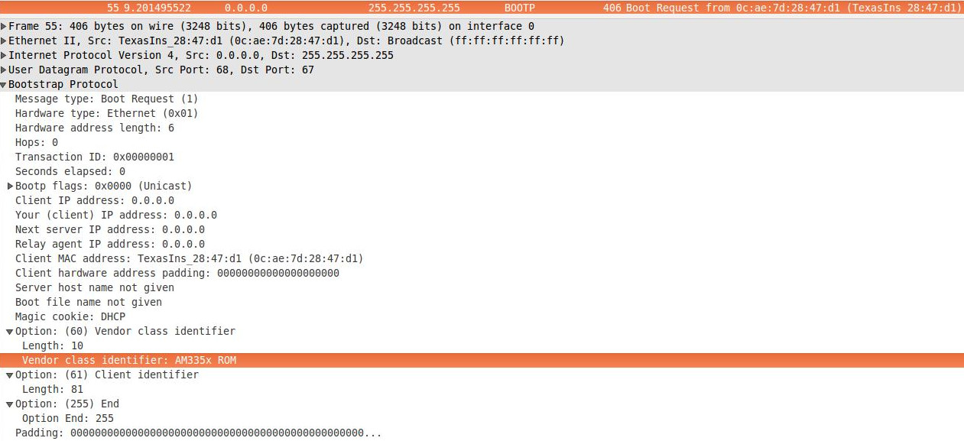
2) In response for this message DHCP server provides free IP address and says what file should be downloaded:
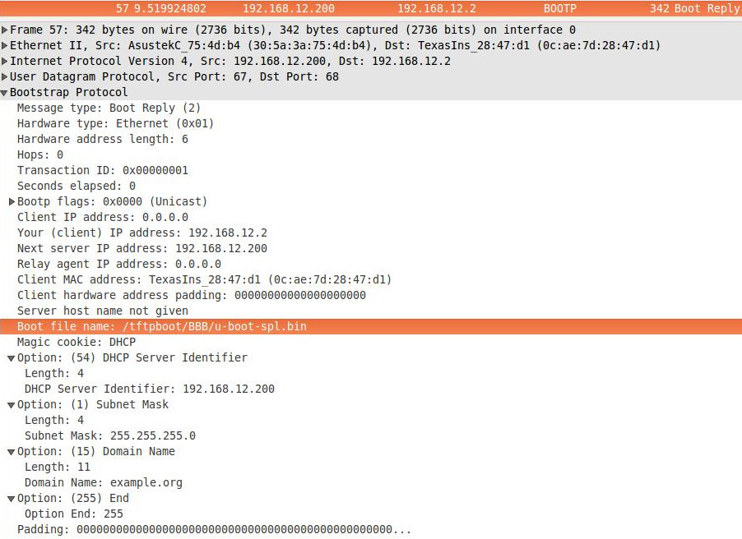
It is necessary to add next lines in file 'dhcpd.conf' to support such mechanism:
allow booting;
allow bootp;
ddns-update-style none;
default-lease-time 600;
max-lease-time 7200;
server-name "working place";
subnet 192.168.???.0 netmask 255.255.255.0
{
interface ????;
next-server 192.168.???.???;
server-identifier 192.168.???.???;
option subnet-mask 255.255.255.0;
pool
{
range dynamic-bootp 192.168.???.??? 192.168.???.???;
allow unknown clients;
}#pool
if substring (option vendor-class-identifier, 0, 10) = "AM335x ROM"
{
#filename "/tftpboot/???/u-boot-spl.bin"; #xinetd
filename "/???/u-boot-spl.bin"; #tftp-server
} #AM335x ROM
elsif substring (option vendor-class-identifier, 0, 17) = "AM335x U-Boot SPL"
{
#filename "/tftpboot/???/u-boot.img"; #xinetd
filename "/???/u-boot.img"; #tftp-server
} #AM335x U-Boot SPL
elsif substring (option vendor-class-identifier, 0, 13) = "AM335x U-Boot"
{
#filename "/tftpboot/???/zImage"; #xinetd
filename "/???/zImage"; #tftp-server
}#AM335x U-Boot
}#subnet
Example configuration files for Fedora are provided by the designer of this system.
3) After MPU downloads its SPL, it executes it.

As it seen from picture above SPL downloads what full loader (Das U-Boot currently).
After full loader is downloaded into the DDR, it is executing:
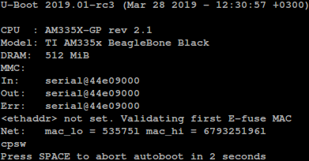
4) Loader will download kernel and device tree blob (here and after – DTB) and executes kernel. DTB will be passed to kernel's main in its arguments.
5) Kernel will try to mount root FS from NFS:
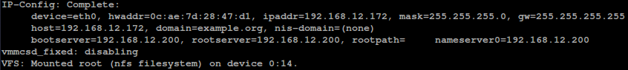

Start up
After audio device have made all necessary hardware configuration, it sends Protobuf message to the DHCP server with it's (audio-device) capabilities. After reception of such message appropriate class will be created by the workplace's communication matrix application.
=== Should be tested ===

Backward compatibility
To avoid cluster-fuck with Yakutsk project, some intermediate version of the proposed system will be presented. This system will support USB connection (signal and power supply), but Sitara will replace AVR. The purpose of such trick is to represent digital automatic gain control (here and after AGC) in exchange of analogue one, that is presently used.
Base task for this design is to contain present day system in state as is – for this purpose Sitara will emulate FTDI behavior by it's own (Sitara's) USB port.
=== Near feature ===

