| Course Name | ITD 2313 – Script Programming |
| --- | --- |
| Instructor | Rene Hurst |
| Student Name | Brian Fabian |
| Due date | Nov 10 |
| Grade | Put grade earned here |
| Grading Comments | Put instructor comments here |

Project # 1

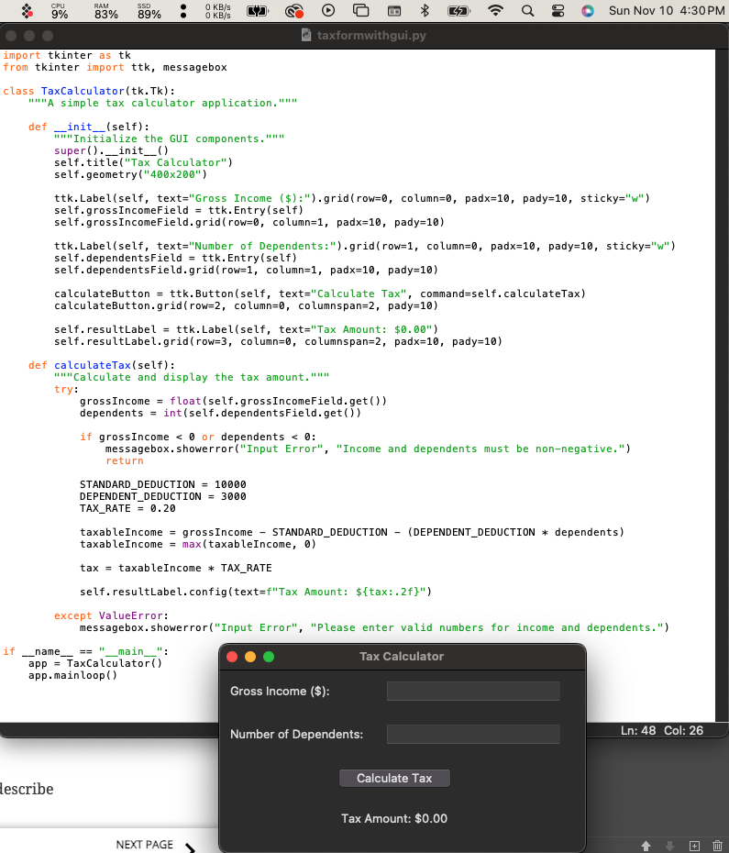

Project # 3

