| Course Name | ITD 2313 – Script Programming |
| --- | --- |
| Instructor | Rene Hurst |
| Student Name | Brian Fabian |
| Due date | Oct. 06 |
| Grade | Put grade earned here |
| Grading Comments | Put instructor comments here |

Scripting Projects

**Project # 3**

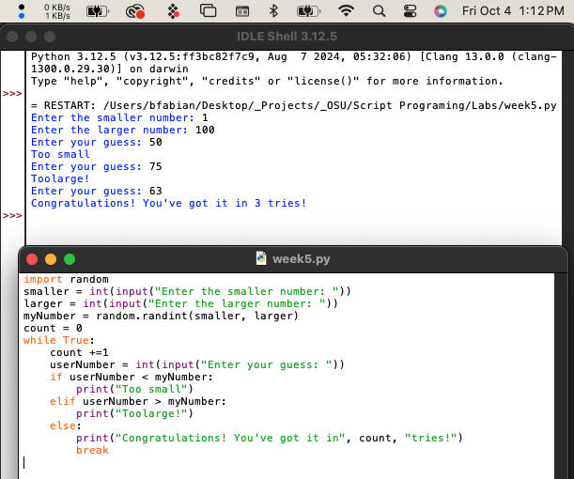

**Project # 7**

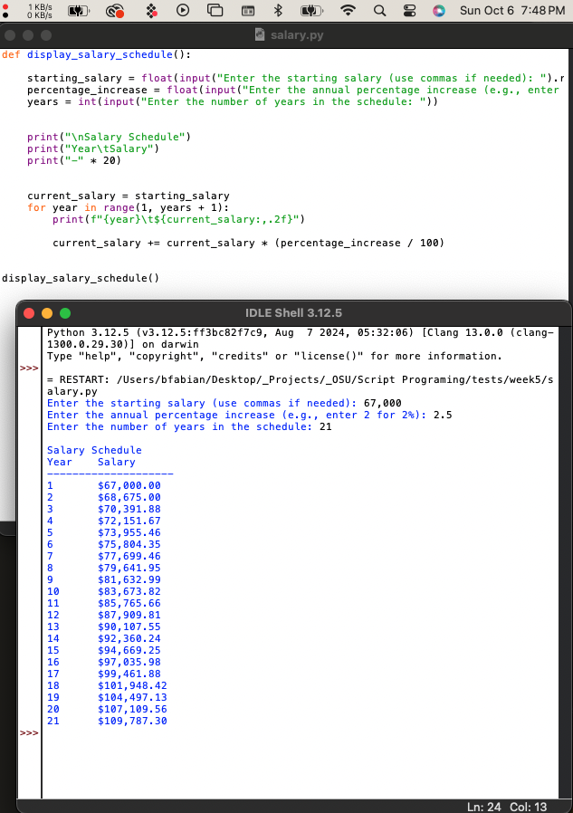

**Project # 10**

