| Course Name | ITD 2313 – Script Programming |
| --- | --- |
| Instructor | Rene Hurst |
| Student Name | Brian Fabian |
| Due date | Oct. 27 |
| Grade | Put grade earned here |
| Grading Comments | Put instructor comments here |

Page 163 - 164

Project # 3

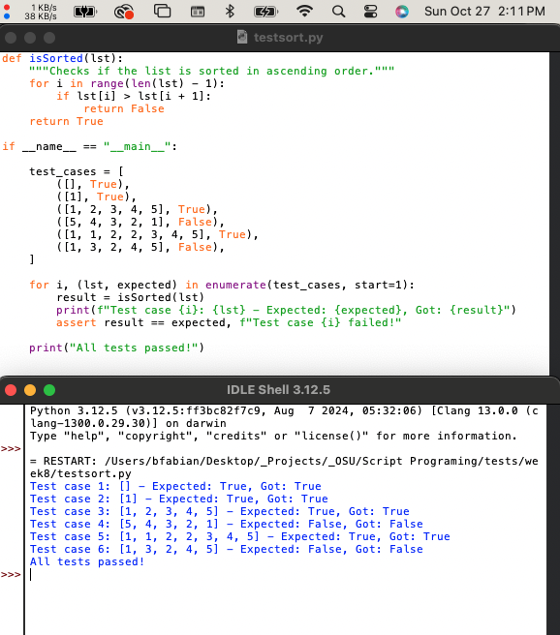

Project # 7

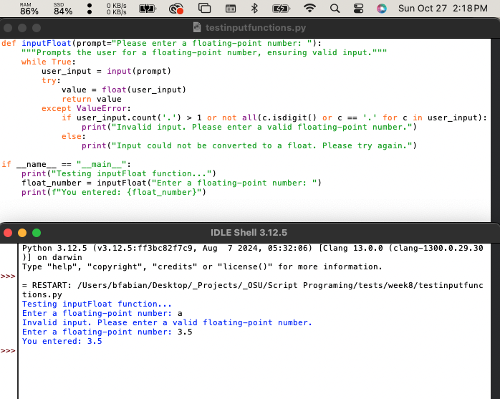

Page 187

Project # 6

