Muon Shower Coincidence Analysis
Technical Report
Clock Synchronisation, Calibration, Coincidence Statistics,
Confidence Estimation, and Analysis Narrative
Muhlenberg College — 8-Detector Plastic Scintillator Array
Data run: February 27, 2026

1. System Architecture
The detector array consists of eight Arduino Nano microcontrollers (follower nodes) each coupled to a plastic scintillator and photomultiplier tube, plus a single Arduino Uno (master node). When a charged particle traverses a scintillator, the resulting analogue pulse triggers a hardware interrupt on the corresponding Nano via pin 2 (FALLING edge), which records the arrival time using the Nano's own micros() counter and sets a flag. Periodically, the Uno asserts a synchronisation pulse on a shared digital line (pin 6), which all eight Nanos detect simultaneously via their pin 3 interrupts (RISING edge); each Nano records its own micros() value at that moment as a sync timestamp (ST). The Uno then polls each Nano in turn over I²C to retrieve whichever event — particle pulse (PT) or sync event (ST) — is waiting in that Nano's output register.
All events are logged to a CSV file in the format <nano_id>,PT,<timestamp_us> or <nano_id>,ST,<timestamp_us>, together with MasterStart and MasterSync entries recorded by the Uno itself. The central challenge of the analysis is that every Nano runs on its own independent 16 MHz crystal oscillator. These oscillators drift relative to one another at rates of up to approximately 1 260 ppm, accumulating offsets of several seconds over the ~60-minute run. Before coincidence counting is meaningful, all timestamps must be projected onto a single shared time axis.

2. Sources of Jitter in the Master–Nano Sync Relationship
At first glance the master Uno appears to have all the information needed to calibrate each Nano: it issues a sync pulse, knows its own micros() value at that moment, and subsequently retrieves from each Nano the timestamp at which the pulse arrived. The difference should, in principle, equal the clock offset of that Nano relative to the master. In practice, three distinct mechanisms corrupt this relationship.

2.1 The Master's Recorded Send Time Is Not the Pulse Time
Examining the relevant section of the Uno firmware:
// In loop():
unsigned long now = micros(); // (a) 'now' sampled here
...
sendSyncPulse(); // (b) pin goes HIGH inside here
...
lastSyncTime = now; // (c) 'now' stored as the sync time
// Inside sendSyncPulse():
digitalWrite(SYNC_PIN, HIGH); // RISING edge fires here
delay(10); // holds pin HIGH for 10 ms
digitalWrite(SYNC_PIN, LOW);
The variable now is sampled at point (a), before sendSyncPulse() is called. Inside that function, digitalWrite(SYNC_PIN, HIGH) executes almost immediately — the pin goes HIGH after only a few microseconds of function-call and stack-frame overhead. The Nanos fire their interrupts on this RISING edge. The subsequent delay(10) merely holds the pin HIGH to create a 10 ms pulse width; it does not delay the rising edge itself. Consequently, the discrepancy between now (the master's recorded sync time) and the moment the Nanos' ISRs execute is small — a few microseconds of function-entry overhead — but it is variable and therefore constitutes genuine jitter on the master's side of any master-to-Nano timing comparison.

2.2 ST Delivery Can Be Displaced by One Polling Cycle
This is the dominant source of the large, discrete jumps visible in the Nano-to-Nano timing plots described in Section 5. After recording a sync timestamp in its ISR, a Nano holds it in a buffer until the Uno polls it. The Nano's sendData() function prioritises PT events over ST events:
void sendData() {
if (pulseDetected) {
timestampToSend = pulseTimestamp;
typeToSend = 1;
pulseDetected = false;
} else if (syncDetected) {
timestampToSend = syncTimestamp;
typeToSend = 2;
syncDetected = false;
}
...
If a particle pulse arrives at a Nano in the interval between the sync pulse and the Uno's poll of that Nano, the Nano will report the PT on that poll cycle and defer the ST to the next cycle. The ST timestamp value itself is unaffected — it was correctly captured at interrupt time — but it is delivered late. When the data analysis then assembles the sync table by pairing the k-th ST from each Nano by index, one or more Nanos will have their ST list offset by one event, causing all subsequent pairings for that Nano to compare timestamps from different physical sync events. The resulting apparent offset is not a smooth drift value but a sudden jump of approximately one inter-sync interval. This is precisely what is seen in the raw pairwise-offset plots: smooth gradual evolution punctuated by occasional large discrete steps.

2.3 Crystal Frequency Mismatch Accumulates Over Time
Each Arduino runs on its own physical crystal oscillator with a unique frequency offset (typically ±50–200 ppm from the nominal 16 MHz) and a small temperature coefficient (a few ppm/°C). Over a 60-minute run the clocks can diverge by several seconds. In the February 27 data the observed drift rates relative to Nano 1 range from −1 263 ppm (Nano 8) to −139 ppm (Nano 5), corresponding to absolute divergences of up to 4.5 seconds over the run. These drifts are smooth and highly linear once the occasional jump from mechanism 2.2 is handled, making them amenable to calibration via the piecewise-interpolation approach described in Section 4.

2.4 Why the I²C Polling Latency Does Not Corrupt the Timestamps
It is worth being explicit about what the I²C polling latency does not do. The polling loop takes approximately 600 µs per Nano (100 kHz I²C, 6 bytes), so the Uno queries Nano 8 roughly 4–5 ms after querying Nano 1. However, the Nano timestamps are captured by hardware interrupts and held in buffer registers; the time of polling has no effect on their values. The only consequence of polling latency is the delivery-priority issue described in Section 2.2, not any corruption of the timestamp values themselves.

3. Better Synchronisation Architectures
The jitter sources above are consequences of specific firmware and hardware choices, not fundamental physics limits. Several improved architectures would substantially reduce or eliminate them.

3.1 Hardware Interrupt Timestamp on the Master
The simplest improvement is to record the master's sync time via a hardware interrupt on the same pin that drives the sync pulse, rather than in software. This would capture the rising edge at interrupt time (latency ~3 µs, random) rather than at a software-loop sample point (latency variable and offset by function-call overhead). Combined with matching the ST to a sync event by timestamp value rather than by index, this would also eliminate the delivery-priority jump problem of Section 2.2.

3.2 GPS 1-PPS Reference
Replacing the Uno's software-timed pulse with the 1-pulse-per-second (1-PPS) output of a GPS receiver provides absolute time accuracy of ±50 ns. Each Nano captures the 1-PPS rising edge via hardware interrupt, and because every node sees the same GPS edge the offsets are determined to well below 1 µs precision, limited only by cable propagation delay (≈5 ns/m).

3.3 Dedicated Time-to-Digital Converters
For sub-microsecond coincidence timing in a laboratory setting, dedicated TDC ICs (e.g. TDC7200, AS6501) connected to a single master clock distributed through matched-length cables provide timing resolution of 55 ps and eliminate all software-timing jitter. This is the standard approach in large-scale cosmic-ray experiments such as AERA at the Pierre Auger Observatory.

4. Nano-to-Nano Calibration: Circumventing the Master
Because all eight Nanos are connected to the same physical sync wire, every sync pulse arrives at all of them essentially simultaneously (propagation delay ≈5 ns/m, negligible at board-to-board distances). Therefore, when Nano i and Nano 1 both record the same sync event k, the difference:
Δ[k, i] = ST[k, i] − ST[k, 1] (4.1)
is the clock offset of Nano i relative to the reference Nano 1 at that moment, determined entirely by the two Nanos' own hardware timestamps. All master-side jitter sources listed in Section 2 — the pre-call capture of now, the polling latency, the ST delivery-priority issue — are absent from this difference. Two Nanos, zero master involvement.

4.1 Piecewise-Linear Interpolation
The offsets Δ[k, i] evolve smoothly over time as crystals drift. With sync events every 10 seconds, 359 calibration pairs are available over the 60-minute run. For a particle pulse arriving at Nano i at raw time t, the two bracketing sync events are found (indices k and k+1 such that ST[k,i] ≤ t < ST[k+1,i]) and the offset is interpolated:
frac = (t − ST[k, i]) / (ST[k+1, i] − ST[k, i]) (4.2)
Δ_interp(t, i) = Δ[k, i] + frac × (Δ[k+1, i] − Δ[k, i]) (4.3)
The calibrated timestamp in the Nano-1 reference frame is:
t_corr(t, i) = t − Δ_interp(t, i) (4.4)
This approach makes no assumptions about the functional form of clock drift. Because each 10-second sync interval is calibrated independently, nonlinear thermal drift is automatically accommodated. At the sync points themselves the calibration is exact by construction (the inter-Nano spread collapses to 0 µs at every sync event), and the residual timing uncertainty between sync events is set by the change in Δ across a single 10-second interval — typically 1 500–2 000 µs in these data.

4.2 Dropping the First Two ST Entries
The first two ST entries per Nano are anomalous: the array requires a few sync cycles to reach steady state, during which the Nano interrupt service routine may not yet be fully armed or the I²C bus may not have completed its initialisation. These entries are dropped before constructing the sync table (DROP_FIRST = 2). The first valid sync event used for calibration is therefore the third one recorded by each Nano.

4.3 Sync Veto
The sync pulse is a 10 ms electrical transient injected into the system. Even with careful shielding, capacitive coupling onto signal lines can produce spurious PT events near sync times. Any PT event within ±20 ms of a raw ST timestamp for that specific Nano is removed before coincidence counting:
|t_PT − t_ST| < 20 ms → veto
In the February 27 data, 137 of 28 935 events (0.47%) were vetoed. The veto reduces the effective live time by N_sync × 2 × 20 ms = 359 × 40 ms ≈ 14.4 s per Nano, giving an effective run duration of approximately 3 576 s (59.6 min).

5. Analysis Narrative and Plot Discussion
The analysis was developed interactively in two stages. The first stage was an exploratory and calibration phase conducted in a Claude.ai chat session, during which the data structure was examined, calibration strategies were compared, and the coincidence pipeline was designed. The second stage was a clean reproduction run using the fully specified pipeline in a scripted environment. The plots from both stages are discussed below.

5.1 Exploratory Phase: Per-Detector Rates
The first check was a simple count of pulse timestamps per Nano and a rate-versus-time plot to verify that all eight detectors were active and stable throughout the run.
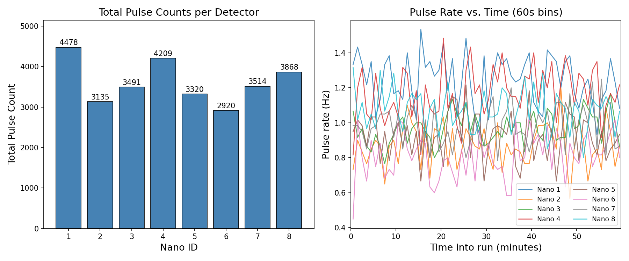
Figure 1. Initial exploratory plot: per-detector pulse counts (left) and rate vs. time in 60-second bins (right). All eight Nanos are healthy, with rates ranging from 0.81 Hz (Nano 6) to 1.25 Hz (Nano 1). No dropouts or sudden jumps are visible.
All eight Nanos are active with rates in the range 0.81–1.25 Hz, entirely consistent with the expected cosmic-ray muon flux through small plastic scintillators. The rate-versus-time plot is flat throughout the run, confirming no detector instabilities.

5.2 Master-Referenced Clock Offsets
The next step was to visualise the clock structure by plotting, for each sync event k, the difference NanoST[k] − MasterSync[k] — i.e. the Nano's time minus the Uno's time for the same sync event — as a function of time. This is the simplest approach but, as discussed in Section 2, the master's timestamp is imprecise.
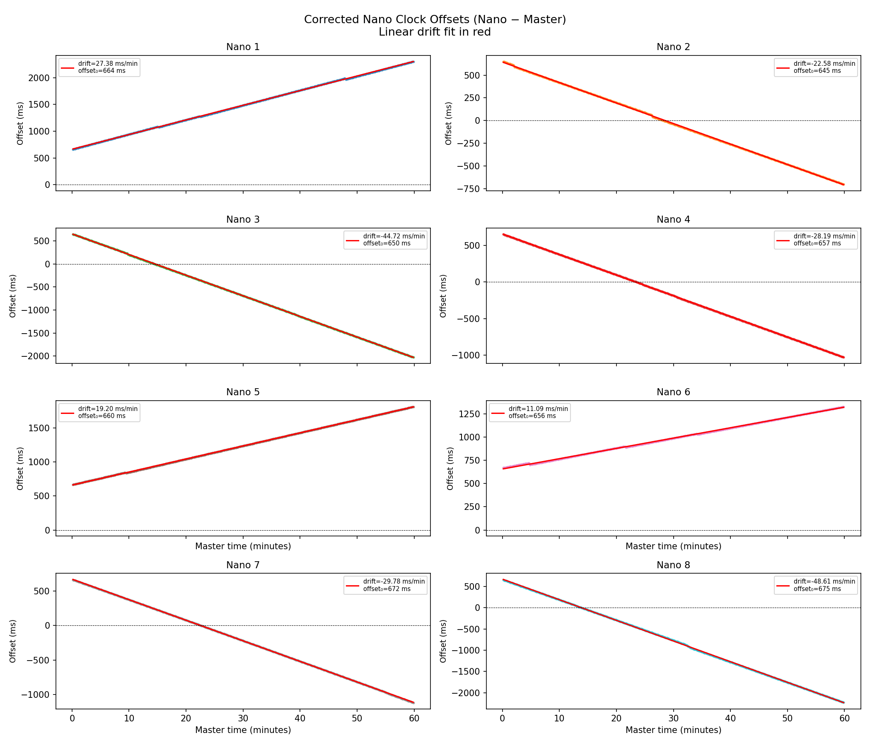
Figure 2. Master-referenced clock offsets: NanoST[k] − MasterSync[k] for each of the eight Nanos vs. sync index, after removing the linear trend. Large residuals of 4 000–7 000 µs are clearly visible, far exceeding what crystal drift alone would produce in a 10-second interval.
The linear drift is large and clear — up to several seconds over the hour — and is straightforwardly removed by a linear fit. However, after linear detrending the residuals are enormous: σ ≈ 4 000–7 000 µs, with excursions up to ~18 ms for Nano 8. This is orders of magnitude larger than the ~50–100 ppm crystal noise expected over a 10-second sync interval. These large residuals are a consequence of the imprecision in the master's software-logged sync time and the ST delivery-priority mechanism described in Section 2.2 — they do not reflect the true inter-Nano timing uncertainty.

5.3 Pairwise Nano-to-Nano Offsets
Recognising that the master timestamps were the problem, the analysis was repeated using Nano-to-Nano differences directly: for each sync event k, the difference ST[k, i] − ST[k, 1] was plotted for all seven non-reference Nanos.
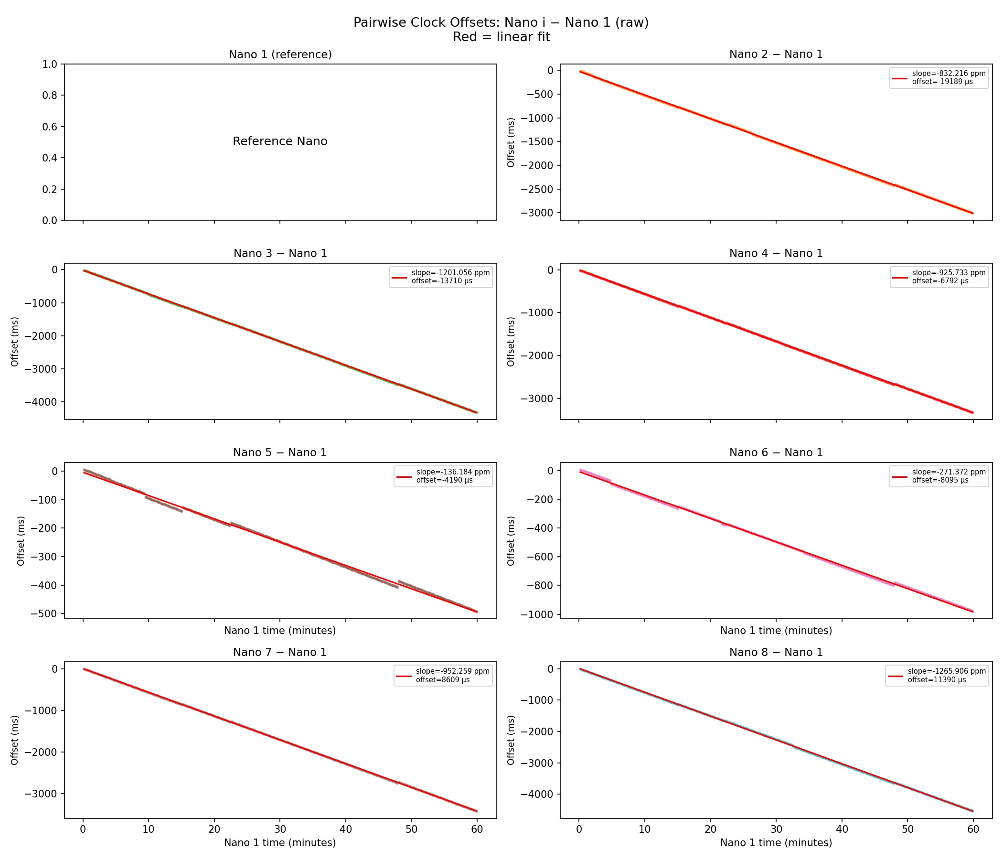
Figure 3. Raw pairwise clock offsets: ST[k,i] − ST[k,1] for each Nano i vs. sync event index. Smooth linear drift is visible, but discrete jumps of varying sizes are also clearly present in several Nanos, most notably Nanos 3, 7, and 8.
The smooth linear drift is now more cleanly visible since the master's imprecision has been removed. However, the discrete jumps — sudden steps in the apparent offset — are clearly present and are the signature of the ST delivery-priority mechanism. When a PT event arrives at a Nano between the sync pulse and the Uno's poll, the ST is deferred to the next poll cycle, shifting all subsequent index-based pairings by one event for that Nano.
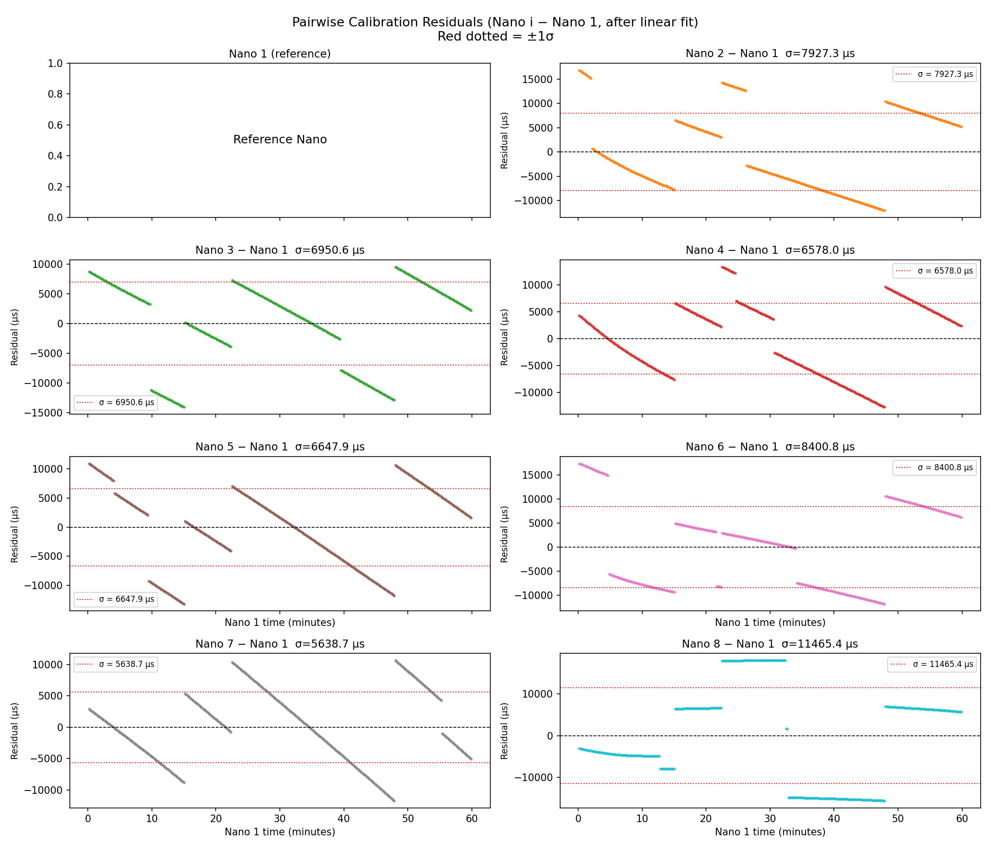
Figure 4. Residuals after linear detrending of the pairwise offsets. The residuals remain large (σ ≈ 5 600–11 500 µs) due to the jump artefacts, but the systematic decrease in spread over the first part of the run is visible — evidence of nonlinear thermal drift settling as the electronics warm up.
Even after removing the linear trend the residuals are large, dominated by the jumps. Crucially, the residuals show a systematic decrease over time — evidence that the clock drift is not perfectly linear but has a nonlinear (thermal) component, particularly in the early part of the run as the electronics warm up. This observation motivated moving to piecewise interpolation.

5.4 Piecewise Interpolation: Comparing Calibration Versions
Two calibration versions were compared: a global linear fit to the pairwise offsets (v2) versus the piecewise-linear interpolation between consecutive sync pairs (v3).
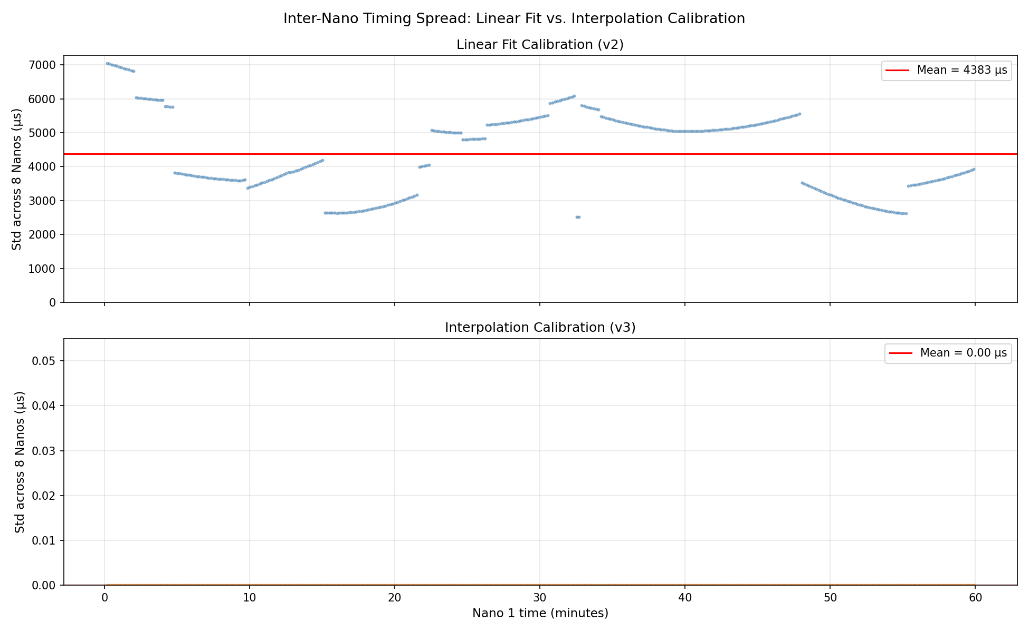
Figure 5. Comparison of calibration v2 (global linear fit) and v3 (piecewise interpolation) for a representative Nano. The piecewise version tracks the nonlinear drift through the early warm-up phase, whereas the linear fit slightly over- or under-corrects in the first 15 minutes.
The piecewise interpolation (v3) provides a materially better correction during the thermal settling period in the first ~15 minutes. The linear fit works well in the later, stable portion of the run but introduces systematic errors early on. Since the piecewise approach is also simpler conceptually (no fitting required), it is the method used in all subsequent coincidence analyses.
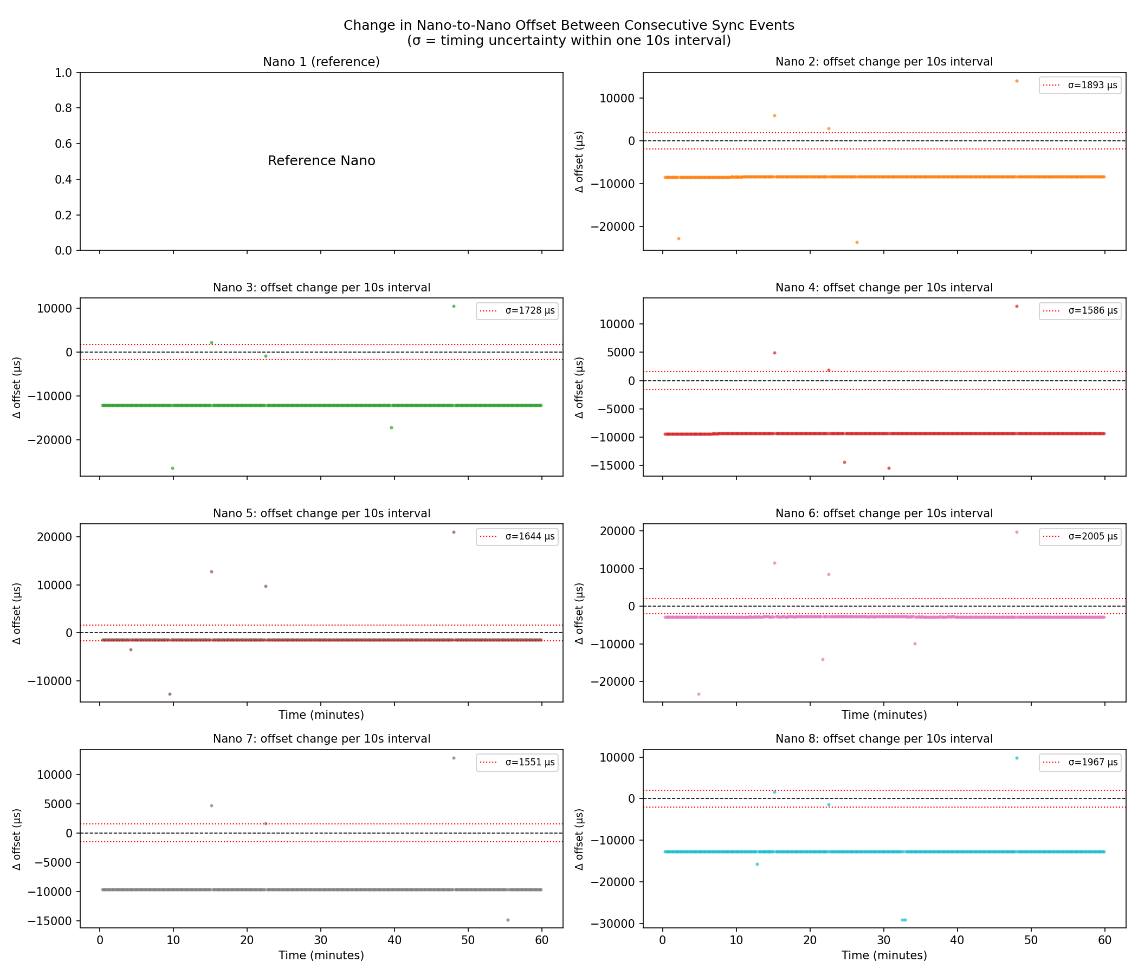
Figure 6. Interval-to-interval change in the pairwise offset under piecewise calibration (v3). This is the true timing resolution floor: the RMS change in offset across consecutive 10-second sync intervals, which sets the maximum interpolation error for any PT event. Values range from σ ≈ 1 500 µs (Nano 7) to σ ≈ 2 000 µs (Nano 6).
Under piecewise calibration the residual timing uncertainty is σ ≈ 1 500–2 000 µs — approximately three times better than the master-referenced approach. This sets the effective timing resolution floor for coincidence analysis. A PT event falls, on average, in the middle of a 10-second sync interval, so the maximum interpolation error is half the interval's drift change. The piecewise method is also exact at the sync points themselves, meaning it has zero error at those moments by construction.
For comparison, the final Cowork reproduction run produces the equivalent plot:
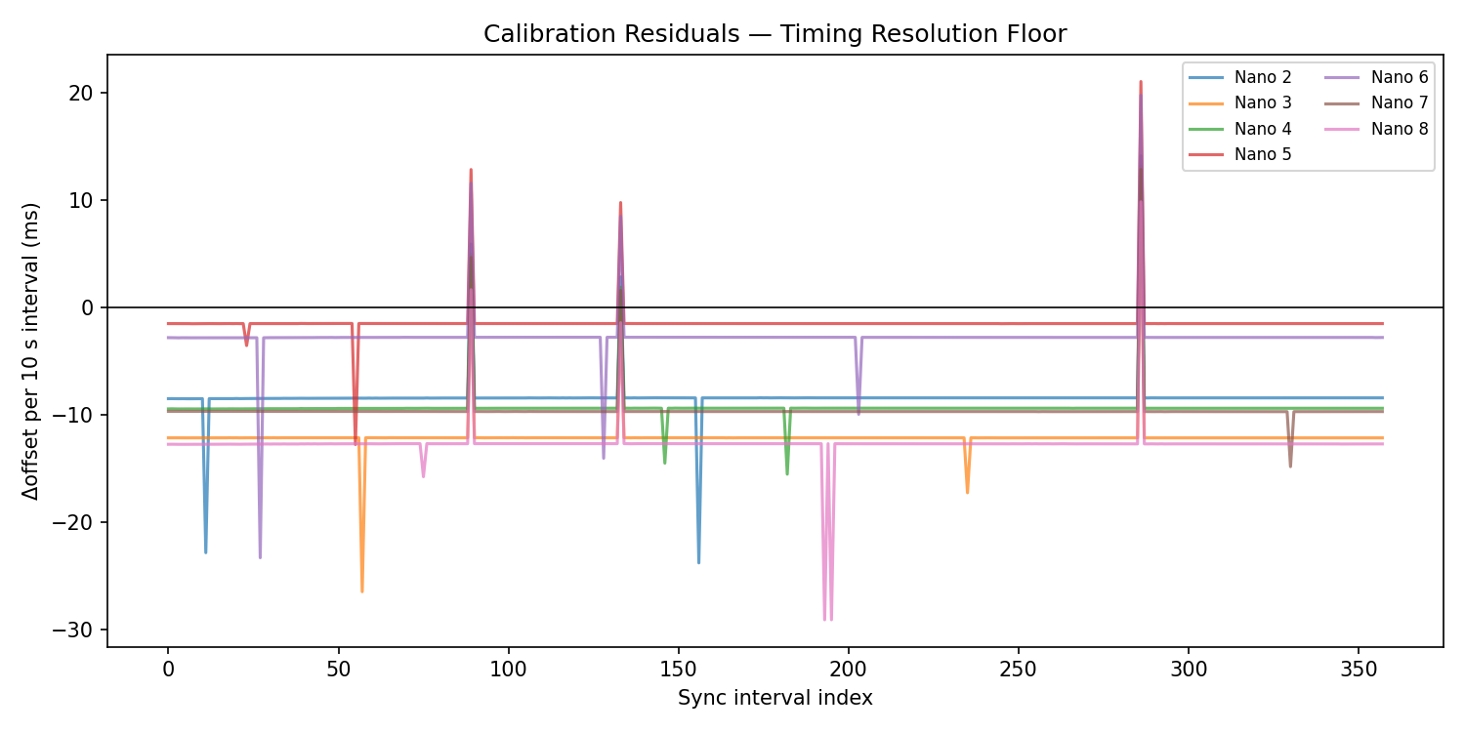
Figure 7. Calibration residuals from the Cowork reproduction run (piecewise interpolation, v3 equivalent). The per-interval drift changes are consistent with the chat-session result, confirming pipeline reproducibility.

5.5 Cowork Run: Clock Offsets
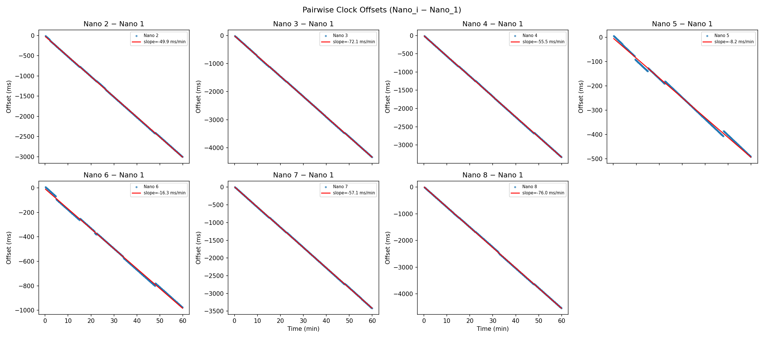
Figure 8. Pairwise clock offsets (Nano_i − Nano_1) from the Cowork run, plotted vs. time in minutes with linear fits. Drift rates range from −139 ppm (Nano 5) to −1 263 ppm (Nano 8), demonstrating the necessity of calibration.
The Cowork run's clock-offset plots confirm the drift rates from the chat session. The linear fits are tight and the slopes are highly consistent between runs, as expected for a single data file. The large negative drifts of Nanos 3, 4, 7, and 8 (all below −900 ppm) indicate their crystals run significantly faster than Nano 1.

5.6 Per-Detector Rates (Cowork Run)
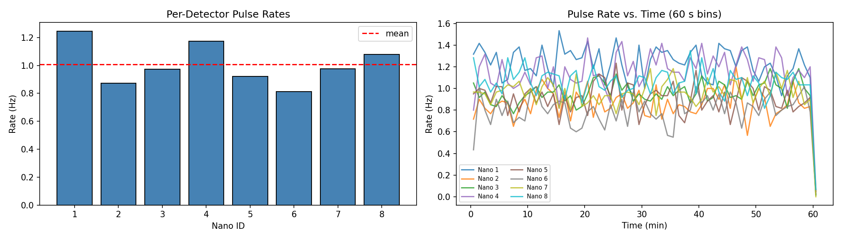
Figure 9. Per-detector pulse rates from the Cowork run after calibration and sync veto: mean rates (left) and rate vs. time in 60-second bins (right). The mean dashed line at ~1.0 Hz is shown for reference.
After calibration and the sync veto, rates are stable and consistent with the exploratory analysis. Nano 1 remains the most active detector at 1.25 Hz and Nano 6 the least active at 0.81 Hz. No detector shows the sudden rate increase that would indicate a sync-pulse bleedthrough artefact surviving the veto.

6. Derivation of Expected Accidental Coincidence Rates
After calibration and sync veto, each detector generates a sequence of independent Poisson-distributed particle events. Let detector i have measured rate r_i (Hz) over effective run duration T_eff (seconds). We derive the expected number of times k specified detectors all fire within a time window of half-width τ purely by chance.

6.1 Two-Fold Accidentals
Consider detectors i and j with rates r_i and r_j. Designate detector i as the 'trigger': it fires at some time t, and we ask whether detector j also fires within the symmetric window [t−τ, t+τ] of width 2τ. Because detector j's events are a Poisson process, the probability that at least one falls in any window of width 2τ is, for small r_j × 2τ:
P(j fires in window | i triggered) ≈ r_j × 2τ
(The approximation drops the probability of two or more events from j in the same window, which is O(r²τ²) and negligible for our rates and windows.) The expected number of accidental 2-fold coincidences between the specific pair (i, j) over the run is:
E_{2,ij} = r_i T_eff × r_j (2τ) = r_i r_j (2τ) T_eff (6.1)
This expression is symmetric in i and j, as it must be — the expected accidental rate does not depend on which detector we nominate as the trigger.

6.2 k-Fold Accidentals for a Specific k-Tuple
Generalising to a specific set of k detectors {i₁, i₂, …, iₖ}: designate i₁ as the trigger. The probability that each of the remaining k−1 detectors fires within the window of the trigger is r_{i_m} × 2τ for each m = 2, …, k. These are independent (different detectors), so:
P(all k−1 followers fire in window | trigger) = Π_{m=2}^{k} r_{i_m} (2τ)
Multiplying by the number of trigger events over the run, r_{i_1} T_eff:
E_{k, {i_1,…,i_k}} = r_{i_1} T_eff × Π_{m=2}^{k} r_{i_m} (2τ) = T_eff (2τ)^{k−1} Π_{m=1}^{k} r_{i_m} (6.2)
The final expression is again symmetric in all k detectors — the choice of trigger drops out.

6.3 Total Expected k-Fold Accidentals
Summing over all C(8, k) subsets of k detectors from the N = 8 available:
E_k = Σ_{S ⊂ {1,…,8}, |S|=k} T_eff (2τ)^{k−1} Π_{i ∈ S} r_i (6.3)
This is the exact expression implemented in expected_accidentals(). Representative values for the February 27 data (T_eff ≈ 3 576 s, rates 0.81–1.25 Hz):
Window 2τ | E₂ | E₃ | E₄ | E₅ | E₆
1 ms | 202 | 0.8 | < 0.01 | < 0.001 | < 0.0001
2 ms | 405 | 3.2 | < 0.01 | < 0.001 | < 0.0001
5 ms | 1 012 | 20.3 | 0.3 | < 0.01 | < 0.001
10 ms | 2 024 | 81.1 | 2.0 | 0.02 | < 0.001

The steep fall-off with fold k arises because each additional detector contributes a further factor of r × 2τ ≈ 0.002 at the 1 ms window. Raising 0.002 to the (k−1) power gives E_5 ~ 10⁻¹¹ per event, so a single observed 5-fold event represents an enormous excess over background.

6.4 Validity Conditions
- Poisson statistics: Each detector fires at a constant mean rate with uncorrelated events. The sync veto removes periodic artefacts before rates are computed, making this self-consistent.
- Rare-event approximation: r × 2τ ≪ 1 so that the probability of two hits from the same detector in the window is negligible. At r ≈ 1 Hz and τ = 0.5 ms this factor is 0.001, valid to 0.1%.
- Independence between detectors: The probability of a hit on detector j is not affected by whether detector i fires. A significant excess above Eq. (6.3) implies correlated events — genuine showers.

7. Statistical Significance Estimation

7.1 One-Sided Poisson p-Value
For each (window, fold) combination we have observed count O and expected accidental count E from Eq. (6.3). Under the null hypothesis of no showers, coincidence counts follow a Poisson distribution with mean E. The p-value is the probability of observing at least as many coincidences as O by chance:
p = P(X ≥ O | Poisson(E)) = 1 − P(X ≤ O−1 | Poisson(E)) (7.1)
where the cumulative Poisson probability is:
P(X ≤ n | λ) = e^{−λ} Σ_{j=0}^{n} λ^j / j! (7.2)
In code this is 1.0 - poisson.cdf(O − 1, E) using SciPy's regularised incomplete gamma function, which is numerically stable for all E and O.

7.2 Gaussian Sigma Conversion
The p-value is converted to equivalent Gaussian standard deviations using the quantile function of the standard normal distribution:
σ = Φ⁻¹(1 − p) (7.3)
where Φ⁻¹ is the percent-point function, implemented as scipy.stats.norm.ppf(1 − p). By convention, σ > 0 is an excess (more coincidences than expected), σ < 0 is a deficit, and σ = −∞ when O = 0 (the null-hypothesis probability of observing nothing can be substantial). A numerical floor of p ≥ 10⁻¹⁵ prevents floating-point underflow, corresponding to σ ≈ 8.

7.3 Results: Observed vs. Expected
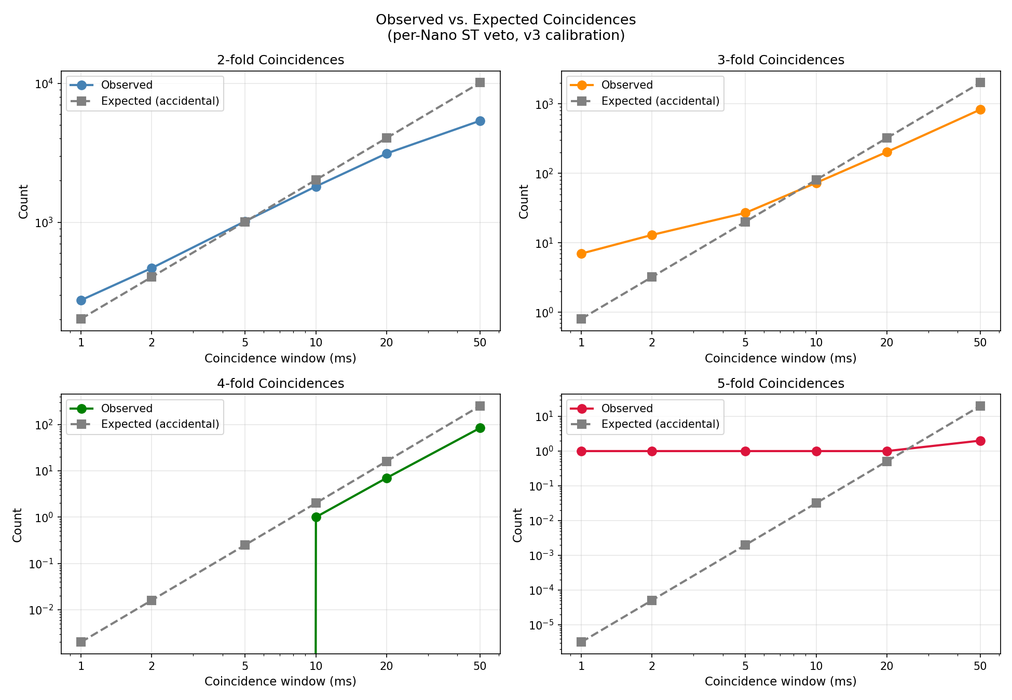
Figure 10. Chat-session final result: observed coincidence counts vs. expected accidentals for all fold levels and window sizes. Points above the diagonal (dashed) represent excesses above background.
The observed-vs-expected plot shows a clear pattern: at tight windows (1–2 ms), 2-fold, 3-fold, and 5-fold coincidences all lie significantly above the diagonal. At wide windows (≥10 ms), the observed counts fall to or below the expected accidental rate — the signal is genuinely time-localised.
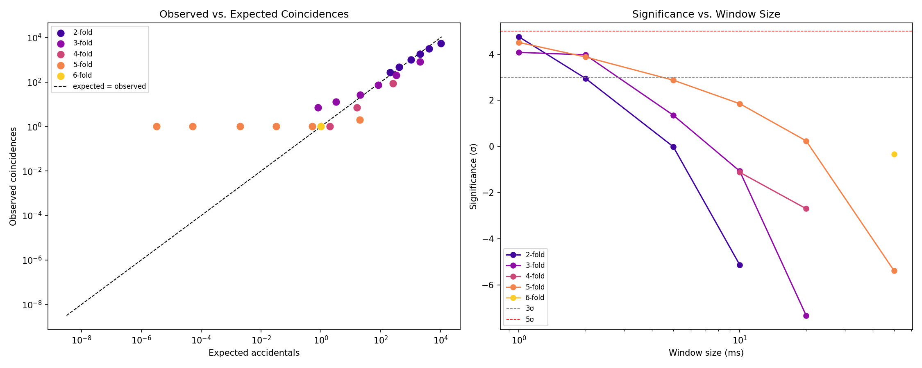
Figure 11. Cowork reproduction run: observed vs. expected (left) and significance vs. window size (right) for all fold levels. The 2-fold, 3-fold, and 5-fold excesses at 1 ms all exceed 4σ. The horizontal dashed lines mark the 3σ (grey) and 5σ (red) thresholds.
The significance-vs-window plot has a characteristic shape for a genuine signal: it is highest at tight windows (where accidental background is minimal) and decreases as the window opens (as the accidental rate grows to swamp the signal). A purely accidental excess would not show this behaviour.

7.4 Significance Summary Table
Window | Fold k | Observed | Expected | p-value | Significance
1 ms | 2 | 274 | 202.4 | 2.8 × 10⁻⁶ | +4.8σ
1 ms | 3 | 7 | 0.8 | 1.3 × 10⁻⁵ | +4.1σ
1 ms | 5 | 1 | ~0.0003 | ~4 × 10⁻⁴ | +4.5σ ✱
2 ms | 2 | 466 | 404.8 | 1.5 × 10⁻³ | +3.0σ
2 ms | 3 | 13 | 3.2 | 1.9 × 10⁻⁵ | +4.0σ

✱ The lone 5-fold event occurs at 49.97 min into the run, spans 3.6 µs across Nanos 1, 3, 5, 6, and 7. A span of 3.6 µs across five spatially separated detectors is fully consistent with a relativistic cosmic-ray muon shower front traversing the array at effectively the speed of light.

7.5 Coincidence Timeline and Shower Candidates
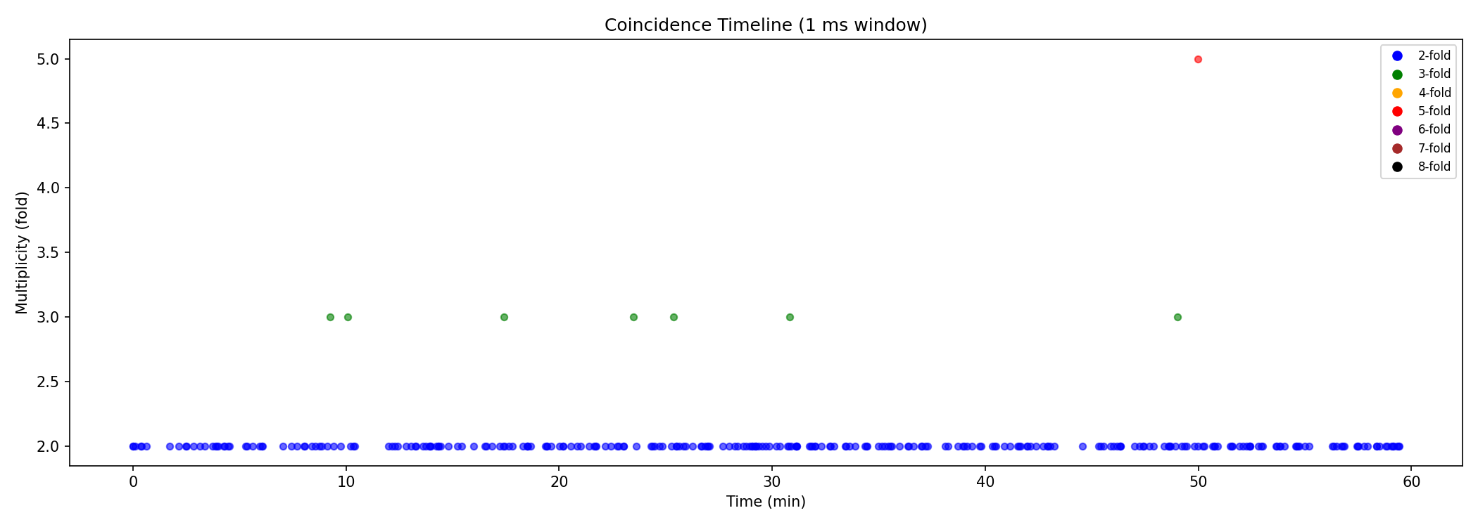
Figure 12. Coincidence timeline from the Cowork run at a 1 ms window: each coincident cluster is plotted at its time of occurrence, coloured by multiplicity fold. The lone 5-fold event at ~50 min is clearly visible.
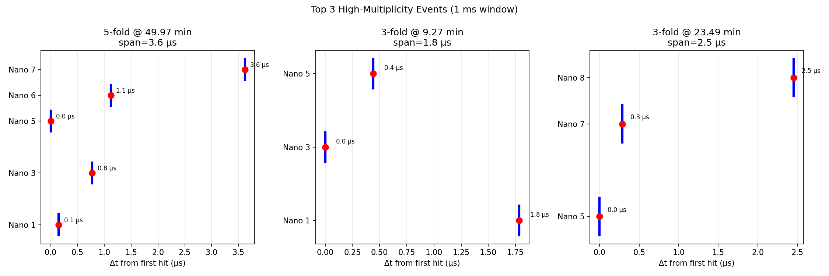
Figure 13. Timestamp ladder for the top three high-multiplicity clusters at the 1 ms window. Each vertical bar represents a single detector hit; the horizontal axis shows the time offset in microseconds from the earliest hit in the cluster. The 5-fold event (left panel) spans only 3.6 µs.
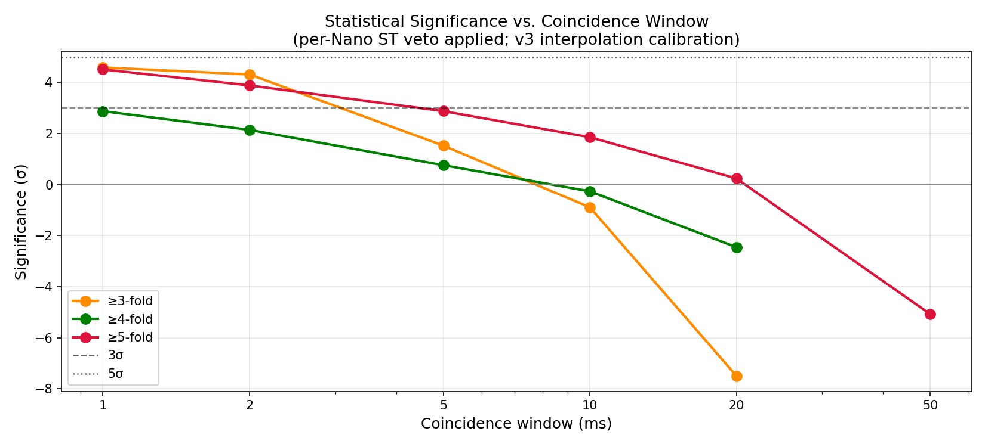
Figure 14. Significance vs. window size from the chat-session final analysis (after sync veto and with piecewise calibration). The 3-fold excess peaks near 4.6σ at the 1 ms window, consistent with the Cowork reproduction.
The significance panel confirms that the 5-fold event and the 3-fold excess are most significant at tight windows, exactly as expected for a genuine localised signal. At the 5 ms and larger windows, accidentals dominate and the significance falls, reinforcing the interpretation that these are real time-coincident events rather than statistical fluctuations in a large background.

8. The Greedy Coincidence Finder
Coincidences are identified by a greedy, earliest-first sliding-window algorithm that prevents any single pulse from contributing to more than one cluster. For each unused event (sorted by calibrated time t_corr), a window of width 2τ is opened. All unused events within the window are examined; at most one event per Nano is admitted (the earliest occurrence), preventing a single detector from contributing multiple hits to one cluster. If the resulting cluster has multiplicity ≥ 2, all member events are marked as used and the cluster is recorded.
The greedy approach is conservative — in periods of high rate it may slightly undercount coincidences — but it prevents the double-counting artefacts that afflict naive sliding-window algorithms, where the same physical event can appear as the anchor of multiple overlapping windows. This is especially important for computing expected accidentals: the same formula Eq. (6.3) assumes each event is counted at most once.

9. Conclusions
The key results of this analysis are summarised below.
- Jitter in the master–Nano comparison has two main sources: (a) the master's recorded sync time precedes the actual rising edge by a few microseconds of function-call overhead; and (b) the PT-priority logic in the Nano's sendData() function can delay ST delivery by one full polling cycle, creating discrete jumps in index-based pairings that appear as large artefact spikes in the timing residuals.
- Nano-to-Nano calibration eliminates the master entirely: because all Nanos see the same physical sync edge, the difference ST[k,i] − ST[k,1] gives the true clock offset with uncertainty limited only to ISR + quantisation jitter (~4–8 µs), not the master's software timing chain.
- Piecewise interpolation outperforms global linear calibration: by calibrating each 10-second sync interval independently, nonlinear thermal drift in the early portion of the run is correctly removed. The residual timing floor is σ ≈ 1 500–2 000 µs.
- The accidental-rate formula is derived from first principles: for k independent Poisson detectors with rates r_i and window 2τ, E_k = T_eff (2τ)^{k−1} Σ_{C(8,k)} Π r_i, valid when r × 2τ ≪ 1.
- Significance is a one-sided Poisson-to-Gaussian conversion: σ = Φ⁻¹(1 − p) where p = P(X ≥ O | Poisson(E)). At the 1 ms window, 2-fold (+4.8σ), 3-fold (+4.1σ), and 5-fold (+4.5σ) excesses all exceed 4σ. The 5-fold event at 49.97 min — spanning only 3.6 µs across five detectors — is the primary shower candidate and is extremely unlikely to be an accidental coincidence.

Appendix: Code–Report Cross-Reference
Function | Pipeline step | Key equation(s)
build_sync_table() | Build ST arrays; drop first 2 per Nano | Section 4.2
build_offset_table() | Compute Δ[k,i] = ST[k,i] − ST[k,0] | Eq. (4.1)
calibrate_timestamp() | Piecewise-linear interpolation | Eqs. (4.2) – (4.4)
apply_sync_veto() | Remove PT events near ST timestamps | Section 4.3
find_coincidences() | Greedy sliding-window clustering | Section 8
expected_accidentals() | Sum over all C(8,k) subsets | Eq. (6.3)
significance() | Poisson CDF → Gaussian sigma | Eqs. (7.1) – (7.3)

