Subsystem title: Purchasing

# ERD for UX process

Place your ERD diagram here.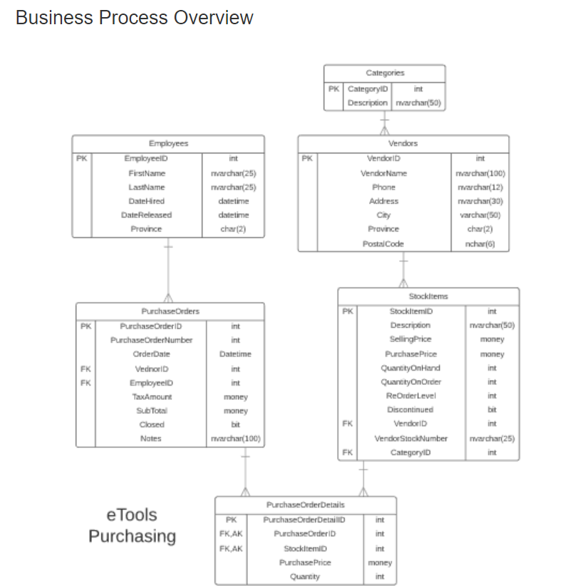

# Possible UX Interface:

1. **Suggested New Purchase Order:**

generating purchase order record and purchase order details records for suggested purchase order to become a current active order( second possible ux interface)

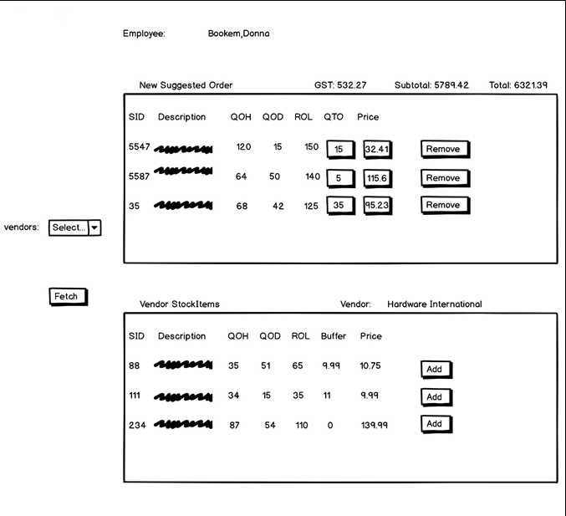

**OR**

1. **Current Active Purchase Order:**

Retrieving a list of current open order to modify and finalize for sending to Vendor

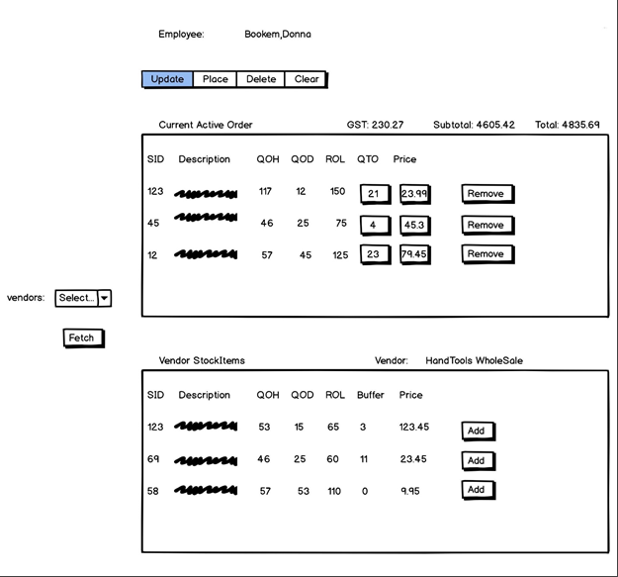

Place your screen design(s) here:

|  |  |  |
| --- | --- | --- |
| **Controls** | | **Events** |
| Fetch (Vendor, PurchaseOrders, PurchaseorderDetails), StockItems, SearchArgID | | OnClick   * Move selection value to ItemsBy, DDL id to SearchArgID; * Bind data to StockItems   OnCommand   * Collect StockItems information and validate * Send to BLL for adding StockItems to PurchaseOrderslist; creating PurchaseOrderId, Total arear along with PurchaseOrderDetails records to database * Refresh PurchaseOrde |
| **BBL Class(es) and Method (s)** | | |
| PurchaseOrdersController, PurchaseOrdersDetailsController,  StockItemscontroller | ● List< CurrentActiveOrdersList >List_StockItemsForCurrentActiveOrder (string itemsby, int argid)  Retrieve a current open order list for Placing Orders. Return stockItemId, description, quantityonhand, quantityonorder, reorderlevel, quantityonorder, Price. Display in Current Active Order.  ● List< VendorStockItemsList > List_VendorStockItemsForCurrentActiveOrder (string itemsby, argid)  Retrieve a list of VendorStockItems (displayed with vendor full name and empty address area) for Adding to current orders. Return stockItemId, description, quantityonhand, quantityonorder, reorderlevel, buffer, Price. Display in Vendor StockItems.  ● Void Add_ SuggestedNewOrderToPurchaseOrders (int purchaseorderid**,** intpurchaseorderdetailsid**,** string username**,** int stockItmeid, money purchaseprice, int quantity, money total, int argid)  Create a list of New Orders for generating PurchaseOrder and PurchaseOrderDetails. Return stockItemId, description, quantityonhand, quantityonorder, reorderlevel, quantitytoorder, Price. Display in NewSuggestedOrders  TRX **(**createPurchaseOrderrecord**,** PurchaseOrderDetails records)  ● List< VendorStockItemsList >List_StockItemsForNewSuggestedOrder (string itemsby, argid)  Retrieve a list of VendorStockItems (displayed with vendor full name and empty address area) for Adding to new orders. Return stockItemId, description, quantityonhand, quantityonorder, reorderlevel, buffer, Price. Display in Vendor StockItems. | |
| **SQL Table(s): (C,R,U,D)** | | **Entities/DTOs/POCOs** |
| StockItems (R), PurchaseOrder(C), PurchaseOrderDeatails(C) | | CurrentActiveOrders (P), VendorStockItems (P), SuggestedNewOrdersList(P) |

|  |  |  |
| --- | --- | --- |
| **Controls** | | **Events** |
| Employee | | Page Load |
| **BBL Class(es) and Method (s)** | | |
| ApplicationUserManager | EmployeeInfo User_GetEmployee (string username)  Get Employee Full name off Application User record  And retrieve a single value from that instance sql security table | |
| **SQL Table(s): (C,R,U,D)** | | **Entities/DTOs/POCOs** |
| Employee(R) | | EmployeeInfo(P) |

|  |  |  |
| --- | --- | --- |
| **Controls** | | **Events** |
| VendorDDL | | BindVendorList()   * obtain a collection of vendor records in the database * send to the BLL controller to bind data to Vendor |
| **BBL Class(es) and Method (s)** | | |
| VendorContoller | List< Vendor > List_VendorList()  Retrieve a list of vendor name and vendor id for DDL | |
| **SQL Table(s): (C,R,U,D)** | | **Entities/DTOs/POCOs** |
| Vendors(R) | | Vendor(E) |

|  |  |  |
| --- | --- | --- |
| **Controls** | | **Events** |
| Remove, lineItems (CurrentActiveOrders) | | OnClick   * Collect line Item, purchseorderId and purchaseorderDetailsiId and validate * Send to BLL for removing line Item from purchase order * Refresh current Active purchase order |
| **BBL Class(es) and Method (s)** | | |
| PurchaseorderDetailsController | Void Remove_CurrentActivePurchaseOrdder(int purchaseorderid, string username, int stockItmeid)  TRX (find item, remove item, shift remaining item’s lines up, and renumber Item’s line). | |
| **SQL Table(s): (C,R,U,D)** | | **Entities/DTOs/POCOs** |
| PurchaseOrders( R), PurchseOrderDetails(U/D) | | CurrentActiveOrders (P), VendorStockItems (P) |

|  |  |  |
| --- | --- | --- |
| **Controls** | | **Events** |
| Add( lineItems), VendorStockItems | | OnClick   * Collect line Item and validate * Send to BLL for adding Vendor line Item to current active order * Refresh current Active purchase order |
| **BBL Class(es) and Method (s)** | | |
| StockItemscontroller, | Void Add_LinItemToCurrentActivePurchaseOrdderList (string username, int stockItmeid) | |
| **SQL Table(s): (C,R,U,D)** | | **Entities/DTOs/POCOs** |
| PurchaseOrder(C, opt) | | CurrentActiveOrders (p), VendorStockItems (P) |

|  |  |  |
| --- | --- | --- |
| **Controls** | | **Events** |
| Update (CurrentActiveOrder) | | OnClick   * Collect line items and edit rows to modify desired rows (QTO, Price) * Refresh current Active purchase order |
| **BBL Class(es) and Method (s)** | | |
| PurchaseorderDetailsController | ● void Update_ItemsFromCurrentOrder (int stockitmeid, int quantitytoorder, money price, string username)  TRX (find items, edit desired rows, bulk update of all rows) | |
| **SQL Table(s): (C,R,U,D)** | | **Entities/DTOs/POCOs** |
| PurchaseOrderDetails(U), PurchaseOrder(R) | | UpdateCurrentOrders(P) |

|  |  |  |
| --- | --- | --- |
| **Controls** | | **Events** |
| Delete, CurrentActivePurchaseOrder, PurchaseOrderDetails | | OnClick   * Collect purchaseorderid ,purchaseorderdetailsid, stockitem and validate * Send to BLL for removing purchaseorderdetails and purchaseorders from database * Refresh purchaseorder |
| **BBL Class(es) and Method (s)** | | |
| PurchaseorderController,  PurchaseOrderDetailsController | * Void Delete_CurrentOpenPurchaseOrderDetils (intpurchaseorderdetailsid**,** string username**,** int stockItmeid, money purchaseprice, int quantity)   TRX (find items, delete the current open purchaseorderdetails records from database).   * Void Delete_CurrentOpenPurchaseOrders (intpurchaseorderid**,** string username**,** int vendorid, datetime orderdate, int purchaseordernumber)   TRX (find items, delete the current open purchaseorder records from database). | |
| **SQL Table(s): (C,R,U,D)** | | **Entities/DTOs/POCOs** |
| PurchaseOrderDetails(U/D), PurchaseOrder(U/D) | | PurchaseOrderDetails, PurchaseOrder |

|  |  |  |
| --- | --- | --- |
| **Controls** | | **Events** |
| Place(CurrentActivePurchaseOrder) | | Save OnClick   * Collect line Items from Active Purchase order and set the OrderDate and PurhcaseOrderNumber to PurchaseOrder * Update the quantityonorder for StockItems on Purchase Order * Send for processing to BLL |
| **BBL Class(es) and Method (s)** | | |
| PurchaseorderController,  PurchaseOrderDetailsController | * Void Add_ToPurchaseOrder (int purchaseorderid, string username, datetimeorderdate**,** intpurchaseordernumber , list< CurrentActivePurchaseOrder > CurrentActivePurchaseOrder )   TRX (set the datetime to current date, assign new purchaseordernumber; orderdate to PurchaseOrders, update )   * Void Update_StockItemsForPurchaseOrder (int quantityonorder, string username, list<StockItmes> int quantiyonorder)   TRX( match incoming quantityonorder to existing quantityonorder, update differences) | |
| **SQL Table(s): (C,R,U,D)** | | **Entities/DTOs/POCOs** |
| StockLineItems (U), PurchaseOrder(U) | | CurrentActiveOrders (p), StockItmes(E) |

|  |  |  |
| --- | --- | --- |
| **Controls** | | **Events** |
| Clear, CurrentActivePurchaseOrder, VendorStockItems | | OnClick   * Collect information from current active order and clear web page * Reset vendor list to show prompt to select vendor |
| **BBL Class(es) and Method (s)** | | |
| PurchaseOrdersController, StockItemsController | Void Clear_ List< CurrentActiveOrdersList >List ()  Void Clear_List<VendorStockItemsList > List_VendorName () | |
| **SQL Table(s): (C,R,U,D)** | | **Entities/DTOs/POCOs** |
|  | | CurrentActiveOrders (P), VendorStockItems(P) |

Comments

You seem to understand what needs to be done. There are a couple of events that need to be rethought as you indicate multiple methods for what should be a single transaction therefore a single method.