Rentals

ERD for Rentals

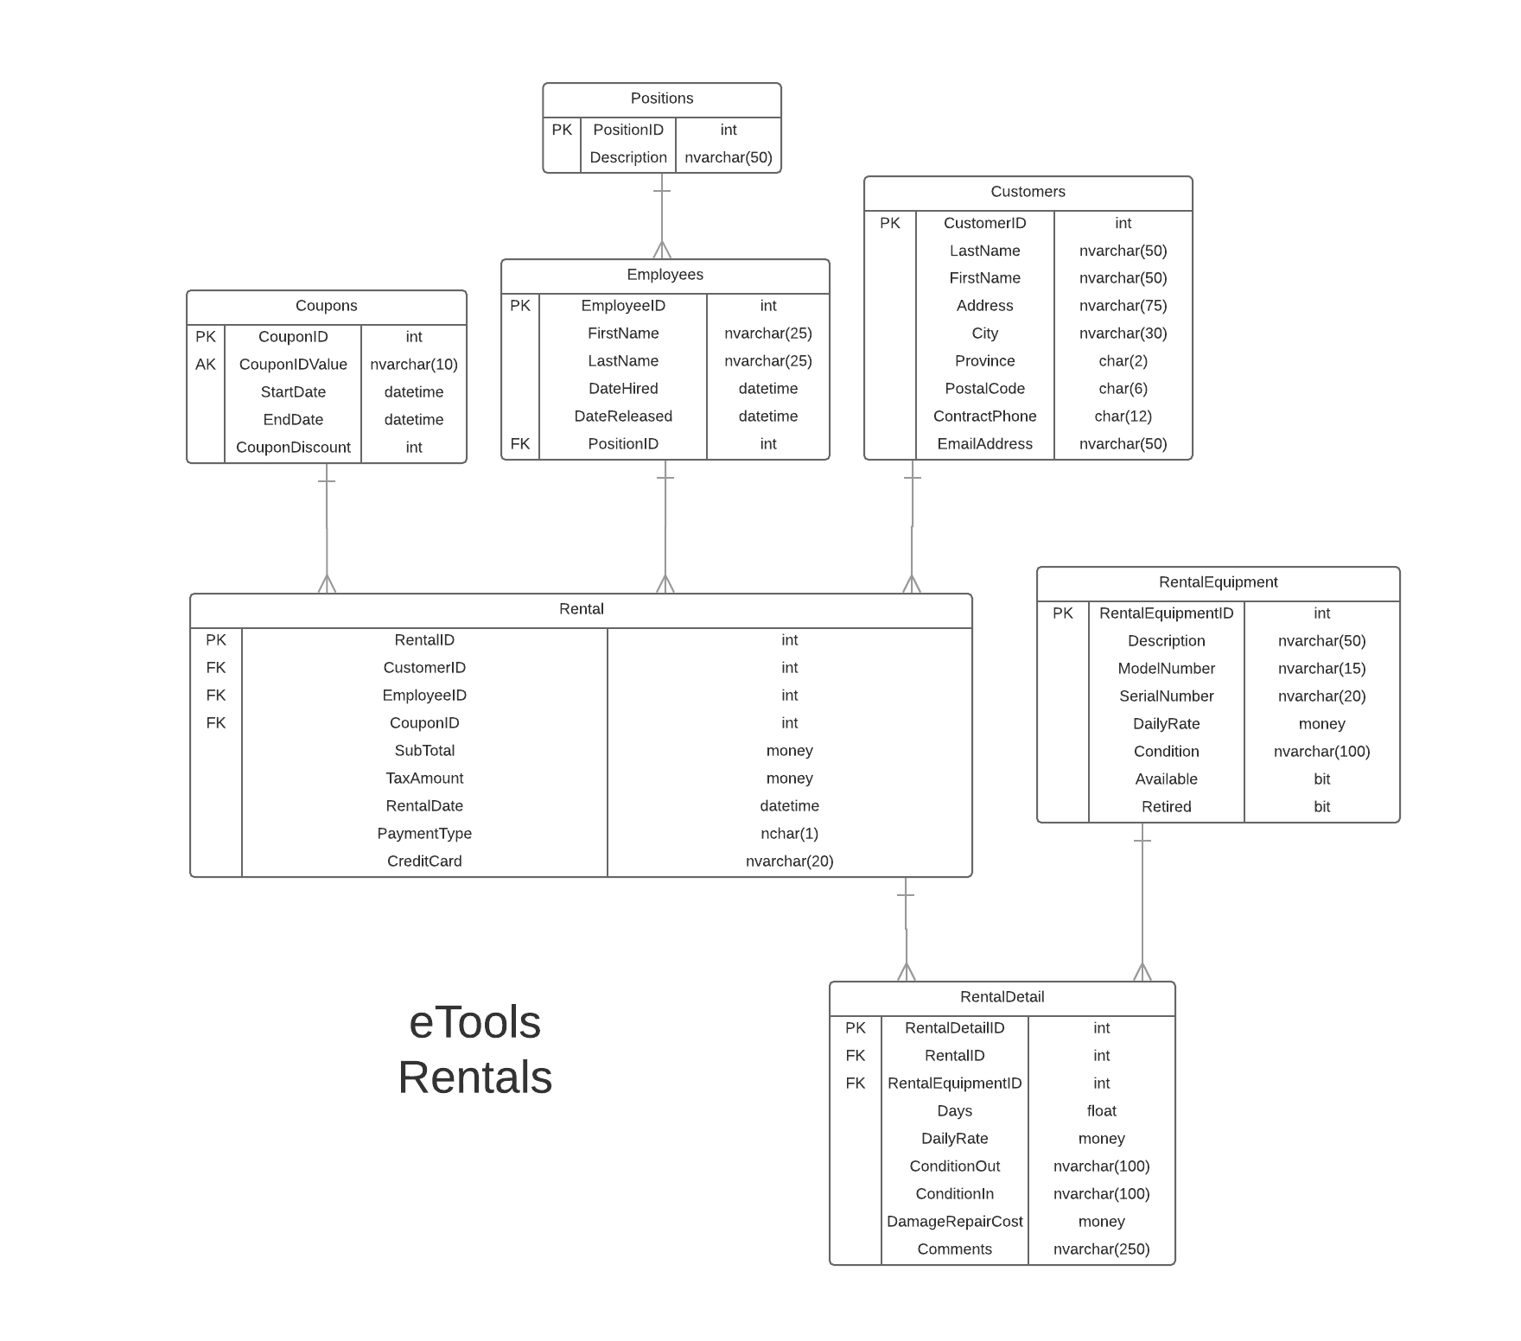

User Interface Design

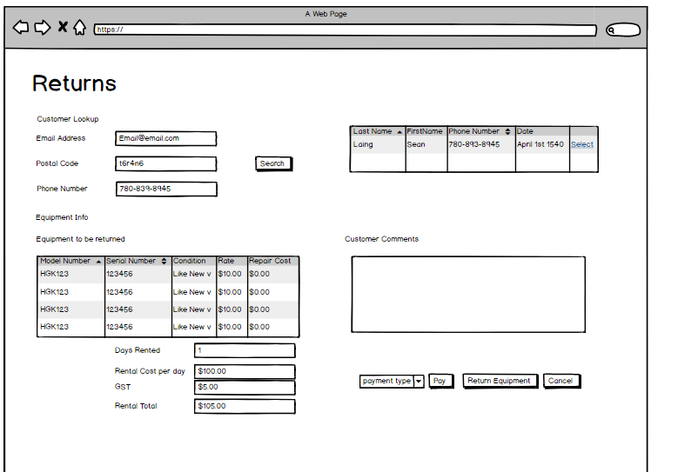

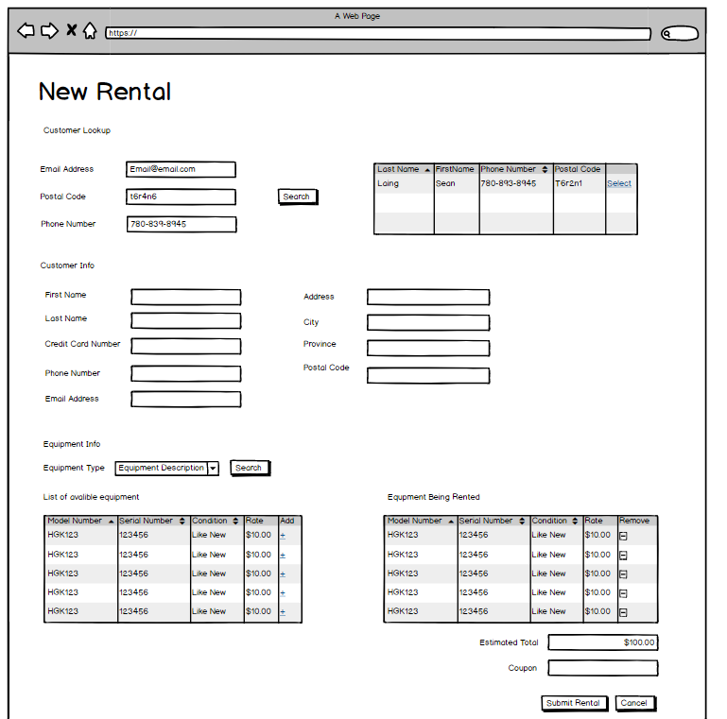

Rental Screens

Search For Customer

|  |  |  |
| --- | --- | --- |
| **Controls** | | **Events** |
| SearchForCustomr (PhoneNumber, PostalCode, EmailAddress) | | OnClick / wired via ObjectDataSource   * Get Customers who matched the supplied * Bind data to CustomerList |
| **BBL Class(es) and Method (s)** | | |
| CustomerController, | ● List<Customers>  List_GetCustomersByPhoneNumber(string PhoneNumber)  Retrieve a List of Customers whos phone number mathes the supplied phone number. Return FirstName, LastName, PhoneNumber, EmailAddress, CreditCardNumber, CustomerID, Address, City, PostalCode. Display in CustomerList.  ● List<Customer>  List_GetCustomersByPostalCode(string PostalCode)  Retrieve a List of Customers whos postalcode mathes the supplied postalcode. Return FirstName, LastName, PhoneNumber, EmailAddress, CreditCardNumber, CustomerID, Address, City, PostalCode. Display in CustomerList.  ● List<Customer>  List_GetCustomersByEmail(string email)  Retrieve a List of Customers whos email mathes the supplied postalcode. Return FirstName, LastName, PhoneNumber, EmailAddress, CreditCardNumber, CustomerID, Address, City, PostalCode. Display in Customer List. | |
| **SQL Table(s): (C,R,U,D)** | | **Entities/DTOs/POCOs** |
| Customers(R,) | | Customers(E,) |

Select Customer

|  |  |  |
| --- | --- | --- |
| **Controls** | | **Events** |
| SelectCustomer | | OnClick / wired via ObjectDataSource   * Get Customer Info * Bind to ActiveCustomer--------* |
| **BBL Class(es) and Method (s)** | | |
| CustomerController | ● List<Customers>  List_GetCustomersByPhoneNumber(string PhoneNumber)  Retrieve a List of Customers whos phone number mathes the supplied phone number. Return FirstName, LastName, PhoneNumber, EmailAddress, CreditCardNumber, CustomerID, Address, City, PostalCode. Display in CustomerList.  ● List<Customer>  List_GetCustomersByPostalCode(string PostalCode)  Retrieve a List of Customers whos postalcode mathes the supplied postalcode. Return FirstName, LastName, PhoneNumber, EmailAddress, CreditCardNumber, CustomerID, Address, City, PostalCode. Display in CustomerList.  ● List<Customer>  List_GetCustomersByEmail(string email)  Retrieve a List of Customers whos email mathes the supplied postalcode. Return FirstName, LastName, PhoneNumber, EmailAddress, CreditCardNumber, CustomerID, Address, City, PostalCode. Display in Customer List. | |
| **SQL Table(s): (C,R,U,D)** | | **Entities/DTOs/POCOs** |
| Customers(R,) | | Customers(E,) |

GetEquipmentByDescription

|  |  |  |
| --- | --- | --- |
| **Controls** | | **Events** |
| GetEquipmentByDescription (Description) | | OnClick / wired via ObjectDataSource   * Get Equipment that has the supplied description * Bind data to EquipmentList |
| **BBL Class(es) and Method (s)** | | |
| EquipmentController, | ● List<Equipment>  List_GetEquipmentByDescription(string Description)  Retrieve a List of Equipment whos description matches the chosen description and that the avalible flag is true. Return RentalEquipmentID, ModelNumber, SerialNumber, DailyRate, Condition in EquipmentList. | |
| **SQL Table(s): (C,R,U,D)** | | **Entities/DTOs/POCOs** |
| RentalEquipment(R,) | | RentalEquipment(p) |

EquipmentDescriptionDDL

|  |  |  |
| --- | --- | --- |
| **Controls** | | **Events** |
| EquipmentDescriptionDDL | | OnClick / wired via ObjectDataSource   * List equipment descriptions |
| **BBL Class(es) and Method (s)** | | |
| EquipmentController, | ● List all description types | |
| **SQL Table(s): (C,R,U,D)** | | **Entities/DTOs/POCOs** |
| Equipment(R,) | | SelectionList(p) |

AddEquipmentToRental

|  |  |  |
| --- | --- | --- |
| **Controls** | | **Events** |
| AddEquipmentToRental (EquipmentID, Description, SerialNumber, ModelNumber, DailyRate, Condition) | | OnClick / wired via ObjectDataSource   * Get Equipment info from EquipmentList that has the selected EquipmentID * Bind data to RentalList |
| **BBL Class(es) and Method (s)** | | |
| EquipmentController, | ● List<Equipment>  List_GetEquipmentByDescription(string Description)  Retrieve a List of Equipment whos description matches the chosen description and that the avalible flag is true. Return RentalEquipmentID, ModelNumber, SerialNumber, DailyRate, Condition in EquipmentList. | |
| **SQL Table(s): (C,R,U,D)** | | **Entities/DTOs/POCOs** |
| RentalEquipment | | RentalEquipment(p) |

Submit (Create Rental Page and rental details pages)

|  |  |  |
| --- | --- | --- |
| **Controls** | | **Events** |
| CreateNewRental (CustomerID, EmployeeID, Date, CouponID),  CreateRetalDetails (EquipmentID, SerialNumber, ModelNumber, ConditionOut, DailyRate) | | OnClick / wired via ObjectDataSource   * Create a new rental record with supplied details * Create a new rental details record for each piece of equipment |
| **BBL Class(es) and Method (s)** | | |
| Rental, RentalDetails | ● | |
| **SQL Table(s): (C,R,U,D)** | | **Entities/DTOs/POCOs** |
| Rentals(C,), RentalDetails(C,) | | Rentals(E,), RentalDetails(E,) |

RETURNS

Search For Customer with outstanding rentals

|  |  |  |
| --- | --- | --- |
| **Controls** | | **Events** |
| SearchForCustomr (PhoneNumber, PostalCode, EmailAddress) | | OnClick / wired via ObjectDataSource   * Get Customers who matched the supplied * Bind data to CustomerList |
| **BBL Class(es) and Method (s)** | | |
| CustomerController, | ● List<Customers>  List_GetCustomersByPhoneNumber(string PhoneNumber)  Retrieve a List of Customers whos phone number mathes the supplied phone number. Return FirstName, LastName, PhoneNumber, EmailAddress, CreditCardNumber, CustomerID, Address, City, PostalCode. Display in CustomerList.  ● List<Customer>  List_GetCustomersByPostalCode(string PostalCode)  Retrieve a List of Customers whos postalcode mathes the supplied postalcode. Return FirstName, LastName, PhoneNumber, EmailAddress, CreditCardNumber, CustomerID, Address, City, PostalCode. Display in CustomerList.  ● List<Customer>  List_GetCustomersByEmail(string email)  Retrieve a List of Customers whos email mathes the supplied postalcode. Return FirstName, LastName, PhoneNumber, EmailAddress, CreditCardNumber, CustomerID, Address, City, PostalCode. Display in Customer List. | |
| **SQL Table(s): (C,R,U,D)** | | **Entities/DTOs/POCOs** |
| Rental (R,) | | Rental(P) |

Select Customer

|  |  |  |
| --- | --- | --- |
| **Controls** | | **Events** |
| SelectCustomer | | OnClick / wired via ObjectDataSource   * Get Customer Info * Bind to ActiveCustomer--------* |
| **BBL Class(es) and Method (s)** | | |
| CustomerController | ● List<Customers>  List_GetCustomersByPhoneNumber(string PhoneNumber)  Retrieve a List of Customers whos phone number mathes the supplied phone number. Return FirstName, LastName, PhoneNumber, EmailAddress, CreditCardNumber, CustomerID, Address, City, PostalCode. Display in CustomerList.  ● List<Customer>  List_GetCustomersByPostalCode(string PostalCode)  Retrieve a List of Customers whos postalcode mathes the supplied postalcode. Return FirstName, LastName, PhoneNumber, EmailAddress, CreditCardNumber, CustomerID, Address, City, PostalCode. Display in CustomerList.  ● List<Customer>  List_GetCustomersByEmail(string email)  Retrieve a List of Customers whos email mathes the supplied postalcode. Return FirstName, LastName, PhoneNumber, EmailAddress, CreditCardNumber, CustomerID, Address, City, PostalCode. Display in Customer List. | |
| **SQL Table(s): (C,R,U,D)** | | **Entities/DTOs/POCOs** |
| Rental(R,), RentalDetails(R,) | | Rental(E,), RentalDetails(E,) |

Process Equipment rental PAY

|  |  |  |
| --- | --- | --- |
| **Controls** | | **Events** |
| PayButton | | OnClick / wired via ObjectDataSource   * Mark the rental as paid |
| **BBL Class(es) and Method (s)** | | |
| RentalController | ● Get and save rental payment type | |
| **SQL Table(s): (C,R,U,D)** | | **Entities/DTOs/POCOs** |
| Rental(U,) | | Rental(E) |

Process Equipment Return

|  |  |  |
| --- | --- | --- |
| **Controls** | | **Events** |
| ReturnEquipmentButton | | OnClick / wired via ObjectDataSource   * Get and save Updated equipment condition * Apply flag for availability |
| **BBL Class(es) and Method (s)** | | |
| RentalController | ● Mark Equipment as returned and avalible if the condition is good | |
| **SQL Table(s): (C,R,U,D)** | | **Entities/DTOs/POCOs** |
| Rental(U,), RentalDetails(U,) | | Rental(E,), RentalDetails(E,) |

CostCalculations

|  |  |  |
| --- | --- | --- |
| **Controls** | | **Events** |
| EquipmentBeingRentedList, EquipmentBeingReturnedList, DaysRented | | When changes are made on the page, update the cost fields |
| **BBL Class(es) and Method (s)** | | |
| RentalController | ● Updates costs based on on page calculations | |
| **SQL Table(s): (C,R,U,D)** | | **Entities/DTOs/POCOs** |
| Rental(R,) | | Rental(E,) |

Comments

You seem to have a partial handle on what needs to be done but there is a lack of details on the design in some areas. Review your Add to Rental. Where is your Remove from Rental? Your Return is mssing all detail. You should complete your detail design especially where transactions are needed. You also have several search criteria which are not needed such as by email. These will not add points to the project. The indicated lookups (by phone/ by rentalid - by phone) are sufficient. Where is the coupon handling?