Brian Faure

RUID:150003563

NetID:bdf39

Programming Meth. II

Homework #2

Problem #4

🡪 Both the Iterative and Recursive timed programs are in the Problem4 folder (same as this file)

🡪 They are generally the same as the Problem2 and Problem3 programs but with the added timing portion.

🡪 For both I used a for loop to input 1 through 22 discs and recorded the execution time for each operation

🡪 The following are the terminal outputs

Iterative Execution Times

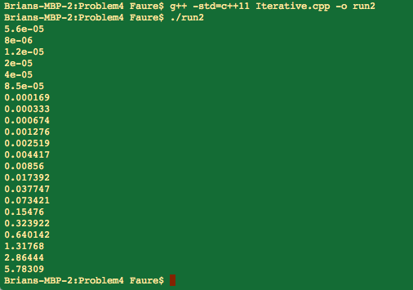

Recursive Execution Times

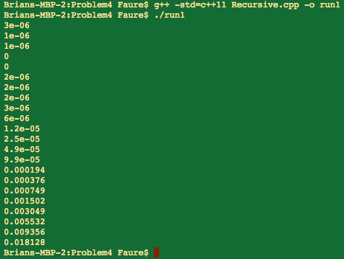

🡪 Using MATLAB, I created a plot of N vs. Execution time including both the Iterative and Recursive data. I chose to make the Y Axis logarithmic to help preserve the trend of the time increase:

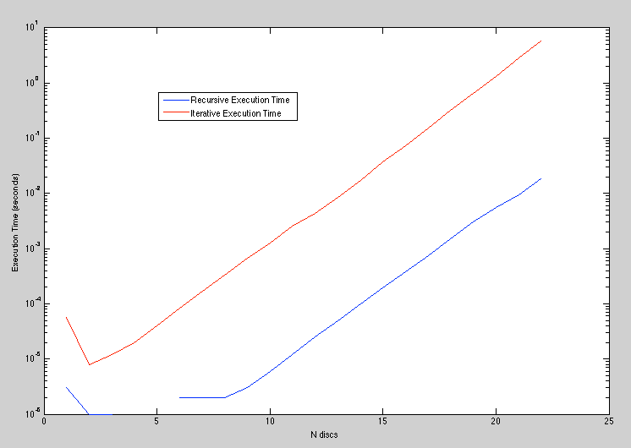

It seems as if both methods show a similar slope so their increase in execution time for every added disc is similar. The huge difference is the fact that the Recursive method is significantly faster in every case. This is most likely due to the extreme simplicity in its operation when compared to the Iterative method. Even though both methods are fairly quick, in this case the Recursive method is definitely the best bet for most applications.