**CURRICULAM VITAE**

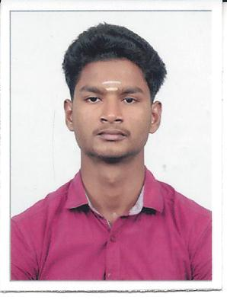

**SATHYAMOORTHY. M**

**B.Com,**

**S/O A. MANIMARAN,**

**No. 5, Iyyanar Kovil Street,**

**Sothanaikuppam,**

**Kottakuppam,**

**Tamil Nadu – 605104.**

**Email:** [**sathyaips310@gmail.com**](mailto:sathyaips310@gmail.com)

**Mobile no: +91 9092711157**

### CAREER OBJECTIVE:

To sincerely and whole heartily work with an Organization that gives me scope to update my knowledge and make contributions through my creative ideas, knowledge, skill and to work in a team for professional satisfaction, organizational and individual excellence.

### ACADEMIC ATTAINMENTS

|  |  |  |  |  |
| --- | --- | --- | --- | --- |
| Qualification | University/Board | Institution/School Name | Year of passing | Percentage of marks |
| **B.Com** | Thiruvalluvar university | ST. Joseph college. of Arts & Science (Autonomous) Cuddalore. | 2019 | 63% |
| **Hr. Sec. School** | Matriculation | Fatima Hr.Sec.School. Pondicherry. | 2016 | 92% |
| **S.S.L.C** | Matriculation | Fatima Hr.Sec.School. Pondicherry. | 2014 | 85% |

**EXTRA CURRICULAR ACHIEVEMENTS:**

* Enrolled in **NSS Programme** actively participated in all the activities.
* Type Writing.
* Presented papers in Students Eye-National Level Seminar.
* Attented one day workshop on Entrepreneurial Development Skill.

**WORK EXPERIENCE:**

* Worked as a Office Admin. and Trainer in Oxygen Fitness Centre, from July 2019 to Jan. 2020.
* Working as a Gym Trainer in Indian Gym Fitness Centre from Jan. 2020 to till date.

**COMPUTER SKILLS:**

* Operating Systems: Windows 2003/2008 (Desktop/Server), XP, 7,8.
* Windows Suite: MS Office 2003, 2007, 2010

**HOBBIES:**

* Surfing internet
* Swimming, Sports, Listening Music and driving
* Dancing , reading book and watching T.V

**LANGUAGES KNOWN:**

English, Tamil

**PERSONAL PROFILE:**

* Name : Sathyamoorthy. M
* Father’s name : Mr. A. Manimaran
* Mother’s name : Mrs. M. Kannagi
* Date of Birth : 10-06-1999
* Sex : Male
* Marital Status : Single
* Mother Tongue : Tamil
* Blood Group : B+ve

**CHARACTERS ABOUT ME**

* Capable of working in a team and also individually,
* Hard and smart working,
* Willing to learn new things,
* Very much eager to work sincerely,
* Youthful and self-confident,
* Positive attitude,
* More innovative person and implement the creative ideas,

**DECLARATION:**

I am strongly believing in hard work and putting my best in everything in my life. I hereby declare that the information furnished above is true to the best of my knowledge and belief.

Place: Puducherry Yours sincerely,

Date :

(**M.SATHYAMOORTHY)**