Laboratory 4 Documentation
Role-Based Asset Transaction and Approval Management System
This documentation presents the current Supabase-backed Role-Based Asset Transaction and Approval Management System. The system manages laboratory equipment, borrowing requests, approval workflows, equipment release and return processes, user roles, and audit logs. Supabase Authentication is used for user identity management, while the application database stores user profiles, roles, equipment records, transactions, and system activity.

3. Updated ERD and Use Case Diagram
Entity Relationship Diagram
erDiagram

AUTH_USERS ||--|| USERS : "has profile"
USERS ||--o{ TRANSACTIONS : requests
USERS ||--o{ TRANSACTIONS : approves
USERS ||--o{ AUDIT_LOGS : creates
EQUIPMENT ||--o{ TRANSACTIONS : included_in

AUTH_USERS {
uuid id PK
string email
boolean email_confirmed
}

USERS {
uuid id PK, FK
varchar full_name
varchar email UK
varchar role
timestamptz created_at
}

EQUIPMENT {
uuid id PK
varchar asset_code UK
varchar name
varchar category
varchar status
varchar condition_status
timestamptz created_at
}

TRANSACTIONS {
uuid id PK
uuid requester_id FK
uuid equipment_id FK
varchar status
uuid approved_by FK
timestamptz request_date
timestamptz release_date
timestamptz return_date
text notes
timestamptz created_at
}

AUDIT_LOGS {
uuid id PK
uuid user_id FK
varchar user_name
varchar action
varchar module
varchar record_id
text description
timestamptz created_at
}
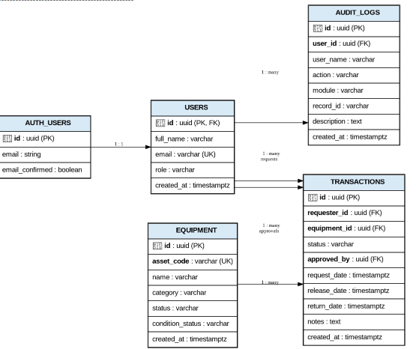

The auth.users table is managed by Supabase Authentication and contains the user's authentication information. The public.users table serves as the application's user profile table and uses the same UUID as the corresponding Auth account.
The application role is stored in public.users.role. A database trigger is configured to automatically create a corresponding user profile when a new Supabase Auth account is registered.

Use Case Diagram
flowchart LR

Admin([Administrator])
Staff([Laboratory Staff])
Requester([Requester / Viewer])
Auth([Supabase Auth])

Login((Sign in))
ViewEquipment((View equipment))
Borrow((Submit borrowing request))
Review((Approve or reject request))
Release((Release equipment))
Return((Process return))
Audit((View audit logs))
Manage((Manage equipment))
Test((Run functional tests))

Admin --> Login
Admin --> ViewEquipment
Admin --> Borrow
Admin --> Review
Admin --> Release
Admin --> Return
Admin --> Audit
Admin --> Manage
Admin --> Test

Staff --> Login
Staff --> ViewEquipment
Staff --> Borrow
Staff --> Release
Staff --> Return
Staff --> Test

Requester --> Login
Requester --> ViewEquipment
Requester --> Borrow
Requester --> Test

Login --> Auth

Borrow --> Audit
Review --> Audit
Release --> Audit
Return --> Audit
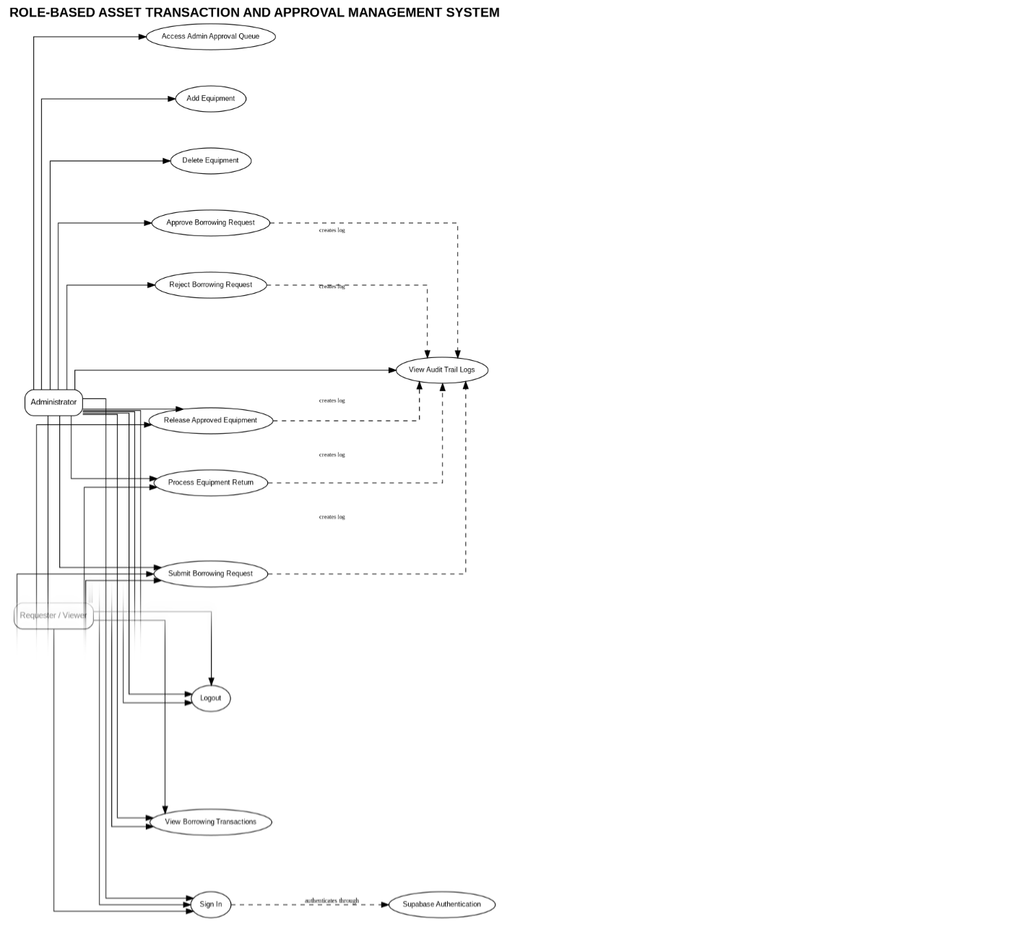

The use case diagram illustrates how each type of user interacts with the system. The Administrator has the highest level of access, while Laboratory Staff can manage operational borrowing and returning activities. Requesters can view available equipment and submit borrowing requests but cannot perform administrative actions.

4. Role-Permission Matrix
Permission / Action | Administrator | Laboratory Staff | Requester / Viewer
Sign in through Supabase Auth | Yes | Yes | Yes
View dashboard | Yes | Yes | Yes
View equipment catalog | Yes | Yes | Yes
Submit borrowing request | Yes | Yes | Yes
View borrowing transactions | Yes | Yes | Yes
Approve borrowing request | Yes | No | No
Reject borrowing request | Yes | No | No
Access Admin Approval Queue | Yes | No | No
Access Audit Trail Logs | Yes | No | No
Add equipment | Yes | No | No
Delete equipment | Yes | No | No
Release approved equipment | Yes | Yes | No
Process equipment return | Yes | Yes | No
Run functional test suite | Yes | Yes | Yes, when signed in
Logout | Yes | Yes | Yes
The role-permission matrix defines the access boundaries of the system. Administrative functions such as approval, rejection, equipment management, and audit-log access are restricted to the Administrator. Laboratory Staff are given operational permissions for releasing and returning equipment, while Requesters are limited to viewing equipment and submitting borrowing requests.
Supabase Auth is responsible for authentication and user identity. The application role is retrieved from the matching public.users profile.

5. Workflow Diagram
flowchart TD

A[User signs in] --> B{Auth account valid and confirmed?}

B -- No --> X[Display login error]
B -- Yes --> C[Load public.users role profile]

C --> D{Profile exists?}

D -- No --> Y[Display missing role profile error]
D -- Yes --> E[Open role-based dashboard]

E --> F[Select equipment]

F --> G{Equipment available?}

G -- No --> H[Reject request]
G -- Yes --> I[Create Pending transaction]

I --> J[Create SUBMITTED audit log]

J --> K{Administrator review}

K -- Reject --> L[Set status to Rejected]
L --> M[Create REJECTED audit log]

K -- Approve --> N[Set status to Approved]
N --> O[Create APPROVED audit log]

O --> P[Release equipment]

P --> Q[Set transaction to Released]
Q --> R[Set equipment status to Borrowed]

R --> S[Create RELEASED audit log]

S --> T[Process return]

T --> U[Set transaction to Returned]
U --> V[Set equipment status to Available]

V --> W[Create RETURNED audit log]
The workflow begins when a user signs in. The system first verifies the Supabase Auth account and checks whether the user's email has been confirmed. After successful authentication, the application loads the user's corresponding role profile from public.users.
Depending on the assigned role, the user is provided with the appropriate dashboard and available functions. Borrowing requests begin with a Pending status and require Administrator review before the equipment can be released.

6. Business Rules
ID | Business Rule
BR-A4-01 | Only equipment with an Available status may be requested.
BR-A4-02 | An approver cannot approve their own borrowing request.
BR-A4-03 | Only the Administrator may approve or reject borrowing requests.
BR-A4-04 | Only an Approved transaction may be released.
BR-A4-05 | Releasing equipment changes its status to Borrowed.
BR-A4-06 | Returning equipment changes its status to Available.
BR-A4-07 | A Rejected transaction cannot be released.
BR-A4-08 | A Returned or Closed transaction cannot be returned a second time.
BR-A4-09 | Equipment marked as Maintenance cannot be borrowed.
BR-A4-10 | Important system actions create an audit-log entry containing the actor, action, module, record, and timestamp.
BR-A4-11 | A user must have a confirmed Supabase Auth account and a matching public.users role profile.
BR-A4-12 | The public.users.id must match the UUID of the corresponding Supabase Auth user.
These business rules help maintain the integrity of the borrowing process and prevent unauthorized or invalid transactions.

7. Audit-Log Screenshot
The system provides an Audit Trail Logs module for monitoring important activities performed by users.
To generate the required evidence:
- Sign in using the Administrator account.
- Open Audit Trail Logs from the sidebar.
- Run the functional test suite to generate sample transaction and security activities.
- Return to Audit Trail Logs.
- Capture a screenshot showing the System Audit Logs table.
The audit table should contain information such as:
Timestamp | Actor | Action | Module | Record ID | Description
Current time | Administrator | APPROVED | Borrowing | Transaction ID | Approved borrowing request
Current time | Laboratory Staff | SUBMITTED | Borrowing | Transaction ID | Borrowing request submitted
Current time | Laboratory Staff | REJECTED / RESTRICTED | Security | Equipment ID | Unauthorized operation blocked
Current time | Requester | SUBMITTED | Borrowing | Transaction ID | Submitted equipment borrowing request
The exact timestamps and transaction IDs are generated dynamically by the application. Therefore, the screenshot should show the actual records generated during the demonstration rather than manually entered sample data.

8. Functional Test Results
The application contains a Test Suite (TC-01..10) module that allows the system's major functions and security restrictions to be tested.
The following test cases are expected to pass:
Test Case | Scenario | Expected Result | Result
TC-A4-01 | Requester attempts to access Admin Approval Queue | Access is denied | PASS
TC-A4-02 | Staff submits a borrowing request | Transaction is saved as Pending | PASS
TC-A4-03 | Administrator approves a request | Status becomes Approved and audit log is created | PASS
TC-A4-04 | Administrator rejects a request | Status becomes Rejected | PASS
TC-A4-05 | User attempts to release a rejected request | Operation is blocked | PASS
TC-A4-06 | Staff releases approved equipment | Transaction becomes Released and equipment becomes Borrowed | PASS
TC-A4-07 | Staff processes equipment return | Transaction becomes Returned and equipment becomes Available | PASS
TC-A4-08 | Verify audit log after approval | Approval audit entry exists | PASS
TC-A4-09 | Staff attempts restricted equipment deletion | Operation is blocked and logged | PASS
TC-A4-10 | User logs out and attempts to open a protected page | Access is blocked after logout | PASS

Execution Evidence
To produce the actual execution evidence, open the Test Suite page and select Execute All 10 Test Cases.
The application should display the individual test results using a PASSED [✓] indicator and provide a final success message when all ten scenarios have completed successfully.
A screenshot of the completed test suite should be included in the final laboratory documentation as proof of execution.

Supabase Setup Required Before Demonstration
Before demonstrating the application, the required accounts must be created through Supabase Authentication.
The following accounts should be available:
Email | Application Role
admin@gmail.com | Administrator
staff@gmail.com | Laboratory Staff
requester@gmail.com | Requester / Viewer
Each account must have:
- A valid Supabase Auth account.
- A confirmed email.
- A corresponding record in public.users.
- The correct application role.
- The same UUID in public.users.id as the UUID shown in Supabase Authentication.
For example:
Authentication → Users

admin@gmail.com
↓
UUID: [actual Auth UUID]
↓
public.users
↓
role: Administrator
The same process applies to the Laboratory Staff and Requester accounts.
Before the final demonstration, verify that all three accounts can successfully sign in and that the correct role-based dashboard is displayed.

Conclusion
The Role-Based Asset Transaction and Approval Management System demonstrates a complete laboratory equipment borrowing workflow supported by Supabase Authentication and a structured relational database.
The system applies role-based permissions to separate administrative, staff, and requester responsibilities. It also implements approval controls, equipment availability rules, release and return processes, and audit logging to provide accountability for important system activities.
The functional test suite provides additional evidence that unauthorized actions are blocked and that valid borrowing transactions follow the expected approval, release, and return workflow.

