**Library Cataloging**

**Bryan Fendley**

**3/18/2018**

**Table of Contents**

Introduction.................................................................................... 2

Audience........................................................................................ 2

Methods………………………………….......................................... 2

Importance of Organization in the library........................................3

Different Types of Library Cataloging............................................ 3

Paper vs Digital............................................. ………………………3

Conclusion..................................................................................... 4

Appendix A..................................................................................... 5

Appendix B..................................................................................... 6

Appendix C..................................................................................... 7

Works Cited................................................................................... 8

**Introduction**

Library cataloging is what creates the fine line between a collection of books and a library. Cataloging provides organization that makes books not only easy to find, but sorts them to help readers find books relevant to their previous searches. There are multiple systems that are used to organize libraries, but they all put books into sections so that the library patron may find them with ease.

These organization techniques help the librarian tell exactly where a patron can find a book. If the patron can find one book they can learn the system and find the books themselves. This creates an efficient library. These systems also help keep track of lost books as there will be an obvious gap within books.

What good would a library be if all of the books were randomly placed around? These cataloging systems get the books down into very specific sections. For instance in one library I worked in, there was an entire shelf of just nonfiction books about sea turtles. This was possible due to the cataloging systems narrowing them down for the ease of the user.

**Audience**

The audience for library cataloging is either the librarian or patrons of the library. It is used differently by both parties. The librarian will use these cataloging systems to create an efficient library. They do not want patrons sitting all day lost trying to find a book. They want to let someone get the information they need as fast as they can so that the next person may access the book. The librarian will also use this system to make sure books are where they should be and not missing.

The patron will use this system to locate books to use and may need help navigating the system. This plays off of the librarians role as they use the systems to keep track of books and make sure they are easy to find by the patrons. The patron may not pay as much attention to the systems as the librarian, but that is because the systems are meant to be maintained in a smooth and easy fashion.

**Methods**

The majority of my gathering of data for this genre was actually done over the past few years. I had spent my high school career infatuated with the library. I began volunteering my time there and learning how it worked. That library was organized using the Dewey Decimal System. When I began college at UALR I spent some time working in the Ottenheimer library on campus. This library was organized using the Library of Congress system. These experiences working in multiple libraries heavily influenced the content of this genre analysis. I also am going to school for information science so this is something delving into the career field of organization that I am going into. I also spent time online researching how other libraries organized their books and I figured out that they are usually done the same throughout all libraries.

**Importance of Organization in the Library**

If the library was not organized well the users would not be able to utilize it properly. Patrons do not have time to spend searching aimlessly for a book. They need information and they need it reasonably fast. These cataloging systems are implemented so that the user may locate a book within minutes and also find related topics nearby. A library is just a useless collection of books without organization.

**Different Types of Library Cataloging**

The two most popular cataloging systems used in libraries are the Dewey Decimal System and the Library of Congress System. They are each divided into subsections so that books of a similar subject will be within reach of each other. The Library of congress system gets more specific though, and Dewey Decimal is often criticized for having long drawn out call numbers. While each one has shortcomings, individuals quite often swear by one or the other. Both of these call numbers are represented on a catalog card though. A catalog card is used to keep track of books in the library.

**Paper VS Digital Catalog Cards**

Catalog cards used to be a physical piece of paper used to keep track of books in a library. This system was effective in keeping track of books that were already there, but adding new books was often a problem. This was changed during the upbringing of the digital age. The digital age of catalog cards are easy to add or take books away from the collection. The cards are a quick at a glance system for either the librarian or now the patron to search and find a reference number. This reference number is what connects the card to the organization systems such as Library of Congress or Dewey Decimal. The change in physical to digital cards is just another part of the library trying to be as efficient as possible.

**Conclusions**

Library cataloging is the use of organization systems to create an efficient library. A library is a place where information is stored and available to the public. Without cataloging a library would be a disorganized mess. If a library was a mess the patrons would not be able to properly utilize it to gather information. The organization techniques are not just for the patrons use, but the librarians. These techniques allow the librarian to keep track of books and make sure nothing is lost or stolen. There are catalog cards, whether digital or paper, that are used to locate the books based on their call number. A library is nothing without the ability to quickly locate the information.

**Appendix A**

**An example of a catalog card:**

These cards are used to locate books quickly. They contain both Library of Congress call numbers and Dewey Decimal System numbers. They also contain basic information on the book and author. These cards were paper for along time, but now they are often times found in digital format to make adding or taking away books quicker and more efficient.

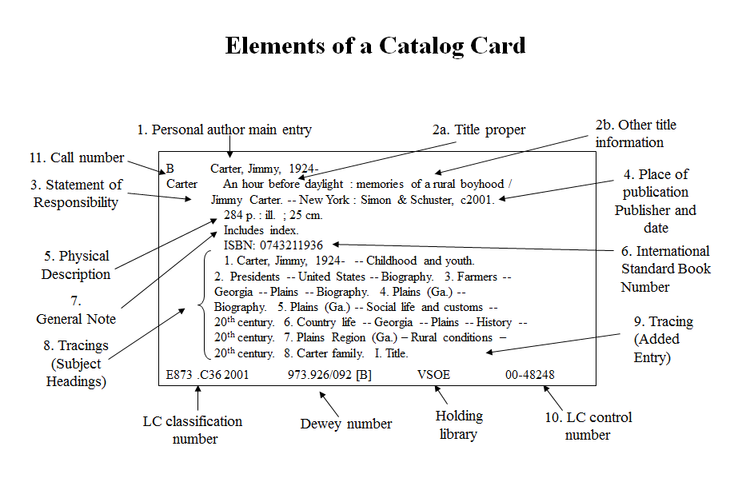

**Appendix B**

**An example of the Dewey Decimal System:**

The Dewey Decimal System is used to organize books under a specific library. It narrows sections down into subsections until they are specific enough to contain a certain book. It is often criticized for its long call numbers, but it is praised for its ability to narrow certain sections down to such specific things.

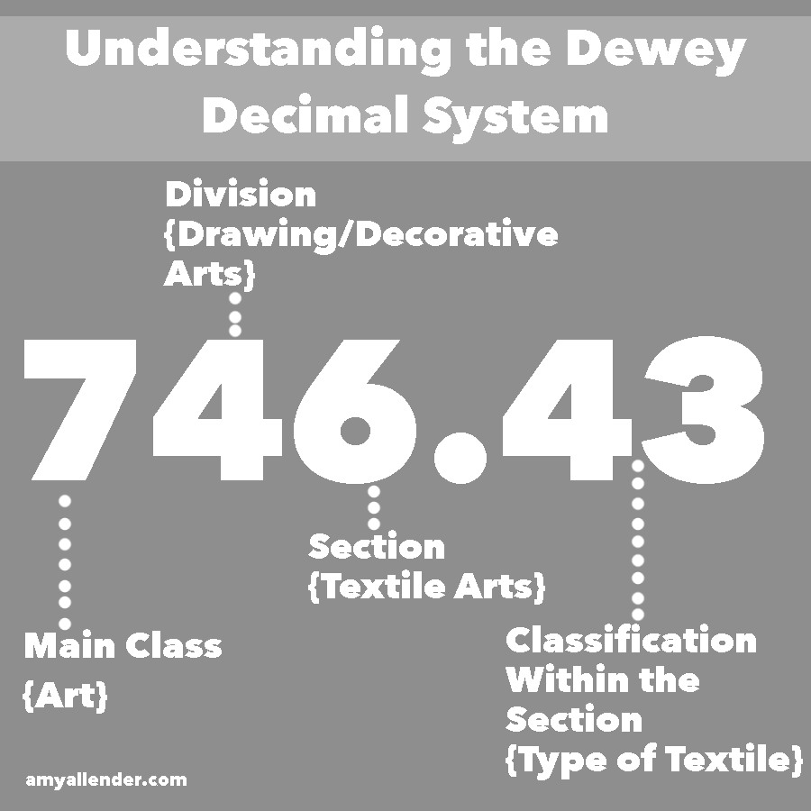

**Appendix C**

**An example of the Library of Congress System:**

The Library of Congress system in my experience is the more useful system. It allows for new books to be added into it such as computers which the Dewey Decimal System places in the general category. The Library of Congress system allows for a more specific narrowing down of the subject before the book is found.

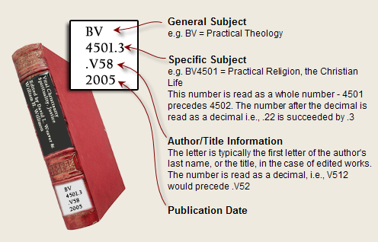

Works Cited

“KSU Library System FAQs.” *KSU Library System FAQs - Ask-A-Librarian*, libanswers.kennesaw.edu/collectiondev/faq/198173.

“University of Saskatchewan Student Assistant Resource Guide: Chart with Examples.”*Library Research Guides*, libguides.usask.ca/c.php?g=16552&p=2695220.

*The Library of Congress Classification System (LC)*, [www.usg.edu/galileo/skills/unit03/libraries03_04.phtml](http://www.usg.edu/galileo/skills/unit03/libraries03_04.phtml).

*Study.com*, Study.com, study.com/articles/Dewey_Decimal_System_vs_Library_of_Congress_Whats_the_Difference.html.

“Posts about Dewey Decimal Classification on ‘The Library, and Step on It.’” *"The Library, and Step on It"*, thelibraryand.wordpress.com/tag/dewey-decimal-classification/.