kitchen 1

# Kitchen

Stylish kitchen modernization for a rental unit

## Before

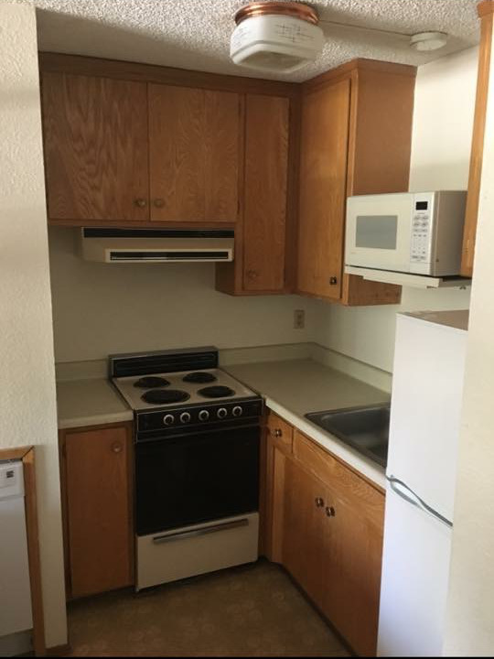

Kitchen

Fields Construction was asked to change out the appliances and maximize storage capacity for this small apartment kitchen.

## After

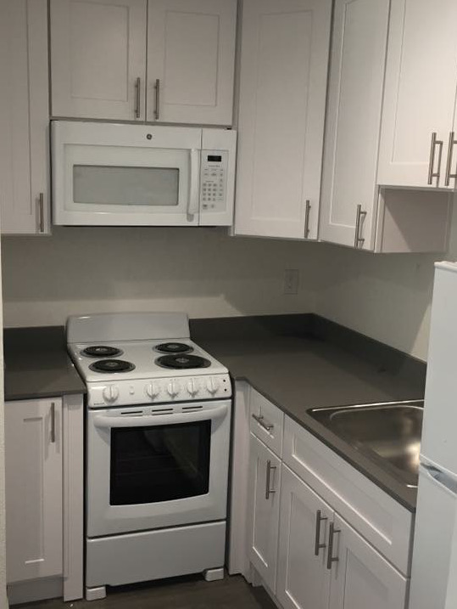

Kitchen

Italian stone counter-tops and solid plywood cabinets. This kitchen is built to last and stay in style for years to come. recessed can light (not pictured). Luxury vinal plank flooring that is easy to replace if damaged.