Current pulse on oscilloscope with data-rate 300 kbps.

Region A: MCU off, radio off.
Region E: MCU on, radio off.
Region F: MCU on, radio on (radio being initialized).
Region G: MCU on, radio on (radio transmitting).
Region H: MCU on, radio off.
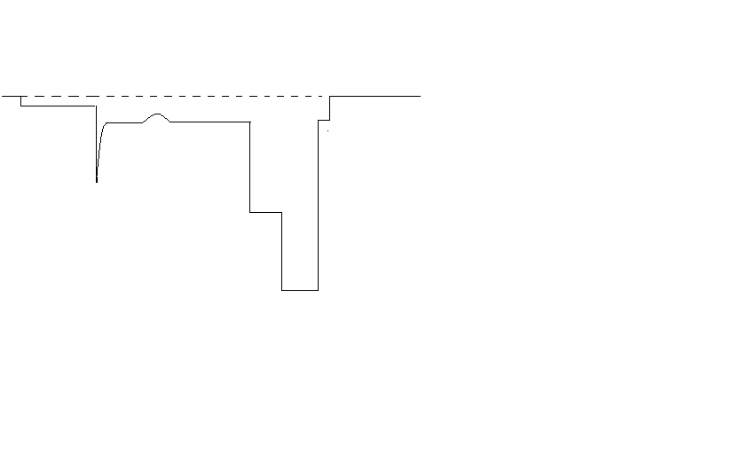
0.8 mV
GND
11 mV
4 mV
2 mV
10 mV
20 mV
4 mV
A
B
C
D
E
F
G
H

Data transmitted 160 bits + overhead 90 bits. System clock – 1.5 MHz.

Data transmitted 16 bits + overhead 90 bits. System clock – 1.5 MHz.

E | 1.1 ms
F | 800 us
G | 325 us

Data transmitted 160 bits + overhead 90 bits. System clock – 6 MHz.
A
B | 40 us
C | 100 us
D | 100 us
E | 4.2 ms
F | 800 us
G | 775 us
H | 285 us

E | 1.28 ms
F | 800 us
G | 775 us

Data transmitted 16 bits + overhead 90 bits. System clock – 6 MHz.

E | 512 us
F | 800 us
G | 325 us

