Exercise 4 : Personas and Scenarios

|  |  |  |  |
| --- | --- | --- | --- |
| Weather/News Website by customer characteristics, by group | | | |
| User Characteristics | Teens - Young Adults | Young adult - middle age | Middle age to senior citizen |
| Age | 15-25 | 25-50 | 50-80+ |
| Sex | Both male and female | Both male and female | Both male and female |
| Computer/ IT Use | Will have the highest degree of computer and internet use and experience. | Will have limited amount of computer and internet use and experience. | May have little or no prior computer or internet experience. |
| Educational Background | May have minimal or some of minimal educational qualifications. | May have only minimal educational qualifications. | May have only minimal educational qualifications. |
| Attitude | Attitudes may vary but lean towards the most forgiving in site design due to highest chance of knowledge. | Attitudes may vary but lean towards being in the middle by being forgiving but still get frustrated with overly complicated sites. | Attitudes may vary but lean to getting quicker to get frustrated or judge based off of single use. |
| Motivation | Mostly liking motivated to determine weather for or school closings for the day. | Could be motivated to find weather or stay up to date on global and local news | Most likely reading in free leisure time, may prefer newspapers. |
| Physical Capabilities | Limitations may vary among group; sight limitations will be most prevalent | Limitations may vary among group; sight limitations will be most prevalent | Limitations may vary among group; sight limitations will be most prevalent |

**Scenario**

Lead: Brianna Jones

Jennifer Dorian is a 27 year old is a certified X-ray technician. After years of work and classes Jennifer has her dissertation review at 11am today. Unfortunately she overslept and is now rushing to make it to her review in a timely manner. The review is held downtown, a 30 minute drive from her home. Like normal days for Jennifer she does not have time to waste sitting in traffic or fumble with her clothes. Jennifer sits down on her laptop in her bedroom and goes to one of 13WHAM Rochester’s website. After struggling with the site for 45 seconds and having trouble finding the navigation to the traffic cams she proceeds to the most reliable source for real time traffic updates with image cams to find the quickest path to her dissertation review downtown. Jennifer then moves to her closet but remembers from the traffic cams that is looked decently warm outside and realizes it may be too hot to wear her desired outfit. Jennifer then goes to the Rochester weather/news site on her iPhone and takes two clicks on the fast and fluid interface to find the weather section to find out the the it will be 80 degrees and decides that it would be for the best if she chose a lighter attire. Thanks to the new and improved Rochester weather/news sit Jennifer gets to her dissertation on time without an traffic setbacks in her weather conscious professional dress.

**Personas**

**(leads: Caityln, Brett, and Alexander)**

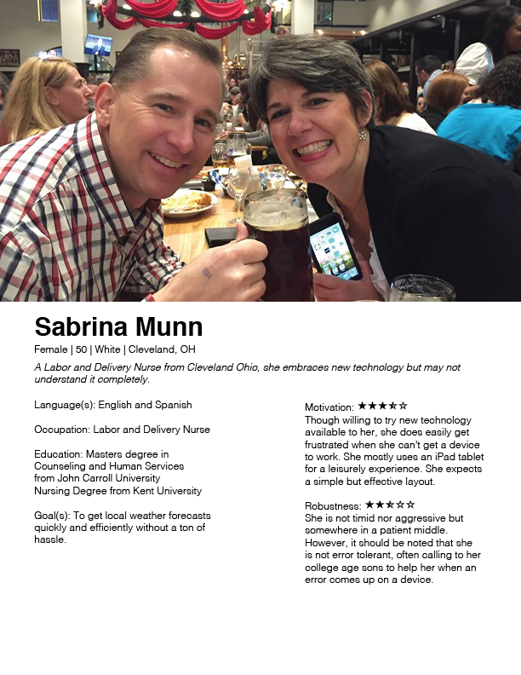

Middle Age to Senior Citizen Persona

Lead: Caitlyn Orta

Source Photo: Personal Facebook

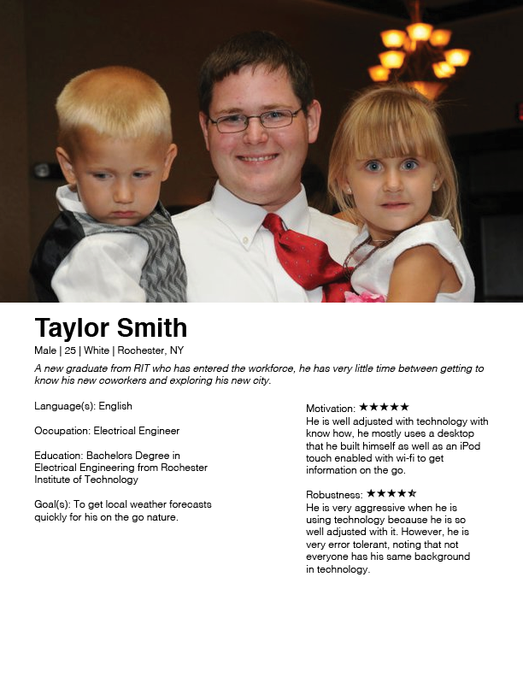

Young Adult to Middle Age Persona

Lead: Caitlyn Orta

Source Photo: Personal Facebook



Teens-Young Adults Persona

Lead: Brett Mace

Source Photo: <https://www.flickr.com/photos/jbhonig/6261290269/>

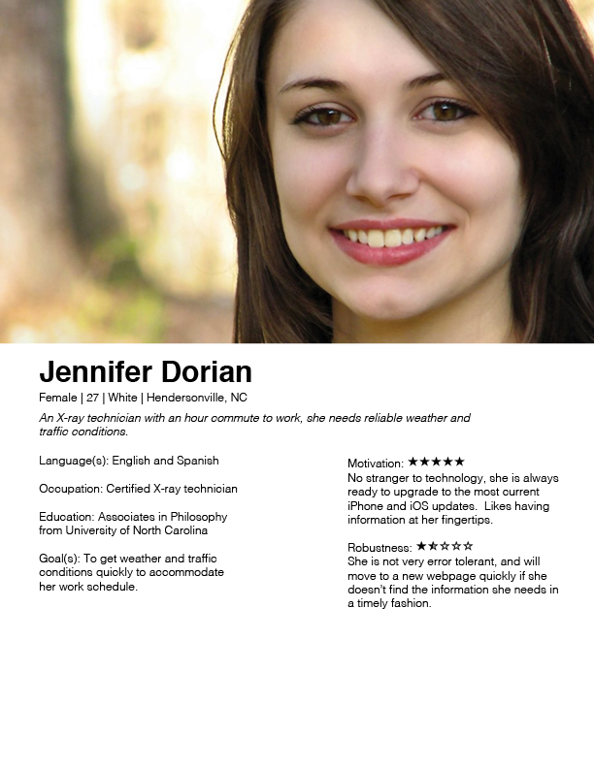

Young Adult to Middle Age Persona

Lead: Alex Murtha

Source Photo:

<http://res.freestockphotos.biz/pictures/11/11248-close-up-portrait-of-a-beautiful-girl-posing-outdoors-pv.jpg>