Interaction Scenario #1

Character: Sabrina Munn the Labor and Delivery Nurse

I have just gotten off of work at the Fairview Hospital, and am going to head home for the night. I’m trying to decide whether I want to leave my jacket in the office. I realize, I do not know the weather outside because I have not been by windows all day. I head over to my desk and pull out my iPad from my purse. I get on the Safari app and head to the Rochester Weather/News site. Once there, I look at the navigation system on the top of the page and search for the weather tab. I find it easily, and click on it to take me to the weather page. I see the that the temperature is 65 degrees with a 35% chance of rain. I decide that I am going to leave my jacket in the office if it will not be raining when I come in the next morning. I click on the ‘show weekly forecast’ link below the daily forecast, and the daily forecast shifts to the weekly forecast showing me the estimated weather and precipitation percentages. While this shows me the chance of rain for the day, I want to know the chance of rain for the morning around 9am. I click on the ‘show daily forecast’ link that has taken place of the ‘show weekly forecast’ link which turns it back to the information I was originally at. I scroll down on the daily forecast and see the hourly forecast for the next 24 hours. I can easily swipe to the left and see the hours transition through time until I get to 9am where I see the temperature and precipitation percentage which is 70 degrees and 40% chance of rain. I lock my iPad and put it back in my purse and head out of the office leaving my jacket behind.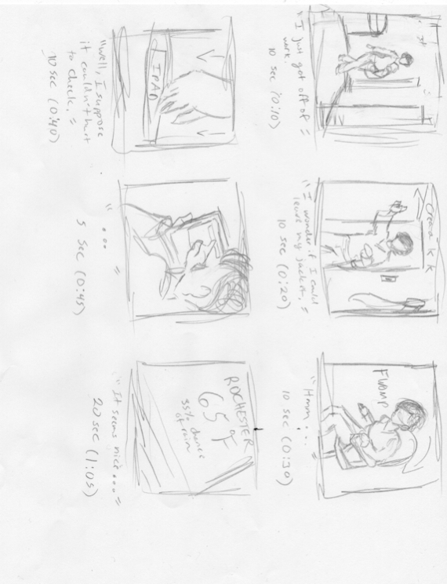

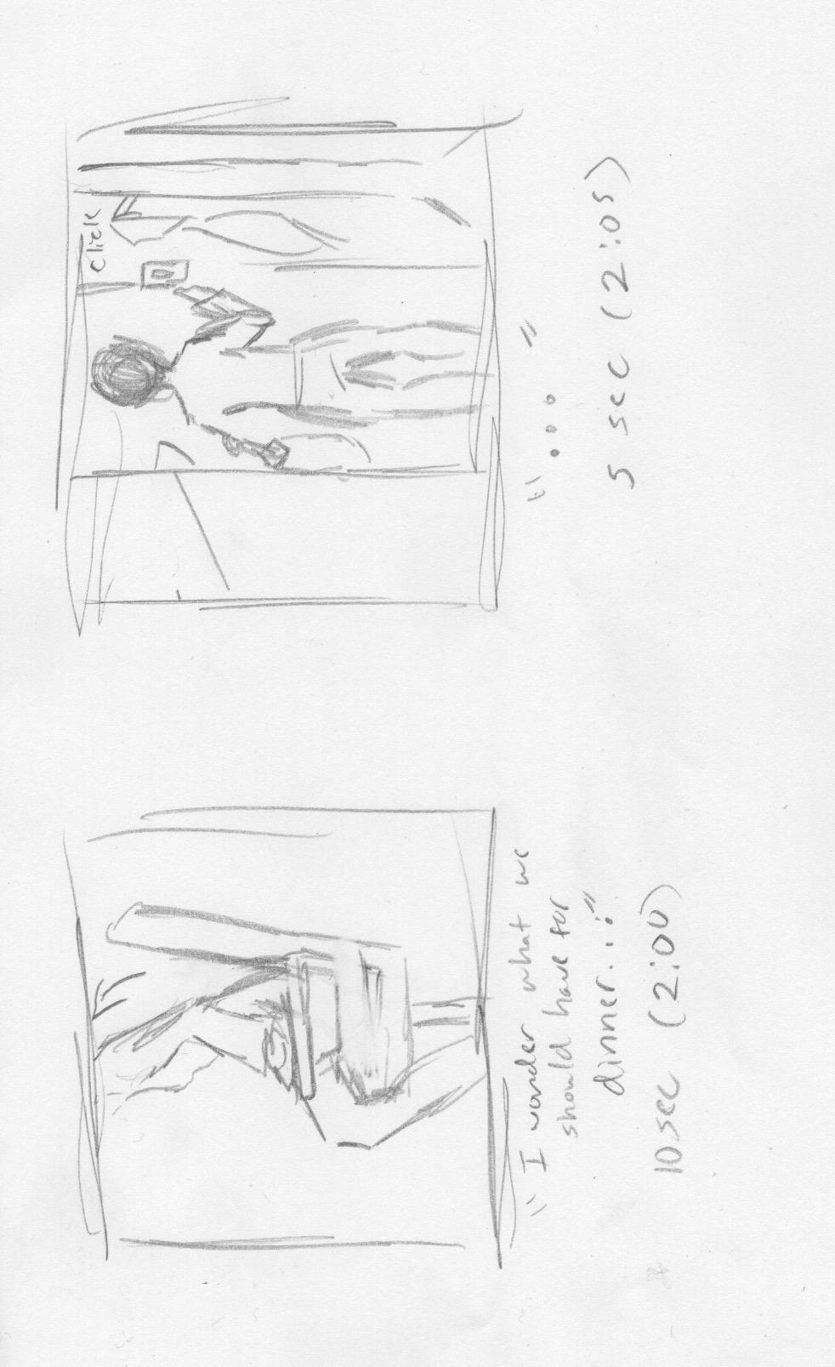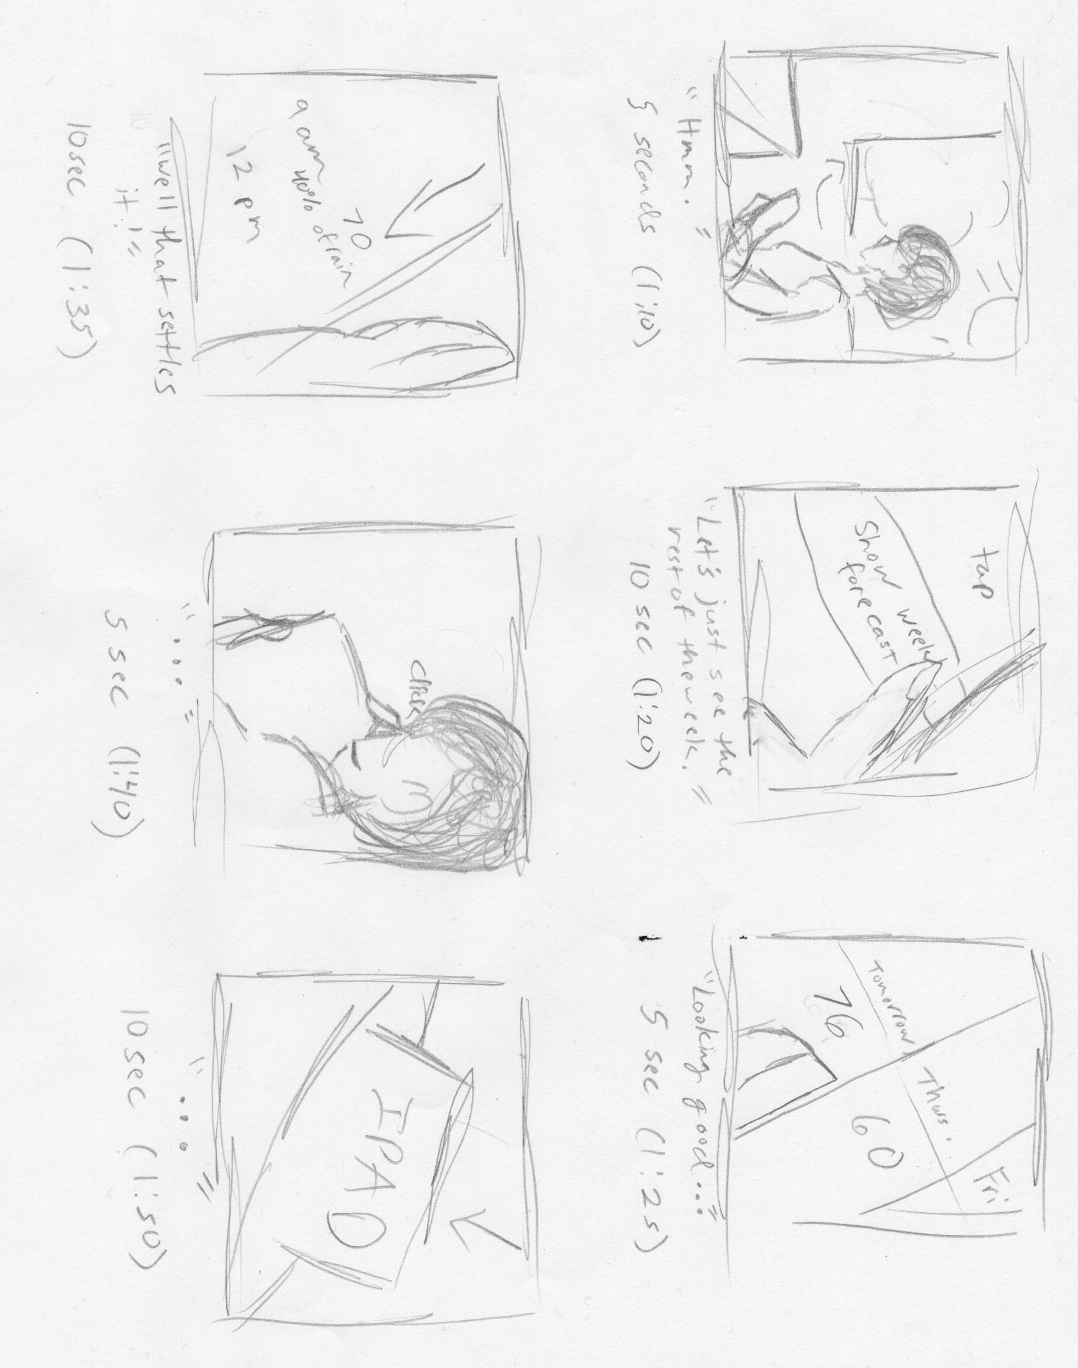

Interaction Scenario #2

Character: Taylor Smith - Electrical Engineer

I wake up at 7:15 AM, ready to start my day. I have an on site consult in Webster, New York where a data center is being developed. I need to get the kids ready to go to daycare, and while I’m getting their outfits for the day, I need to check the current traffic conditions so I’m not late for the site visit. With the kids dressed, I turn on the TV to some cartoons to keep them occupied while I check the Rochester weather/News website. I navigate to the page using Google Chrome, and browse the top navigation bar links for traffic. After I click on the ‘traffic’ link, I’m brought to main traffic page. From here I can view live cameras of the highway, or view a map of the Rochester area which has markers denoting where there is construction. Under the map there are also links showing any noteworthy traffic incidents. I click on a live camera link that displays Route 590 where it merges with Route 390, and Route 490. The footage from the camera shows that the area is quite busy, so I better get the kids to daycare a little earlier than usual. I close the camera, and scroll down past the map to check the traffic incidents. I click on the ‘Traffic Incidents’ link and am brought to a simple list page showing any accidents in the area. I scroll through the list for a few seconds, and notice that there haven’t been any reported accidents within the last few hours, so I feel confident that I will be on schedule for the site visit. I logout, lock my computer, and leave with the kids to daycare.

Storyboard for Information Scenario 2: