**Problem 1.**

%%%%%%%%%%%%%%%%%%%%%%%%%%%%%%%%%%%%%%%%%%%%%%%%%%%%%%%%%%%%%%%%%%%%%%%%%%%%%%%%

%%% compute the numerical solution using CDS convection and CDS diffusion %%%

function numerical_1d_cds

% compute the numerical solution of the steady, linear, 1D convection-diffusion

% problem at each grid point using a finite-difference method

% with CDS convection and CDS diffusion

% Call global variables needed by this function

global phil phir np1 n den vel dif x

global aw ap ae q phi

% global variables set by this function

global phicds Pe

% Apply BCs

phicds(1) = phil;

phicds(np1) = phir;

% compute product of density and velocity

denvel = den*vel;

% loop over interior grid points (i = 2 to i = n)

for i = 2:n

% CDS convection contributions

awc = -denvel / ( x(i+1) - x(i-1) ); % West coefficient

aec = denvel / ( x(i+1) - x(i-1) ); % East coefficient

apc = 0; % Coefficient at point

% CDS diffusion contributions (unchanged)

%dxr = 2.*dif / ( x(i) - x(i-1) ); %

awd = -dif / ( (x(i) - x(i-1))*(x(i+1) - x(i-1))/2 ); % West coefficient

aed = -dif / ( (x(i+1) - x(i-1))*(x(i+1) - x(i))/2 ); % East coefficient

apd = 2*dif / ( (x(i) - x(i-1))*(x(i+1) - x(i)) ); % Coefficient at point

% fill row i coefficient matrix and right-hand-side values

aw(i) = awc + awd;

ae(i) = aec + aed;

ap(i) = apc + apd;

q(i) = 0.;

end

% take care of the boundary conditions

i = 2;

q(i) = q(i) - aw(i)*phicds(i-1);

aw(i) = 0.;

i = n;

q(i) = q(i) - ae(i)*phicds(i+1);

ae(i) = 0.;

phi(1) = phicds(1);

phi(np1) = phicds(np1);

%--- solve for phi using the TDMA direct solver ---

tdma;

% copy the solution from phi to phicds

for i=2:n

phicds(i) = phi(i);

end

end

%%% end of numerical_1d_cds %%%

%%%%%%%%%%%%%%%%%%%%%%%%%%%%%%%%%%%%%%%%%%%%%%%%%%%%%%%%%%%%%%%%%%%%%%%%%%%%%%%%

%%% compute errors of the numerical solutions wrt/the analytic solution %%%

function errors

% compute differences between two numerical solutions and the analytic solution

# global inputs to this function

global phicds phiuds phian

# global outputs to this function

global errcds erruds

erruds = abs(phian - phiuds); % compute error in uds solution

errcds = abs(phian - phicds); % compute error in cds solution

end

%%% end of errors %%%

%%%%%%%%%%%%%%%%%%%%%%%%%%%%%%%%%%%%%%%%%%%%%%%%%%%%%%%%%%%%%%%%%%%%%%%%%%%%%%%%

%%% generate figures %%%

function figures

% plot the analytic solution and two numerical solutions as functions of x

% plot errors between two numerical solutions and the analytic solution

% as functions of x

% save both figures to the current working directory as .png files

global x phian phiuds phicds erruds errcds

% Make figure for phi vs x for analytical, UDS, and CDS solutions

figure(1) % Create Figure "1"

% Plot Phi_analytic vs x with black line

% Plot Phi_UDS vs x with dash-dot blue line

% Plot Phi_CDS vs x with dotted red line

p = plot(x, phian, 'k', x, phiuds, 'b-.', x, phicds, 'r:');

set(p, 'linewidth', 3) % Set line thickness to 3

xl = xlabel('x'); yl = ylabel('\phi'); % Add axis labels

% Add legend and specify its location

l = legend('Analytic', 'UDS1', 'CDS2', 'location', 'northwest');

% Increase font size of plot elements

set([gca, l, xl, yl], 'fontsize', 16);

figure(1, 'position', [50 50 600 450])

saveas(1,'hw2_figure1.png'); % Save figure to file "hw2_figure1.png"

close(1) % Close the figure

% Make figure for |error| vs x for UDS and CDS solutions

figure(2) % Create Figure "2"

p = plot(x, erruds, 'b-.', x, errcds, 'r:');

set(p, 'linewidth', 3) % Set line thickness to 3

xl = xlabel('x'); yl = ylabel('|Error|');

% Add legend and specify its location

l = legend('UDS1', 'CDS2', 'location', 'northwest');

% Increase font size of plot elements

set([gca, l, xl, yl], 'fontsize', 16);

figure(2, 'position', [650 50 600 450])

saveas(2,'hw2_figure2.png'); % Save figure to file "hw2_figure2.png"

close(2) % Close the figure

end

%%% end of figures %%%

%%%%%%%%%%%%%%%%%%%%%%%%%%%%%%%%%%%%%%%%%%%%%%%%%%%%%%%%%%%%%%%%%%%%%%%%%%%%%%%%

%%% write an output file %%%

function outfile

% write an ascii text output file

% echoes input parameters and key derived quantitites,

% and generates six columns of output for each grid point:

% x phian phiuds phicds erruds errcds

% Call global variables needed to state at top of text file

global xmin xmax den vel dif phil phir n dxrat dxmin dxmax pe pedxmin pedxmax

% Call global variables needed for table

global x phian phiuds phicds erruds errcds

% Name output file and open it

outfile = 'hw2_results.txt'

fid = fopen(outfile, 'w'); % Open a file to store results

% Print each variable in nice formatting

fprintf(fid, 'Input quantities:\n')

fprintf(fid, '%8s = %12.6f\n', 'xmin', xmin)

fprintf(fid, '%8s = %12.6f\n', 'xmax', xmax)

fprintf(fid, '%8s = %12.6f\n', 'den', den)

fprintf(fid, '%8s = %12.6f\n', 'vel', vel)

fprintf(fid, '%8s = %12.6f\n', 'dif', dif)

fprintf(fid, '%8s = %12.6f\n', 'phil', phil)

fprintf(fid, '%8s = %12.6f\n', 'phir', phir)

fprintf(fid, '%8s = %12.6f\n', 'n', n)

fprintf(fid, '%8s = %12.6f\n', 'dxrat', dxrat)

fprintf(fid, '\nDerived quantities:\n')

fprintf(fid, '%8s = %12.6f\n', 'dxmin', dxmin)

fprintf(fid, '%8s = %12.6f\n', 'dxmax', dxmax)

fprintf(fid, '%8s = %12.6f\n', 'pe', pe)

fprintf(fid, '%8s = %12.6f\n', 'pedxmin', pedxmin)

fprintf(fid, '%8s = %12.6f\n', 'pedxmax', pedxmax)

% Print header

fprintf(fid, '\nTabulated results:\n')

fprintf(fid, '\n%3s,%12s,%12s,%12s,%12s,%12s\n',...

'x', 'phian', 'phiuds', 'phicds', 'erruds', 'errcds')

% Print results one line at a time

for i = 1:length(phian)

fprintf(fid, '%3.2f,%12.6e,%12.6e,%12.6e,%12.6e,%12.6e\n',...

x(i), phian(i), phiuds(i), phicds(i), erruds(i), errcds(i))

end

fclose(fid); % Close the file

end

%%% end of outfile %%%

**Problem 2.**

Problem

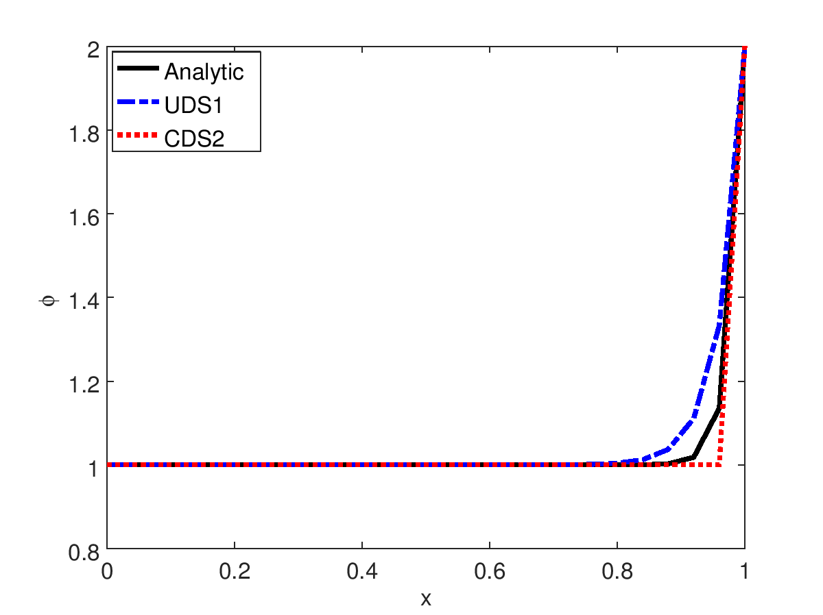P

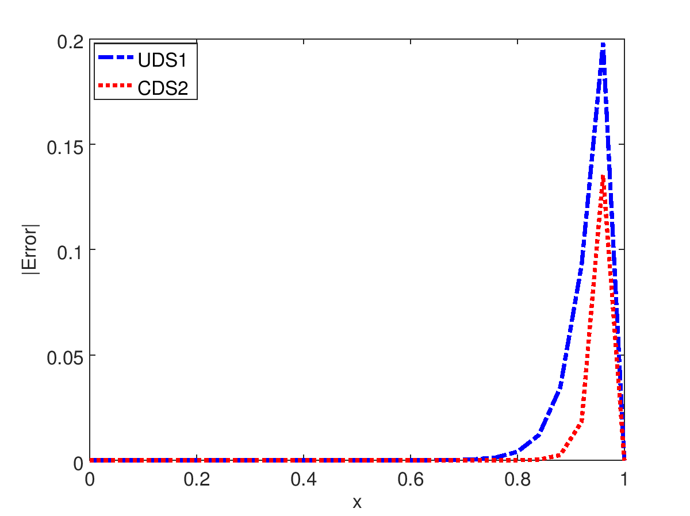

**Output in text file:**

Input quantities:

xmin = 0.000000

xmax = 1.000000

den = 1.000000

vel = 10.000000

dif = 0.200000

phil = 1.000000

phir = 2.000000

n = 25.000000

dxrat = 1.000000

Derived quantities:

dxmin = 0.040000

dxmax = 0.040000

pe = 50.000000

pedxmin = 2.000000

pedxmax = 2.000000

Tabulated results:

x, phian, phiuds, phicds, erruds, errcds

0.00,1.000000e+000,1.000000e+000,1.000000e+000,0.000000e+000,0.000000e+000

0.04,1.000000e+000,1.000000e+000,1.000000e+000,2.360556e-012,0.000000e+000

0.08,1.000000e+000,1.000000e+000,1.000000e+000,9.441781e-012,0.000000e+000

0.12,1.000000e+000,1.000000e+000,1.000000e+000,3.068612e-011,1.110223e-016

0.16,1.000000e+000,1.000000e+000,1.000000e+000,9.441870e-011,1.110223e-016

0.20,1.000000e+000,1.000000e+000,1.000000e+000,2.856166e-010,2.220446e-016

0.24,1.000000e+000,1.000000e+000,1.000000e+000,8.592111e-010,3.330669e-016

0.28,1.000000e+000,1.000000e+000,1.000000e+000,2.579994e-009,8.881784e-016

0.32,1.000000e+000,1.000000e+000,1.000000e+000,7.742342e-009,2.331468e-015

0.36,1.000000e+000,1.000000e+000,1.000000e+000,2.322938e-008,1.321165e-014

0.40,1.000000e+000,1.000000e+000,1.000000e+000,6.969045e-008,9.403589e-014

0.44,1.000000e+000,1.000000e+000,1.000000e+000,2.090733e-007,6.920020e-013

0.48,1.000000e+000,1.000001e+000,1.000000e+000,6.272192e-007,5.109579e-012

0.52,1.000000e+000,1.000002e+000,1.000000e+000,1.881637e-006,3.775147e-011

0.56,1.000000e+000,1.000006e+000,1.000000e+000,5.644749e-006,2.789471e-010

0.60,1.000000e+000,1.000017e+000,1.000000e+000,1.693303e-005,2.061154e-009

0.64,1.000000e+000,1.000051e+000,1.000000e+000,5.079003e-005,1.522998e-008

0.68,1.000000e+000,1.000152e+000,1.000000e+000,1.523033e-004,1.125352e-007

0.72,1.000001e+000,1.000457e+000,1.000000e+000,4.564158e-004,8.315287e-007

0.76,1.000006e+000,1.001372e+000,1.000000e+000,1.365598e-003,6.144212e-006

0.80,1.000045e+000,1.004115e+000,1.000000e+000,4.069826e-003,4.539993e-005

0.84,1.000335e+000,1.012346e+000,1.000000e+000,1.201022e-002,3.354626e-004

0.88,1.002479e+000,1.037037e+000,1.000000e+000,3.455828e-002,2.478752e-003

0.92,1.018316e+000,1.111111e+000,1.000000e+000,9.279547e-002,1.831564e-002

0.96,1.135335e+000,1.333333e+000,1.000000e+000,1.979981e-001,1.353353e-001

1.00,2.000000e+000,2.000000e+000,2.000000e+000,0.000000e+000,0.000000e+000

Problem 2 Discussion: The analytical solution resulted in the expected shape for a high Peclet number. Both approximations were able to capture the same shape as the analytical solution within some error. In both approximations, the largest errors were near x = 0.95, where the slope of the analytical solution is steepest. The CDS2 approximation had lower error than the UDS1 at all points, especially near x = 0.95.

**Problem 4.**

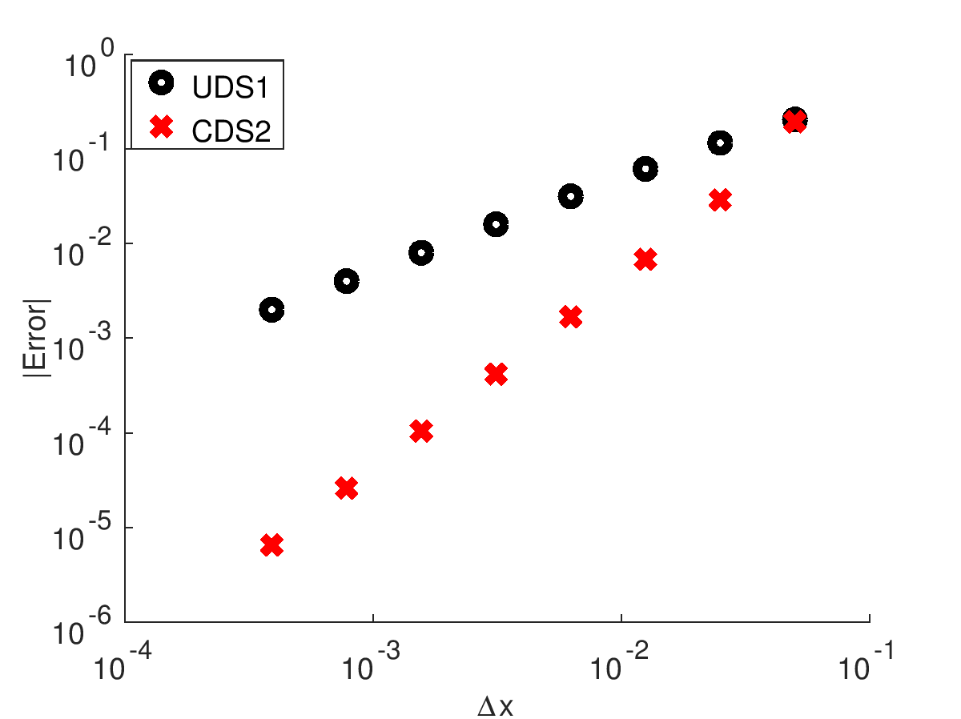

**For UDS1, P = 0.9957**

**For CDS2, P = 2.0004**

Problem 4 Discussion:

**Problem 5.**

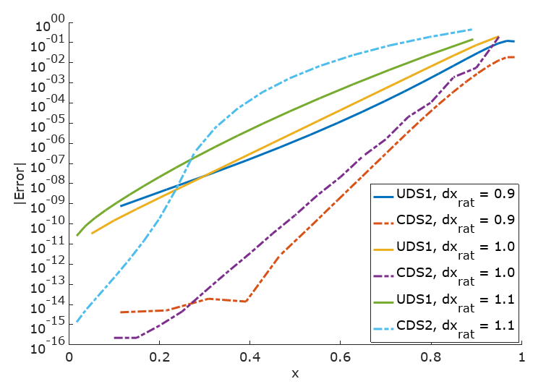

Problem 5 Discussion: