**Problem 1.**

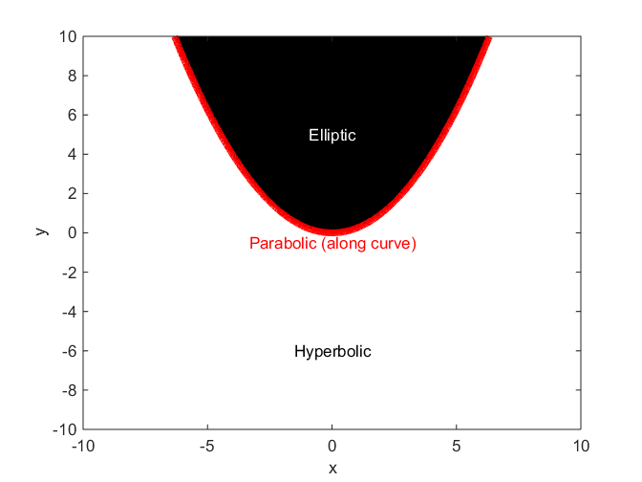

%{

Brian Knisely

ME523, HW1, P1

The purpose of this code is to determine the regions in space in which a

PDE is characterized as elliptic, parabolic, or hyperbolic

Given PDE is

u_xx + x*u_xy + y*u_yy = 0

Typical format is

a*u_xx + b*u_xy + c*u_yy = f

Character determined by value of b^2 - 4*a*c

%}

clear; close all; format compact; home;

x = -10:0.01:10; % Range of x

y = -10:0.01:10; % Range of y

[b, c] = meshgrid(x, y);

% make mesh grid for x, y locations and define coefficients b and c

a = 1; % Set first coefficient equal to 1

ch = b.^2 - 4.*a.*c; % Compute value of character at every x-y location

v = [-100,0,200]; % Set contour levels (so the plot has distinct regions)

contourf(b, c, ch, v, 'linewidth',6,'linecolor','r'); colormap gray

% Plot filled contour in b, c (x, y) space with character as z-values

xlabel('x'); ylabel('y'); % Label axes

text(0, 5, 'Elliptic', 'horizontalAlignment', 'center', 'color', 'w');

text(0, -0.5, 'Parabolic (along curve)', ...

'horizontalAlignment', 'center', 'color', 'r');

text(0, -6, 'Hyperbolic', 'horizontalAlignment', 'center', 'color', 'k');

% Add text to plot to show regions