**Problem 3.**

Output from code:

i | h | Error:FDS1 | Error:BDS1 | Error:CDS2 | Error:FDS3 | Error:BDS3 | Error:CDS4

1, 2.00000e+00,-5.15286e-01, 8.37611e-01, 1.61162e-01,-2.21578e-01, 4.17056e-01, 9.77388e-02

2, 1.00000e+00,-3.92317e-01, 4.86015e-01, 4.68485e-02,-5.85506e-02, 7.60385e-02, 8.74393e-03

3, 5.00000e-01,-2.21739e-01, 2.46060e-01, 1.21603e-02,-8.94686e-03, 1.01421e-02, 5.97608e-04

4, 2.50000e-01,-1.15728e-01, 1.21865e-01, 3.06873e-03,-1.19284e-03, 1.26922e-03, 3.81939e-05

5, 1.25000e-01,-5.88618e-02, 6.03998e-02, 7.68983e-04,-1.52686e-04, 1.57487e-04, 2.40048e-06

6, 6.25000e-02,-2.96522e-02, 3.00369e-02, 1.92358e-04,-1.92735e-05, 1.95740e-05, 1.50239e-07

7, 3.12500e-02,-1.48778e-02, 1.49740e-02, 4.80966e-05,-2.41976e-06, 2.43854e-06, 9.39324e-09

8, 1.56250e-02,-7.45139e-03, 7.47544e-03, 1.20246e-05,-3.03094e-07, 3.04268e-07, 5.87129e-10

9, 7.81250e-03,-3.72876e-03, 3.73477e-03, 3.00618e-06,-3.79246e-08, 3.79980e-08, 3.66953e-11

10, 3.90625e-03,-1.86514e-03, 1.86664e-03, 7.51546e-07,-4.74289e-09, 4.74751e-09, 2.30260e-12

11, 1.95313e-03,-9.32758e-04, 9.33133e-04, 1.87887e-07,-5.93073e-10, 5.93268e-10, 9.75886e-14

12, 9.76563e-04,-4.66426e-04, 4.66520e-04, 4.69717e-08,-7.41683e-11, 7.42688e-11, 3.12528e-14

13, 4.88281e-04,-2.33225e-04, 2.33248e-04, 1.17430e-08,-9.17738e-12, 9.27780e-12, 5.01821e-14

14, 2.44141e-04,-1.16615e-04, 1.16621e-04, 2.93577e-09,-9.91929e-13, 1.13021e-12, 6.91669e-14

15, 1.22070e-04,-5.83084e-05, 5.83098e-05, 7.33880e-10,-9.91929e-13, 2.20712e-13, 2.20712e-13

16, 6.10352e-05,-2.91544e-05, 2.91547e-05, 1.83635e-10,-2.20457e-12, 1.43341e-12, 8.27061e-13

17, 3.05176e-05,-1.45772e-05, 1.45773e-05, 4.63018e-11, 3.85869e-12,-2.20457e-12, 1.43341e-12

18, 1.52588e-05,-7.28862e-06, 7.28865e-06, 1.35600e-11, 2.64605e-12, 6.28403e-12, 3.25240e-12

19, 7.62939e-06,-3.64431e-06, 3.64432e-06, 2.64605e-12,-4.62991e-12,-2.20457e-12,-9.91929e-13

20, 3.81470e-06,-1.82215e-06, 1.82214e-06,-4.62991e-12, 9.92201e-12,-3.37337e-11,-7.05525e-12

21, 1.90735e-06,-9.11085e-07, 9.11047e-07,-1.91818e-11, 1.96233e-11,-8.70908e-11,-1.43312e-11

22, 9.53674e-07,-4.55436e-07, 4.55514e-07, 3.90258e-11, 9.72335e-11, 9.72335e-11, 7.78310e-11

23, 4.76837e-07,-2.27728e-07, 2.27689e-07,-1.91818e-11,-1.74402e-10, 1.96233e-11,-1.16195e-10

24, 2.38419e-07,-1.13873e-07, 1.13835e-07,-1.91818e-11, 2.13649e-10,-3.29623e-10, 1.96233e-11

25, 1.19209e-07,-5.61314e-08, 5.65587e-08, 2.13649e-10, 6.79310e-10, 5.24090e-10, 4.46479e-10

26, 5.96046e-08,-2.81917e-08, 2.76877e-08,-2.52012e-10,-8.72894e-10, 1.30019e-09,-4.07233e-10

27, 2.98023e-08,-1.32905e-08, 1.27865e-08,-2.52012e-10, 3.68869e-10,-8.72894e-10,-2.52012e-10

28, 1.49012e-08,-2.11466e-09, 5.33592e-09, 1.61063e-09, 3.68869e-10, 5.33592e-09, 2.85240e-09

29, 7.45058e-09, 5.33592e-09, 5.33592e-09, 5.33592e-09, 5.33592e-09, 1.03030e-08, 5.33592e-09

30, 3.72529e-09, 2.02371e-08,-9.56524e-09, 5.33592e-09,-9.56524e-09, 3.51382e-08, 7.81945e-09

31, 1.86265e-09, 2.02371e-08,-3.93676e-08,-9.56524e-09,-3.93676e-08,-2.94335e-08,-2.44664e-08

32, 9.31323e-10, 2.02371e-08,-9.89722e-08,-3.93676e-08,-1.78445e-07, 7.98417e-08,-8.90381e-08

33, 4.65661e-10, 1.39446e-07,-9.89722e-08, 2.02371e-08, 5.99735e-08,-1.94993e-08, 2.02371e-08

34, 2.32831e-10, 3.77865e-07,-9.89722e-08, 1.39446e-07,-9.89722e-08, 5.99735e-08, 5.99735e-08

35, 1.16415e-10, 3.77865e-07,-5.75809e-07,-9.89722e-08,-1.21159e-06, 8.54702e-07,-4.96337e-07

36, 5.82077e-11, 1.33154e-06,-5.75809e-07, 3.77865e-07, 6.95756e-07, 5.99735e-08, 3.77865e-07

37, 2.91038e-11, 3.23889e-06,-5.75809e-07, 1.33154e-06,-5.75809e-07, 5.78202e-06, 1.96732e-06

38, 1.45519e-11, 3.23889e-06,-4.39051e-06,-5.75809e-07,-4.39051e-06,-3.11894e-06,-2.48316e-06

39, 7.27596e-12, 3.23889e-06,-1.20199e-05,-4.39051e-06,-2.21924e-05,-9.47677e-06,-5.75809e-07

40, 3.63798e-12, 1.84977e-05,-1.20199e-05, 3.23889e-06, 8.32515e-06, 3.88427e-05, 1.34114e-05

41, 1.81899e-12, 4.90153e-05,-1.20199e-05, 1.84977e-05, 2.86702e-05, 8.32515e-06, 1.84977e-05

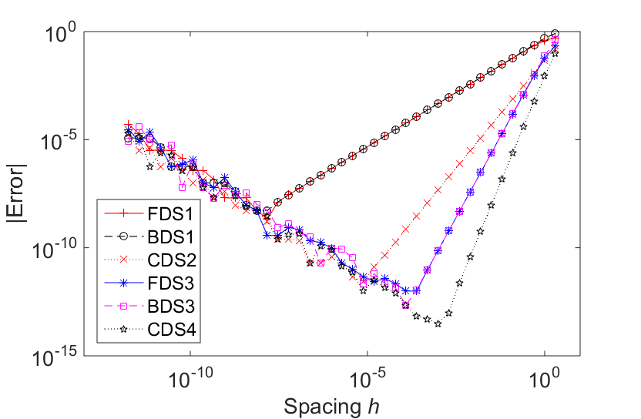

Discussion:

The results confirm the expected order of accuracy for each scheme. It is clear that the higher-order schemes have lower error than the lower-order schemes for the same spacing (at low values of spacing). At large values of h, the error in estimating the derivative is high. Decreasing the size of spacing causes the error to decrease, to an extent. At a certain minimum spacing, the solution begins losing accuracy. This may be due to either the finite-precision number systems used in calculations or due to a lack of stability in the numerical model. At extremely small increments of *h*, the finite-precision number system may not be able to resolve the exact numbers accurately, causing errors to be amplified. Comparing the absolute minimum error, the highest-order scheme is able to reach a lower minimum error than any lower-order scheme. We also see that for schemes of the same order, e.g. FDS3 and BDS3, the reduction in error with spacing is the same.

Problem 3 Source code:

%{

Brian Knisely

ME523, HW1, P3

January 21, 2018

The purpose of this code is to compare five differencing schemes for

taking the first derivative with respect to x of cos(x) at x = 0.3

and calculating the corresponding errors. The schemes to be compared are

BDS1, CDS2, FDS3, BDS3, and CDS4.

%}

clear; close all; format compact; home;

n = 41; % Number of iterations to compute

x = 0.3; % Location to evaluate derivative

h = zeros(n, 1); % Initialize array of spacings

h(1) = 2; % Initialize first value of spacing to be 2

for i = 1:n-1

h(i+1) = h(i)/2; % Reduce size of spacing by 50% each iteration

end

% Initialize arrays for each scheme

% The first column in each array holds its value, and the second column

% stores its error

bds1 = zeros(n, 2); % 1st order backward difference

cds2 = zeros(n, 2); % 2nd order central difference

fds3 = zeros(n, 2); % 3rd order forward difference

bds3 = zeros(n, 2); % 3rd order backward difference

cds4 = zeros(n, 2); % 4th order central difference

for i = 1:n

exact = -sin(0.3); % Compute analytical derivative

% Approximate derivative with each scheme

fds1(i, 1) = (cos(x+h(i))-cos(x)) / h(i);

bds1(i, 1) = (cos(x)-cos(x-h(i))) / h(i);

cds2(i, 1) = (cos(x+h(i))-cos(x-h(i))) / (2*h(i));

fds3(i, 1) = (-cos(x+2*h(i))+6*cos(x+h(i))-3*cos(x)-2*cos(x-h(i))) /...

(6*h(i));

bds3(i, 1) = (2*cos(x+h(i))+3*cos(x)-6*cos(x-h(i))+cos(x-2*h(i))) / ...

(6*h(i));

cds4(i, 1) = (-cos(x+2*h(i))+8*cos(x+h(i))-8*cos(x-h(i))+...

cos(x-2*h(i))) / (12*h(i));

% Compute errors for each scheme

fds1(i, 2) = fds1(i, 1) - exact;

bds1(i, 2) = bds1(i, 1) - exact;

cds2(i, 2) = cds2(i, 1) - exact;

fds3(i, 2) = fds3(i, 1) - exact;

bds3(i, 2) = bds3(i, 1) - exact;

cds4(i, 2) = cds4(i, 1) - exact;

end

figure(1); % Create figure to show error

loglog(h, abs(fds1(:, 2)), 'r+-', h, abs(bds1(:, 2)), 'ko--', ...

h, abs(cds2(:, 2)), 'rx:', h, abs(fds3(:, 2)), 'b*-', ...

h, abs(bds3(:, 2)), 'ms--', h, abs(cds4(:, 2)), 'kp:');

xlabel('Spacing \it{h}'); ylabel('|Error|');

legend('FDS1', 'BDS1', 'CDS2', 'FDS3', 'BDS3', 'CDS4', ...

'location', 'southwest');

set(gca, 'fontsize', 16);

xlim([1e-13, 10]);

set(gcf, 'outerposition', [50 50 850 650])

fid = fopen('results.txt', 'w'); % Open a file to store results

% Print error results

fprintf(fid,'%-2s|%-12s|%-12s|%-12s|%-12s|%-12s|%-12s|%-12s\n', ...

'i', ' h', ' Error:FDS1', ' Error:BDS1', ' Error:CDS2', ...

' Error:FDS3', ' Error:BDS3', ' Error:CDS4');

for i = 1:n

fprintf(fid,'%2.0f,%12.5e,%12.5e,%12.5e,%12.5e,%12.5e,%12.5e,%12.5e', ...

i, h(i), fds1(i, 2), bds1(i, 2), cds2(i, 2), fds3(i, 2), bds3(i, 2), cds4(i, 2));

fprintf(fid,'\n');

end

fclose(fid); % Close the file