a. The convergence rate, estimated exact solution, and discretization error are tabulated below for the coarse grids (n = 10, 20, 40).

|  |  |
| --- | --- |
| PCDS,coarse | 2.5873 |
| φCDS,coarse,RE | 1.1943 |
| εhdCDS,coarse | 0.0057353 |

b. The convergence rate, estimated exact solution, and discretization error are tabulated below for the fine grids (n = 160, 320, 640).

|  |  |
| --- | --- |
| PCDS,fine | 2.0014 |
| φCDS,fine,RE | 1.1384 |
| εhdCDS,fine | 2.2029e-005 |

c. The errors in the numerical solutions with respect to the “exact” solutions are shown below.

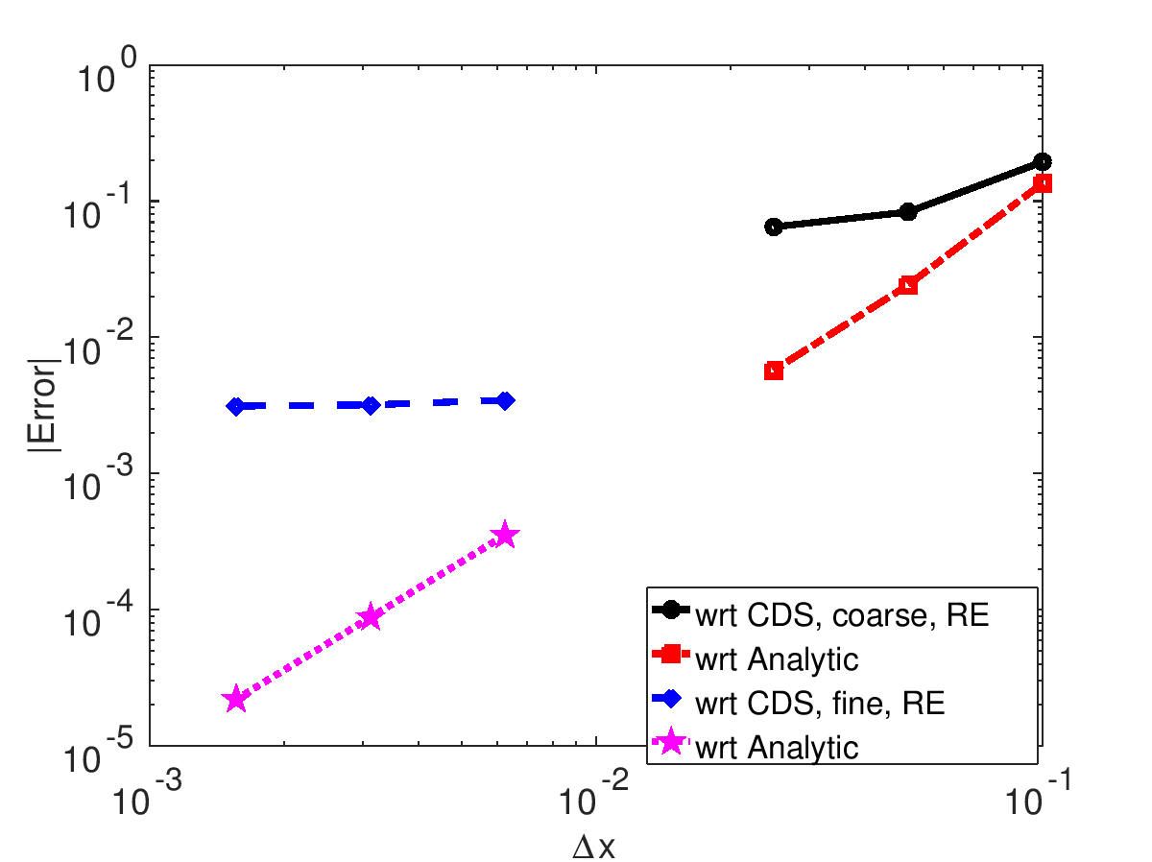

d. The convergence rate, estimated exact solution, and discretization error are tabulated below for the coarse grids (n = 10, 20, 40) and for the fine grids (n = 160, 320, 640).

|  |  |
| --- | --- |
| PUDS,coarse | 0.66726 |
| φUDS,coarse,RE | 1.2142 |
| εhdUDS,coarse | 0.062196 |
| PUDS,fine | 0.97704 |
| φUDS,fine,RE | 1.1411 |
| εhdUDS,fine | 0.0042072 |

The errors in the numerical solutions with respect to the “exact” solutions are shown below.

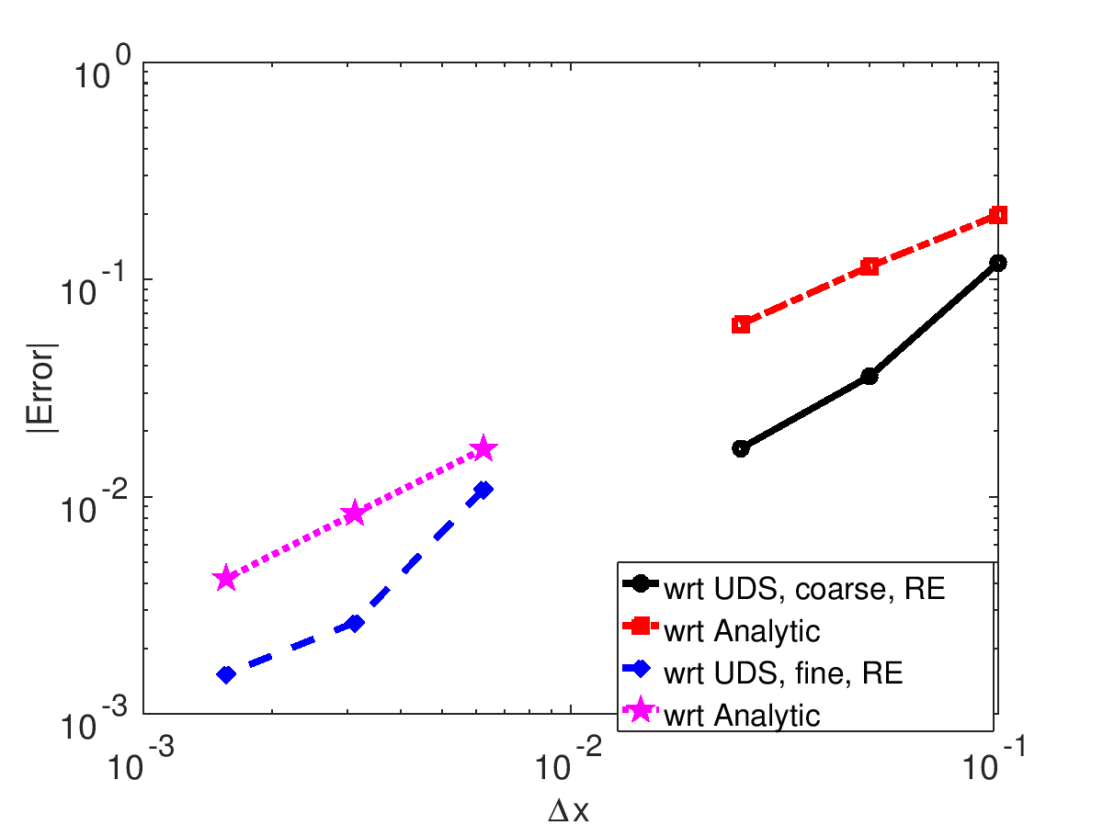

**Summary of Results:**

φAN @ x = 0.9 = 1.1353

|  |  |  |
| --- | --- | --- |
| n | φCDS @ x = 0.9 | φUDS @ x = 0.9 |
| 10 | 1.00000 | 1.3333 |
| 20 | 1.1111 | 1.2500 |
| 40 | 1.1296 | 1.1975 |
|  |  |  |
| 160 | 1.1350 | 1.1519 |
| 320 | 1.1352 | 1.1437 |
| 640 | 1.1353 | 1.1395 |

|  |  |
| --- | --- |
| PCDS,coarse | 2.5873 |
| φCDS,coarse,RE | 1.1943 |
| εhdCDS,coarse | 0.0057353 |
| PCDS,fine | 2.0014 |
| φCDS,fine,RE | 1.1384 |
| εhdCDS,fine | 2.2029e-005 |
|  |  |
| PUDS,coarse | 0.66726 |
| φUDS,coarse,RE | 1.2142 |
| εhdUDS,coarse | 0.062196 |
| PUDS,fine | 0.97704 |
| φUDS,fine,RE | 1.1411 |
| εhdUDS,fine | 0.0042072 |