BRANDI FLETCHER RÉSUMÉ
Referee • Assessor • Assigning Officer • NCAA • NISOA • NJCAA • NIRSA • NFHS
EXECUTIVE PROFILE  A referee administrator and leader dedicated to recruiting, developing, and retaining officials through mentorship, education, and performance management. Utilizing 18+ years of experience in officiating to combine extensive on-field experience with assigning, assessment, and organizational leadership to strengthen referee programs and create sustainable pathways for official development. A proven ability to recruit, develop, mentor, and retain officials while maintaining a complex assignment operation and fostering collaborative relationships with administrators and other stakeholders. Committed to building high-performing referee programs through servant leadership, operational excellence, and a culture of continuous development.    RÉSUMÉ WEBSITE  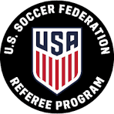  CONTACT  Name: Brandi Fletcher  Phone: 423-552-4921  Email: brandifletchersoccer@gmail.com  USSF ID: USSF-ID: 2013-1229-4467-9828  CERTIFICATIONS  • US Soccer  • NISOA  • NCAA  • NFHS  • NAIA  • ECSR  • US Soccer D Coaching License  Education  • BS Organizational Management, Tusculum University  • Data Analytics Certificate (current), UNA  Select Achievements  • Marathon Runner: Demonstrated exceptional endurance, goal orientation, and consistency through marathon training and completion  • Elite College Referee Assignments: merit-based assignments earned through advanced leadership, communication, and conflict management  • Assessor/Mentor: evaluated and developed talent through objective performance assessment and constructive coaching      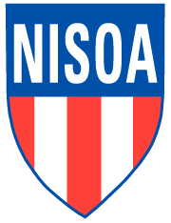  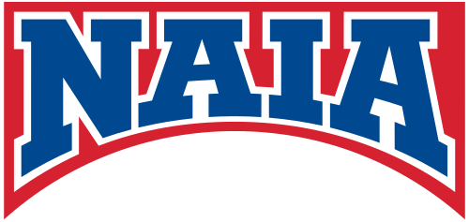   | EXECUTIVE SUMMARY  Accomplished soccer official and assessor with demonstrated leadership, elite match management, mentoring experience, and progressive assignments across scholastic and collegiate competitions.  CAREER HIGHLIGHTS  Leadership Achievement Rebuilt SASOA from the ground up  National/Regional Events Youth Regionals  Championship Assignments NJCAA D2 Men’s Semifinal and Women’s Final, Regionals u19 Men’s Semi-Final (2013)  Mentoring & Development Mentored referees such as Zach McHorter and Walt Heatherly  US SOCCER REFEREE PROGRAM EXPERIENCE  Current Level Grassroots Referee  Years Active 18  Highest Level State Referee (2013-2016| 3 Years at grade)  Regional Events Youth Regionals: 2013 (Top AR), 2014, 2015. Regional President’s Cup: x2  Notable Tournaments WAGS Virginia 2025  Professional/Amateur Leagues WPSL Women’s Semi- Pro Referee, 4th  US SOCCER ASSESSOR EXPERIENCE  Certification Lapsed 2026  Years Active 9  Certification Year 2013- North Carolina, Paul James, Ernie Fisher retired USSF National/National Assessor, John Budha National Assessor  Instructor Roles Certification Classes, Field Sessions, Video Review  Mentoring Experience Developmental | State Referee Maintenance Assessment  HIGH SCHOOL EXPERIENCE  State Associations TSSAA, AHSAA  Years Active 16  Varsity TSSAA, AHSAA  Playoffs TSSAA, AHSAA  State Finals TSSAA 6 Championship Tournaments, on the finals as R or AR every tournament  Leadership Positions TSSAA Executive Board 2011-2014, AHSAA NASRA Assigning Officer 2023, SASOA Assigning Officer 2017-Present  NAIA EXPERIENCE  Conferences SSAC  Conference Tournament Assignments SSAC  NCAA EXPERIENCE  Division I SOCON, Big South AR (Roger Morton), ASUN AR, 4th (Rachel Woo)  Division II Gulf South R Men & Women(Ackerman) , AR Women (Herrington), SSAC & Conference of Carolinas AR (Roger Morton)  Division III R Women, AR Men & Women (Stuart Dunn)  Conference Tournament Assignments SOCON, SAA  NCAA Tournament Assignments D2 Women 2nd round AR1 (Carson-Newman), D1 Women 4th (UT-Chattanooga  National Semifinal/Final Experience NJCAA Men Semi SAR1, NJCAA Women Final AR2 2024, NIRSA (Memphis, TN)

