

Functional Safety Concept Lane Assistance

**Document Version: [Version]**

**Template Version 1.0, Released on 2017-06-21**



# Document history

**[Instructions: Fill in the date, version and description fields. You can fill out the Editor field with your name if you want to do so. Keep track of your editing as if this were a real world project.**

**For example, if this were your first draft or first submission, you might say version 1.0. If this is a second submission attempt, then you'd add a second line with a new date and version 2.0]**

|  |  |  |  |
| --- | --- | --- | --- |
| Date | Version | Editor | Description |
| 31/07/2018 | 1.0 | Banning Lyth | First edits |
|  |  |  |  |
|  |  |  |  |
|  |  |  |  |
|  |  |  |  |

# Table of Contents

**[Instructions: We have provided a table of contents. If you change the document structure, please update the table of contents accordingly. The table of contents should show each section of the document and page numbers or links. Most word processors can do this for you. In** [**Google Docs**](https://support.google.com/docs/answer/116338?co=GENIE.Platform%3DDesktop&hl=en)**, you can use headings for each section and then go to Insert > Table of Contents.** [**Microsoft Word**](https://support.microsoft.com/en-us/help/285059/how-to-create-a-table-of-contents-by-marking-text-in-word) **has similar capabilities]**

Document history

Table of Contents

Purpose of the Functional Safety Concept

Inputs to the Functional Safety Analysis

Safety goals from the Hazard Analysis and Risk Assessment

Preliminary Architecture

Description of architecture elements

Functional Safety Concept

Functional Safety Analysis

Functional Safety Requirements

Refinement of the System Architecture

Allocation of Functional Safety Requirements to Architecture Elements

Warning and Degradation Concept

# Purpose of the Functional Safety Concept

**[Instructions: Answer what is the purpose of a functional safety concept?]**

The purpose of the Functional Safety Concept is to look at the project from a high level and refine the goals from the Hazard Analysis and Risk Assessment as Safety Requirements. The FSC also applies safety requirements to relevant parts of the system. To end the Concept, verification and validation of the requirements are defined in order to quantify the progress of the project.

# Inputs to the Functional Safety Concept

## Safety goals from the Hazard Analysis and Risk Assessment

**[Instructions:**

**REQUIRED:**

**Provide the lane departure warning and lane keeping assistance safety goals as discussed in the lessons and derived in the hazard analysis and risk assessment.**

**OPTIONAL:**

**If you expanded the hazard analysis and risk assessment to include other safety goals, include them here.**

**]**

|  |  |
| --- | --- |
| **ID** | **Safety Goal** |
| Safety_Goal_01 | The oscillating steering torque from the lane departure warning function shall be limited |
| Safety_Goal_02 | The lane keeping assistance function shall be time limited, and the additional steering torque shall end after a given time interval so that the driver cannot misuse the system for autonomous driving. |

## 

## Preliminary Architecture

**[Instructions: Provide a preliminary architecture for the lane assistance item. Hint: See Lesson 3: Item Definition]**

The preliminary lane assistance system architecture displaying the ITEM and 2 systems.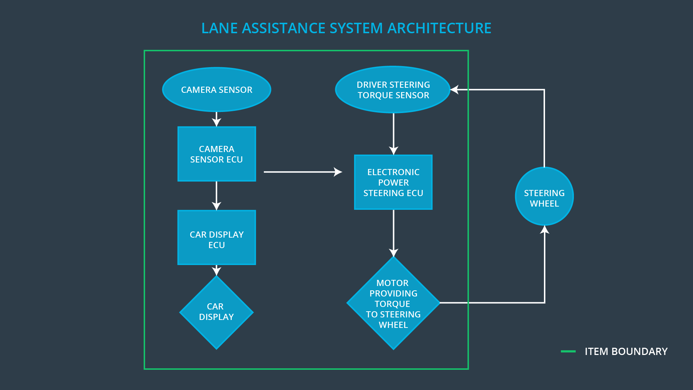

Image taken from Udacity lesson.

### Description of architecture elements

**[Instructions: Provide a description for each of the item elements; what is each element's purpose in the lane assistance item? ]**

|  |  |
| --- | --- |
| **Element** | **Description** |
| Camera Sensor | Provide imagery to analyze lane lines |
| Camera Sensor ECU | Run algorithm to predict lane lines, measure center, and send data to Car_Display_ECU and Electronic_Power_Steering_ECU |
| Car Display | Provide information to driver about vehicle state |
| Car Display ECU | Determine information to be provided to driver, accept data from Camera_Sensor_ECU |
| Driver Steering Torque Sensor | Measure current angle of steering wheel |
| Electronic Power Steering ECU | Accept steering angle measurements and Camera_Sensor_ECU data to make decisions for motor |
| Motor | Apply torque to steering wheel to make changes to vehicle heading |

# 

# Functional Safety Concept

The functional safety concept consists of:

* Functional safety analysis
* Functional safety requirements
* Functional safety architecture
* Warning and degradation concept

## Functional Safety Analysis

**[Instructions: Fill in the functional safety analysis table below.]**

|  |  |  |  |
| --- | --- | --- | --- |
| **Malfunction ID** | **Main Function of the Item Related to Safety Goal Violations** | **Guidewords (NO, WRONG, EARLY, LATE, MORE, LESS)** | **Resulting Malfunction** |
| Malfunction_01 | Lane Departure Warning (LDW) function shall apply an oscillating steering torque to provide the driver a haptic feedback | MORE | LDW applies torque to the wheel with too high of a frequency |
| Malfunction_02 | Lane Departure Warning (LDW) function shall apply an oscillating steering torque to provide the driver a haptic feedback | MORE | LDW applies torque to the wheel with too high of an amplitude |
| Malfunction_03 | Lane Keeping Assistance (LKA) function shall apply the steering torque when active in order to stay in ego lane | NO | LKA is not limited in duration of assistance |

## 

## Functional Safety Requirements

**[Instructions: Fill in the functional safety requirements for the lane departure warning ]**

Lane Departure Warning (LDW) Requirements:

|  |  |  |  |  |
| --- | --- | --- | --- | --- |
| **ID** | **Functional Safety Requirement** | **ASIL** | **Fault Tolerant Time Interval** | **Safe State** |
| Functional  Safety  Requirement  01-01 | The lane keeping item shall ensure that the lane departure oscillating torque amplitude is below Max_Torque_Amplitude | C | 50 ms | Vibration torque amplitude at or below Max_Torque_Amplitude |
| Functional  Safety  Requirement  01-02 | The lane keeping item shall ensure that the lane departure oscillating torque frequency is below Max_Torque_Frequency | C | 50 ms | Vibration torque frequency at or below Max_Torque_Amplitude |

Lane Departure Warning (LDW) Verification and Validation Acceptance Criteria:

|  |  |  |
| --- | --- | --- |
| **ID** | **Validation Acceptance**  **Criteria and Method** | **Verification Acceptance**  **Criteria and Method** |
| Functional  Safety  Requirement  01-01 | Validate Max_Torque_Amplitude is enough to alert the driver, but not so much to lose control of steering | Verify system turns off when it reaches Max_Torque_Amplitude |
| Functional  Safety  Requirement  01-02 | Validate Max_Torque_Frequency is high enough to alert the driver, but not high enough to lose control of steering | Verify system stops shaking when it reaches Max_Torque_Frequency |

**[Instructions: Fill in the functional safety requirements for the lane keeping assistance]**

Lane Keeping Assistance (LKA) Requirements:

|  |  |  |  |  |
| --- | --- | --- | --- | --- |
| **ID** | **Functional Safety Requirement** | **ASIL** | **Fault Tolerant Time Interval** | **Safe State** |
| Functional  Safety  Requirement  02-01 | The electronic power steering ECU shall ensure that the lane keeping assistance torque is applied for only Max_Duration | B | 500 ms | Assistance duration is less than Max_Duration(500 ms) |

Lane Keeping Assistance (LKA) Verification and Validation Acceptance Criteria:

|  |  |  |
| --- | --- | --- |
| **ID** | **Validation Acceptance**  **Criteria and Method** | **Verification Acceptance**  **Criteria and Method** |
| Functional  Safety  Requirement  02-01 | Validate the Max_Duration is long enough to engage the driver to move the steering wheel into a corrective action | Verify the system disengages when it reaches the Max_duration |

## 

## Refinement of the System Architecture

**[Instructions: Include the refined system architecture. Hint: The refined system architecture should include the system architecture from the end of the functional safety lesson including all of the ASIL labels.]**

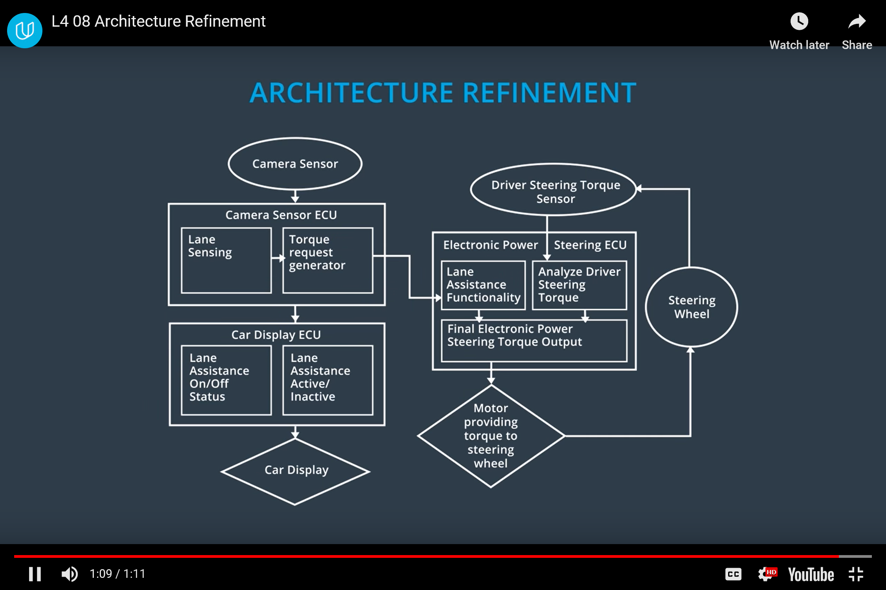

Image taken from Udacity Lesson

## Allocation of Functional Safety Requirements to Architecture Elements

**[Instructions: Mark which element or elements are responsible for meeting the functional safety requirement. Hint: Only one ECU is responsible for meeting all of the requirements.]**

|  |  |  |  |  |
| --- | --- | --- | --- | --- |
| **ID** | **Functional Safety Requirement** | **Electronic Power Steering ECU** | **Camera ECU** | **Car Display ECU** |
| Functional  Safety  Requirement  01-01 | The lane keeping item shall ensure that the lane departure oscillating torque amplitude is below Max_Torque_Amplitude | **X** |  |  |
| Functional  Safety  Requirement  01-02 | The lane keeping item shall ensure that the lane departure oscillating torque amplitude is below Max_Torque_Frequency | **X** |  |  |
| Functional  Safety  Requirement  02-01 | The electronic power steering ECU shall ensure that the lane keeping assistance torque is applied for only Max_Duration | **X** |  |  |

## Warning and Degradation Concept

**[Instructions: Fill in the warning and degradation concept.]**

|  |  |  |  |  |
| --- | --- | --- | --- | --- |
| **ID** | **Degradation Mode** | **Trigger for Degradation Mode** | **Safe State invoked?** | **Driver Warning** |
| WDC-01 | Turn off LDW | Malfunction_01, Malfunction_02 | Yes | Message on Car_Display “Lane Departure Warning OFF” |
| WDC-02 | Turn off LKA | Malfunction_03 | Yes | Message on Car_Display “Lane Keeping Assistance OFF” |