

Technical Safety Concept Lane Assistance

**Document Version: [Version]**

**Template Version 1.0, Released on 2017-06-21**



# Document history

**[Instructions: Fill in the date, version and description fields. You can fill out the Editor field with your name if you want to do so. Keep track of your editing as if this were a real world project.**

**For example, if this were your first draft or first submission, you might say version 1.0. If this is a second submission attempt, then you'd add a second line with a new date and version 2.0]**

|  |  |  |  |
| --- | --- | --- | --- |
| Date | Version | Editor | Description |
| 06/08/2018 | 1.0 | Banning Lyth | First edits |
|  |  |  |  |
|  |  |  |  |
|  |  |  |  |
|  |  |  |  |

# 

# Table of Contents

**[Instructions: We have provided a table of contents. If the table of contents is not showing up correctly in your word processor of choice, please update it. The table of contents should show each section of the document and page numbers or links. Most word processors can do this for you. In** [**Google Docs**](https://support.google.com/docs/answer/116338?co=GENIE.Platform%3DDesktop&hl=en)**, you can use headings for each section and then go to Insert > Table of Contents.** [**Microsoft Word**](https://support.microsoft.com/en-us/help/285059/how-to-create-a-table-of-contents-by-marking-text-in-word) **has similar capabilities]**

Document history

Table of Contents

Purpose of the Technical Safety Concept

Inputs to the Technical Safety Concept

Functional Safety Requirements

Refined System Architecture from Functional Safety Concept

Functional overview of architecture elements

Technical Safety Concept

Technical Safety Requirements

Refinement of the System Architecture

Allocation of Technical Safety Requirements to Architecture Elements

Warning and Degradation Concept

# Purpose of the Technical Safety Concept

**[Instructions: Answer what is the purpose of a technical safety concept?]**

This document provides a system-level approach to the item. The functional safety requirements are refined as technical safety requirements. Functions are assigned to sub-level systems to conform to ISO 26262

# Inputs to the Technical Safety Concept

## Functional Safety Requirements

**[Instructions: Provide the functional safety requirements derived in the functional safety concept ]**

|  |  |  |  |  |
| --- | --- | --- | --- | --- |
| **ID** | **Functional Safety Requirement** | **ASIL** | **Fault Tolerant Time Interval** | **Safe State** |
| Functional  Safety  Requirement  01-01 | The electronic power steering ECU  shall ensure that the lane departure  oscillating torque amplitude is below  Max_Torque_Amplitude. | C | 50 ms | Vibration torque  amplitude  below  Max_Torque_A  mplitude. |
| Functional  Safety  Requirement  01-02 | The electronic power steering ECU  shall ensure that the lane departure  oscillating torque frequency is below  Max_Torque_Frequency. | C | 50 ms | Vibration torque  amplitude  below  Max_Torque_Frequency. |
| Functional  Safety  Requirement  02-01 | The electronic power steering ECU  shall ensure that the Lane Keeping  Assistance torque is applied only  Max_Assist_Time | B | 500 ms | Assistance time is below Max_Assist_Time |

## Refined System Architecture from Functional Safety Concept

**[Instructions: Provide the refined system architecture from the functional safety concept]**

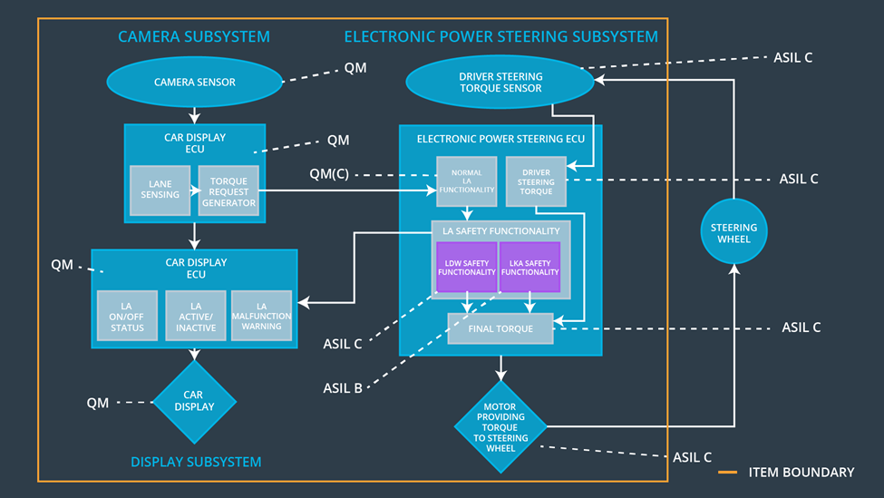

Image taken from Udacity lesson material

### Functional overview of architecture elements

**[Instructions: Provide a description for each functional safety element; what is each element's purpose in the lane assistance item? ]**

|  |  |
| --- | --- |
| **Element** | **Description** |
| Camera Sensor | Capture images and send them to the Camera Sensor ECU |
| Camera Sensor ECU - Lane Sensing | Process Images to detect lane lines and calculate vehicle position with respect to the lane lines |
| Camera Sensor ECU - Torque request generator | Calculate the torque required to maintain vehicle in the lane |
| Car Display | Display the Lane Departure Warning and status of the Lane Assistance System |
| Car Display ECU - Lane Assistance On/Off Status | Identify the status of the Lane Assistance System (ON/OFF) |
| Car Display ECU - Lane Assistant Active/Inactive | Identify the status of the Lane Assistance System (Active/Inactive) |
| Car Display ECU - Lane Assistance malfunction warning | Identify Lane Assistance Malfunction |
| Driver Steering Torque Sensor | Measure the torque applied to the steering  wheel by the driver |
| Electronic Power Steering (EPS) ECU - Driver Steering Torque | Software module receiving the driver’s torque  request from the steering wheel |
| EPS ECU - Normal Lane Assistance Functionality | Software module receiving data from the Camera Sensor  ECU torque request |
| EPS ECU - Lane Departure Warning Safety Functionality | Software module ensuring the torque  amplitude is below Max_Torque_Amplitude  and torque frequency is below  Max_Torque_Frequency |
| EPS ECU - Lane Keeping Assistant Safety Functionality | Software module ensuring the Lane Keeping  Assistance functionality application is not  activate more than Max_Assist_Time time |
| EPS ECU - Final Torque | Combine the torque request from the Lane  Keeping and Lane Departure Warning  functionalities and sends them to the Motor |
| Motor | Applies the specified torque to the steering  wheel |

# Technical Safety Concept

## Technical Safety Requirements

**[Instructions: Fill in the technical safety requirements for the lane departure warning first functional safety requirement. We have provided the associated functional safety requirement in the first table below. Hint: The technical safety requirements were discussed in the lesson videos. The architecture allocation column should contain element names such as LDW Safety block, Data Transmission Integrity Check, etc. Allocating the technical safety requirements to the "EPS ECU" does not provide enough detail for a technical safety concept.]**

**Lane Departure Warning (LDW) Requirements:**

Functional Safety Requirement 01-01 with its associated system elements

(derived in the functional safety concept)

|  |  |  |  |  |
| --- | --- | --- | --- | --- |
| **ID** | **Functional Safety Requirement** | **Electronic Power Steering ECU** | **Camera ECU** | **Car Display ECU** |
| Functional  Safety  Requirement  01-01 | The lane keeping item shall ensure that the lane departure oscillating torque amplitude is below Max_Torque_Amplitude | X |  |  |

Technical Safety Requirements related to Functional Safety Requirement 01-01 are:

|  |  |  |  |  |  |
| --- | --- | --- | --- | --- | --- |
| **ID** | **Technical Safety Requirement** | **ASIL** | **Fault Tolerant Time Interval** | **Architecture Allocation** | **Safe State** |
| Technical  Safety  Requirement  01-01-01 | The LDW safety component shall ensure that the amplitude of the ‘LDW_Torque_Request’ sent to the ‘Final electronic power steering Torque’ component is below ‘Max_Torque_Amplitude.’ | C | 50 ms | LDW Safety | Lane  Departure  Warning  Torque Request Amplitude shall be set to  zero. |
| Technical  Safety  Requirement  01-01-02 | When the LDW is  deactivated, the ‘LDW  Safety’ software module  shall send a signal to the  Car Display ECU to turn  on a warning signal. | C | 50 ms | LDW Safety | Lane  Departure  Warning  Torque Request Amplitude shall be set to  zero. |
| Technical  Safety  Requirement  01-01-03 | When a failure is  detected by the Lane  Departure Warning  functionality, it shall  deactivate the Lane  Departure Warning  feature and set  ‘LDW_Torque_Request’  to zero. | C | 50 ms | LDW Safety | Lane  Departure  Warning  Torque Request Amplitude shall be set to  zero. |
| Technical  Safety  Requirement  01-01-04 | The validity and integrity  of the data transmission  for  ‘LDW_Torque_Request’ signal shall be ensured. | C | 50 ms | Data Transmission Integrity Check | Lane  Departure  Warning  Torque Request Amplitude shall be set to  zero. |
| Technical  Safety  Requirement  01-01-05 | Memory test shall be  conducted at startup of  the EPS ECU to check  for any memory problems | A | Ignition cycle | Memory Test | Lane  Departure  Warning  Torque Request Amplitude shall be set to  zero. |

**[Instructions: Fill in the technical safety requirements for the lane departure warning second functional safety requirement. We have provided the associated functional safety requirement in the table below. Hint:. Most of the technical safety requirements will be the same. At least one technical safety requirement will have to be slightly modified because we are talking about frequency instead of amplitude. These requirements were not given in the lessons]**

Functional Safety Requirement 01-2 with its associated system elements

(derived in the functional safety concept)

|  |  |  |  |  |
| --- | --- | --- | --- | --- |
| **ID** | **Functional Safety Requirement** | **Electronic Power Steering ECU** | **Camera ECU** | **Car Display ECU** |
| Functional  Safety  Requirement  01-02 | The lane keeping item shall ensure that the lane departure oscillating torque frequency is below Max_Torque_Frequency | X |  |  |

Technical Safety Requirements related to Functional Safety Requirement 01-02 are:

|  |  |  |  |  |  |
| --- | --- | --- | --- | --- | --- |
| **ID** | **Technical Safety Requirement** | **ASIL** | **Fault Tolerant Time Interval** | **Architecture Allocation** | **Safe State** |
| Technical  Safety  Requirement  01-01-01 | The LDW safety component shall ensure that the amplitude of the ‘LDW_Torque_Request’ sent to the ‘Final electronic power steering Torque’ component is below ‘Max_Torque_Frequency.’ | C | 50 ms | LDW Safety | Lane  Departure  Warning  Torque Request Frequency shall be set to  zero. |
| Technical  Safety  Requirement  01-01-02 | When the LDW is  deactivated, the ‘LDW  Safety’ software module  shall send a signal to the  Car Display ECU to turn  on a warning signal. | C | 50 ms | LDW Safety | Lane  Departure  Warning  Torque Request Frequency shall be set to  zero. |
| Technical  Safety  Requirement  01-01-03 | When a failure is  detected by the Lane  Departure Warning  functionality, it shall  deactivate the Lane  Departure Warning  feature and set  ‘LDW_Torque_Request’  to zero. | C | 50 ms | LDW Safety | Lane  Departure  Warning  Torque Request frequency shall be set to  zero. |
| Technical  Safety  Requirement  01-01-04 | The validity and integrity  of the data transmission  for  ‘LDW_Torque_Request’ signal shall be ensured. | C | 50 ms | Data Transmission Integrity Check | Lane  Departure  Warning  Torque Request Frequency shall be set to  zero. |
| Technical  Safety  Requirement  01-01-05 | Memory test shall be  conducted at startup of  the EPS ECU to check  for any memory problems | A | Ignition cycle | Memory Test | Lane  Departure  Warning  Torque Request Frequency shall be set to  zero. |

**Lane Departure Warning (LDW) Verification and Validation Acceptance Criteria:**

**[OPTIONAL: For each technical safety requirement, identify both the verification and validation acceptance criteria. “Validation” asks whether or not you chose the appropriate parameters. “Verification” involves testing to make sure the vehicle behaves as expected when the parameter value is crossed. There is not necessarily one right answer. Look at your verification and validation acceptance criteria from the functional safety concept for inspiration.]**

**Lane Keeping Assistance (LKA) Requirements:**

**[Instructions: Fill in the technical safety requirements for the lane keeping assistance functional safety requirement 02-01. We have provided the associated functional safety requirement in the table below. Hint:. You can reuse the technical safety requirements from functional safety requirement 01-01. But you need to change the language because we are now looking at a different system. The ASIL and Fault Tolerant Time Interval are different as well.]**

Functional Safety Requirement 02-1 with its associated system elements

(derived in the functional safety concept)

|  |  |  |  |  |
| --- | --- | --- | --- | --- |
| **ID** | **Functional Safety Requirement** | **Electronic Power Steering ECU** | **Camera ECU** | **Car Display ECU** |
| Functional  Safety  Requirement  02-01 | The lane keeping item shall ensure that the lane keeping assistance torque is applied for only Max_Duration | X |  |  |

Technical Safety Requirements related to Functional Safety Requirement 02-01 are:

|  |  |  |  |  |  |
| --- | --- | --- | --- | --- | --- |
| **ID** | **Technical Safety Requirement** | **ASIL** | **Fault Tolerant Time Interval** | **Allocation to Architecture** | **Safe State** |
| Technical  Safety  Requirement  02-01-01 | The Lane Keeping Assistance safety component shall ensure the duration of the lane keeping assistance torque is applied for less than Max_Duration | B | 500 ms | LKA Safety | Lane Keeping Assistance Torque shall be set to zero. |
| Technical  Safety  Requirement  02-01-02 | When the Lane Keeping Assistance function deactivates, the ‘LKA Safety’ shall send a signal to the Car Display ECU to turn on a warning light. | B | 500 ms | LKA Safety | Lane Keeping Assistance Torque shall be set to zero. |
| Technical  Safety  Requirement  02-01-03 | When a failure is detected, the Lane Keeping Assistance function shall deactivate and the ‘LKA_Torque_Request’ shall be zero. | B | 500 ms | LKA Safety | Lane Keeping Assistance Torque shall be set to zero. |
| Technical  Safety  Requirement  02-01-04 | The validity and integrity of the data transmission for ‘LKA_Torque_Request’ signal shall be ensured. | B | 500 ms | Data Transmission Integrity Check | Lane Keeping Assistance Torque shall be set to zero. |
| Technical  Safety  Requirement  02-01-05 | Memory test shall be conducted at startup of the EPS ECU to check for any memory problems | A | Ignition cycle | Memory Test | Lane Keeping Assistance Torque shall be set to zero. |

**Lane Keeping Assistance (LKA) Verification and Validation Acceptance Criteria:**

**[OPTIONAL: For each technical safety requirement, identify both the verification and validation acceptance criteria. “Validation” asks whether or not you chose the appropriate parameters. “Verification” involves testing to make sure the vehicle behaves as expected when the parameter value is crossed. There is not necessarily one right answer. Look at your verification and validation acceptance criteria from the functional safety concept for inspiration.]**

## Refinement of the System Architecture

**[Instructions: Include the refined system architecture. Hint: The refined system architecture should include the system architecture from the end of the technical safety lesson, including all of the ASIL labels.]** 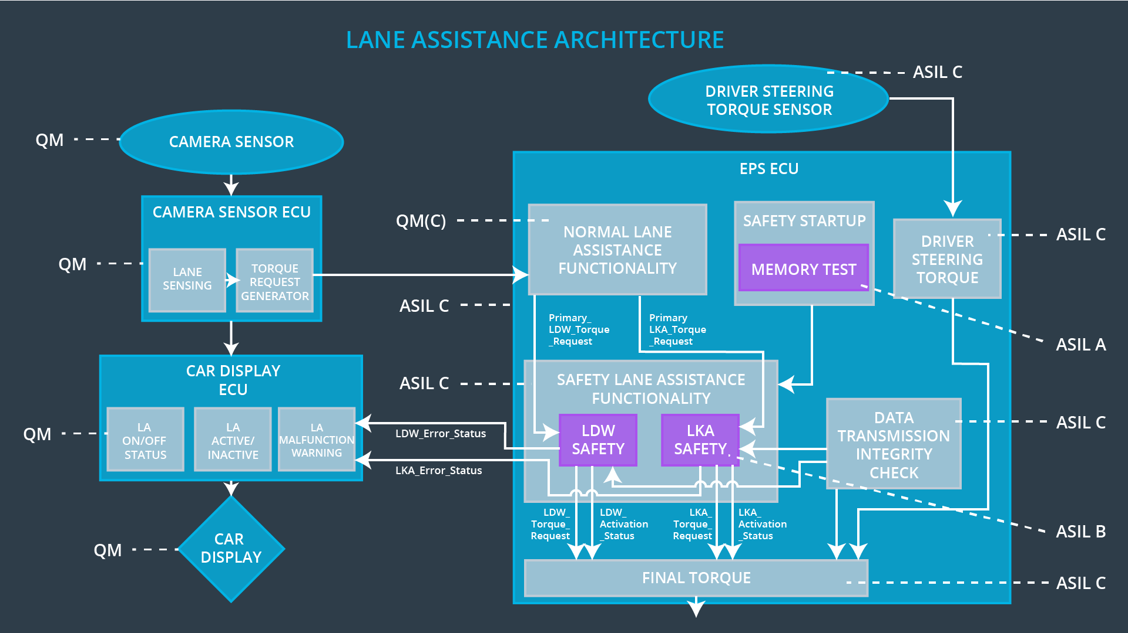

Image taken from Udacity lesson material

## Allocation of Technical Safety Requirements to Architecture Elements

**[Instructions: We already included the allocation as part of the technical requirement tables. Here you can state that for this particular item, all technical safety requirements are allocated to the Electronic Power Steering ECU]**

|  |  |  |  |  |
| --- | --- | --- | --- | --- |
| **ID** | **Technical Safety Requirement** | **Electronic Power Steering ECU** | **Camera ECU** | **Car Display ECU** |
| Technical  Safety  Requirement  01-01-01 | The Lane Departure Warning safety component shall ensure that the amplitude of the ‘LDW_Torque_Request’ sent to the ‘Final electronic power steering Torque’ component is below ‘Max_Torque_Amplitude.’ | **X** |  |  |
| Technical  Safety  Requirement  01-01-02 | When the Lane Departure Warning is deactivated, the ‘LDW Safety’ software module shall send a signal to the Car Display ECU to turn on a warning signal. | **X** |  |  |
| Technical  Safety  Requirement  01-01-03 | When a failure is detected by the Lane Departure Warning functionality, it shall deactivate the Lane Departure Warning feature and set ‘LDW_Torque_Request’ to zero. | **X** |  |  |
| Technical  Safety  Requirement  01-01-04 | The validity and integrity of the data transmission for ‘LDW_Torque_Request’ signal shall be ensured. | **X** |  |  |
| Technical  Safety  Requirement  01-01-05 | Memory test shall be conducted at startup of the EPS ECU to check for any memory problems | **X** |  |  |
| Technical  Safety  Requirement  01-02-01 | The Lane Departure Warning safety component shall ensure the frequency of the ‘LDW_Torque_Reques’ sent to the ‘Final electronic power steering Torque’ component is below ‘Max_Torque_Frequency.’ | **X** |  |  |
| Technical  Safety  Requirement  02-01-01 | The Lane Keeping Assistance safety component shall ensure the duration of the lane keeping assistance torque is applied for less than Max_Duration | **X** |  |  |
| Technical  Safety  Requirement  02-01-02 | When the Lane Keeping Assistance function deactivates, the ‘LKA Safety’ shall send a signal to the Car Display ECU to turn on a warning light. | **X** |  |  |
| Technical  Safety  Requirement  02-01-03 | When a failure is detected, the Lane Keeping Assistance function shall deactivate and the ‘LKA_Torque_Request’ shall be zero. | **X** |  |  |
| Technical  Safety  Requirement  02-01-04 | The validity and integrity of the data transmission for ‘LKA_Torque_Request’ signal shall be ensured. | **X** |  |  |
| Technical  Safety  Requirement  02-01-05 | Memory test shall be conducted at start-up of the EPS ECU to check for any memory problems | **X** |  |  |

## Warning and Degradation Concept

**[Instructions: We've already identified that for any system malfunction, the lane assistance functions will be turned off and the driver will receive a warning light indication. The technical safety requirements have not changed how functionality will be degraded or what the warning will be.**

**So in this case, the warning and degradation concept is the same for the technical safety requirements as for the functional safety requirements. You can copy the functional safety warning and degradation concept here.**

**Oftentimes, a technical safety analysis will lead to a more detailed warning and degradation concept. ]**

|  |  |  |  |  |
| --- | --- | --- | --- | --- |
| **ID** | **Degradation Mode** | **Trigger for Degradation Mode** | **Safe State invoked?** | **Driver Warning** |
| WDC-01 | Turn off Lane Departure Warning functionality | Malfunction_01,  Malfunction_02,  Malfunction_05 | Yes | Lane Departure Warning Malfunction Warning on Car Display |
| WDC-02 | Turn off Lane Keeping Assistance functionality | Malfunction_03,  Malfunction_04 | Yes | Lane Keeping Assistance Malfunction Warning on Car Display |