

Software Safety Requirements and Architecture

Lane Assistance

**Document Version: [Version]**

**Template Version 1.0, Released on 2017-06-21**



# Document history

**[Instructions: Fill in the date, version and description fields. You can fill out the Editor field with your name if you want to do so. Keep track of your editing as if this were a real world project.**

**For example, if this were your first draft or first submission, you might say version 1.0. If this is a second submission attempt, then you'd add a second line with a new date and version 2.0]**

|  |  |  |  |
| --- | --- | --- | --- |
| Date | Version | Editor | Description |
| 06/08/2018 | 1.0 | Banning Lyth | First edits |
|  |  |  |  |
|  |  |  |  |
|  |  |  |  |
|  |  |  |  |

# 

# Table of Contents

**[Instructions: We have provided a table of contents. If the table of contents is not showing up correctly in your word processor of choice, please update it. The table of contents should show each section of the document and page numbers or links. Most word processors can do this for you. In** [**Google Docs**](https://support.google.com/docs/answer/116338?co=GENIE.Platform%3DDesktop&hl=en)**, you can use headings for each section and then go to Insert > Table of Contents.** [**Microsoft Word**](https://support.microsoft.com/en-us/help/285059/how-to-create-a-table-of-contents-by-marking-text-in-word) **has similar capabilities]**

Document history

Table of Contents

Purpose

Inputs to the Software Requirements and Architecture Document

Technical safety requirements

Refined Architecture Diagram from the Technical Safety Concept

Software Requirements

Refined Architecture Diagram

# Purpose

**[Instructions: Answer what is the purpose of this document?]**

This document aims to identify possible problems with software design or architecture that could lead to violations of safety goals. New requirements are identified at a component level, and requirements are more detail oriented than technical safety requirements.

# Inputs to the Software Requirements and Architecture Document

**[Instructions:**

**REQUIRED:**

**You are only required to develop this document for the LDW (lane departure warning) amplitude malfunction. So here, provide the technical safety requirements for the LDW amplitude malfunction as well as the refined system architecture diagram from the technical safety concept.**

**OPTIONAL:**

**Expand this document to include software safety requirements for the LDW frequency malfunction as well. Go even further and document software safety requirements for the Lane Keeping Assistance (LKA) function as well.**

**]**

## Technical safety requirements

Technical Safety Requirements related to Functional Safety Requirement 01-01 are:

|  |  |  |  |  |  |
| --- | --- | --- | --- | --- | --- |
| ID | Technical Safety Requirement | ASIL | Fault Tolerant Time Interval | Architecture Allocation | Safe State |
| Technical  Safety  Requirement  01-01-01 | The LDW safety component shall ensure that the amplitude of the ‘LDW_Torque_Request’ sent to the ‘Final electronic power steering Torque’ component is below ‘Max_Torque_Amplitude.’ | C | 50 ms | LDW Safety | Lane  Departure  Warning  Torque Request Amplitude shall be set to  zero. |
| Technical  Safety  Requirement  01-01-02 | When the LDW is  deactivated, the ‘LDW  Safety’ software module  shall send a signal to the  Car Display ECU to turn  on a warning signal. | C | 50 ms | LDW Safety | Lane  Departure  Warning  Torque Request Amplitude shall be set to  zero. |
| Technical  Safety  Requirement  01-01-03 | When a failure is  detected by the Lane  Departure Warning  functionality, it shall  deactivate the Lane  Departure Warning  feature and set  ‘LDW_Torque_Request’  to zero. | C | 50 ms | LDW Safety | Lane  Departure  Warning  Torque Request Amplitude shall be set to  zero. |
| Technical  Safety  Requirement  01-01-04 | The validity and integrity  of the data transmission  for  ‘LDW_Torque_Request’ signal shall be ensured. | C | 50 ms | Data Transmission Integrity Check | Lane  Departure  Warning  Torque Request Amplitude shall be set to  zero. |
| Technical  Safety  Requirement  01-01-05 | Memory test shall be  conducted at startup of  the EPS ECU to check  for any memory problems | A | Ignition cycle | Memory Test | Lane  Departure  Warning  Torque Request Amplitude shall be set to  zero. |

## Refined Architecture Diagram from the Technical Safety Concept

**[Instructions:**

**REQUIRED: Provide the refined system architecture diagram from the technical safety concept**

**]**

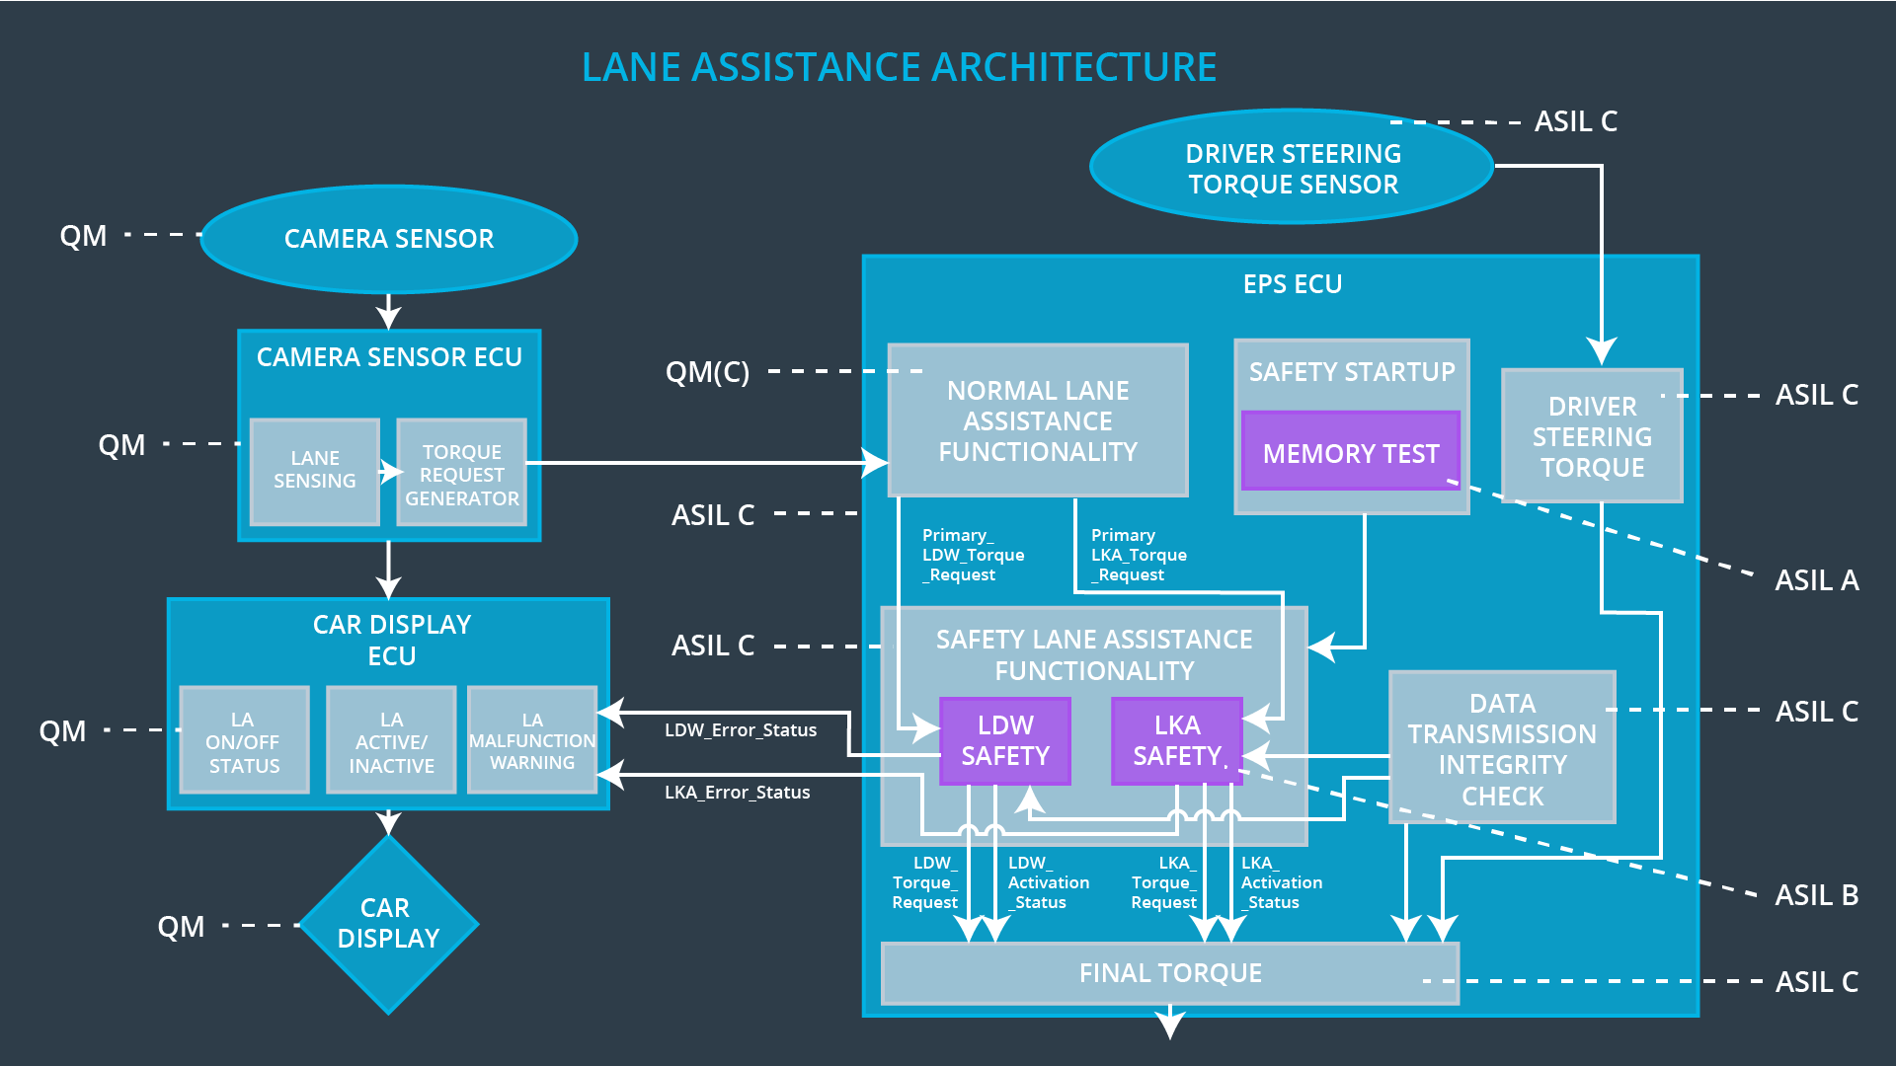

Image taken from Udacity lesson material

# Software Requirements

**Lane Departure Warning (LDW) Amplitude Malfunction Software Requirements:**

**[Instructions: Fill in the software safety requirements for the LDW amplitude malfunction technical safety requirements. We have provided the associated technical safety requirements. Hint: The software safety requirements were discussed in the text from the software and hardware lesson.**

**OPTIONAL:**

**CHALLENGE ONE**

**Develop software safety requirements for the Lane Departure Warning (LDW) frequency function and modify the system architecture as needed.**

**CHALLENGE TWO**

**Develop software safety requirements for the Lane Keeping Assistance (LKA) function and modify the system architecture as needed.**

**]**

|  |  |  |  |  |  |
| --- | --- | --- | --- | --- | --- |
| **ID** | **Technical Safety Requirement** | **ASIL** | **Fault Tolerant Time Interval** | **Allocation to Architecture** | **Safe State** |
| Technical  Safety  Requirement  01-01-01 | The LDW safety component shall ensure that the amplitude of the LDW_Torque_Request sent to the Final Electronic Power Steering Torque component is below Max_Torque_Amplitude | C | 50 ms | LDW safety | Lane Departure Warning Torque Request Amplitude shall be set to zero |

|  |  |  |  |  |
| --- | --- | --- | --- | --- |
| ID | Software Safety Requirement | ASIL | Allocation Software Elements | Safe State |
| Software  Safety  Requirement  01-01-01-01 | The input signal ‘Primary_LDW_Torq_Req’ shall be read and pre-processed to determine the torque request coming from the ‘Basic/Main LAFunctionality’ SW Component. Signal ‘processed_LDW_Torq_Req’ shall be generated at the end of the processing. | C | LDW_SAFETY_INPUT_PROCESSING | N/A |
| Software Safety Requirement 01-01-01-02 | In case the ‘processed_LDW_Torq_Req’ signal has a value greater than ‘Max_Torque_Amplitude_LDW’ (maximum allowed safe torque), the torque signal ‘limited_LDW_Torq_Req’ shall be set to zero, else ‘limited_LDW_Torq_Req’ shall take the value of ‘processed_LDW_Torq_Req’ | C | TORQUE_LIMITER | ‘limited_LDW_Torq_Req’ = 0 (Nm=Newton-meter) |
| Software Safety Requirement 01-01-01-03 | The ‘limited_LDW_Torq_Req’ shall be transformed into a signal ‘LDW_Torq_Req’ which is suitable to be transmitted outside the LDW Safety component (‘LDW Safety’) to the ‘Final EPS Torque’ component. | C | LDW_SAFETY_OUTPUT_GENERATOR | LDW_Torq_Req = 0 (Nm) |

|  |  |  |  |  |  |
| --- | --- | --- | --- | --- | --- |
| **ID** | **Technical Safety Requirement** | **ASIL** | **Fault Tolerant Time Interval** | **Allocation to Architecture** | **Safe State** |
| Technical  Safety  Requirement  01-01-02 | When the LDW is  deactivated, the ‘LDW  Safety’ software module  shall send a signal to the  Car Display ECU to turn  on a warning signal. | C | 50 ms | LDW safety | Lane  Departure  Warning  Torque output shall be set to  zero. |

|  |  |  |  |  |
| --- | --- | --- | --- | --- |
| **ID** | **Software Safety Requirement** | **ASIL** | **Allocation Software Elements** | **Safe State** |
| Software Safety Requirement 01-01-02-01 | When the LDW function is deactivated (activation_status set to 0), the activation_status shall be sent to the car displayECU. | C | LDW safety, car display ECU | N/A |

|  |  |  |  |  |  |
| --- | --- | --- | --- | --- | --- |
| **ID** | **Technical Safety Requirement** | **ASIL** | **Fault Tolerant Time Interval** | **Allocation to Architecture** | **Safe State** |
| Technical  Safety  Requirement  01-01-03 | As soon as a failure is detected by the LDW function, it shall deactivate the LDW feature and the LDW_Torque_Request shall be set to zero |  | 50 ms | LDW safety | Lane  Departure  Warning  Torque Request Amplitude shall be set to  zero. |

|  |  |  |  |  |
| --- | --- | --- | --- | --- |
| **ID** | **Software Safety Requirement** | **ASIL** | **Allocation Software Elements** | **Safe State** |
| Software Safety Requirement 01-01-03-01 | Each of the SW elements shall output a signal to indicate any error which is detected by the element. Error signal = error_status_input(LDW_SAFETY_INPUT_PROCESSING), error_status_torque_limiter(TORQUE_LIMITER), error_status_output_gen(LDW_SAFETY_OUTPUT_GENERATOR) | C | All | N/A |
| Software Safety Requirement 01-01-03-02 | A software element shall evaluate the error status of all the other software elements and in case any 1 of them indicates an error, it shall deactivate the LDW feature (“activation_status”=0) | C | LDW_SAFETY_ACTIVATION | Activation_status = 0 (LDW function deactivated) |
| Software Safety Requirement 01-01-03-03 | A software element shall evaluate the error status of all the other software elements and in case any 1 of them indicates an error, it shall deactivate the LDW feature (“activation_status”=0) | C | LDW_SAFETY_ACTIVATION | N/A |
| Software Safety Requirement 01-01-03-04 | In case an error is detected by any of the software elements, it shall set the value of its corresponding torque to 0 so that “LDW_Torq_Req” is set to 0 | C | All | LDW_Torq_Req = 0 |
| Software Safety Requirement 01-01-03-05 | Once the LDW functionality has been deactivated, it shall stay deactivated till the time the ignition is switched from off to on again. | C | LDW_SAFETY_ACTIVATION | Activation_status = 0 (LDW function deactivated) |

|  |  |  |  |  |  |
| --- | --- | --- | --- | --- | --- |
| **ID** | **Technical Safety Requirement** | **ASIL** | **Fault Tolerant Time Interval** | **Allocation to Architecture** | **Safe State** |
| Technical  Safety  Requirement  01-01-04 | The validity and integrity  of the data transmission  for  ‘LDW_Torque_Request’ signal shall be ensured. | C | 50 ms | Data transmission integrity | N/A |

|  |  |  |  |  |
| --- | --- | --- | --- | --- |
| **ID** | **Software Safety Requirement** | **ASIL** | **Allocation Software Elements** | **Safe State** |
| Software Safety Requirement 01-01-04-01 | Any data to be transmitted outside of the LDW Safety component (“LDW Safety”) including "LDW_Torque_Req" and “activation_status” (see SofSafReq03-02) shall be protected by an End2End(E2E) protection mechanism | C | E2ECalc | LDW_Torq_Req= 0 (Nm) |
| Software Safety Requirement 01-01-04-02 | The E2E protection protocol shall contain and attach the control data: alive counter (SQC) and CRC to the data to be transmitted. | C | E2ECalc | LDW_Torq_Req = 0 (Nm) |

|  |  |  |  |  |  |
| --- | --- | --- | --- | --- | --- |
| **ID** | **Technical Safety Requirement** | **ASIL** | **Fault Tolerant Time Interval** | **Allocation to Architecture** | **Safe State** |
| Technical  Safety  Requirement  01-01-05 | Memory test shall be conducted at start-up of the EPS ECU to check for any faults in memory | A | Ignition cycle | Memory check | Lane  Departure  Warning  Torque Request Amplitude shall be set to  zero. |

|  |  |  |  |  |
| --- | --- | --- | --- | --- |
| **ID** | **Software Safety Requirement** | **ASIL** | **Allocation Software Elements** | **Safe State** |
| Technical Safety Requirement 01-01-05-01 | A CRC verification check over the software code in the Flash memory shall be done every time the ignition is switched from off to on to check for any corruption of content. | A | Memory test | Activation_status = 0 |
| Technical Safety Requirement 01-01-05-02 | Standard RAM tests to check the data bus, address bus and device integrity shall be done every time the ignition is switched from off to on (E.g.walking 1s test, RAM pattern test. Refer RAM and processor vendor recommendations ) | A | Memory test | Activation_status = 0 |
| Technical Safety Requirement 01-01-05-03 | The test result of the RAM or Flash memory shall be indicated to the LDW_Safety component via the “test_status” signal | A | Memory test | Activation_status = 0 |
| Technical Safety Requirement 01-01-05-04 | In case any fault is indicated via the “test_status” signal the INPUT_LDW_PROCESSING shall set an error on error_status_input (=1) so that the LDW functionality is deactivated and the LDWTorque is set to 0 | A | LDW safety | Activation_status = 0 |

# Refined Architecture Diagram

**[Instructions: Include the refined system architecture. Hint: The refined system architecture should include the system architecture from the end of the software and hardware lesson, including all of the ASIL labels.]**

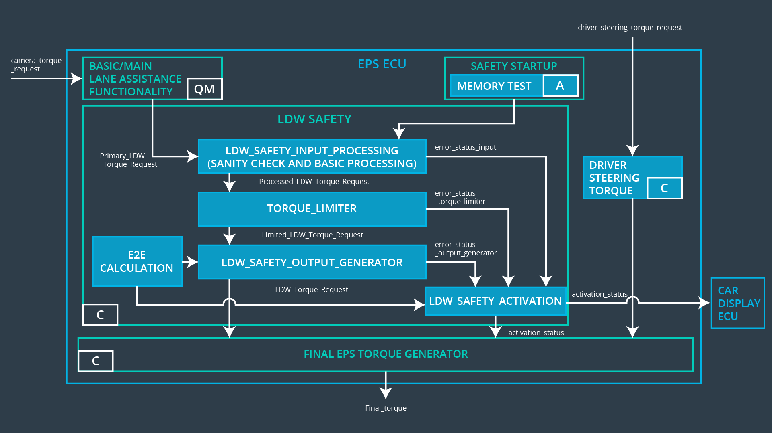

Image taken from Udacity lesson material