SpeakCraft
Real English for Real Skills

Consolidated Product, Learning, UX and Technical Blueprint
Alpha 0.1 • Beauty & Cosmetology • iOS + Android

Mission: Help TVET learners become confident, understandable and professionally capable English communicators through voice-first, vocationally contextualised practice.

1. Executive Summary
SpeakCraft is a voice-first, AI-powered vocational English coach designed initially for TVET learners in Ghana. The first pathway focuses on Beauty & Cosmetology—hairdressing, cosmetology, wig making and design—while the underlying platform is intended to expand into other vocational fields.
The product is built around a simple principle:
Don't learn English. Learn to say what you need to say.
Instead of beginning with abstract grammar, SpeakCraft teaches through real situations: greeting customers, understanding hairstyle requests, explaining procedures, discussing prices and time, recommending products, arranging appointments, responding to complaints, and presenting oneself professionally.
The initial product hypothesis is measurable: a learner who struggles with practical spoken English should show noticeable improvement in successful real-world conversations after a structured 30-day programme, with a five-day Alpha used first to validate the learning loop.

2. Problem and Opportunity
Many vocational learners may understand parts of English yet struggle to articulate themselves clearly in classrooms, workplaces and customer interactions. The difficulty can involve listening comprehension, vocabulary, sentence construction, pronunciation/intelligibility, confidence, or several of these at once.
Generic language-learning applications often teach broad English. SpeakCraft instead contextualises English around the learner's profession. The first learner is represented by the persona “Ama”: a Ghanaian TVET cosmetology student whose primary goal is not to master grammatical terminology, but to understand people and confidently say what she means.

Representative learner: Ama
Dimension | Alpha assumption
Context | TVET Beauty & Cosmetology learner in Ghana
Primary need | Practical spoken English
Professional areas | Hairdressing, cosmetology, wig making/design
Device strategy | Mobile-first; Android and iOS
Likely constraints | Mobile data, intermittent connectivity, small screens, limited storage
Desired outcome | Understand others and communicate confidently in everyday and professional situations

3. Product Positioning
SpeakCraft is not positioned as another generic English-learning application. It is a vocational communication platform.
SpeakCraft is an AI vocational English coach that teaches TVET learners to communicate confidently by practising the real conversations they encounter in classrooms, workplaces and businesses.
The platform launches with Beauty & Cosmetology, but the architecture can later support Fashion, Catering, Hospitality, Electrical Installation, Automotive, Construction, Plumbing, ICT and other vocational fields.

4. Learning Philosophy

Communication before perfection
Successful meaning comes first; refinement follows.

Speak more than read
A 15–20 minute session should devote most active time to listening and speaking.

Teach phrases, not isolated words
Learners acquire reusable language chunks such as “What hairstyle would you like?”

Correct one important thing at a time
Kora prioritises the correction with the greatest communication value.

Recycle difficult language
Weak phrases return through spaced practice and later scenarios.

Intelligibility over accent imitation
The aim is clear, understandable English—not forcing a British or American accent.

5. Core Learning Loop
Hear → Speak → Understand → Correct → Retry → Apply → Review
Grammar is introduced when it helps communication. The learner should encounter a situation, hear useful language, attempt it, receive simple feedback, retry it, then use it in a realistic conversation.

6. Core Product Experiences
Mode | Purpose
Today's Lesson | Structured 10–20 minute vocational English mission
Speak & Repeat | Hear a phrase, speak it, receive simple feedback, retry
AI Salon | Role-play with simulated customers of increasing difficulty
Help Me Say It | Turn the learner's intended meaning into useful English, then practise it
English Mirror | Compare earlier and later recordings/performance to make progress visible
My Words / Review | Revisit weak vocabulary and phrases using adaptive scheduling
Progress | Show practical capability, not only points or streaks

Signature feature: Help Me Say It
The learner speaks whatever English—or eventually a supported local language—they can. SpeakCraft identifies the intended meaning and produces an appropriate English expression at the learner's level.
Example: “I want tell customer the hair she bring cannot good for style.”
SpeakCraft: “This hair may not work well for this style.”
The learner then listens, repeats and uses the phrase in a short role-play. Translation becomes a micro-lesson rather than an endpoint.

7. Kora — The AI Tutor
Kora is SpeakCraft's AI English practice partner. Kora must behave as a structured tutor, not a generic chatbot.

Kora should
- Use simple English and short responses
- Praise successful communication specifically
- Correct the most important error first
- Give hints before full answers
- Reuse difficult vocabulary later
- Adjust speaking speed
- Stay within the current learning objective
- Distinguish harmless accent variation from speech that affects understanding

Kora should not
- Deliver grammar lectures unless requested
- Correct every error simultaneously
- Use unnecessarily advanced vocabulary
- Shame or patronise the learner
- Treat Ghanaian pronunciation as inherently wrong
- Overwhelm the learner with text
- Fabricate learning progress

8. Assistance Ladder
Level | Example
0 — Independent | Learner answers without assistance
1 — Hint | “Try beginning with: I recommend…”
2 — Structure | “I recommend ___ because ___.”
3 — Full model | “I recommend this hairstyle because it is easier to maintain.”

Assistance level becomes a learning metric. Progress is demonstrated when the learner completes comparable tasks with less help.

9. Day-1 Baseline Assessment
The assessment should feel like a conversation, not an examination.

A. Basic conversation
Name, origin, course of study, reasons for choosing cosmetology.

B. Description
Describe a salon-related image and what is happening.

C. Professional explanation
Explain how to make a wig or perform a familiar procedure.

D. Listening
Listen to a short customer scenario and answer comprehension questions.

E. Customer role-play
Respond to a simulated customer for several conversational turns.
The learner-facing result should be simple—Speaking, Listening, Pronunciation, Work Vocabulary, Conversation and Confidence—while richer metrics remain internal.

10. Thirty-Day Curriculum
Day | Theme | Mission
1 | Assessment | Discover my English
2 | Greetings | Meet someone confidently
3 | Introducing myself | Tell people about myself
4 | Asking questions | Get information
5 | Clarification | Handle things I don't understand
6 | Daily routine | Explain my day
7 | Review | First conversation challenge
8 | Salon vocabulary | Identify workplace objects
9 | Hair vocabulary | Describe hair
10 | Hairstyles | Discuss styles
11 | Tools | Explain what tools do
12 | Products | Discuss products
13 | Procedures | Explain what I'm doing
14 | Review | Salon challenge
15 | Welcoming customers | Start professionally
16 | Customer needs | Discover what they want
17 | Recommendations | Give professional advice
18 | Prices | Discuss money confidently
19 | Time | Explain duration
20 | Appointments | Arrange bookings
21 | Review | Full customer consultation
22 | Problems | Explain problems
23 | Complaints | Respond professionally
24 | Phone conversations | Communicate without visual cues
25 | Business English | Talk about my services
26 | Job interview | Present myself professionally
27 | Difficult customer | Remain professional
28 | Independent salon | Run simulated conversations
29 | Final challenge | Complete workplace simulation
30 | Reassessment | See my transformation

Typical daily structure: 2 min warm-up, 3 min new language, 4 min listen/repeat, 5 min interactive conversation, 3 min challenge, 1 min progress.

11. Five-Day Alpha Curriculum

Day 1 — This Is Me
Introduce yourself, explain what you study, and complete a 30–60 second introduction.

Day 2 — My Salon
Name and describe common salon objects: comb, brush, dryer, scissors, wig, shampoo, conditioner, extensions.

Day 3 — Welcome a Customer
Greet a customer, ask what they need, and complete a 90-second consultation.

Day 4 — Recommend
Use “I recommend…”, “I think…”, and “This would be better because…” to advise a customer.

Day 5 — Salon Challenge
Complete a structured customer conversation covering greeting, needs, questions, recommendation, explanation and closing.

12. AI Salon
AI Salon is the game-like simulation layer. Scenarios are structured rather than fully improvised so learning objectives remain measurable.
Difficulty | Example scenario
1 | Friendly customer wants braids and asks the price
2 | Customer wants an appointment and asks about time
3 | Customer is unsure which hairstyle suits them
4 | Customer speaks faster or presents a more complex request
5 | Dissatisfied customer requires professional complaint handling

A scenario stores the customer goal/personality, target vocabulary, learner objectives and success conditions. Kora may improvise inside those boundaries.

13. English Mirror
English Mirror repeats comparable speaking challenges over time and contrasts earlier and later performance. Useful measures include longest independent answer, complete sentences, vocabulary range, hints required, successful task completion and conversation duration.
The purpose is motivational and evidential: learners should be able to hear and see their progress.

14. Success Metrics

North-star: Successful Conversation Rate (SCR)
Give the learner realistic vocational situations and measure how many they can complete successfully. For example, improvement from 3/10 successful scenarios on Day 1 to 8/10 on Day 30 would be more meaningful than an XP total.

Supporting metrics
- Assistance Dependency Score
- Independent speaking duration
- Conversation task completion
- Listening comprehension
- Vocabulary retention
- Return/completion rate
- Confidence self-rating (1–5)
- Speech intelligibility judged against human review

15. UX Principles
- Voice-first: Listen → Speak → Respond is the dominant interaction.
- Large touch targets, little text and strong visual hierarchy.
- Important instructions should ideally have text + icon + audio.
- The learner should not need strong English merely to navigate the app.
- If Kora can say it, do not automatically require the learner to read it.
- Support-language scaffolding can gradually reduce as English improves.
- Connectivity failures must preserve progress and allow offline-capable activities to continue.

16. Core Screens
- Welcome / Splash
- Profession selection
- Support-language selection
- Meet Kora
- Microphone/audio permission
- Baseline assessment
- Assessment result
- Home
- Today's lesson
- Listen & Repeat
- Speaking feedback
- AI Salon
- Live customer conversation
- Help Me Say It
- English Mirror
- Progress
- Settings / Privacy

17. Early Visual Direction
The following concept board captures the initial visual direction. It is not final UI; several screens should ultimately contain less text and more audio guidance.
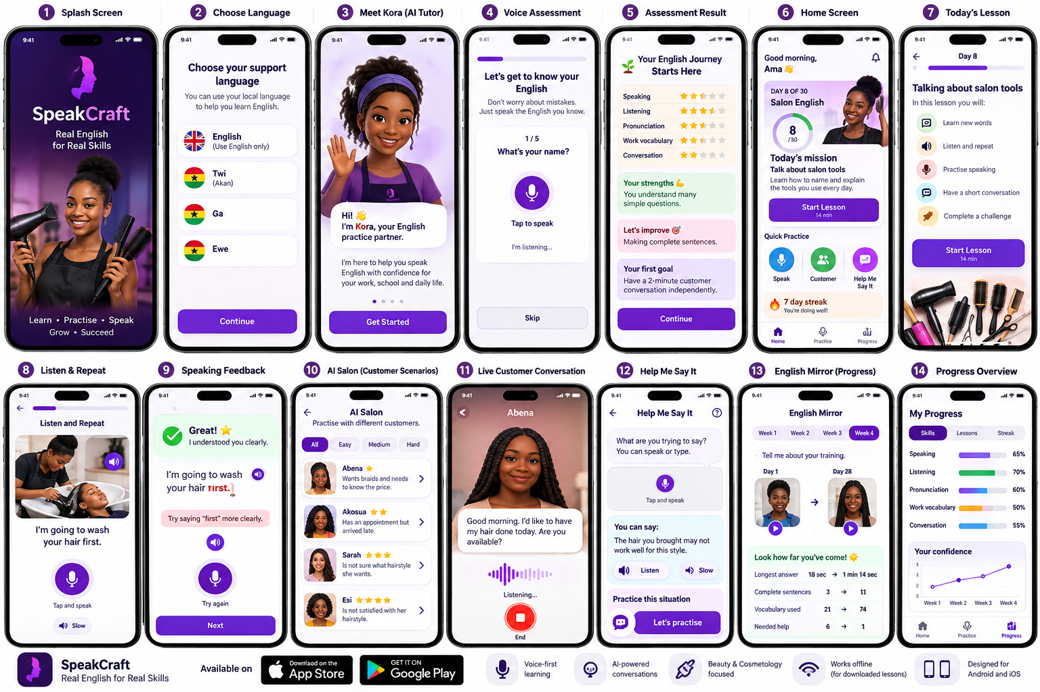

18. Cross-Platform Strategy
SpeakCraft is mobile-first and cross-platform from day one. The application should use a shared Flutter codebase for iOS and Android, with continuous testing on both platforms rather than building one and porting later.
The product must work across smaller and larger iPhones, low/mid-range Android devices, varying screen sizes, wired/Bluetooth audio, microphone permission states and interrupted networks.

19. Alpha Technical Architecture
Recommended Alpha stack:
Layer | Decision
Mobile | Flutter / Dart
Platforms | iOS + Android
State management | Riverpod
Navigation | GoRouter
Backend | FastAPI / Python
Database | PostgreSQL
Auth / storage | Supabase
Local/offline | SQLite/Drift or equivalent
AI | Provider-abstracted backend orchestration
Analytics | Privacy-conscious product/learning events

Critical architectural rule: the Flutter app should not know or care which AI provider is used. It calls SpeakCraft backend concepts such as /speech/evaluate or /salon/{session}/turn. Provider credentials remain server-side.

20. Voice Architecture

Learning Mode
Record → Transcribe → Evaluate → Correct → Generate example → Retry
Used for deliberate pronunciation, phrase and sentence exercises where pauses and explicit feedback are desirable.

Conversation Mode
Speak ↔ Listen ↔ Respond
Used for AI Salon and natural role-play. It should support low-latency conversational turn-taking while preserving scenario objectives.

21. Kora Processing Pipeline
Learner speech → Speech recognition → Transcript → Intent → Communication evaluation → Learner-level evaluation → Correction priority → Response → Learning-memory update → Speech output
Internal evaluation may score task completion, clarity of meaning, grammar, vocabulary, assistance level and speech intelligibility. The learner should see simple, actionable feedback rather than a technical score dump.

22. Correction Hierarchy
- Meaning failure
- Important missing information
- Major sentence structure
- Vocabulary misuse
- Pronunciation affecting understanding
- Grammar
- Minor stylistic issue
Kora normally addresses only the highest-value issue at a time.

23. Learner State and Adaptive Memory
Each interaction should receive a compact learner state: level, profession, current lesson/objective, known phrases, weak phrases, speaking speed, correction intensity and current hint level.
A skill-memory system tracks mastery, attempts, last practice and next review. A conceptual lesson mix is 60% current material, 25% weak material and 15% previous material; this should be tuned from pilot evidence rather than treated as fixed.

24. Simplified Data Model

users
id, name, support_language, profession, created_at

learner_profiles
user_id, estimated_level, speaking/listening/pronunciation/vocabulary/conversation/confidence scores

courses
id, profession, title, version

lessons
id, course_id, day, title, objective, estimated_minutes

lesson_items
id, lesson_id, type, content, sequence

phrases
id, lesson_id, text, difficulty, meaning, audio_reference

skill_memory
user_id, skill_id, mastery, attempts, last_seen, next_review

speaking_attempts
user_id, lesson_id, prompt_id, transcript, communication_score, feedback, assistance_level, timestamp

conversations
user_id, scenario_id, duration, completion_score, assistance_count

conversation_turns
conversation_id, speaker, transcript, feedback, timestamp

25. Initial API Contract
- POST /v1/assessment/start
- POST /v1/assessment/respond
- POST /v1/speech/evaluate
- GET /v1/lessons/today
- POST /v1/lessons/{id}/complete
- POST /v1/kora/respond
- POST /v1/help-me-say-it
- POST /v1/salon/start
- POST /v1/salon/{session}/turn
- POST /v1/salon/{session}/complete
- GET /v1/progress
- GET /v1/review/today

26. Offline and Connectivity Strategy
Offline-capable: downloaded lessons, cached example audio, vocabulary review, basic listen-and-repeat, and saved local progress.
Initially online: speech recognition, advanced AI feedback, live Kora conversation, AI Salon and Help Me Say It.
If connectivity drops, the learner should be told that progress is saved and allowed to continue with offline-capable activities. Synchronisation should occur quietly when the connection returns.

27. Privacy and Safety by Design
- Tell learners clearly when audio is recorded and why.
- Do not retain routine raw audio indefinitely if derived metrics/transcripts are sufficient.
- English Mirror recordings should be retained only as part of an explicit learner-facing feature/choice.
- Provide proper account/data deletion before public launch.
- Keep privileged API keys and database service credentials off the mobile client.
- Use row-level access controls so learners only access authorised records.
- Identify Kora clearly as an AI tutor.
- Review Ghanaian-language translations and voice behaviour with native speakers before presenting them as reliable.

28. Speech Evaluation Research
Before sophisticated pronunciation scoring, collect a small, consented sample of natural utterances from target learners and compare human transcription/judgement with candidate speech-recognition and intelligibility systems.
The benchmark should prioritise Ghanaian-accented English and functional intelligibility. Recognition quality on American or British English alone is not sufficient evidence for the target population.

29. Alpha Analytics
- lesson_started / lesson_completed
- speaking_attempt_started / completed
- hint_requested / full_answer_requested
- conversation_started / completed
- help_me_say_it_used
- session_duration
- day_returned
Analytics should answer: Do learners return? Do they actually speak? Where do they abandon lessons? Do they use fewer hints? Are conversations becoming longer and more successful?

30. Alpha Success Criteria
Area | Signal
Engagement | At least 4 of 5 Alpha lessons completed
Usability | Core features navigable with minimal outside assistance
Speaking | Learner repeatedly uses microphone tasks rather than avoiding them
Independence | Assistance usage begins to decline
Communication | Day-5 scenario outperforms a comparable Day-1 baseline
Desire | Learner wants to continue to Day 6

31. Development Roadmap
Build / Sprint | Deliverable
Sprint 1 / Build 0.1 | Cross-platform shell: design system, routing, onboarding, Home, Day 1, microphone permission/recording UI
Sprint 2 / Build 0.2 | Speech recognition: make Kora hear and return reliable transcripts
Sprint 3 / Build 0.3 | Teaching feedback: evaluate meaning, select one correction, provide example and retry
Sprint 4 / Build 0.4 | Conversation: natural Kora voice interaction
Sprint 5 / Build 0.5 | AI Salon: first structured customer scenario
Sprint 6 / Build 0.6 | Help Me Say It: intent → English → practice → scenario
Build 0.7 | Adaptive memory and spaced review
Alpha pilot | Five-day test with first learner, then 5–10 learners

After a successful Alpha: expand 5 → 10 days, then 10 → 30 days, then conduct a private beta with approximately 10–50+ learners and potentially 1–2 TVET institutions.

32. What Is Deliberately Out of Scope for Alpha
- Social network
- Public profiles
- Marketplace
- Employer portal
- Certificates
- Many professions at launch
- Leaderboards
- Complex avatars
- Desktop application
- Elaborate teacher analytics
- Subscription system
The Alpha exists to answer one question: does SpeakCraft materially improve practical spoken English and make learners want to continue?

33. Long-Term Platform Vision
Once Beauty & Cosmetology is proven, SpeakCraft Core can power vocational packs for Fashion, Hospitality, Catering, Electrical Installation, Automotive and other fields. The same engine—speech, conversation, adaptive learning, progress measurement—serves different professional communication worlds.
Longer term, demonstrated workplace capabilities could be more meaningful than generic “intermediate English” labels: for example, “Can independently conduct a basic salon consultation in English.” Teacher dashboards and employer-facing assessments may follow only after learner value is proven.

34. Research and Impact Hypothesis
A future research question is: Can vocationally contextualised, AI-mediated conversational practice accelerate functional English acquisition among TVET learners?
Any future claims—such as percentage improvement in task completion, listening comprehension or independent speaking duration—must come from real studies and pilot data, not invented figures.

35. Immediate Next Step Before Coding
Build one excellent vertical slice: “Welcome a Customer.”
The slice must record the learner, transcribe speech, understand the intended response, evaluate communication, identify one useful correction, respond naturally, continue the scenario and record performance.
In parallel, Sprint 1 should create the runnable Flutter shell for both iOS and Android: Welcome → Support Language → Meet Kora → Home → Day 1 → microphone recording.
Once this end-to-end loop feels excellent with the first learner, expand the learning engine—not merely the number of screens.

36. Product Principles to Preserve
- Real English for real situations.
- Communication before grammatical perfection.
- Voice before text wherever practical.
- Simple learner-facing feedback; sophisticated evaluation stays behind the scenes.
- One meaningful correction at a time.
- Human-designed curriculum with AI-adapted practice.
- Evidence before scale.
- Build for Ghanaian learners without treating their accent as a defect.
- Cross-platform from day one.
- Five excellent days before thirty average ones.

37. Decision Log
Decision | Status
Product name: SpeakCraft | Working name retained
Tagline: Real English for Real Skills | Working tagline retained
AI tutor name: Kora | Working name retained
Launch pathway: Beauty & Cosmetology | Locked for Alpha
Platforms: Android + iOS | Locked
Mobile framework: Flutter | Recommended for implementation
Alpha duration: 5 days | Locked for first pilot
Full initial curriculum: 30 days | Designed; implement after Alpha validation
Voice-first interaction | Core principle
Ghanaian-language scaffolding | Experimental until native-speaker and speech-quality validation

