AN OPERATIONAL, MORAL, AND ETHICAL IMPERATIVE
Crisis Standards of Care for Large-Scale Combat Operations — a PACE Framework for the Role 1–2 Continuum
CDR Brian S. Ford, MC, USN • Dan Hanfling, MD • John L. Hick, MD
Outline — Military Medicine Perspective, target ~3,000 words. Rev 3: thesis reframed around three imperatives (operational, moral, ethical); pillar threads tagged through §1–§4; new substantiating citations for each pillar.
ABSTRACT (~200 w)
- Frame. Adopting CSC for LSCO is an operational, moral, and ethical imperative — not three problems but one, with three faces.
- Operational: LSCO will degrade medical capability beyond what triage alone can resolve; CSIS wargames project ~3,200 KIA in 3 weeks for a Taiwan scenario, with daily casualty rates not seen since WWII. [24]
- Moral: without an institutional framework, providers carry system-level decisions as personal moral burden; the duty to plan for foreseeable scarcity is violated by inaction. [16,25]
- Ethical: scarcity decisions made ad hoc cannot satisfy fairness, transparency, proportionality, accountability — the IOM 2009 ethical core. [4]
- Proposal: PACE-mapped CSC anchored to JTS CPG “best/better/minimum” tiers; triggered by logistics/evacuation state; pre-authorized at command level; surfaced in the commander’s common operating picture.
- Implication: force-level readiness, reduced provider moral injury, common language for resupply prioritization, defensible ethical position.
INTRODUCTION (~450 w)
Posture: “We need this concept.” Constructive, not critical.
- Operational scene-setter: contested logistics, interdicted evacuation, prolonged casualty care as expected, not exceptional. [1,2]
- GWOT trained the force on a permissive logistics paradigm; LSCO inverts it. [3]
- CSIS Taiwan-invasion wargame: ~3,200 KIA, ~6,960 personnel casualties in 3 weeks; ~140 casualties/day — not seen since WWII. [24]
- Clinical reality: providers already make allocation, substitution, and standard-of-care decisions ad hoc — without doctrine, authority, or recovery path.
- Civilian medicine codified the answer in 2009 / refined in 2012 (CSC). Military medicine has not adopted it. [4,5]
- Thesis. Thesis (one sentence): Adopting Crisis Standards of Care for LSCO — operationalized through a PACE construct that maps existing JTS CPG tiers to operational triggers — is an operational, moral, and ethical imperative.
- Frame. The three faces of one imperative:
[OPERATIONAL] LSCO degrades the system around the bedside; the question is not how to triage harder, it is what framework triage decisions sit inside. Developed in §1.
[MORAL] Failure to plan for foreseeable scarcity violates the profession’s duty to plan and externalizes institutional decisions onto individual providers as moral injury. Developed in §2.
[ETHICAL] Decisions made under crisis without a framework cannot satisfy fairness, transparency, proportionality, or accountability — the IOM 2009 ethical core. Developed in §3.
- Hook line. Hook line: “CSC is not a triage protocol; it is the institutional scaffolding that makes triage decisions legitimate, communicable, and recoverable.”
§1 WHY TRIAGE ALONE CANNOT CARRY LSCO (~600 w)
Argument: Triage is a bedside clinical decision; LSCO degrades the system around the bedside.
[OPERATIONAL] Lead pillar of this section.
[MORAL] Seeded here via moral injury; fully developed in §2.
- Triage's actual scope: allocates clinical attention among casualties present. [6]
  - Reverse triage [7], expectant management, SALT [8] are tactics within a system — not the system.
  - Triage does not address Class VIII consumption, evacuation interdiction, gapped billets, degraded comms.
- LSCO degradation is systemic, not episodic.
  - Eastridge mortality data [9]; Holcomb prolonged-evacuation findings [10]; PCC doctrine [11,12]; Remley LSCO casualty-care synthesis [24].
  - Loss of air superiority precludes golden-hour evacuation for most wounded — a foundational planning assumption inverts. [24]
  - Multiple inputs degrade simultaneously: supply, evacuation, staffing, space, comms.
- Without a system frame, moral burden falls on the individual provider.
  - Litz [13], Shay [14] establish the construct; Trichilo et al. (JAMA Network Open 2023) document moral injury and distress in deployed Role 2 surgeons — distressing outcomes, medical rules of engagement, second-guessing decisions, communication with command. [25]
  - Frame as force readiness, not wellness: providers leave the profession when MID accumulates without institutional support. [25]
- Vignette. Worked vignette: Role 2 surgeon, hour 60 of interdicted resupply, transfusion-allocation decision — no pre-briefed authority, no recovery trigger, no doctrine. Not a triage decision; a CSC decision made in absence of CSC.
- Close. Closing line: “The question is not whether to revisit triage. The question is what framework triage decisions sit inside.”
§2 CRISIS STANDARDS OF CARE: THE FRAMEWORK MILITARY MEDICINE HAS NOT ADOPTED (~700 w)
Argument: CSC is mature, validated, operationally translatable. Hick/Hanfling co-authorship anchors this section.
[MORAL] Lead pillar of this section — the “duty to plan.”
[OPERATIONAL] Translation problem from civilian to military baseline.
- Origins and definition: IOM 2009 (H1N1 letter report) [4]; 2012 systems framework [5].
- Moral anchor. Duty to plan: foreseeable scarcity creates an institutional obligation to pre-establish allocation principles. Failure to plan is not ethical neutrality — it is a moral failure that externalizes decisions onto the bedside. [16]
  - Hick et al. (NAM Perspectives, 2020): “Duty to plan” as obligation owed to clinicians, patients, and the public. [16]
- Conventional / Contingency / Crisis: Hick's surge-capacity taxonomy [15] as the conceptual spine.
  - Space, Staff, Stuff, Standards degrade across three tiers, with explicit indicators and triggers.
  - Foreshadow PACE mapping in §3.
- Five operational elements of CSC [5,16]: pre-event planning; ethical grounding; legal authority; indicators/triggers; recovery.
- Civilian-to-military translation problems:
  - Civilian CSC presumes a recovering supply chain.
  - Civilian CSC presumes intact higher-echelon coordination.
  - Civilian CSC presumes regulatory infrastructure (governor's declaration, EMTALA waivers).
  - Military medicine starts from a posture civilian systems would call catastrophic. Austere is the baseline, not the crisis. [17]
- Translation insight. The duty to plan therefore arrives sooner in military medicine than in civilian — not at the moment of declared crisis, but at the moment of deployment.
- Close. Closing line: “The framework exists. The translation does not. The duty to plan is undischarged.”
§3 A PACE FRAMEWORK FOR MILITARY CSC (~700 w — centerpiece)
Argument: PACE is the operational vocabulary already in the joint planner's toolkit. Mapping CSC onto PACE makes the framework executable in an OPORD — and embeds the ethical core in the framework, not the bedside.
[ETHICAL] Lead pillar of this section — the framework operationalizes the IOM ethical core.
[OPERATIONAL] Mechanics of the mapping itself.
- Why PACE: joint planners use Primary/Alternate/Contingency/Emergency for comms [18]. Extension, not new doctrine.
- The mapping (compact table in final manuscript):
  - PRIMARY ↔ JTS CPG Best ↔ full Role 2 ↔ Class VIII <24h ↔ Prudence
  - ALTERNATE ↔ JTS CPG Better ↔ degraded but capable ↔ 24–72h ↔ Prudence + Justice
  - CONTINGENCY ↔ JTS CPG Minimum ↔ capability gaps ↔ >72h or interdicted ↔ Justice + Courage
  - EMERGENCY ↔ below minimum (survivability focus) ↔ supply chain severed ↔ Courage + Temperance
- JTS CPGs as clinical anchors [19]: framework activates existing doctrine, doesn't compete with it. CPGs use “best / better / minimum” tiering across DCR-PFC, Burn Care, PCC, Nursing-PCC, TBI-PFC; tiering remains the measuring stick at every level.
- Triggers tied to operational reality: Class VIII rate, evac timeline, staffing posture, MASCAL throughput, comms state.
  - Triggers must be displayed in the commander’s common operating picture, not a separate medical COP. [20,21]
  - Standing point: the I MEF Urgent Universal Need Statement (Nov 2024) drove USMC enterprise licensing of MAVEN Smart System (MARADMIN 424/25, Sep 2025) [22] — USMC has standing to specify how medical state surfaces in the commander’s COP.
- Ethical anchor. How the framework satisfies the IOM 2009 ethical core [4]:
  - Fairness: pre-published triggers and tiers eliminate ad hoc allocation that disadvantages whoever the bedside provider happens to be.
  - Duty to care + duty to steward resources: framework discharges both simultaneously — best clinical care available at this PACE state, while preserving capability for next casualty.
  - Transparency: PACE state is visible in the commander’s COP; clinicians, command, and higher echelons share one mental model.
  - Proportionality: degradation is graduated and reversible — not a binary collapse from “normal” to “crisis.”
  - Accountability: every transition is a documented decision with a named pre-authorized authority (CO/CMO).
  - Consistency: JTS CPG tiering applies the same standards across all Role 2 platforms in theater.
- Bridge to MORAL pillar. Virtue ethics scaffolding (prudence → justice → courage → temperance): supplies the moral psychology the IOM principles lack — what kind of practitioner can hold this framework? [26]
- Close. Closing line: “PACE makes CSC legible to commanders. JTS CPGs make it legible to clinicians. The IOM ethical core makes it defensible. Together they form a single mental model.”
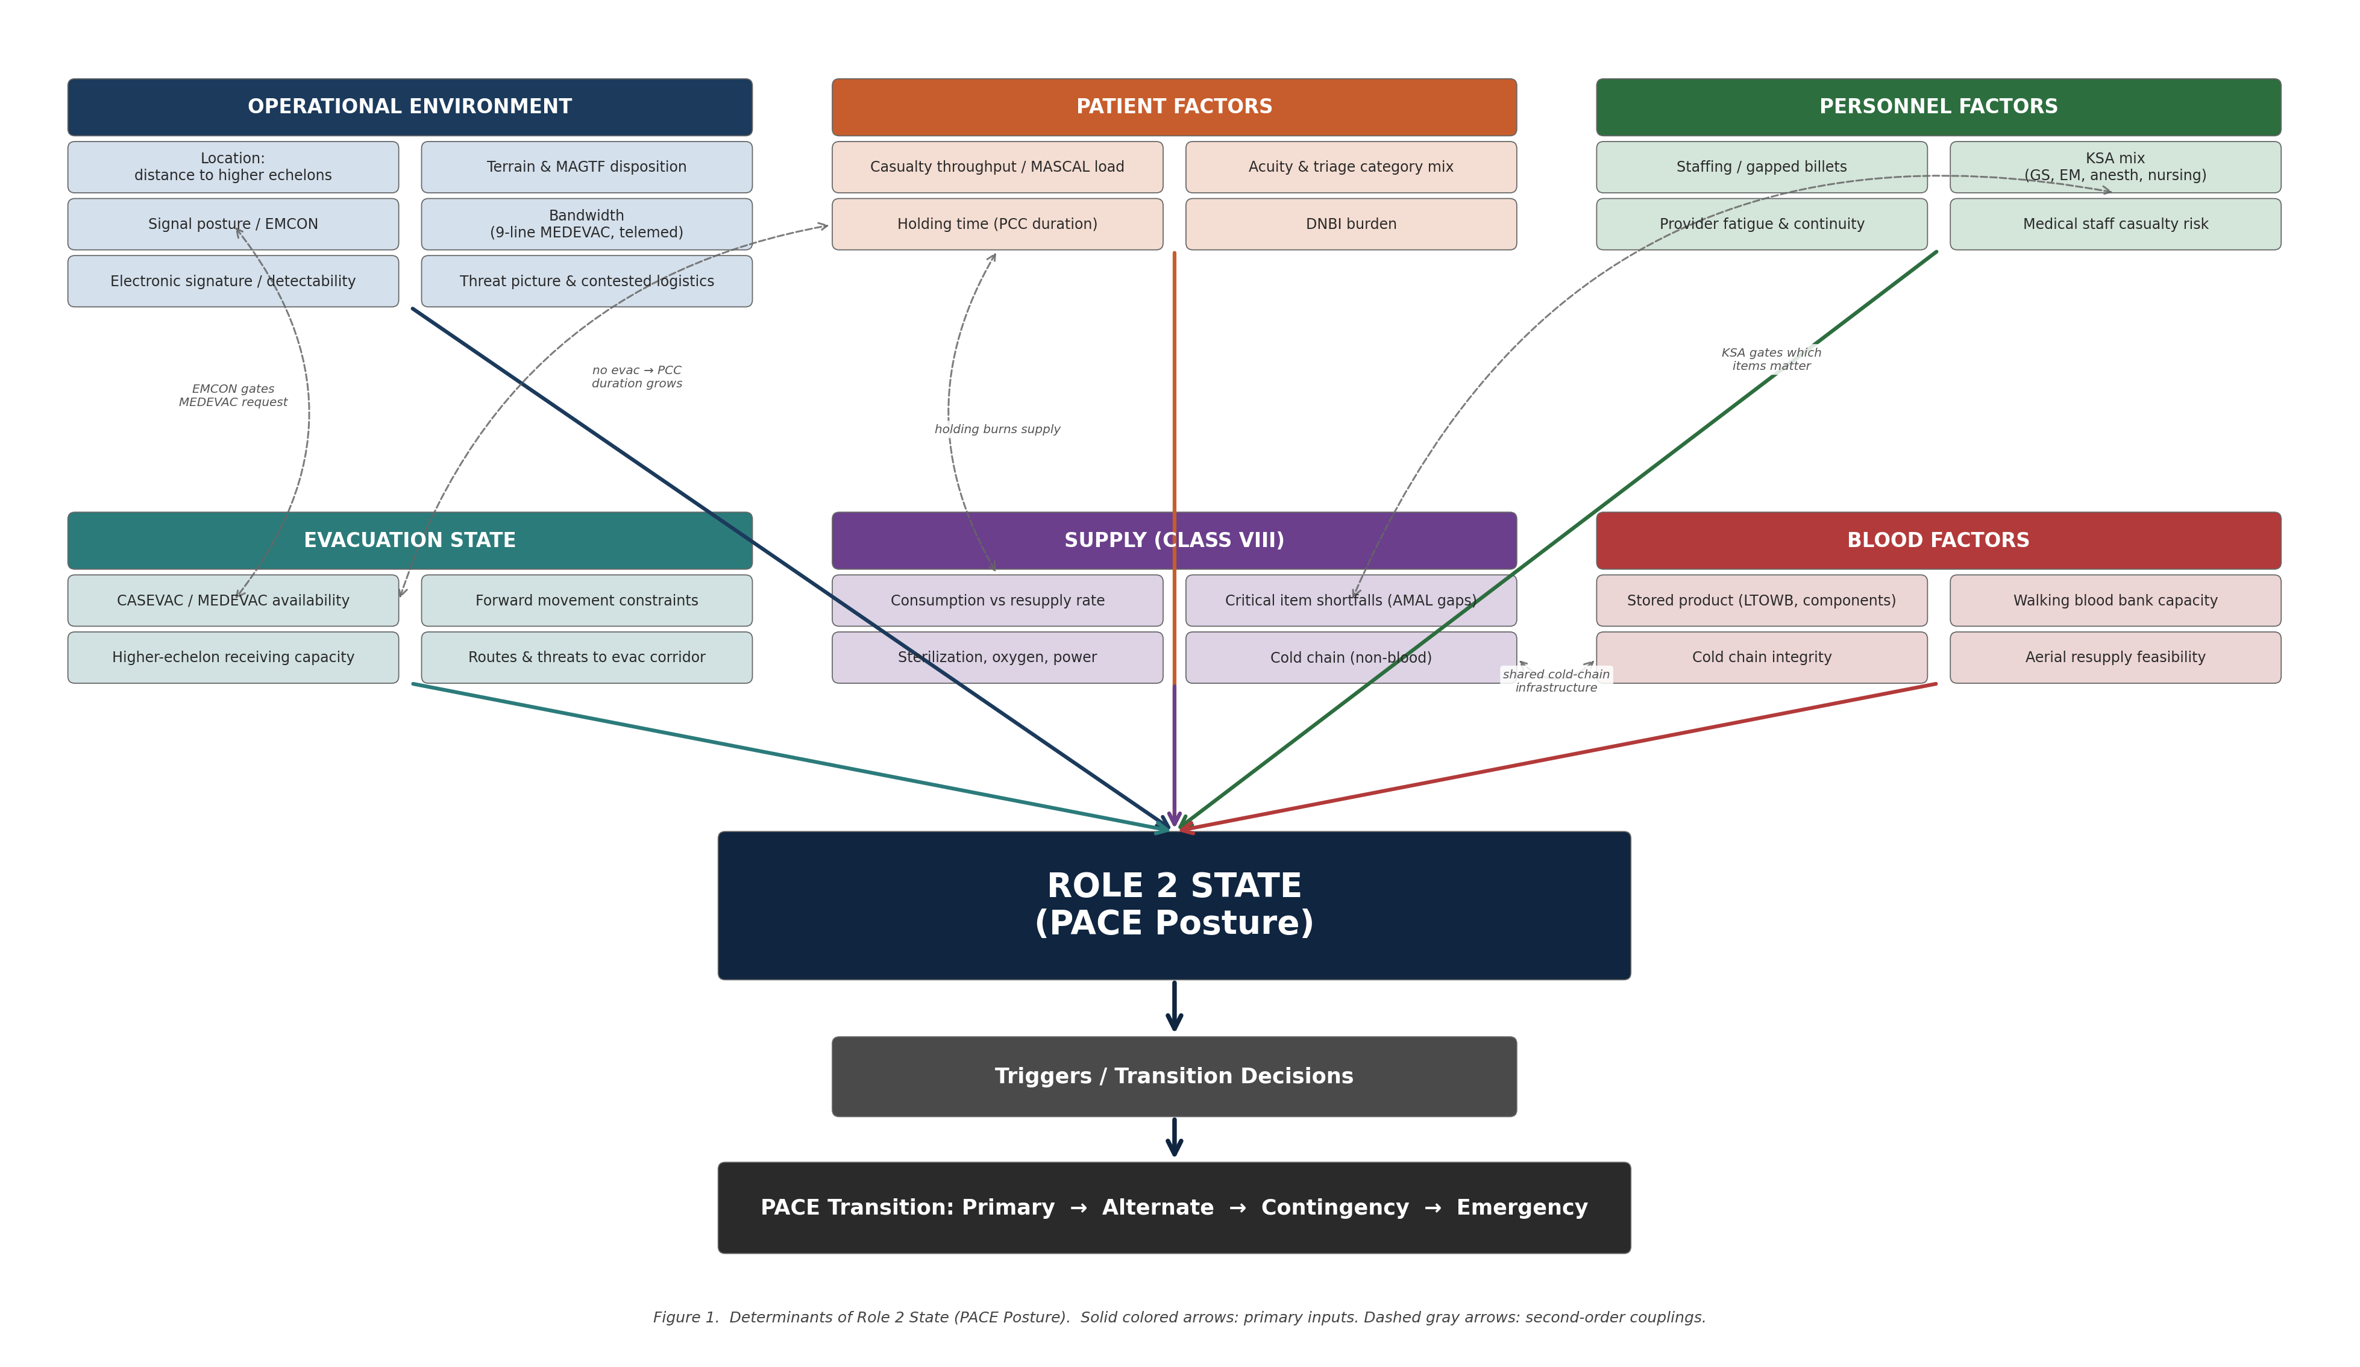
Figure 1. Determinants of Role 2 State (PACE Posture). Solid colored arrows: primary inputs from each factor cluster. Dashed gray arrows: second-order couplings. Downstream: state → triggers → PACE transition.
§4 IMPLICATIONS AND PATH TO ADOPTION (~350 w)
Frame: Each implication discharges one or more of the three imperatives.
- Pre-deployment workup: CSC PACE brief in every Role 2 workup, alongside MASCAL drills. [OPERATIONAL + MORAL]
- Authority pre-designation: CO/CMO pre-authorize transitions; moral burden becomes institutional. [16] [MORAL + ETHICAL]
- Resupply prioritization signal: PACE state communicates to higher echelons which finite assets restore which capability. [OPERATIONAL]
- QI persistence: JTS CPGs as measuring stick; QI tracking persists into degraded operations. [ETHICAL — accountability]
- Recovery planning: each PACE state has named recovery triggers; degradation is reversible by design. [ETHICAL — proportionality + duty to care]
- Limitations: conceptual until exercise-validated; trigger thresholds need empirical refinement; allied integration (NATO AJP-4.10, ABCANZ) is open work. [23]
CONCLUSION (~200 w)
- Restate thesis: adopting CSC for LSCO is a single imperative with three faces.
- Operational: a Marine division that has rehearsed PACE-mapped CSC before first contact will allocate, substitute, and recover better than one that has not.
- Moral: providers will come home with less moral injury for having operated within an institutional framework, not against its absence.
- Ethical: the force will hold a defensible position — fair, transparent, accountable, proportionate — when scarcity decisions are reviewed after the fact.
- Direct call: integrate CSC PACE into Role 2 workups, the commander’s common operating picture, and joint medical doctrine.
REFERENCES (target 30–35; staged by section)
Foundational CSC (§2 anchors)
4. Institute of Medicine. Guidance for Establishing Crisis Standards of Care for Use in Disaster Situations. National Academies Press; 2009.
5. Institute of Medicine. Crisis Standards of Care: A Systems Framework for Catastrophic Disaster Response. National Academies Press; 2012. [Hanfling co-edited]
15. Hick JL, Barbera JA, Kelen GD. Refining surge capacity: conventional, contingency, and crisis capacity. Disaster Med Public Health Prep. 2009;3(2 Suppl):S59–S67.
16. Hick JL, Hanfling D, Wynia MK, Pavia AT. Duty to plan: health care, crisis standards of care, and novel coronavirus SARS-CoV-2. NAM Perspectives. 2020.
Mass critical care / triage (§1)
6. Iserson KV, Moskop JC. Triage in medicine, part I. Ann Emerg Med. 2007;49(3):275–281.
7. Kelen GD, Kraus CK, McCarthy ML, et al. Inpatient disposition classification for the creation of hospital surge capacity. Lancet. 2006;368:1984–1990.
8. Lerner EB, Schwartz RB, Coule PL, et al. Mass casualty triage: an evaluation of the data and development of a proposed national guideline (SALT). Disaster Med Public Health Prep. 2008;2(Suppl 1):S25–S34.
—. Christian MD, Sprung CL, King MA, et al. Triage: care of the critically ill and injured during pandemics and disasters. Chest. 2014;146(4 Suppl):e61S–e74S.
Combat casualty care / LSCO
1. Joint Publication 4-02. Joint Health Services.
2. Marine Corps Tentative Manual for Expeditionary Advanced Base Operations.
3. Headquarters, Department of the Army. Field Manual 4-0, Sustainment Operations. (defines contested logistics environment)
3a. Headquarters Marine Corps. Installations and Logistics 2030. February 2023. (USMC contested logistics framing)
9. Eastridge BJ, Mabry RL, Seguin P, et al. Death on the battlefield (2001–2011): implications for the future of combat casualty care. J Trauma Acute Care Surg. 2012;73(6 Suppl 5):S431–S437.
10. Holcomb JB. Transport time and preoperating room hemostatic interventions. J Trauma. 2017.
11. Keenan S, Riesberg JC. Prolonged field care: beyond the “golden hour.” Wilderness Environ Med. 2017;28(2S):S135–S139.
12. Joint Trauma System. Prolonged Casualty Care Guidelines (CPG ID: 91). Lead authors Remley M, Loos P, Riesberg J. 21 December 2021.
17. MCRP 3-40A.5. Health Service Support Operations.
JTS / doctrine (§3 anchors)
18. Joint Publication 6-0. Joint Communications System. (PACE methodology)
19. Joint Trauma System. Damage Control Resuscitation in Prolonged Field Care (CPG ID: 73). 1 October 2018. (representative “minimum, better, best” tiering format; same format used in Burn Care CPG ID 12 [10 June 2025], PCC Guidelines CPG ID 91, TBI in PFC CPG, Nursing Interventions in PCC CPG ID 70)
20. Defense Health Agency / Joint Operational Medicine Information Systems. Medical Common Operating Picture (MedCOP) Fact Sheet. health.mil Reference Center, 2024.
21. U.S. Army. Army Medicine integrates point-of-injury battlefield medical software (BATDOK-J) into Maven Smart System. JRTC Rotation 25-11, September 2025. Doctrinal stance: “Medical data must be integrated into the commander’s common operating picture, not a separate medical COP.”
22. MARADMIN 424/25. Announcement of Maven Smart System Licensing for Marine Corps. 9 September 2025. (originating I MEF UUNS #24296UA, 11 September 2024)
23. NATO AJP-4.10. Allied Joint Doctrine for Medical Support.
Moral injury (§1–§2 thread)
13. Litz BT, Stein N, Delaney E, et al. Moral injury and moral repair in war veterans. Clin Psychol Rev. 2009;29(8):695–706.
14. Shay J. Moral injury. Psychoanal Psychol. 2014;31(2):182–191.
25. Trichilo VG, Mitchell CC, Halat MA, et al. Characterizing moral injury and distress in US military surgeons deployed to far-forward combat environments in Afghanistan and Iraq. JAMA Netw Open. 2023;6(2):e2256128.
LSCO operational data (§1 anchor for OPERATIONAL pillar)
24. Remley MA, Riley K, Kotwal RS, et al. Casualty care implications of large-scale combat operations. J Trauma Acute Care Surg. 2023;95(2S Suppl 1):S180–S184. (CSIS Taiwan-invasion wargame: ~3,200 KIA, ~6,960 personnel casualties in 3 weeks; ~140 casualties/day; loss of air superiority precludes golden-hour evacuation for most wounded)
Virtue ethics in military medicine (§3 bridge)
26. Gross ML. Bioethics and Armed Conflict: Moral Dilemmas of Medicine and War. MIT Press; 2006. (virtue ethics framework for military medical practice; moral psychology of practitioners holding scarcity decisions)

