Quote

Quote Name: XXX

Customer Project No: XX123456 Version No: V1R2

|  |  |  |  |
| --- | --- | --- | --- |
| **Release Date:** | **XX/XX/XXXX** | **Expiry Date:** | **XX/XX/XXXX** |
| Customer Business Unit Contact Name: | | XXXX | |
| Customer Business Unit Contact Number: | | XXXX XXX XXX | |
| Customer Business Unit Contact Email: | | XX@CUSTOMER.com.au | |

Quote Terms and Conditions

This Quote and any work performed as a result shall be governed by the terms and conditions of the Master Services Agreement between Customer and Supplier dated 29 April 2011 (MSA).

****Quote Confidentiality Statement****

The content of this Quote, including any supporting information provided in connection with this Quote, is the commercially valuable confidential information of Supplier and may only be used by Customer for the evaluation of the proposed solution. The content of this Quote and supporting information is governed by the terms of Part P, clause 69 (Confidentiality) of the MSA.

****Intellectual**** Property

All intellectual property owned by Supplier and/or its third party suppliers will remain with its respective owner subject to Part P, Clause 71 of the MSA.

****Tax Statement****

Unless otherwise expressly stated, all prices in this Quote are exclusive of GST.

# Customer Service Order

Supplier has prepared this Quote in response to Customer Service Order No. XX123456 and subsequent clarification of requirements via discussions and meetings held between Customer and Supplier summarised below.

## ****Customer Request and Scope confirmation:****

**Background**

On September 3, 1973 6:28 pm and 32 sec. a blue fly of the Calliphorides species, whose wings can flutter 14670 times per minute landed in Saint-Vincent Street, Montmartre. At the exact same second, outside a restaurant, the wind was sweeping in under a tablecloth, causing the glasses to dance without anybody noticing it.

## ****Customer Executive Summary and Benefits Statement****

On September 3, 1973 6:28 pm and 32 sec. a blue fly of the Calliphorides species, whose wings can flutter 14670 times per minute landed in Saint-Vincent Street, Montmartre. At the exact same second, outside a restaurant, the wind was sweeping in under a tablecloth, causing the glasses to dance without anybody noticing it.

# Scope Overview

## ****Service Description****

On September 3, 1973 6:28 pm and 32 sec. a blue fly of the Calliphorides species, whose wings can flutter 14670 times per minute landed in Saint-Vincent Street, Montmartre. At the exact same second, outside a restaurant, the wind was sweeping in under a tablecloth, causing the glasses to dance without anybody noticing it.

## ****Solution Architecture - Existing****

On September 3, 1973 6:28 pm and 32 sec. a blue fly of the Calliphorides species, whose wings can flutter 14670 times per minute landed in Saint-Vincent Street, Montmartre. At the exact same second, outside a restaurant, the wind was sweeping in under a tablecloth, causing the glasses to dance without anybody noticing it.

**Contractor QSAFE Data Centre Devices**

|  |  |  |  |
| --- | --- | --- | --- |
| **IBM Components** | | | |
| **Device Name** | **Manufacturer** | **Model** | **Location** |
| XXX | YYY | ZZZ | LLL |
| XXX | YYY | ZZZ | LLL |
| XXX | YYY | ZZZ | LLL |
| XXX | YYY | ZZZ | LLL |
| XXX | YYY | ZZZ | LLL |
| XXX | YYY | ZZZ | LLL |
| XXX | YYY | ZZZ | LLL |
| XXX | YYY | ZZZ | LLL |
| XXX | YYY | ZZZ | LLL |
| XXX | YYY | ZZZ | LLL |
| XXX | YYY | ZZZ | LLL |
| XXX | YYY | ZZZ | LLL |
| XXX | YYY | ZZZ | LLL |
| XXX | YYY | ZZZ | LLL |
| XXX | YYY | ZZZ | LLL |
| XXX | YYY | ZZZ | LLL |
| XXX | YYY | ZZZ | LLL |
| XXX | YYY | ZZZ | LLL |
| XXX | YYY | ZZZ | LLL |
| XXX | YYY | ZZZ | LLL |
| XXX | YYY | ZZZ | LLL |
| XXX | YYY | ZZZ | LLL |
| XXX | YYY | ZZZ | LLL |
| XXX | YYY | ZZZ | LLL |
|  |  |  |  |

**Table 1a. List of existing Contractor QSAFE Data Centre Devices**

**Supplier QSAFE Data Centre Devices**

|  |  |  |  |  |
| --- | --- | --- | --- | --- |
| **Supplier Components** | | | | |
| **Device Name** | **Manufacturer** | **Model** | **Location** |
| XXX | |  |  | |
| XXX | YYY | ZZZ | LLL | |
| XXX | YYY | ZZZ | LLL | |
| XXX | YYY | ZZZ | LLL | |
|  |  |  |  | |
| XXX | |  |  | |
| XXX | YYY | ZZZ | LLL | |
| XXX | YYY | ZZZ | LLL | |
| XXX | YYY | ZZZ | LLL | |
| XXX | YYY | ZZZ | LLL | |
| XXX | YYY | ZZZ | LLL | |
| XXX | YYY | ZZZ | LLL | |
|  |  |  |  | |
| XXX | |  |  | |
| XXX | YYY | ZZZ | LLL | |
| XXX | YYY | ZZZ | LLL | |
| XXX | YYY | ZZZ | LLL | |
|  |  |  |  | |
| XXX | |  |  | |
| XXX | YYY | ZZZ | LLL | |
| XXX | YYY | ZZZ | LLL | |
| XXX | YYY | ZZZ | LLL | |
| XXX | YYY | ZZZ | LLL | |
| XXX | YYY | ZZZ | LLL | |
| XXX | YYY | ZZZ | LLL | |
|  |  |  |  | |

**Table 1b. List of existing Supplier QSAFE Data Centre Devices**

The following table provides a high level breakdown of the services provided by the QSAFE environment. This includes a description of the firewall, associated zones and function.

|  |  |  |  |
| --- | --- | --- | --- |
| **LLL DC** | **LLL DC** | **Firewall** | **Description / Function** |
| **XXXX** | **XXXX** | **XXXX** | **XXXX** |
| **XXXX** | **XXXX** | **XXXX** | **XXXX** |
| **XXXX** | **XXXX** | **XXXX** | **XXXX** |
| **XXXX** | **XXXX** | **XXXX** | **XXXX** |
| **XXXX** | **XXXX** | **XXXX** | **XXXX** |

**Table 2. Firewall Devices by Business Function**

These QSAFE services will be migrated to the new environment maintaining the current separation of service through the use of Virtual Contexts in the proposed Cisco ASA Firewalls.

**Existing QSAFE Services Remaining in Place**

It should be noted that the following QQSAFE services will not be addressed as part of this proposal:

XXX

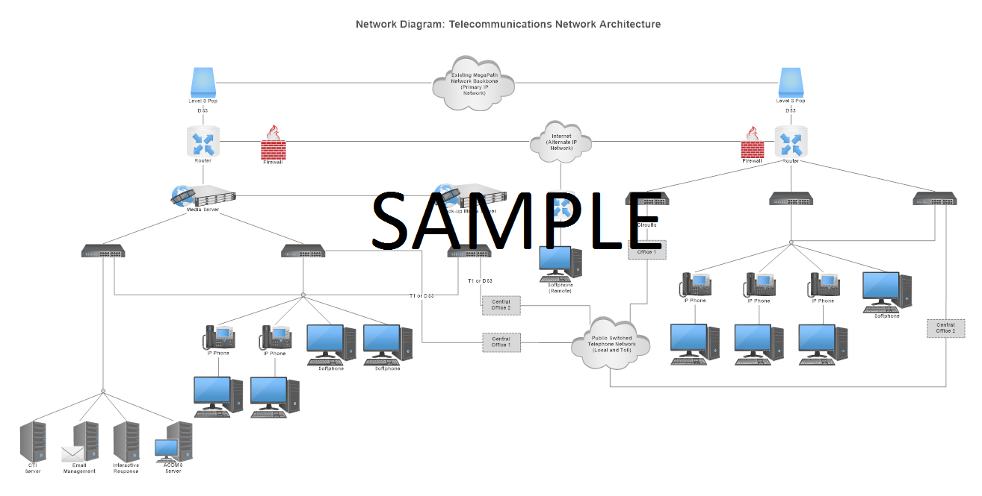

**Figure 1. Current High Level Architecture**

# Solution Design – New HA Internet Gateway

Lorem ipsum dolor sit amet, consectetur adipiscing elit, sed do eiusmod tempor incididunt ut labore et dolore magna aliqua. Ut enim ad minim veniam, quis nostrud exercitation ullamco laboris nisi ut aliquip ex ea commodo consequat. Duis aute irure dolor in reprehenderit in voluptate velit esse cillum dolore eu fugiat nulla pariatur. Excepteur sint occaecat cupidatat non proident, sunt in culpa qui officia deserunt mollit anim id est laborum

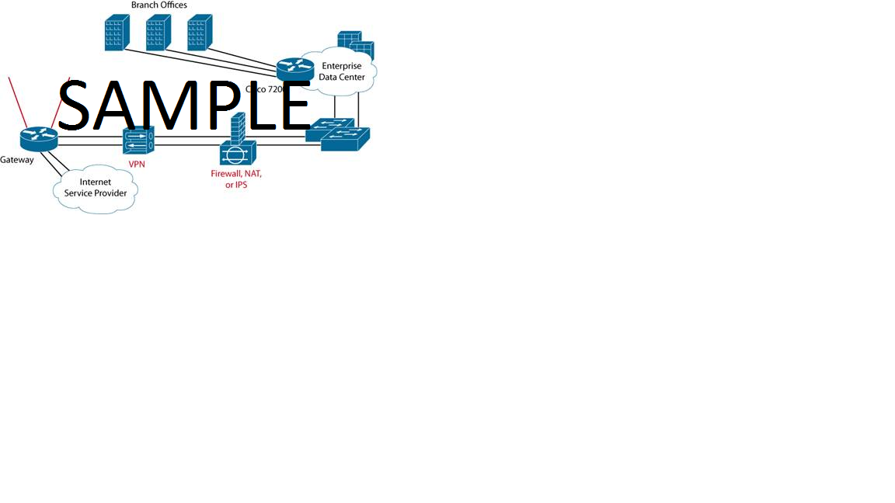

**Figure 4. High Level Internet Gateway Diagram**

Lorem ipsum dolor sit amet, consectetur adipiscing elit, sed do eiusmod tempor incididunt ut labore et dolore magna aliqua. Ut enim ad minim veniam, quis nostrud exercitation ullamco laboris nisi ut aliquip ex ea commodo consequat. Duis aute irure dolor in reprehenderit in voluptate velit esse cillum dolore eu fugiat nulla pariatur. Excepteur sint occaecat cupidatat non proident, sunt in culpa qui officia deserunt mollit anim id est laborum

|  |  |  |
| --- | --- | --- |
| **Current QSAFE Zone** | **Primary DC Context** | **Secondary DC Context** |
| **XXX** | LLL | LLL |
| **XXX** | LLL | LLL |
| **XXX** | LLL | LLL |
| **XXX** | LLL | LLL |
| **XXX** | LLL | LLL |

**Table 3. Proposed view of Security Contexts for QSAFE Zones per Data Centre**

## ****Current and Future Capacity Statement****

Lorem ipsum dolor sit amet, consectetur adipiscing elit, sed do eiusmod tempor incididunt ut labore et dolore magna aliqua. Ut enim ad minim veniam, quis nostrud exercitation ullamco laboris nisi ut aliquip ex ea commodo consequat. Duis aute irure dolor in reprehenderit in voluptate velit esse cillum dolore eu fugiat nulla pariatur. Excepteur sint occaecat cupidatat non proident, sunt in culpa qui officia deserunt mollit anim id est laborum



**Figure 5. Current Architecture Replacement View**

## ****Functional Design Components – New HA Internet Gateway****

**SWITCHES**

Lorem ipsum dolor sit amet, consectetur adipiscing elit, sed do eiusmod tempor incididunt ut labore et dolore magna aliqua. Ut enim ad minim veniam, quis nostrud exercitation ullamco laboris nisi ut aliquip ex ea commodo consequat. Duis aute irure dolor in reprehenderit in voluptate velit esse cillum dolore eu fugiat nulla pariatur. Excepteur sint occaecat cupidatat non proident, sunt in culpa qui officia deserunt mollit anim id est laborum

|  |  |
| --- | --- |
| **Feature** | **Specification** |
| Performance | |
| XXX | YYY |
| XXX | YYY |
| Bandwidth | |
| XXX | YYY |
| XXX | YYY |
| Scaling | |
| XXX | YYY |
| XXX | YYY |
| XXX | YYY |

**SWITCHES**

Lorem ipsum dolor sit amet, consectetur adipiscing elit, sed do eiusmod tempor incididunt ut labore et dolore magna aliqua. Ut enim ad minim veniam, quis nostrud exercitation ullamco laboris nisi ut aliquip ex ea commodo consequat. Duis aute irure dolor in reprehenderit in voluptate velit esse cillum dolore eu fugiat nulla pariatur. Excepteur sint occaecat cupidatat non proident, sunt in culpa qui officia deserunt mollit anim id est laborum

## ****Failover Operation****

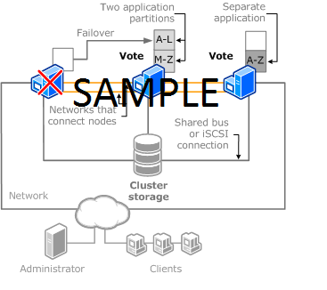

**Figure 6. Internet Gateway – Failover Diagram**

## ****Failover / Redundancy****

Lorem ipsum dolor sit amet, consectetur adipiscing elit, sed do eiusmod tempor incididunt ut labore et dolore magna aliqua. Ut enim ad minim veniam, quis nostrud exercitation ullamco laboris nisi ut aliquip ex ea commodo consequat. Duis aute irure dolor in reprehenderit in voluptate velit esse cillum dolore eu fugiat nulla pariatur. Excepteur sint occaecat cupidatat non proident, sunt in culpa qui officia deserunt mollit anim id est laborum

## ****Connections****

Lorem ipsum dolor sit amet, consectetur adipiscing elit, sed do eiusmod tempor incididunt ut labore et dolore magna aliqua. Ut enim ad minim veniam, quis nostrud exercitation ullamco laboris nisi ut aliquip ex ea commodo consequat. Duis aute irure dolor in reprehenderit in voluptate velit esse cillum dolore eu fugiat nulla pariatur. Excepteur sint occaecat cupidatat non proident, sunt in culpa qui officia deserunt mollit anim id est laborum

## ****Partner Connections****

Lorem ipsum dolor sit amet, consectetur adipiscing elit, sed do eiusmod tempor incididunt ut labore et dolore magna aliqua. Ut enim ad minim veniam, quis nostrud exercitation ullamco laboris nisi ut aliquip ex ea commodo consequat. Duis aute irure dolor in reprehenderit in voluptate velit esse cillum dolore eu fugiat nulla pariatur. Excepteur sint occaecat cupidatat non proident, sunt in culpa qui officia deserunt mollit anim id est laborum

## ****Un-trusted Access****

Lorem ipsum dolor sit amet, consectetur adipiscing elit, sed do eiusmod tempor incididunt ut labore et dolore magna aliqua. Ut enim ad minim veniam, quis nostrud exercitation ullamco laboris nisi ut aliquip ex ea commodo consequat. Duis aute irure dolor in reprehenderit in voluptate velit esse cillum dolore eu fugiat nulla pariatur. Excepteur sint occaecat cupidatat non proident, sunt in culpa qui officia deserunt mollit anim id est laborum

## New Services - Default Internet Gateway

Lorem ipsum dolor sit amet, consectetur adipiscing elit, sed do eiusmod tempor incididunt ut labore et dolore magna aliqua. Ut enim ad minim veniam, quis nostrud exercitation ullamco laboris nisi ut aliquip ex ea commodo consequat. Duis aute irure dolor in reprehenderit in voluptate velit esse cillum dolore eu fugiat nulla pariatur. Excepteur sint occaecat cupidatat non proident, sunt in culpa qui officia deserunt mollit anim id est laborum

## Internet Gateway Solution Inclusions Overview

Lorem ipsum dolor sit amet, consectetur adipiscing elit, sed do eiusmod tempor incididunt ut labore et dolore magna aliqua. Ut enim ad minim veniam, quis nostrud exercitation ullamco laboris nisi ut aliquip ex ea commodo consequat. Duis aute irure dolor in reprehenderit in voluptate velit esse cillum dolore eu fugiat nulla pariatur. Excepteur sint occaecat cupidatat non proident, sunt in culpa qui officia deserunt mollit anim id est laborum

## Service Implementation

**Supplier will:**

Lorem ipsum dolor sit amet, consectetur adipiscing elit, sed do eiusmod tempor incididunt ut labore et dolore magna aliqua. Ut enim ad minim veniam, quis nostrud exercitation ullamco laboris nisi ut aliquip ex ea commodo consequat. Duis aute irure dolor in reprehenderit in voluptate velit esse cillum dolore eu fugiat nulla pariatur. Excepteur sint occaecat cupidatat non proident, sunt in culpa qui officia deserunt mollit anim id est laborum

## ****Ongoing Support – QSAFE Process****

Lorem ipsum dolor sit amet, consectetur adipiscing elit, sed do eiusmod tempor incididunt ut labore et dolore magna aliqua. Ut enim ad minim veniam, quis nostrud exercitation ullamco laboris nisi ut aliquip ex ea commodo consequat. Duis aute irure dolor in reprehenderit in voluptate velit esse cillum dolore eu fugiat nulla pariatur. Excepteur sint occaecat cupidatat non proident, sunt in culpa qui officia deserunt mollit anim id est laborum

# Service Management

## Service Management Toolsets

Lorem ipsum dolor sit amet, consectetur adipiscing elit, sed do eiusmod tempor incididunt ut labore et dolore magna aliqua. Ut enim ad minim veniam, quis nostrud exercitation ullamco laboris nisi ut aliquip ex ea commodo consequat. Duis aute irure dolor in reprehenderit in voluptate velit esse cillum dolore eu fugiat nulla pariatur. Excepteur sint occaecat cupidatat non proident, sunt in culpa qui officia deserunt mollit anim id est laborum

Overall Connectivity Architecture

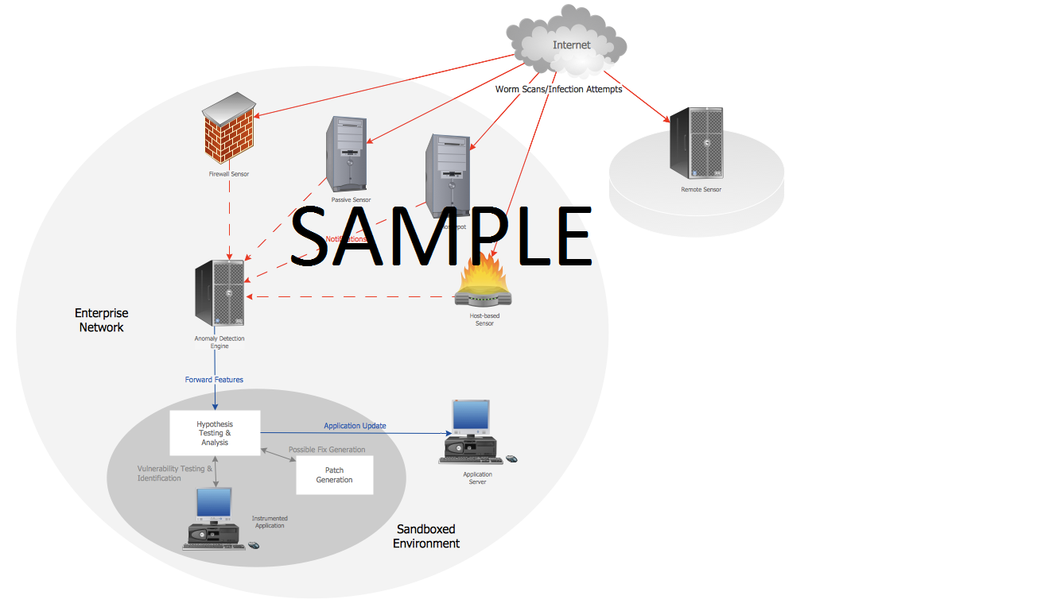

**Figure 12. Service Management Architecture**

### System Configuration

### Service Provisioning

Lorem ipsum dolor sit amet, consectetur adipiscing elit, sed do eiusmod tempor incididunt ut labore et dolore magna aliqua. Ut enim ad minim veniam, quis nostrud exercitation ullamco laboris nisi ut aliquip ex ea commodo consequat. Duis aute irure dolor in reprehenderit in voluptate velit esse cillum dolore eu fugiat nulla pariatur. Excepteur sint occaecat cupidatat non proident, sunt in culpa qui officia deserunt mollit anim id est laborum

### Network Monitoring

Lorem ipsum dolor sit amet, consectetur adipiscing elit, sed do eiusmod tempor incididunt ut labore et dolore magna aliqua. Ut enim ad minim veniam, quis nostrud exercitation ullamco laboris nisi ut aliquip ex ea commodo consequat. Duis aute irure dolor in reprehenderit in voluptate velit esse cillum dolore eu fugiat nulla pariatur. Excepteur sint occaecat cupidatat non proident, sunt in culpa qui officia deserunt mollit anim id est laborum

## Events Monitored by XXXX

Lorem ipsum dolor sit amet, consectetur adipiscing elit, sed do eiusmod tempor incididunt ut labore et dolore magna aliqua. Ut enim ad minim veniam, quis nostrud exercitation ullamco laboris nisi ut aliquip ex ea commodo consequat. Duis aute irure dolor in reprehenderit in voluptate velit esse cillum dolore eu fugiat nulla pariatur. Excepteur sint occaecat cupidatat non proident, sunt in culpa qui officia deserunt mollit anim id est laborum

## Thresholds monitored by XXXX

Lorem ipsum dolor sit amet, consectetur adipiscing elit, sed do eiusmod tempor incididunt ut labore et dolore magna aliqua. Ut enim ad minim veniam, quis nostrud exercitation ullamco laboris nisi ut aliquip ex ea commodo consequat. Duis aute irure dolor in reprehenderit in voluptate velit esse cillum dolore eu fugiat nulla pariatur. Excepteur sint occaecat cupidatat non proident, sunt in culpa qui officia deserunt mollit anim id est laborum

# Dependencies and Assumptions

Lorem ipsum dolor sit amet, consectetur adipiscing elit, sed do eiusmod tempor incididunt ut labore et dolore magna aliqua. Ut enim ad minim veniam, quis nostrud exercitation ullamco laboris nisi ut aliquip ex ea commodo consequat. Duis aute irure dolor in reprehenderit in voluptate velit esse cillum dolore eu fugiat nulla pariatur. Excepteur sint occaecat cupidatat non proident, sunt in culpa qui officia deserunt mollit anim id est laborum

# Exclusions

Lorem ipsum dolor sit amet, consectetur adipiscing elit, sed do eiusmod tempor incididunt ut labore et dolore magna aliqua. Ut enim ad minim veniam, quis nostrud exercitation ullamco laboris nisi ut aliquip ex ea commodo consequat. Duis aute irure dolor in reprehenderit in voluptate velit esse cillum dolore eu fugiat nulla pariatur. Excepteur sint occaecat cupidatat non proident, sunt in culpa qui officia deserunt mollit anim id est laborum

# Lead Times

Lorem ipsum dolor sit amet, consectetur adipiscing elit, sed do eiusmod tempor incididunt ut labore et dolore magna aliqua. Ut enim ad minim veniam, quis nostrud exercitation ullamco laboris nisi ut aliquip ex ea commodo consequat. Duis aute irure dolor in reprehenderit in voluptate velit esse cillum dolore eu fugiat nulla pariatur. Excepteur sint occaecat cupidatat non proident, sunt in culpa qui officia deserunt mollit anim id est laborum

|  |  |
| --- | --- |
| **Activity** | **Estimated Duration in business weeks** |
| XXX | TTT |
| XXX | TTT |
| XXX | TTT |
| XXX | TTT |
| XXX | TTT |
| XXX | TTT |
| XXX | TTT |
| **Milestone 1 -** XXX | **Estimated Week T** |
| XXX | TTT |
| XXX | TTT |
| XXX | TTT |
| **Milestone 2 -** XXX | **Estimated Week T** |
| XXX | TTT |
| **Milestone 3 –** XXX | **Estimated Week T** |

**Delivery Approach**

Lorem ipsum dolor sit amet, consectetur adipiscing elit, sed do eiusmod tempor incididunt ut labore et dolore magna aliqua. Ut enim ad minim veniam, quis nostrud exercitation ullamco laboris nisi ut aliquip ex ea commodo consequat. Duis aute irure dolor in reprehenderit in voluptate velit esse cillum dolore eu fugiat nulla pariatur. Excepteur sint occaecat cupidatat non proident, sunt in culpa qui officia deserunt mollit anim id est laborum

# Customer Security Requirements

## Compliance certification

Lorem ipsum dolor sit amet, consectetur adipiscing elit, sed do eiusmod tempor incididunt ut labore et dolore magna aliqua. Ut enim ad minim veniam, quis nostrud exercitation ullamco laboris nisi ut aliquip ex ea commodo consequat. Duis aute irure dolor in reprehenderit in voluptate velit esse cillum dolore eu fugiat nulla pariatur. Excepteur sint occaecat cupidatat non proident, sunt in culpa qui officia deserunt mollit anim id est laborum

## Unmitigated Threats

Existing: Not applicable

Introduced: No

## Residual security Risks

None.

# 

# Quote Costs

Lorem ipsum dolor sit amet, consectetur adipiscing elit, sed do eiusmod tempor incididunt ut labore et dolore magna aliqua. Ut enim ad minim veniam, quis nostrud exercitation ullamco laboris nisi ut aliquip ex ea commodo consequat. Duis aute irure dolor in reprehenderit in voluptate velit esse cillum dolore eu fugiat nulla pariatur. Excepteur sint occaecat cupidatat non proident, sunt in culpa qui officia deserunt mollit anim id est laborum

22

|  |  |  |  |  |  |  |
| --- | --- | --- | --- | --- | --- | --- |
| **Once Off Charges** |  |  | |  | |  |
| Consultancy Services - GST Excl | Units | Unit Price | | Extended Price | |
| Programme Support/Implementation (Day - 8 hours) | 5 | 1198.2 | | $ 5,991.00 | |  |
| Programme Manager (Day - 8 hours) | 25 | 1120.43 | | $ 28,010.75 | |  |
| Project Manager (Day - 8 hours) | 120 | 1123.52 | | $ 134,822.40 | |  |
| Technical Consultant - Solution Designer (Day - 8 hours) | 90 | 1126.61 | | $ 101,394.90 | |  |
| Test Engineer (Day - 8 hours) | 10 | 1129.7 | | $ 11,297.00 | |  |
| Architect (Day - 8 hours) | 60 | 1132.79 | | $ 67,967.40 | |  |
|  |  |  | |  | |  |
| **Consultancy Services Sub-Total** | ① | | | $ 349,483.45 | |  |
| Once Off Charges - Hard MAC - GST Excl | Quantity | Unit Price | | Extended Price | |  |
| Security Device Complex - Install or Relocate | 5 | $ 1,198.20 | | $ 5,991.00 | |  |
| Security Device - Decommission | 25 | $ 1,120.43 | | $ 28,010.75 | |  |
| Security Device - Upgrade | 120 | $ 1,123.52 | | $ 134,822.40 | |  |
|  |  |  | |  | |  |
| **Hard MAC Sub-Total** | ② | | | $ 168,824.15 | |  |
| One Time Charge - Infrastructure - GST Excl | Quantity | Unit Price | | Extended Price | |  |
| Cisco, SFP-10G-SR, 10GBASE-SR SFP Module | 5 | $ 1,198.20 | | $ 5,991.00 | |  |
| Cisco, SFP-10G-LR, 10GBASE-LR SFP Module | 25 | $ 1,120.43 | | $ 28,010.75 | |  |
| Cisco, Catalyst 4500 E-Series Supervisor 8-E | 120 | $ 1,123.52 | | $ 134,822.40 | |  |
|  |  |  | |  | |  |
| **Infrastructure Sub-Total** | ③ | | | $ 168,824.15 | |  |
| Once Off Charges - Ad-Hoc - GST Excl | Quantity | Unit Price | | Extended Price | |  |
| **Ad-Hoc Sub-Total** | ④ | | | $ - | |  |
| Once Off Charges - Ad-Hoc - GST Excl | Quantity | Unit Price | | Extended Price | |  |
| CSG Data Centre work allowance | 1 | 30,000 | | $ 30,000.00 | |  |
|  |  |  | |  | |  |
| **Other Sub-Total** | ⑤ | | | $ 717,131.75 | |  |
| Total Once Off Charge - GST Excl |  |  | |  | |  |
| ①+②+③+④+⑤=⑥ | | | | $1,404,263.50 | |  |
| **Ongoing Resource Unit Charges** |  |  |  | |  | |
| Additional Resource Units - GST Excl | Quantity | RU Price (per month) | | Unit Extended Price | | Total Contract Value |
| Firewall - Infrastructure - New - Complex (ASA5585) | 2 | $ 1,487.33 | | $ 2,974.66 | | $ 142,783.68 |
| Firewall - Support - Complex | 2 | $ 434.99 | | $ 869.98 | | $ 41,759.04 |
| Firewall - Maintenance - Complex - Gold | 2 | $ 4,930.39 | | $ 9,860.78 | | $ 473,317.44 |
| Firewall - Infrastructure - New - Complex (ASA5585) | 2 | $ - | | $ - | | $ - |
| Firewall - Support - Complex | 2 | $ - | | $ - | | $ - |
| Firewall - Maintenance - Complex - Gold | 2 | $ - | | $ - | | $ - |
| Router - Infrastructure - New - Complex (Cat4506) | 4 | $ 493.34 | | $ 1,973.36 | | $ 94,721.28 |
| Router - Support - Complex | 4 | $ 303.40 | | $ 1,213.60 | | $ 58,252.80 |
| Router - Maintenance - Complex - Gold | 4 | $ 394.20 | | $ 1,576.80 | | $ 75,686.40 |
| Router - Infrastructure - New - Complex (ASR1002) | 2 | $ - | | $ - | | $ - |
| Router - Support - Complex | 2 | $ - | | $ - | | $ - |
| Router - Maintenance - Complex - Gold | 2 | $ - | | $ - | | $ - |
| Switch - Infrastructure - New (Cat3850) | 2 | $ 1,394.34 | | $ 2,788.68 | | $ 133,856.64 |
| Switch - Support - Medium | 2 | $ 439.49 | | $ 878.98 | | $ 42,191.04 |
| Switch - Maintenance - Medium | 2 | $ 4,329.49 | | $ 8,658.98 | | $ 415,631.04 |
| TWS Service 3 - Data Centre - Incremental Internet Gateway | 1 | $ 3,493.43 | | $ 3,493.43 | | $ 167,684.64 |
|  |  |  | |  | |  |
| **Additional Resource Units Sub-total** | ⑦ | | | $ 34,289.25 | | $1,645,884.00 |
| New Resource Units (Subject to Contract Variation) | Quantity | RU Price (per month) | | Unit Extended Price | | Total Contract Value |
| **New Resource Units Sub-Total** | ⑧ | | | $ - | | $ - |
| Reduced Resource Units | Quantity | RU Price (per month) | | Unit Extended Price | | Total Contract Value |
| Medium - Switch - Existing - Infrastructure | 50 | $ 193.40 | | $ 9,670.00 | | $ 464,160.00 |
| Medium - Switch - Existing - Support | 50 | $ 394.20 | | $ 19,710.00 | | $ 946,080.00 |
| Medium - Switch - Existing - Maintenance | 50 | $ 493.48 | | $ 24,674.00 | | $1,184,352.00 |
|  |  |  | |  | |  |
| **Reduced Resource Units Sub-Total** | ⑨ | | | $ 54,054.00 | | $2,594,592.00 |
| Total Ongoing Resource Unit Charges (Excluding GST) |  |  | | (per month) | | Total Contract Value |
| ⑦+⑧=⑩ | | | | $ 34,289.25 | | $1,645,884.00 |
| Financial Approval Total (Including GST) |  | Amount GST Excl $AU | | Amount GST Incl $AU | |  |
|  | ⑥+⑩ | $ 1,438,552.75 | | $3,050,147.50 | |  |
| Purchase Order Total (Including GST) |  | PO Amount GST Excl $AU | | PO Amount GST Incl $AU | |  |
|  | ⑥ | $ 1,404,263.50 | | $4,454,411.00 | |  |

# Revision List

|  |  |  |  |  |
| --- | --- | --- | --- | --- |
| **Version** | **Date Released** | **Modifications / Comments** | **Author(s)** | **Reviewer(s) / Approver(s)** |
| 0.1 | XX/XX/XX | XXX | XXX | XXX |
| 1.0 | XX/XX/XX | XXX | XXX | XXX |
| V1R2 | XX/XX/XX | XXX | XXX |  |
|  |  |  |  |  |

# ****Appendix 1: Bill of Materials****

Internet/Core Firewall and DMZ/Services Architecture

New Equipment

|  |  |  |  |  |
| --- | --- | --- | --- | --- |
| **Line Number** | **Item Name** | **Description** | **Quantity** | **List Price - Each AUD$** |
| **1.0** | **WS-C4506E** | Cat4500 E-Series 6-Slot Chassis fan no ps | 2 | $5,123.45 |
| 1.1 | WS-X4748-RJ45-E | Catalyst 4500 E-Series 48-Port 10/100/1000 Non-Blocking | 2 | $22,003.43 |
| 1.2 | WS-X4748-RJ45-E | Catalyst 4500 E-Series 48-Port 10/100/1000 Non-Blocking | 2 | $22,003.43 |
| 1.3 | WS-X45-SUP8-E | Catalyst 4500 E-Series Supervisor 8-E | 2 | $5,594.43 |
| 1.4 | S8EUK9-33-1511XO | CAT4500e SUP8e Universal Crypto Image | 2 | $4,003.43 |
| 1.5 | PWR-C45-1400AC | Catalyst 4500 1400W AC Power Supply (Data Only) | 2 | $4,939.40 |
| 1.6 | CAB-A3112-C19-AUS | AS-3112 to EIC-C19 14ft Aus | 4 | $543.43 |
| 1.7 | PWR-C45-1400AC/2 | Catalyst 4500 1400W AC Power Supply Reduntant (Data Only) | 2 | $9,065.59 |
| 1.8 | C4500E-IP-ES | Paper IP to Ent Services License | 2 | $43,285.50 |
|  |  |  |  |  |
| **2.0** | **WS-C4506-E** | Cat4500 E-Series 6-Slot Chassis fan no ps | 2 | $5,123.45 |
| 2.1 | WS-X4748-RJ45-E | Catalyst 4500 E-Series 48-Port 10/100/1000 Non-Blocking | 2 | $22,003.43 |
| 2.2 | WS-X4748-RJ45-E | Catalyst 4500 E-Series 48-Port 10/100/1000 Non-Blocking | 2 | $22,003.43 |
| 2.3 | WS-X45-SUP8-E | Catalyst 4500 E-Series Supervisor 8-E | 2 | $5,594.43 |
| 2.4 | S8EUK9-33-1511XO | CAT4500e SUP8e Universal Crypto Image | 2 | $4,003.43 |
| 2.5 | PWR-C45-1400AC | Catalyst 4500 1400W AC Power Supply (Data Only) | 2 | $4,939.40 |
| 2.6 | CAB-A3112-C19-AUS | AS-3112 to EIC-C19 14ft Aus | 4 | $543.43 |
| 2.7 | PWR-C45-1400AC/2 | Catalyst 4500 1400W AC Power Supply Reduntant (Data Only) | 2 | $9,065.59 |
| 2.8 | C4500E-IP-ES | Paper IP to Ent Services License | 2 | $43,285.50 |
|  |  |  |  |  |
| **3.0** | **ASA5585-S40P40-K9** | 3DES/AES | 4 | $432,943.49 |
| 3.1 | SF-ASA-X-9.1-K8 | SM | 4 | $4,329.43 |
| 3.2 | ASA5585-PWR-AC | ASA 5585-X AC Power Supply | 4 | $9,494.44 |
| 3.3 | CAB-AC-16A-AUS | Power Cord 250VAC 16A Australia C19 | 8 | $0.00 |
| 3.4 | ASA5585-BLANK-HD | ASA 5585-X Hard Drive Blank Slot Cover | 8 | $4,324.34 |
| 3.5 | ASA-IPS-40-INC-K9 | ASA 5585-X IPS Security Services Processor-40 with 6GE4SEP+ | 4 | $0.00 |
| 3.6 | ASA-SSP-40-INC | ASA 5585-X Security Services Processor-40 with 6GE 4SFP+ | 4 | $543.54 |
| 3.7 | ASA5500-ENCR-K9 | ASA 5500 Strong Encryption License (3DES/AES) | 4 | $0.00 |
| 3.8 | ASA5585-BLANK-HD | ASA 5585-X Hard Drive Blank Slot Cover | 8 | $4,324.34 |
| 3.9 | SF-ASA-IPS-7.1-K9 | ASA 550-X IPS Software 7.1 for IPS SSP | 4 | $0.00 |
| 3.10 | ASA5585-SEC-PL | ASA 5585-X AC Power Supply | 4 | $0.00 |
| 3.11 | ASA5500-SC-5 | ASA 5500 5 Security Contexts License | 4 | $0.00 |
| 3.12 | ASA5585-SEC-PL | ASA 5585-X Security Plus License (Enables 10G SFP+ Ports) | 4 | $6,548.56 |
| 3.13 | SFP-10G-SR | 10GBASE SE-SR SFP Module | 16 | $0.00 |
| 3.14 | ASA-VPN-CLNT-K9 | Cisco VPN Client Software (Windows Solaris Linus Mac) | 4 | $5,849.30 |
|  |  |  |  |  |
| **4.0** | **WS-C3850-48T-E** | Cisco Catalyst 3850 48 Port Data IP Services | 2 | $4,325.34 |
| 4.1 | CAB-TA-AP | Australia AC Type A Power Cable | 4 | $5,435.30 |
| 4.2 | PWR-C1-1100WAC/2 | 1100W AC Config 1 Secondary Power Supply | 2 | $0.00 |
| 4.3 | S3850UK9-33SE | CAT3850 Universal k9 image | 2 | $432.53 |
| 4.4 | C380-NM-4-10G | Cisco Catalyst 3850 4 x 10GE Network Module | 2 | $4,645.65 |
| 4.5 | STACK-T1-50CM | 50CM Type 1 Stacking Cable | 2 | $7,653.54 |
| 4.6 | CAB-SPWR-30CM | Catalyst 3750X and 3850 Stack Power Cable 30 CM | 2 | $68,765.54 |
| 4.7 | PWR-C-350WAC | 350W AC Config 1 Power Supply | 2 | $5,436.76 |
|  |  |  |  |  |
| 5.0 | SFP-10G-SR= | 10GBASE-SR SFP Module | 6 | $5,347.12 |
|  |  |  |  |  |
| **6.0** | **CSMPR-LIC-50** | Cisco Security Manager Pro - Incr 50 Device License | 1 | $12,345.54 |
|  |  |  |  |  |
| **7.0** | WS-X5-SUP8-E | Catalyst 4500 E-Series Supervisor 8-E | 2 | $65,472.50 |
| **7.0** | SFP-10G-SR | 10GBASE-SR SFP Module | 2 | $54,367.30 |
| **7.0** | SGP-10G-LR | 10GBASE-SR SFP Module | 2 | $23,546.40 |

# Appendix 2 – Existing Internet Gateway Bandwidth Utilisation

Lorem ipsum dolor sit amet, consectetur adipiscing elit, sed do eiusmod tempor incididunt ut labore et dolore magna aliqua. Ut enim ad minim veniam, quis nostrud exercitation ullamco laboris nisi ut aliquip ex ea commodo consequat. Duis aute irure dolor in reprehenderit in voluptate velit esse cillum dolore eu fugiat nulla pariatur. Excepteur sint occaecat cupidatat non proident, sunt in culpa qui officia deserunt mollit anim id est laborum

**Chart 1 Consolidated View - Internet Connectivity from LLL**

Lorem ipsum dolor sit amet, consectetur adipiscing elit, sed do eiusmod tempor incididunt ut labore et dolore magna aliqua. Ut enim ad minim veniam, quis nostrud exercitation ullamco laboris nisi ut aliquip ex ea commodo consequat. Duis aute irure dolor in reprehenderit in voluptate velit esse cillum dolore eu fugiat nulla pariatur. Excepteur sint occaecat cupidatat non proident, sunt in culpa qui officia deserunt mollit anim id est laborum

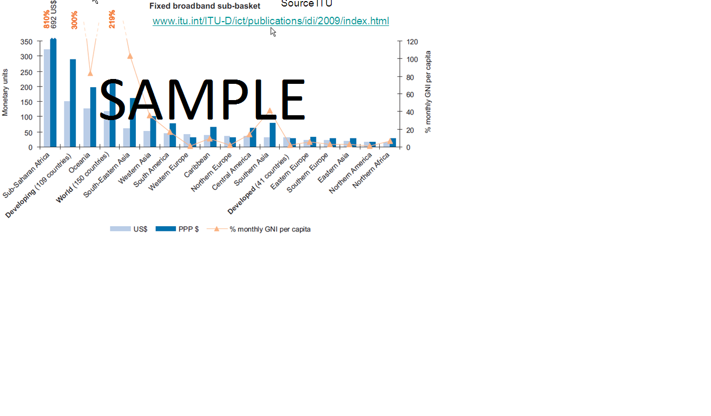

**Chart 1: Consolidated View - Internet Connectivity from LLL**

**Chart 2: Consolidated Customer Untrusted connectivity**

Lorem ipsum dolor sit amet, consectetur adipiscing elit, sed do eiusmod tempor incididunt ut labore et dolore magna aliqua. Ut enim ad minim veniam, quis nostrud exercitation ullamco laboris nisi ut aliquip ex ea commodo consequat. Duis aute irure dolor in reprehenderit in voluptate velit esse cillum dolore eu fugiat nulla pariatur. Excepteur sint occaecat cupidatat non proident, sunt in culpa qui officia deserunt mollit anim id est laborum