### The Driver Behaviour Questionnaire in Kuwait

Jamal Ahmad Al Matawah,*a,[1]*, Other Guy*b*, Brian Freeman*c*

***a*** *Public Authority for Applied Education and Training, Kuwait*

*b Jordan*

*c University of Guelp, Dept of Engineering, Ontario, Canada*

1. **Introduction**

Reason *et al*. (1990) developed a questionnaire to measure concepts and types of driver behaviour (sections entitled ‘Errors’ and ‘Violations’). Stradling and Meadow (2000) modified this further to produce the Manchester Driver Behaviour Questionnaire, on which the questionnaire for this thesis is based. The questionnaire regarding driver behaviour in Kuwait is somewhat modified to suit expected driver behaviour in Kuwait.

According to Lajunen *et al*. (2004), The Manchester Driver Behaviour Questionnaire has been used across the world, for example in Australia by Blockley & Hartley (1995), Sweden (Aberg & Rimmo, 1998), New Zealand (Sulmann & Meadows, 2000), China (Xie *et al*., 2000) Finland and the Netherlands (Lajunen *et al*., 1999) and Turkey (Sümer *et al*., 2002).

The Manchester Driver Behaviour Questionnaire (DBQ) aimed to measure how often drivers experience each of the following three categories of lapses, errors and violations.

As regards lapses, the questionnaire asked how often drivers tried to pull away from traffic lights in third gear, how often they operated the wrong switch, took the wrong lane approaching roundabout or junction, misread signs on exiting roundabouts, how often they felt disorientated, reached a wrong destination, forgot where they had left their car in the car park or hit something when reversing.

Such lapses are usually considered not to be life-threatening. They were more commonly reported by females than by male drivers. Age was also found to be statistically associated with lapses, with older drivers tending to report more.

As regards errors, the Manchester questionnaire asked how often respondents failed to see a `Stop' or `Give Way' sign and narrowly avoided colliding with traffic having the right of way, how often they failed to observe cyclists, pedestrians crossing side roads, failed to check the rear-view mirror before pulling out or changing lanes, and failed to pay attention to the vehicle in front when it was about to turn off the main road. Other errors identified were braking too quickly on a slippery road, or steering the wrong way in a skid, underestimating the speed of an oncoming vehicle when overtaking, and attempting to overtake someone signalling an offside turn. “Errors constitute the failure of planned actions and include failures in observation and misjudgements” (Reason *et al*., 1990).

The Manchester Driver Behaviour Questionnaire asked questions on violations, such as how often drivers disregarded the speed limits late at night or very early in the morning, crossed a junction knowing that the traffic lights were changing, drove close to the car in front in an aggressive manner, overtook on the inside, raced with other drivers, showed hostilityto a particular class of road user, or expressed anger verbally.

Violations are typical of aggressive behaviour driving. They are deliberate deviations from practices believed important to maintain safety in a potentially hazardous system (Reason *et al*., 1990).

Based on the Manchester studies, the driver violation score was found to be a much better predictor of level of accident involvement than the error or lapse score. However, according to Reason *et al*. (1990), both errors and violations potentially lead to accidents, whereas lapses are unlikely to have a major impact on driving safety.

Many road safety professionals cite speeding and alcohol as the most important immediate precursors of crashes. The Manchester analysis divided aberrant driving behaviour into three kinds: speeding, drink-driving and other general classes of violations, speeding being the most frequent violation.

Lawton *et al*. (1997) categorised violations according to motivational interpersonal aggression (‘aggressive violation’) and deliberate deviation (‘ordinary violations’). On the other hand, Lajunen and Parker (2001) and Lajunen *et al*. (1998) stated that violation items are sometimes difficult to differentiate, because of local conditions, snow on the road (Scandinavia) or larger number of cyclists (Holland). Also, culture plays a part. Sounding the horn clearly reflects aggression in Scandinavia, while in Southern Europe; the horn is used much more liberally. Culturally sensitive items need careful consideration for international comparisons. Therefore, the distinction between “ordinary” violation and aggressive violation may depend on the context and the intention behind the act.

The literature referred above noted variations in the categories of lapses, errors and violations that reflect true cultural differences. Traffic cultures may vary at regional level. The Manchester Driver Behaviour Questionnaire Item “brake too quickly on slippery road” has very different meanings in countries with a long snowy winter and in countries where snow tyres are never required. Similarly, cycling is very much more common as a daily form of transport in the Netherlands than in the hilly part of Turkey, and so attention to cyclists is much more relevant in the former country. Traffic environment and culture play a major role. For example, a striking difference in Muslim culture is that alcohol is not commonly consumed.

Aggressive driving behaviour has various kinds of definitions. The most comprehensive definition is as follows: “The operation of a motor vehicle in a manner that endangers or is likely to endanger people or property” (NHTSA, 1998). The factors listed by James and Nahl (2000) as representative of aggressive driving are: Running stop signals, Blocking intersections, Failing to yield right-of-way, Weaving in/out of traffic, Speeding above the limit, Tailgating, Failure to use indicators when required, Changing speed erratically, Blocking other vehicles, Communicating threats or insults with voice, Gestures, or sounding the horn unnecessarily, Intentionally breaking suddenly, and Chasing other vehicles. Other authors add other factors, such as careless driving, failure to stop for pedestrians, cell phone usage and so on.

1. **Material and methods**

## Description of the questionnaire survey data contents

The questionnaire consists of various variables which are grouped into six sections (parts) as follows:

The first section is General Information**'** and it consists of variables related to general demographic information. These include age, sex, nationality, residential area, occupation, living place, education level, and marital status.

The second section is Driving Characteristics and it consists of variables related to car use in terms of distance travelled annually (kilometres), driving experience, seatbelt usage, speeding, vehicle type and activities and violation whilst driving.

The third section is Accidents history**'** and requests information variables related to, accident involved accident cause, and type of injury

The forth section is 'Part E: Driver Behaviour' and it consists of variables related to driving behaviour which are categorise to Violations (10 questions), Errors (8 questions) and Lapses (8 questions). These 26 questions were classified according to various aspects, such as lack of attention, speeding, overtaking, ignoring priorities, passing red traffic lights, not leaving enough distance from the vehicle in front, carelessness while driving…etc. The responses to the questions were taken on a six-point Likert Scale as follows:

0 🡪 'Never'

1 🡪 ' Hardly ever'

2 🡪 ' Occasionally'

3 🡪 ' Quite often'

4 🡪 ' Frequently'

5 🡪 'Nearly all the time'

Thus 5 represent the worst behaviour towards driving and 0 represents the best behaviour toward driving.

The fifth section, is: Driving Strengths and Weakness consists of variables related to the behaviour of some dangerous driving situations and reactions There are 20 questions. The responses to the questions were taken on a five-point Likert Scale as follows:

0 🡪 ' Definitely weak'

1 🡪 ' Weak '

2 🡪 ' Neither weak nor strong '

3 🡪 ' Strong '

4 🡪 ' Definitely Strong '

Thus 0 represent the weakest driving skills and 5 represents the best driving skills.

The sixth section is regards Road Safety Strategies consists of variables related to remedial measures such as road design, enforcement of traffic laws, and road safety campaigns The last page of the questionnaire consisted of free space for 'Suggestions and Comments'

## The questionnaire survey data collection

A pilot survey of 50 questionnaires was distributed to drivers in Kuwaiti in November 2016 to identify potential problems of design.

In the main survey, from 3/12/2016 to 15/5/217, 700 questionnaires were distributed to a random sample of drivers at various locations in Kuwait (six governorates). A total of 496 questionnaires were returned, 76 questionnaires were rejected, either because they were incomplete or because answers were considered to be unrealistic. Therefore the total number of respondents was 420. The overall response rate was 71 %; 70% of the respondents were male and 30% were female. The mean age of the participants was 31.4, the youngest being eighteen and the oldest seventy.

The response rate from Kuwaiti drivers was higher than from non-Kuwaiti drivers (83% and 17%, respectively).

1. **Theory/calculation**
2. **Results**

## Characteristics of respondents

### Education level and socio-economic status

In terms of education level, the respondents were classified into five levels, as follows:

1) High school and below (14.7%)

2) Diploma (28.3%)

3) University (43.3%)

4) Postgraduate (13.6%)

In terms of marital status, 49.5% were married, 47.4% unmarried. 3.1 are Divorced or widowed.

### Experience

The respondents were asked how long you have been driving

|  |  |  |  |  |
| --- | --- | --- | --- | --- |
|  | | | | |
| Years of driving | Frequency | Percent | |
| less_than_2 | 46 | | 11.0 |
| 2-5 | 128 | | 30.5 |
| 5-10 | 75 | | 17.9 |
| more_than_10 | 171 | | 40.7 |
| Total | 420 | | 100.0 |

### Annual kilometres

Annual kilometres ranged from ‘less than 5,000 km’ to ‘over 40,000 km’. Table 5.2 and Figure 5.1 shows the distribution of the annual average kilometres for men and women separately: 22,813 km for men and 14,260 km for females. This shows that men are driving around 60 % more than the distance that females are driving.

Table 5.2 Frequency distribution of annual average kilometres driven.

|  |  |  |
| --- | --- | --- |
| **Kilometers** | Frequency | Percent |
| less_than_5000 | 28 | 6.7 |
| 5000-10000 | 78 | 18.6 |
| 1000-15000 | 83 | 19.8 |
| 15000-20000 | 44 | 10.5 |
| 20000-25000 | 48 | 11.4 |
| 25000-30000 | 49 | 11.7 |
| 30000-35000 | 26 | 6.2 |
| 35000-40000 | 23 | 5.5 |
| over_40000 | 41 | 9.8 |
| Total | 420 | 100.0 |

Figure ‎5.1 Average total kilometres based on gender

### Accidents

It was found in the survey that, out of 420 respondents, 300 (71.4%) had been involved in one or more accidents and 120 (28.6%) were not. 80.4% (241) (of which involved property damage only and 19.4% (58) caused injury and 0.2% (1) involved with fatal accident (in which obtain a ration of 1fatal to 58 injury

|  |  |  |  |  |  |  |  |  |  |
| --- | --- | --- | --- | --- | --- | --- | --- | --- | --- |
|  | | | | | | | | | |
| **Accident_Invo** | | | Frequency | | Percent | Valid Percent | | | Cumulative Percent |
|  | yes | | 300 | | 71.4 | 71.4 | | | 71.4 |
| no | | 120 | | 28.6 | 28.6 | | | 100.0 |
| Total | | 420 | | 100.0 | 100.0 | | |  |
|  | | | | | | | | | | |
| **Harms** | | | | Frequency | | | Percent |
| Valid | | PDO | | 241 | | | 57.4 |
| fatal | | 1 | | | .2 |
| PDO_and_injury | | 58 | | | 13.8 |
| Total | | 300 | | | 71.4 |
| Missing | | System | | 120 | | | 28.6 |
| Total | | | | 420 | | | 100.0 |

### Accident causation

The respondents were asked about the causes of accidents (either their own fault or other drivers’ mistakes). The results show that speed represent 32.5% of accident causes and careless driving represent 15.8% whiles general traffic violation and other combination are 38.9% and 11.2% respective. Accident involving alcohol are only 1.6% in the survey.

|  |  |  |  |  |
| --- | --- | --- | --- | --- |
| **Acc_Cause** | | | | |
| **Accident Causes** | | Frequency | Percent |
| total | careless | 49 | 15.8 |
| speed | 101 | 32.5 |
| violation | 121 | 38.9 |
| alcohol | 5 | 1.6 |
| others | 35 | 11.2 |
|  |  |  |
|  | 311 |  |
|  |  |  |
|  |  |  |
|  |  |  |
|  |  |  |
|  |  |  |
|  |  |  |  |
|  | |  |  |

### 

### Violations

The respondents were asked if they obtained right-light over- speed parking tickets were speeding and parking as the most common violations in Kuwait ( ). The results show that the over- speed is was the most frequent type of violation.

|  |  |  |  |  |  |
| --- | --- | --- | --- | --- | --- |
| **Violation** | | | | | |
|  | | Frequency | Percent | Valid Percent | Cumulative Percent |
|  | Red-light | 37 | 8.8 | 11.0 | 11.0 |
| parking | 106 | 25.2 | 31.5 | 42.4 |
| Over Speed | 126 | 30.0 | 37.4 | 79.8 |
| Others | 2 | .5 | .6 | 80.4 |
| *(Red-light and parking )* | 6 | 1.4 | 1.8 | 82.2 |
| (Red-light and Over Speed ) | 17 | 4.0 | 5.0 | 87.2 |
| (*Parking and Over Speed)* | 23 | 5.5 | 6.8 | 94.1 |
| (Red-light, parking and Over Speed) | 20 | 4.8 | 5.9 | 100.0 |
| Total | 337 | 80.2 | 100.0 |  |
| Missing | System | 83 | 19.8 |  |  |
| Total | | 420 | 100.0 |  |  |

**Activities whilst driving**

The respondents were asked about what of activities that they engage in while driving? The results show that using the mobile phone while driving is was the most frequent one

|  |  |  |  |  |  |
| --- | --- | --- | --- | --- | --- |
| **driving_activities** | | | | | |
|  | | Frequency | Percent | Valid Percent | Cumulative Percent |
| Valid | smoking | 33 | 7.9 | 10.1 | 10.1 |
| alcahool | 1 | .2 | .3 | 10.4 |
| news_paper | 3 | .7 | .9 | 11.3 |
| mobile_use | 183 | 43.6 | 56.0 | 67.3 |
| Folding legs | 13 | 3.1 | 4.0 | 71.3 |
| Put children in front | 31 | 7.4 | 9.5 | 80.7 |
| 12 | 1 | .2 | .3 | 81.0 |
| 14 | 18 | 4.3 | 5.5 | 86.5 |
| 15 | 1 | .2 | .3 | 86.9 |
| 16 | 1 | .2 | .3 | 87.2 |
| 24 | 3 | .7 | .9 | 88.1 |
| 34 | 1 | .2 | .3 | 88.4 |
| 45 | 16 | 3.8 | 4.9 | 93.3 |
| 46 | 11 | 2.6 | 3.4 | 96.6 |
| 56 | 1 | .2 | .3 | 96.9 |
| 145 | 3 | .7 | .9 | 97.9 |
| 146 | 1 | .2 | .3 | 98.2 |
| 456 | 5 | 1.2 | 1.5 | 99.7 |
| 1456 | 1 | .2 | .3 | 100.0 |
| Total | 327 | 77.9 | 100.0 |  |
| Missing | System | 93 | 22.1 |  |  |
| Total | | 420 | 100.0 |  |  |

## 

## Seat belt usage

The respondents were asked if they regularly use they seat belt? 39.8% are using it regularly whereas 44% are occasionally using it and 16.2 % are not using it at all. The reason behind of those who are not using it and occasionally using it are shown in the table below.

|  |  |  |  |  |  |
| --- | --- | --- | --- | --- | --- |
| **seat_belt** | | | | | |
|  | | Frequency | Percent | Valid Percent | Cumulative Percent |
| Valid | yes | 167 | 39.8 | 39.8 | 39.8 |
| occasionally | 185 | 44.0 | 44.0 | 83.8 |
| No | 68 | 16.2 | 16.2 | 100.0 |
| Total | 420 | 100.0 | 100.0 |  |

|  |  |  |  |  |  |
| --- | --- | --- | --- | --- | --- |
| **reasons** | | | | | |
|  | | Frequency | Percent | Valid Percent | Cumulative Percent |
| Valid | Discomfort | 70 | 16.7 | 28.3 | 28.3 |
| Inconvenience | 43 | 10.2 | 17.4 | 45.7 |
| fear of being trapped | 9 | 2.1 | 3.6 | 49.4 |
| Not_Necessary | 9 | 2.1 | 3.6 | 53.0 |
| Forgot | 64 | 15.2 | 25.9 | 78.9 |
| Clothes | 13 | 3.1 | 5.3 | 84.2 |
| Others | 15 | 3.6 | 6.1 | 90.3 |
| 1,2 | 3 | .7 | 1.2 | 91.5 |
| 1,4 | 2 | .5 | .8 | 92.3 |
| 15 | 8 | 1.9 | 3.2 | 95.5 |
| 16 | 3 | .7 | 1.2 | 96.8 |
| 25 | 1 | .2 | .4 | 97.2 |
| 26 | 2 | .5 | .8 | 98.0 |
| 27 | 1 | .2 | .4 | 98.4 |
| 56 | 1 | .2 | .4 | 98.8 |
| 126 | 1 | .2 | .4 | 99.2 |
| 256 | 1 | .2 | .4 | 99.6 |
| 356 | 1 | .2 | .4 | 100.0 |
| Total | 247 | 58.8 | 100.0 |  |
| Missing | System | 173 | 41.2 |  |  |
| Total | | 420 | 100.0 |  |  |

## Approach to statistical and descriptive analysis

There are many kinds of statistical tests, but each kind of test applies to certain assumptions and conditions, so choosing the appropriate statistical test depends on the nature of the data and the kind of dependent and independent variable (continuous or categorical, for example, that may be relevant).

In this survey, the descriptive analysis involves: 1) the overall driver behaviour (violation) score as a continuous dependent variable. SPSS software has been used for all descriptive analysis.

A T-test (two sample T-test) and a one-way analysis of variance (ANOVA) is appropriate for testing hypotheses in the case of the dependent continuous variable with other categorical independent variables.

The T- test is a general method to compare two different independent population means. It is simply a test of whether or not two independent populations have different mean values. The one-way ANOVA technique is an extension of the two sample T-test. It is applied when the comparison involves three or more levels of single independent variables. In ANOVA, the F-test reflects whether the group means of the dependent variable differ significantly from each other.

## Results

### Overall aggressive driver behaviour score with other factors

The overall aggressive driver behaviour score has been introduced as a dependent variable and the other factors (Age, Gender, Education Level, Marital Status, Nationality, Driver Experience,) are independent variables. An overall driver behaviour score is calculated as an average of the10-question Part E of the questionnaire for each individual driver. The T-test is used to compare the significant differences in overall driver behaviour scores between two independent groups (such as Gender, Marital Status, Nationality,). When the analysis involves three or more groups, such as Age, Education Level and Driver Experience, the One Way ANOVA technique will be applied to test the significant differences between them, whilst Scheffe test will be used to test the significant differences between each single group and other groups (multiple comparisons). In both the T- test and One Way ANOVA the level of significance is at the 0.05 level (P< 0.05).

#### 1 Age (Age versus Driver Behaviour Score for violation)

A One-way analysis of variance was conducted to evaluate the relationship between "age" and "driver behaviour score". The hypothesis assumed that the younger age group drivers have more aggressive driving behaviour on the road than the older age group drivers. The independent variable, the age factor, had fife age ranges: 18-24, 25-29, 30-39, 40-49 & 50-above. The dependent variable was the driver behaviour score. A higher driver behaviour score indicates more aggressive behaviour on the road. The ANOVA was significant, **F** (4, 415) = 41.634, ***p*** < .0001

Follow-up tests were conducted to evaluate pair wise differences among the means. The post hoc comparisons were conducted using Scheffe test. The results of these tests, as well as the means and the standard deviations for the four age groups, are given in Table 5.8. There were significant differences in the means between the age groups (18-24, 25-29), (18-24, 30-39), (18-24, 40-49), (18-24, 50-above), (25-29, 40-49), (25-29, 50-above), (30-39, 50-above) but no significant differences in the means between the age groups(25-29, 30-39) (30-39, 40-49) (40-49, 50-above) were found. The drivers of the age group 18-24 showed the highest aggressive behaviour (mean = 2.55), whereas the drivers of the age group 50-above showed the lowest aggressive behaviour (mean= 1.01) (Figure 5.4). Thus the results of the ONE-WAY ANOVA supported the hypothesis that the younger age group displays more aggressive driving on the road than the older age group. Young drivers, compared with other groups, are more likely to underestimate the probability ofspecific risks caused by traffic situations (Brown & Gorger, 1988; Deery, 1999) and they overestimate their own driving skills (Moe, 1986).

Table 5.8 Driver behaviour score among different age groups

|  |  |  |  |  |  |  |  |
| --- | --- | --- | --- | --- | --- | --- | --- |
| Age Group | N | Mean | SD | 18-24 | 25-29 | 30-39 | 40-49 |
| 18-24 | 187 | 2.55 | 0.82 |  |  |  |  |
| 25-29 | 54 | 2.08 | 1.02 | * |  |  |  |
| 30-39 | 64 | 1.73 | 1.06 | * | NS |  |  |
| 40-49 | 68 | 1.48 | 0.75 | * | * | NS |  |
| 50-above | 47 | 1.01 | 0.66 | * | * | * | NS |

Note: NS= non significant differences between pairs of means, while (*) = significance using Scheffe Test.

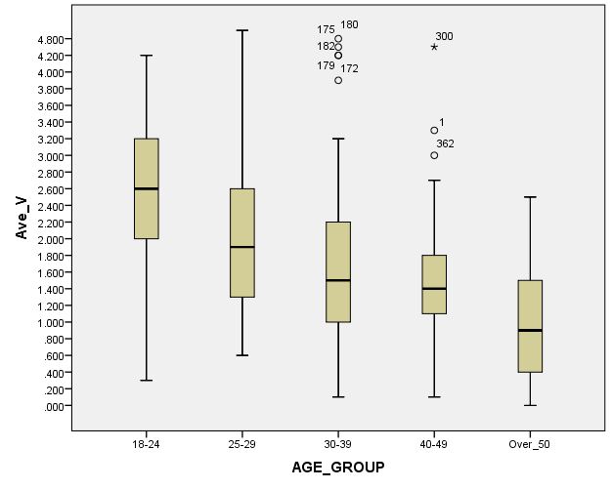

Figure ‎5.4 Aggressive behaviour box plots and means for different age groups

The practical implication of these results is that younger drivers are more aggressive on the roads than older drivers. Thus; it could be recommended that the driving test be made more stringent for younger drivers. More strict penalties should be imposed on drivers who violate the law repeatedly. A points system should be more effective in Kuwait, which may solve many problems regarding this issue.

It could be effective to apply different levels of penalties to different categories of offences. For example, in the form of compulsory driver training, suspending the driving licence or retest. Various types of retest could also be considered depending on the severity of the case and requirements. (It also could be suggested that young Kuwaiti drivers of some social status may be tempted to drive recklessly knowing that they have connections and may be able to get away with their misdemeanour. Traffic laws should be enforced, no matter what the social status of the driver).

#### 2 Gender (Gender versus Driver Behaviour Score)

An independent-sample t -test was conducted to evaluate the hypothesis that male drivers have more aggressive driving behaviour on the road than female drivers. The test was significant, t (241.936) = (2.482), p = 0.014. The results of the independent-sample t -test supported the hypothesis that male drivers (M = 2.097, SD = 1.025, N=295) on average have more aggressive driving behaviour than female drivers (M = 1.833, SD = 0. 987, N=125) (see figure 5.5). This was also found in a survey undertaken by Laapotti *et al*. (2003), which evaluated driver attitudes towards road safety in Finland. The study revealed that female drivers had a more positive attitude towards road safety and rules than male drivers.

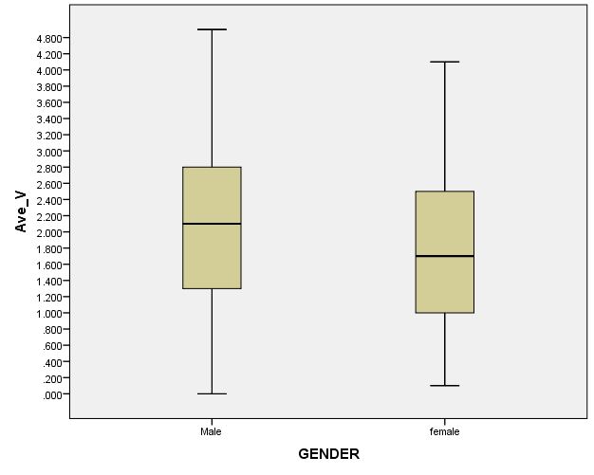

Figure ‎5.5 Aggressive behaviour means and box plots based on gender

#### 3 Nationality (Nationality versus Driver Behaviour Score)

An independent-sample t -test was conducted to evaluate the hypothesis that Kuwaiti drivers have more aggressive driving behaviour than non-Kuwaiti drivers. The test was significant, t (104) = (7.73), p < 0.001. The results of the independent-sample t -test supported the hypothesis that Kuwaiti drivers (M = 2.17, SD = 0.973, N=350) on the average are more aggressive drivers than non-Kuwaiti drivers (M = 1.25, SD = 0.897, N=527) (see figure 5.6).

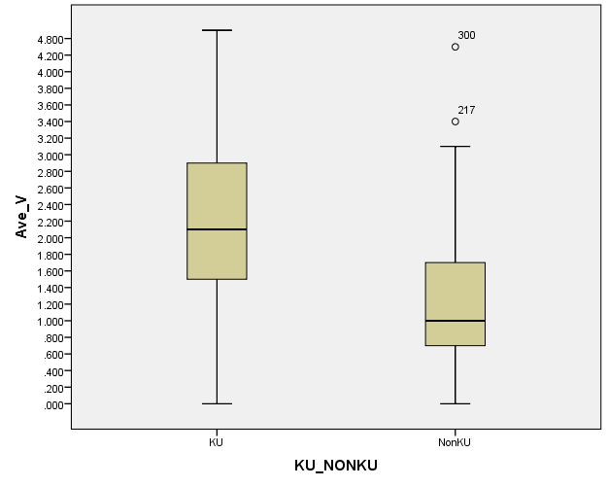

Figure ‎5.6 Aggressive behaviour means and box plots based on nationality

One reason is that there are more young Kuwaiti drivers than young non-Kuwaiti drivers in the country's population. Another reason could be because non-Kuwaitis are more concerned about having to pay fines than Kuwaiti drivers, who generally have better financial status, so normally do not care about the fines they may pay.

The practical implication is that fines on Kuwaiti citizens are ineffective. It might be an idea to have penalties linked to financial status. In Finland, fines are generally based on two factors: the severity of the offence and the driver's income (Lappi-Seppala, 2004)

#### 4 Marital status (Marital status versus Driver Behaviour Score)

An independent-sample t-test was conducted to evaluate the hypothesis that drivers who were single had more aggressive driving behaviour than drivers who were married. The test was significant: t (401.826) = 7.8, p < 0.001. The results of the independent-sample t-test initially supported the hypothesis that single drivers (M = 2.39, SD = 0.89, N=199) on average had more aggressive driving behaviour than married drivers (M = 1.65, SD = 1.005, N= 207) (see Figure 5.7

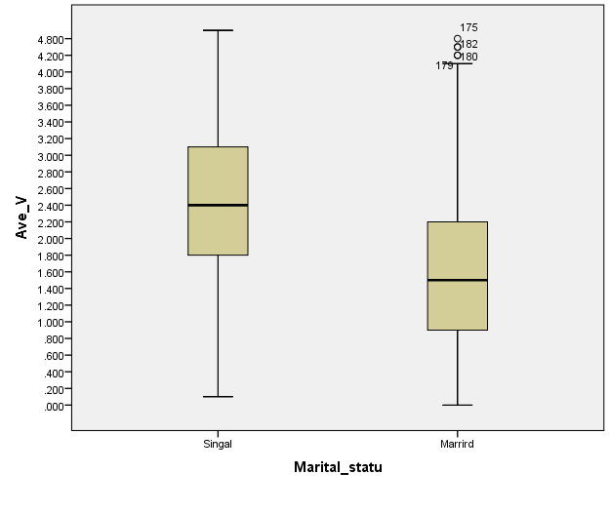

Figure ‎5.7 Aggressive behaviour means and box plots based on marital status

However, there were more young single drivers than married drivers in the sample (88% of drivers in the age group 18-24 were single).

Married drivers perhaps have more concern, due to family responsibilities. There is an implied need for further education and training of young, unmarried drivers, either through the media or driving schools in order to increase their feeling of responsibility and improve their hazard perception.

#### 5 Education level (Education level versus Driver Behaviour Score)

One-way analysis of variance was conducted to evaluate the relationship between "education level" and "driver behaviour score". The hypothesis assumed that the lower the level of education the more aggressive the driving behaviour on the roads would be. The independent variable, the education level factor, included four levels: Up to High school, Diploma, Bachelor Degree, and Postgraduate. The dependent variable was the driver behaviour score. (A higher driver behaviour score indicates more aggressive behaviour.) The ANOVA was significant, **F** (3, 416) =17.35, ***p*** < 0.0001. Follow-up tests were conducted to evaluate pair wise differences among the means. The post hoc comparisons were conducted using Scheffe test.

The results of these tests, as well as the means and the standard deviations for the four groups, are reported in Table 5.10a. There were significant differences in the means between the groups (Up to High school, Bachelor), (Up to High school, Postgraduate), (Diploma, Postgraduate), (Bachelor, Postgraduate) but no significant differences in the means between the groups (Up to High school, Diploma), were found. The drivers with Up to High school level showed the highest aggressive behaviour (mean = 2.36), whereas the Postgraduate drivers showed the lowest aggressive behaviour (mean=1.27) (see figure 5.8).

Initially the results of the ONE-WAY ANOVA supported the hypothesis that lower education level drivers had more aggressive driving behaviour than those who had a higher education level.

However there are more young drivers up to high school and Diploma than the other education levels in the sample. (70.6% of drivers in the age group 18-24 are ‘up to high school’ and Diploma level**)**.

Practically, these results imply that further studies should be conducted to identify areas for improving lower education drivers, targeting certain segments of the population for extra training in safe road usage.

Table 5.10a Driver behaviour score among different education levels

|  |  |  |  |  |  |  |
| --- | --- | --- | --- | --- | --- | --- |
| Groups | N | M | SD | Up to High school | Diploma | Bachelor |
| Up to High school | 62 | 2.36 | 1.07 |  |  |  |
| Diploma | 119 | 2.29 | 0.91 | NS |  |  |
| Bachelor | 182 | 1.95 | 1.01 | * | * |  |
| Postgraduate | 57 | 1.27 | 0.73 | * | * | * |

Note: NS = non significant differences between pairs of means, while (*) = significance using Scheffe test.

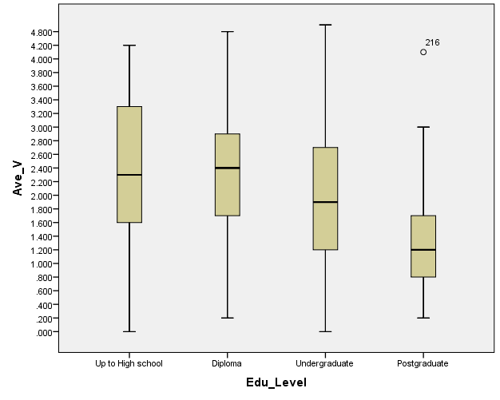

Figure ‎5.8 Aggressive behaviour means and box plots for education level

6 Experience (Experience versus Driver Behaviour Score)

One-way analysis of variance was conducted to evaluate the relationship between "Experience" and “Driver behaviour score". The hypothesis assumed that less experienced drivers would have more aggressive driving behaviour than more experienced drivers. The independent variable, the experience factor, included four levels: less than 2 years, 2-5years 5-10 years and more than 10 years. The dependent variable was the driver behaviour score. The higher the driver behaviour score, the more aggressive the behaviour of the driver would be on the road. The ANOVA was significant: **F** (3, 416) = 34.747, ***p*** < 0.0001.

Post hoc comparisons were conducted using Scheffe test. The results of these tests, as well as the means and the standard deviations for the three groups are reported in Table 5.11a. There were no significant differences in the means between the groups (less than 2 years, 2-5years), (less than 2 years, 5-10 years), (2-5years 5-10 years) but there is significant differences in the means between the groups more than 10 years and all other groups were found.

There were significant differences in the means between all groups. The drivers with the lowest experience (1-5 years) showed the highest aggressive behaviour (mean = 3.48), whereas the drivers with the most experience (more than 15 years) showed the lowest aggressive behaviour (mean= 3.88) (see figure 5.9).

Initially the results of the ONE-WAY ANOVA supported the hypothesis that less experienced drivers have more aggressive driving behaviour than more experienced drivers.

However, age and experience are highly correlated (Pearson correlation = 0.78); the majority of inexperienced drivers are also young (Grayson and Sexton, 2002). (61% of driver age group 18-24 have 2-5 years of driving experience, and 25% are less than 2 years)

Table 5.11a Driver behaviour score and experience

|  |  |  |  |  |  |  |
| --- | --- | --- | --- | --- | --- | --- |
| Groups | N | M | SD | Less than 2 years | 2-5 years | 5-10 years |
| Less than 2 years | 46 | 2.24 | 0.89 |  |  |  |
| 2-5 years | 128 | 2.5 | 0.86 | NS |  |  |
| 5-10 years | 75 | 2.9 | 1.01 | NS | NS |  |
| More than 10 years | 171 | 1.47 | .914 | * | * | * |

Note: NS = non-significant differences between pairs of means, while (*) = significance using Scheffe test.

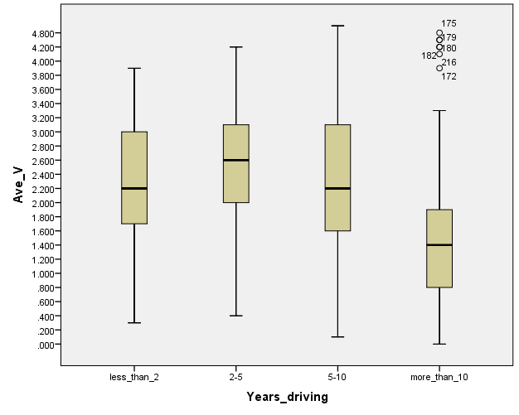

Figure ‎5.9 Aggressive behaviour means and box plots for experience group

It might be suggested that mandatory training courses for aggressive drivers should be organised, perhaps after a first dangerous offence has been penalised. There are different forms of driver training, one of which does not exist in Kuwait, but is believed to be effective, namely Hazard Perception Training. Therefore, it is recommended that this type of training be introduced in addition to the usual training courses.

|  |  |  |  |
| --- | --- | --- | --- |
|  | VIOLATIONS | Mean | Rank |
| 1 | Drive especially close to the car in front as a signal to its driver to go faster or get out of the way | 2.32 | 4 |
| 2 | Cross a junction knowing that the traffic lights have already turned red | 0.99 | 9 |
| 3 | Disregard the speed limits late at night or early in the morning | 2.09 | 6 |
| 4 | Disregard the speed limits on a motorway | 2.18 | 5 |
| 5 | Angered by a particular class of road user and indicate your hostility by whatever means you can | 2.68 | 2 |
| 6 | Become impatient with a slow driver in the outer lane and overtake on the inside (right) lane | 3.18 | 1 |
| 7 | Get involved with unofficial ‘races’ with other drivers | 0.92 | 10 |
| 8 | Angered by another driver’s behavior, you give chase with the intention of giving him/her a piece of your mind | 1.21 | 8 |
| 9 | Sound your horn to indicate your annoyance to another road user | 2.59 | 3 |
| 10 | Stay in a motorway lane that you know will be closed ahead until the last minute before forcing your way into the other lane. | 2.02 | 7 |

|  |  |  |  |
| --- | --- | --- | --- |
|  | ERRORS | Mean | Rank |
| 1 | Attempt to overtake someone that you hadn’t noticed to be signaling a left turn | **1.38** | 3 |
| 2 | Miss ‘Give Way’ signs and hardly avoid colliding with traffic having right of way | **1.31** | 4 |
| 3 | Fail to notice that pedestrians are crossing when turning into a side street from a main road | **1.39** | 2 |
| 4 | Queuing to turn right onto a main road, you pay such close attention to the mainstream of traffic that you nearly hit the car in front | **1.60** | 1 |
| 5 | On turning right nearly hit a two wheeler who has come up on your inside | **1.16** | 6 |
| 6 | Fail to check your rear-view mirror before pulling out or changing lanes, etc | **1.09** | 7 |
| 7 | Under estimate the speed of an oncoming vehicle when overtaking | **1.22** | 5 |
| 8 | Apply sudden brakes on a slippery road, or steer wrong way in a skid | **1.06** | 8 |

|  |  |  |  |
| --- | --- | --- | --- |
|  | LAPSES | Mean | Rank |
| 1 | Get into the wrong lane when approaching a roundabout or a junction | **1.86** | 5 |
| 2 | Misread the signs and exit from the roundabout on the wrong road | **1.21** | 8 |
| 3 | Forget where you left your car in the car park | **1.88** | 3 |
| 4 | Hit something when reversing that you had not previously seen | **1.27** | 7 |
| 5 | Attempt to drive away from the traffic lights | **2.20** | 1 |
| 6 | Switch on one thing, such as headlights, when you meant to switch on something else, such as wipers | **1.35** | 6 |
| 7 | Intending to drive to destination A and, you ‘wake up’ to find yourself in destination B, because the latter is your more usual destination | **2.05** | 2 |
| 8 | Realize you have no clear recollection of the road along which you have been travelling | **1.88** | 4 |

|  |  |  |  |
| --- | --- | --- | --- |
|  | Driving Strengths and Weakness | Mean | Rank |
| 1 | Performance in a critical situation | **2.74** | 10 |
| 2 | Driving behind a slow car without getting impatient | **2.08** | 1 |
| 3 | Managing the care through a skid | **2.65** | 7 |
| 4 | Predicting traffic situations ahead | **2.55** | 5 |
| 5 | Driving Carefully | **2.95** | 15 |
| 6 | Knowing how to act in particular traffic situations | **2.90** | 13 |
| 7 | Fluent lane-changing in heavy traffic | **2.68** | 8 |
| 8 | Fast reactions | **2.79** | 11 |
| 9 | Showing consideration for other road-users | **3.07** | 20 |
| 10 | Staying calm in irritating situations | **2.37** | 3 |
| 11 | Controlling the vehicle | **3.04** | 19 |
| 12 | Avoiding competition in traffic | **2.86** | 12 |
| 13 | Keeping a sufficient following distance | **2.70** | 9 |
| 14 | Make a hill start on a steep incline | **2.17** | 2 |
| 15 | Overtaking | **3.03** | 17 |
| 16 | ‘’Relinquishing’’ legitimate rights when necessary | **3.03** | 18 |
| 17 | Obeying the Speed limit rules | **2.51** | 4 |
| 18 | Avoiding unnecessary risks | **2.99** | 16 |
| 19 | Tolerating other drivers’ errors calmly | **2.62** | 6 |
| 20 | Reverse parking into a narrow gap | **2.93** | 14 |

|  |  |  |  |
| --- | --- | --- | --- |
|  | ROAD SAFETY STRATEGIES | **Yes (Percent)** | **No(Percent)** |
| **21** | Are you aware of any road safety campaigns in Kuwait | **55 %(231)** | **45%(189)** |

|  |  |  |  |
| --- | --- | --- | --- |
|  | road safety campaigns names | **Frequency** | **Percent** |
| **21a** | Not remember the name of campaign | **76** | **32.9** |
|  | GCC Traffic awareness week | **73** | **31.6** |
|  | Come back safe | **11** | **4.8** |
|  | Traffic safety awareness | **25** | **10.8** |
|  | Seat belt | **9** | **3.9** |
|  | Mobile phone | **8** | **3.5** |
|  | Others | **29** | **12.5** |

|  |  |  |  |
| --- | --- | --- | --- |
|  | ROAD SAFETY STRATEGIES | **Yes (Percent)** | **No(Percent)** |
| **22** | Effectiveness of road safety campaigns (231) | **63.6% (147)** | **36.4% (84)** |

|  |  |  |  |  |
| --- | --- | --- | --- | --- |
|  | **Media** | **frequency** | **percent** | **Rank** |
| **1** | **TV** | **127** | **16.5** | **3** |
| **2** | **Radio** | **56** | **7.25** | **4** |
| **3** | **Brochure** | **13** | **1.6** | **7** |
| **4** | **News paper** | **24** | **3.1** | **6** |
| **5** | **Billboard massage** | **192** | **24.9** | **2** |
| **6** | **Internet (social media)** | **304** | **39.4** | **1** |
| **7** | **Magazines** | **2** | **0.25** | **8** |
| **8** | **Educational Institutions** | **54** | **7** | **5** |

|  |  |  |  |  |
| --- | --- | --- | --- | --- |
|  | **Enforcement** | **frequency** | **percent** | **Rank** |
| **1** | Speed Cameras | **242** | **38.9** | **1** |
| **2** | Traffic light Cameras | **111** | **17.84** | **3** |
| **3** | Police Presence (On the spot Fines) | **174** | **27.98** | **2** |
| **4** | Deduction of License Points | **71** | **11.42** | **4** |
| **5** | **Others** | **24** | **3.86** | **5** |

|  |  |  |  |
| --- | --- | --- | --- |
|  | ROAD SAFETY STRATEGIES | **Yes (Percent)** | **No(Percent)** |
| **24** | Do you think that speeding fines are high enough? | **71.4%** | **28.6%** |
| **25** | Do you think that there should be an increased police presence at main junctions? | **78.8** | **21.2** |
| **26** | Do you think that more road safety initiatives should be implemented? | **91.7** | **8.3** |
| **27** | Do you think high powered cars should have speed restricting devices? | **72.1** | **27.9** |
| **28** | Do you think there should be a special hotline to report aggressive drivers? | **88.6** | **11.4** |
| **29** | Do you thing that mobile radars should be used during peak volume traffic? | **59.3** | **40.7** |
| **30** | Do you think that all high peak roundabouts should be equipped with traffic lights? | **66.4** | **33.6** |
| **31** | Are there any suggestions you have that may make roads safer? | **41** | **59** |

1. **Discussion**

## Conclusions

Based on our results age has the most impact on driver behaviours. Young drivers appear to be more aggressive and more likely to have an accident. This is an alarming situation requiring more driver education and training then currently available in Kuwait. Enforcement is an issue that is also a concern. Speed & violations play very important roles in accident occurrence. In Finland and elsewhere in Scandinavia, fines known as day-fines were imposed from 1999 to ensure equal severity of fines for offenders on different incomes and level of wealth. First of all a day-fine is calculated to be roughly half of the offender's daily income, after taxes. Secondly according to the severity of the offence, the number of days’ of day-fines is fixed between 1 and 120. For example the typical number of day-fines for drunken driving would be around 40 day-fines. The monetary value of one day-fine for a person who earns 1500 euros/month would be 20 euros, according to Lappi-Seppala (2004). For someone with a monthly income of 6000 euros, the amount of the one day-fine would be 95 euros. Thus the total fine for the same offence would be for the former offender 800 euros and for the latter 3,800 euros. There was a significant reduction in traffic violations after applying the day-fine system in Finland, according to the table in Lappi-Seppala’s article (Table 5.9).

**Acknowledgements**

**References**

1. Reason, J.T., A.S.R. Manstead, S.G.Stradling, J.S.Baxter & K.A.Campbell (1990), Errors and violations on the road: a real distinction? *Ergonomics*, 33(10/11), 1315-1332.
2. Stradling G. & Meadow L. (2000), Highway Code and Aggressive Violations in UK Drivers, *Global Conference on Aggressive Driving Issues Ontario*, October16-November 30, 2000.
3. Lajunen, Timo, Parker, Dianne and Summala, Heikki (2004), The Manchester driver behaviour questionnaire: a cross-cultural study, *Accident Analysis and Prevention,* 36, pp. 231-238.
4. Lawton, R., Parker, D., Manstead, A.S.R. & Stradling S.G. (1997), The role of affect in predicting social behaviours: The case of road traffic violations, *Journal of Applied Social Psychology*, 27, 1258-1276.
5. Lajunen, T., Parker, D., (2001), Are aggressive people aggressive drivers? A study of the relationship between self-reported general aggressiveness, driver anger and aggressive driving. *Accident Analysis and Prevention,* 33, 243-255.
6. Lajunen, T., Parker, D., Stradling, S. (1998), Dimensions of driver anger, aggressive and highway code violations and their mediation by safety orientation in UK drivers. *Transport Research,* Part F 1,107-121.
7. National Highway Traffic Safety Administration [NHTSA] (1998), *National Survey of Speeding and Other Unsafe Driver Actions*, Vol. II. *Driver Attitudes and Behavior*, Available from: <http://www.nhtsa.dot.gov/people/injury/aggressive/unsafe/att-beh/cov-toc.html>, [Accessed 20 November, 2007].
8. James, L., & Nahl, D. (2000), *Road rage and aggressive driving: Steering clear of highway warfare,* Amherst, NY: Prometheus Books
9. Lappi-Sappällä, Tapio (2004), *Public perception and the fairness of the dayfine system: an evaluation of the 1999 dayfine reform*. Available from: www.optula. om.fi/uploads/ auvfwo7yhpposag. btf [Accessed 10 February, 2008].

1. C*orresponding author at Public Authority for Applied Education and Training, Dept of Civil Engienering, Kuwait, tel +965 xxxxxxxx, email: jamaln1@hotmail.com*