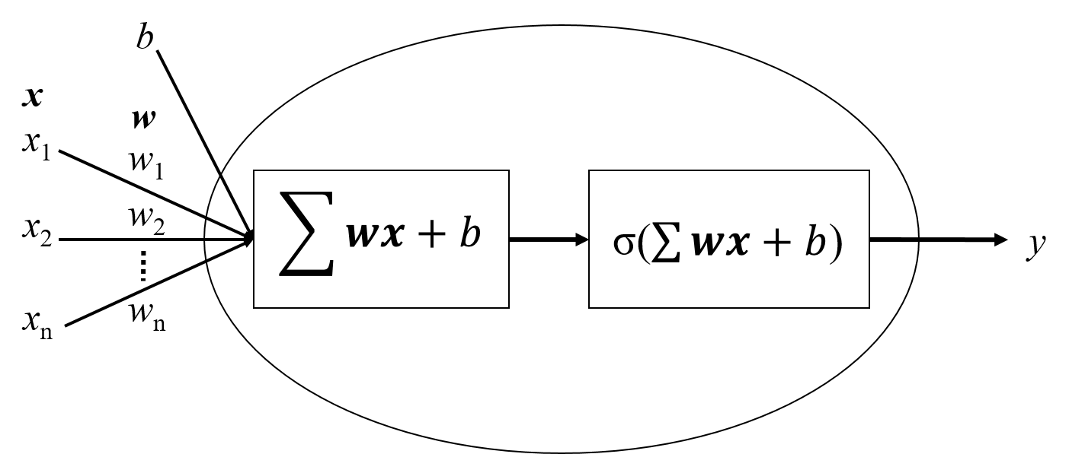

Figure 1: Individual node model.

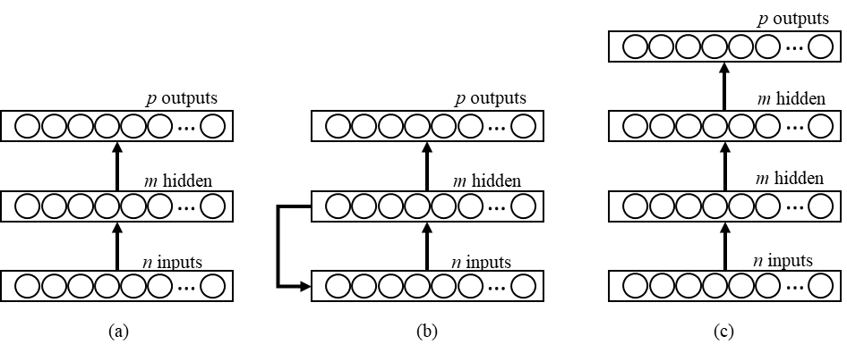

Figure 2. Different ANN model architectures. (a) simple feed forward neural network, (b) a recurrent (Elman) neural network, and (c) a deep feed forward neural network with multiple hidden layers.

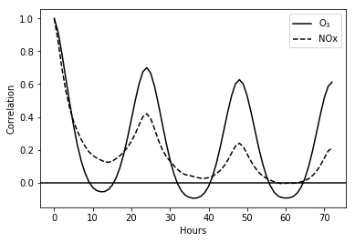

Figure 3. Correlogram of O3 and NOx for 72 hr.

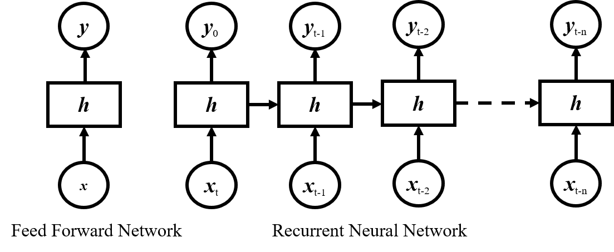

Figure 4. Architecture of an RNN showing layers unfolding in time.

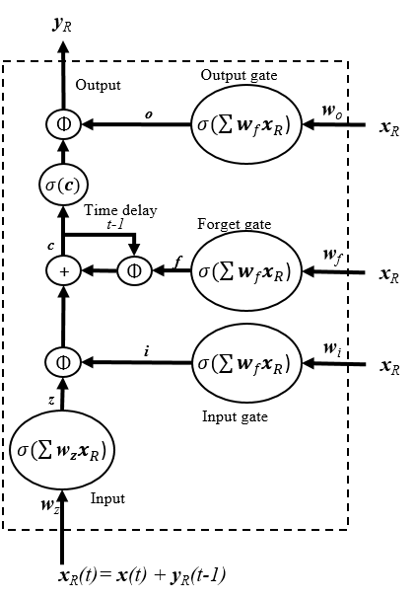

Figure 5. LSTM architecture showing unit time delays (-1), gates and recurrent

activation functions (σ).

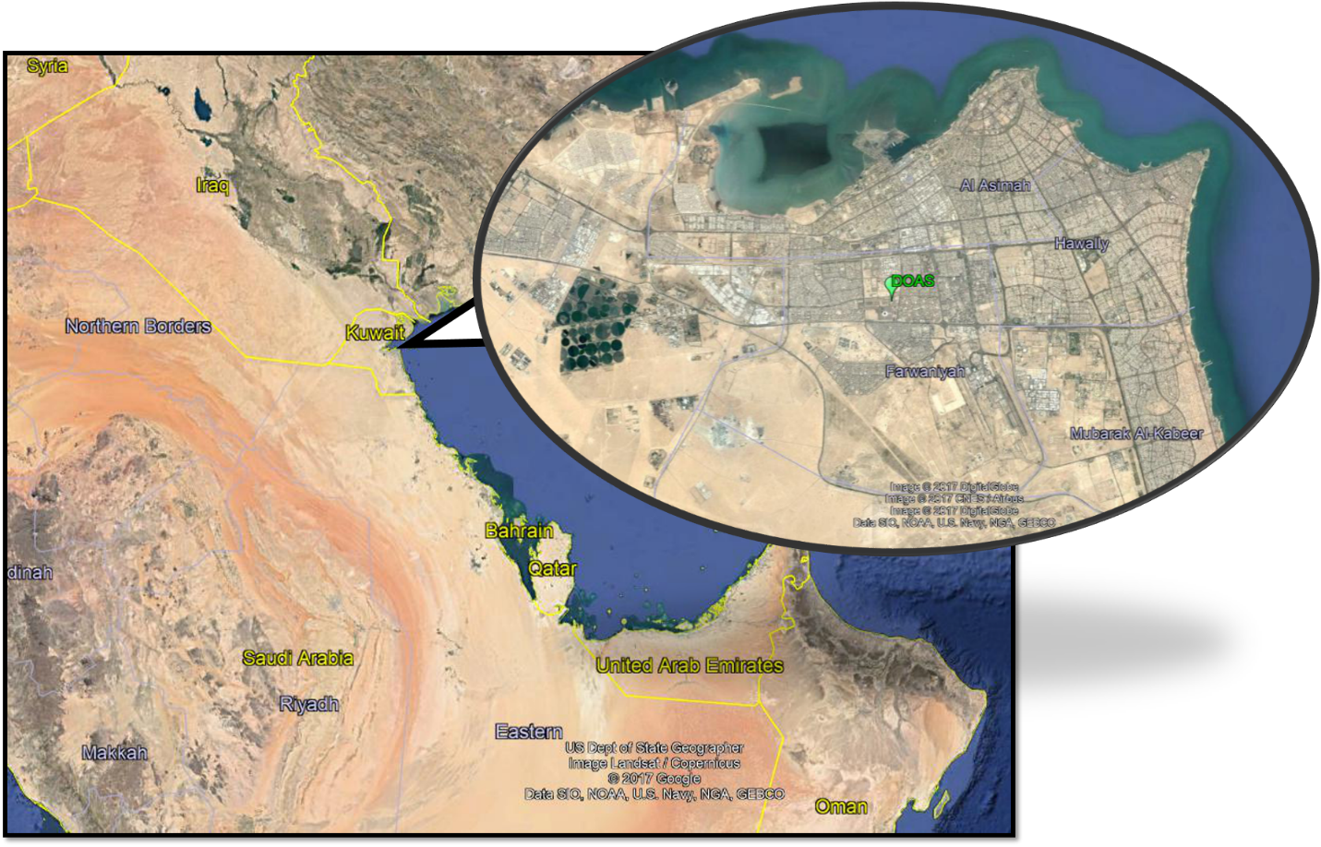

Figure 6. Location of Kuwait and AMS used in the study.

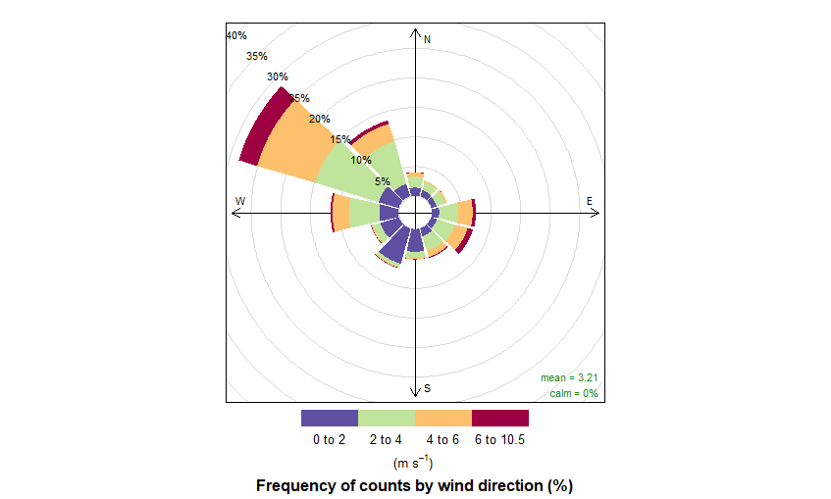

Figure 7. Station wind-rose from 2012 to 2014.

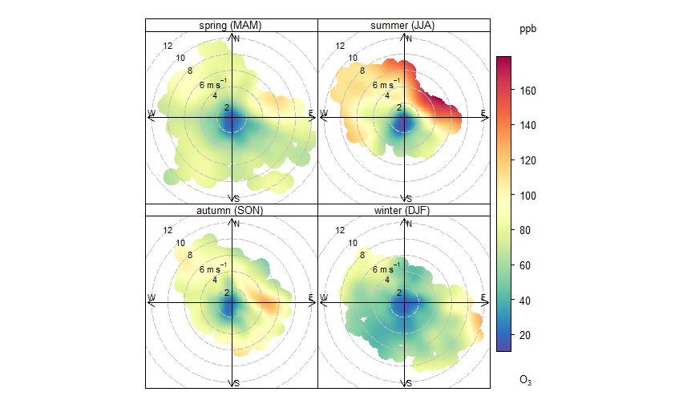

Figure 8. Seasonal bivariate polar plots of 1 hr O3.

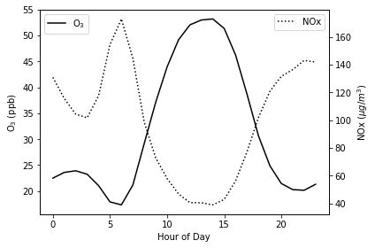

Figure 9. Hourly averages of 1 hr O3 and NOx.

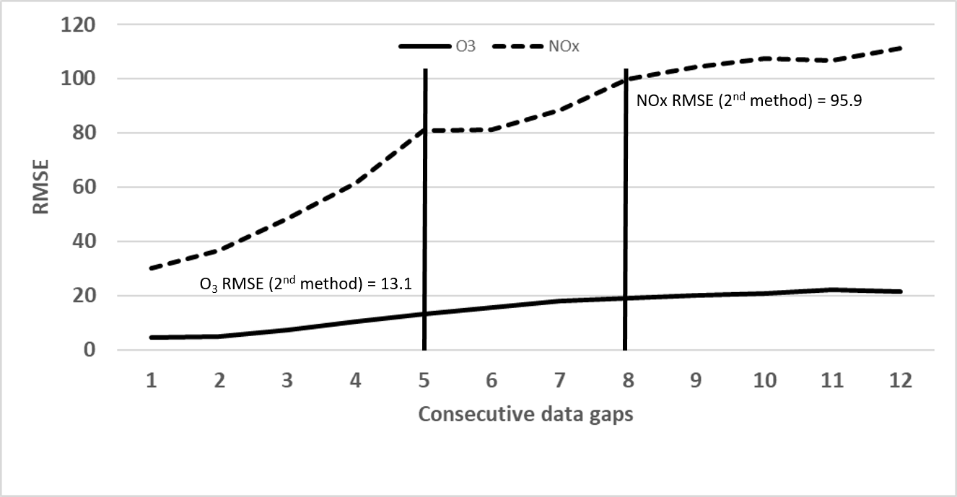

Figure 10. RMSE of O3 and NOx from consecutive gaps of data using the first

imputation method.

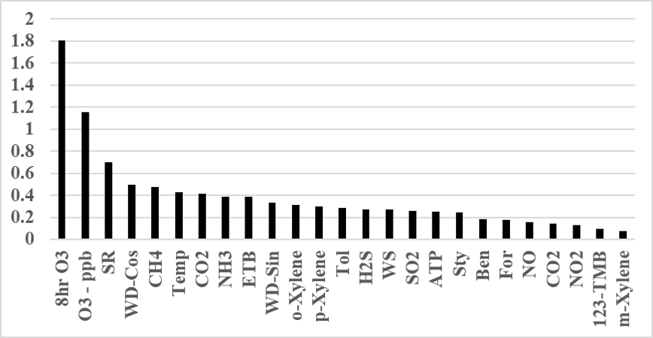

Figure 11. Feature importance from decision tree prediction of 8 hr O3 exceedances from 1 hr to 12 hr.

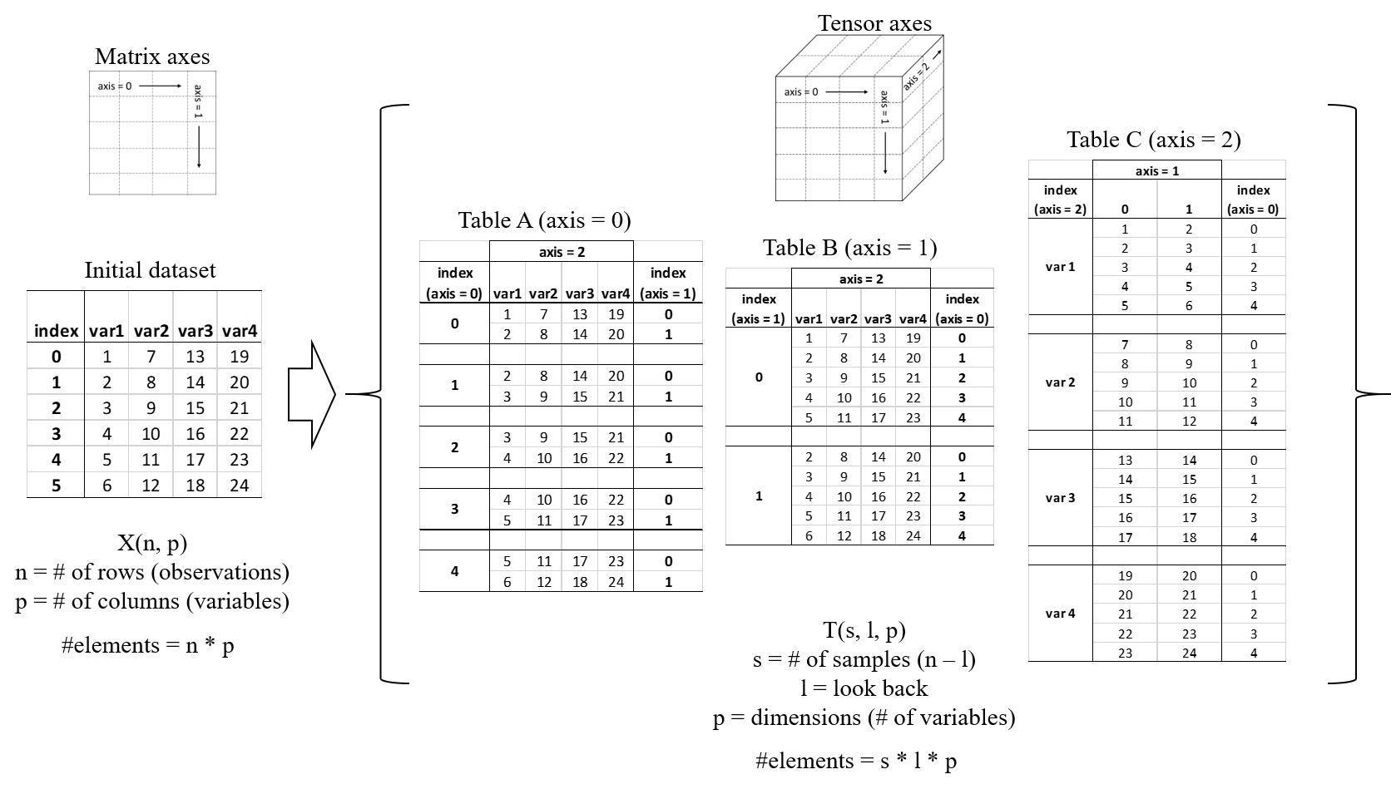

Figure 12. Process of converting data input columns into a Tensor for training

the RNN.

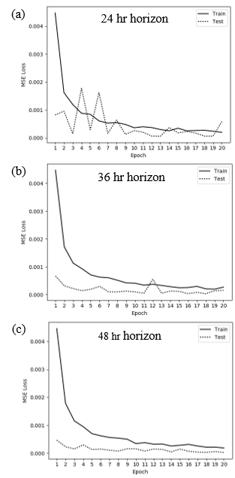

Figure 13. Loss function errors for training and test data sets for different horizons

at (a) 24 hr, (b) 36 hr, and (c) 48 hr.

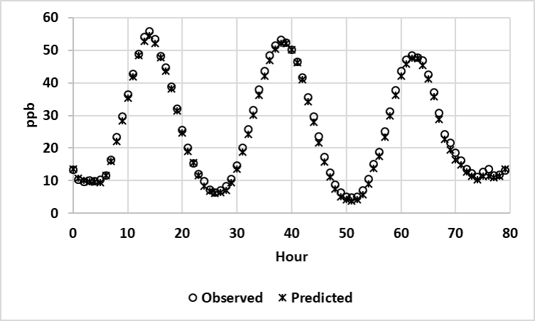

Figure 14. Results of training an RNN with a 24 hr horizon.

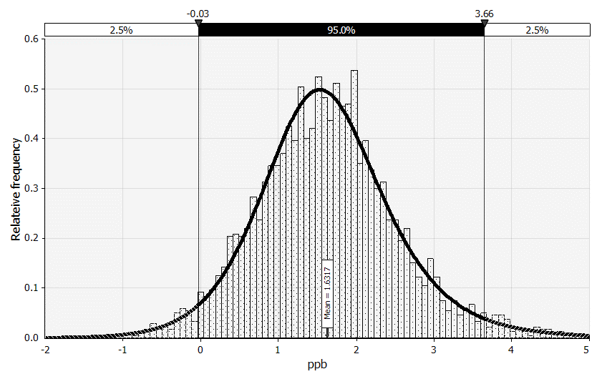

Figure 15. Distribution of residual test errors for 24 hr horizon network.

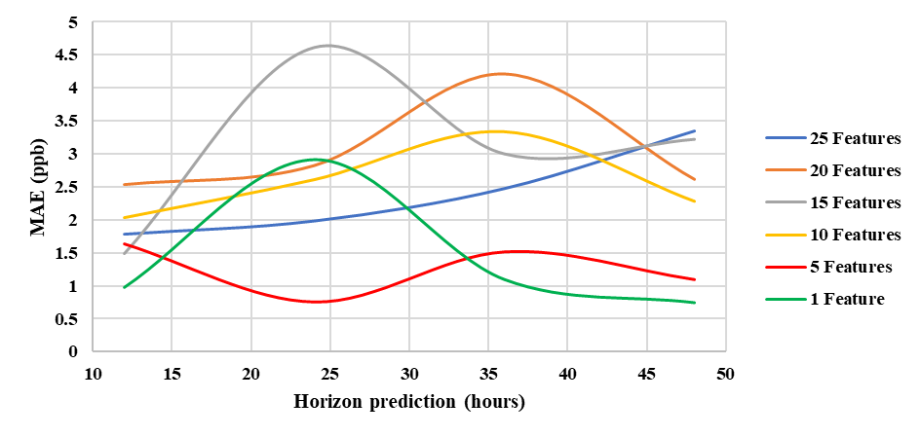

Figure 16. Training error associated with feature reduction on network prediction.

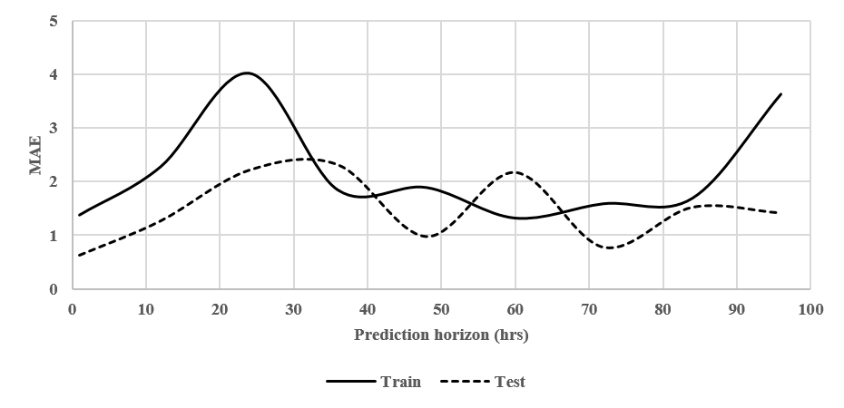

Figure 17. Prediction horizons using 5 features and default parameters (MAE in ppb).

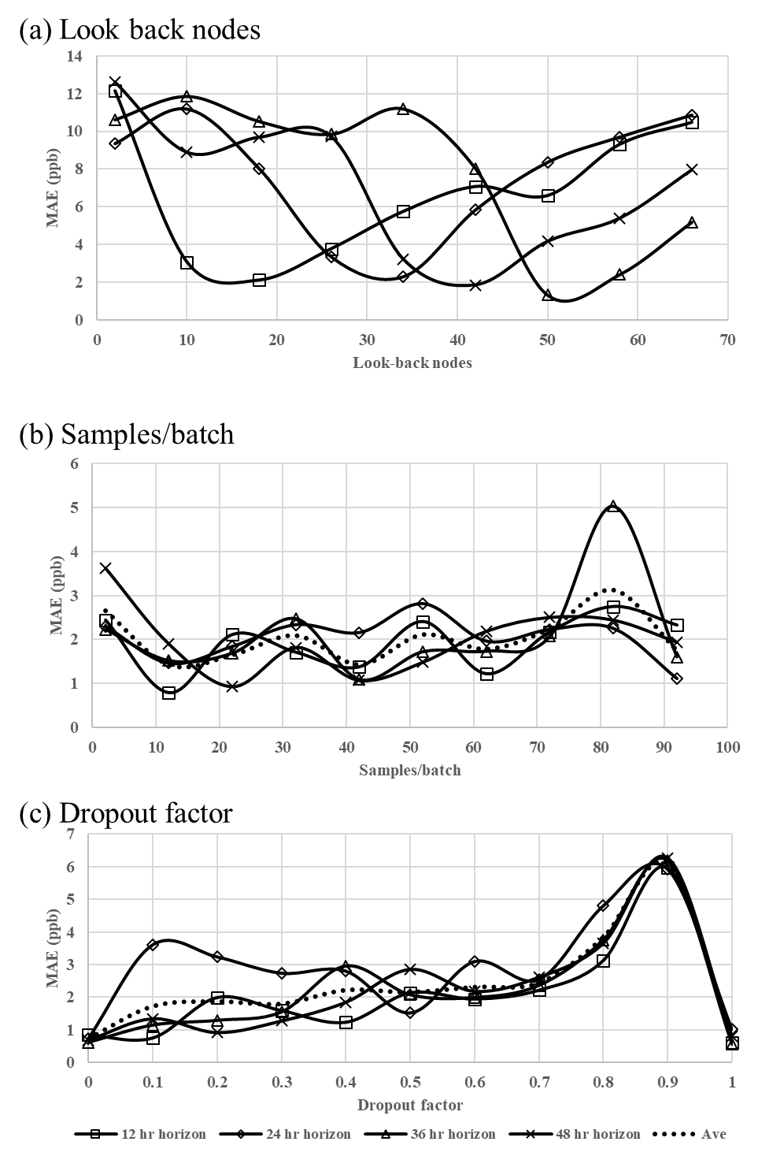

Figure 18. Impact of (a) batch samples, (b) Look back nodes, and (c)

dropout factor parameters on training errors for a model.

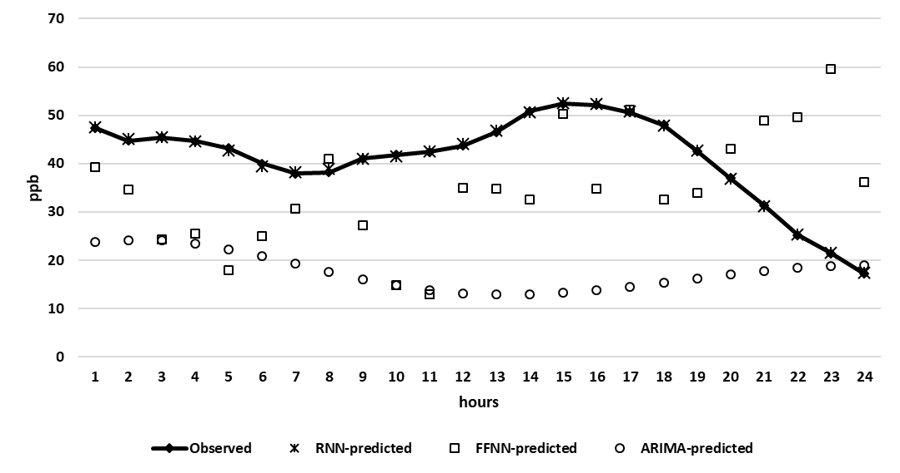

Figure 19. Comparison of different model forecasts over a 24 hr period.