Tkinter visual outputs

- Basic, empty
import tkinter
skylight = tkinter.Tk() # main application window is created by the tkinter method named Tk()
skylight.mainloop() # starts the controller
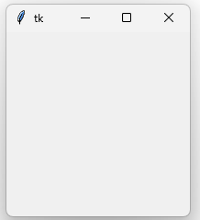

- Setting title
import tkinter

skylight = tkinter.Tk()
skylight.title("Skylight")
skylight.mainloop()
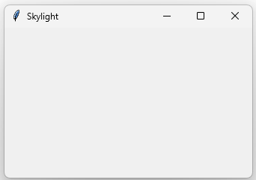

- Adding a button
import tkinter
skylight = tkinter.Tk() # creates the window
skylight.title("Skylight") # creates the window's title
button = tkinter.Button(skylight, text="Bye!") # creates a button into "skylight" window
button.place(x=10, y=10) # button's dimensions
skylight.mainloop()
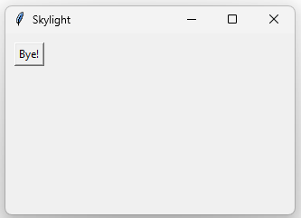

- associate action to a button
import tkinter

def Click(): # function to associate action to button
skylight.destroy();

skylight = tkinter.Tk()
skylight.title("Skylight")
button = tkinter.Button(skylight, text="Bye!", command=Click)
button.place(x=10, y=10)
skylight.mainloop()
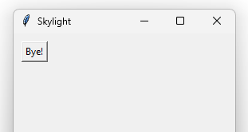 if we click on Bye it will close the window due to destroy() function
- adding message box
import tkinter
from tkinter import messagebox

def Click():
replay = messagebox.askquestion("Quit?", "Are you sure?")
if replay == 'yes':
skylight.destroy();

skylight = tkinter.Tk()
skylight.title("Skylight")
button = tkinter.Button(skylight, text="Bye!", command=Click)
button.place(x=10, y=10)
skylight.mainloop()
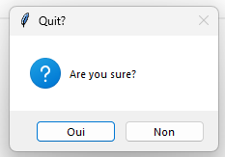

- place()
import tkinter as tk

window = tk.Tk()
button_1 = tk.Button(window, text="Button #1")
button_2 = tk.Button(window, text="Button #2")
button_3 = tk.Button(window, text="Button #3")
button_1.place(x=10, y=10, width = 80)
button_2.place(x=20, y=40)
button_3.place(x=30, y=90, height=50)
window.mainloop()

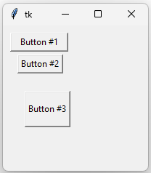

- grid()
import tkinter as tk

window = tk.Tk()
button_1 = tk.Button(window, text="Button #1")
button_2 = tk.Button(window, text="Button #2")
button_3 = tk.Button(window, text="Button #3")
button_1.grid(row=0, column=0)
button_2.grid(row=1, column=1)
button_3.grid(row=2, column=2)
window.mainloop()
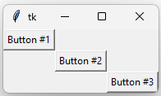

- pack()

import tkinter as tk
window = tk.Tk()
button_1 = tk.Button(window, text="Button #1")
button_2 = tk.Button(window, text="Button #2")
button_3 = tk.Button(window, text="Button #3")
button_1.pack()
button_2.pack()
button_3.pack()
window.mainloop()
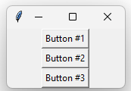

With side:
button_1.pack(side=tk.RIGHT)
button_2.pack()
button_3.pack()
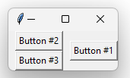

With side and fill:
button_1.pack(side=tk.RIGHT, fill=tk.Y)
button_2.pack()
button_3.pack()
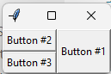
Colouring

import tkinter as tk
window = tk.Tk()
button = tk.Button(window, text="Button #1", bg="red", fg="yellow") # bg= messabox colour, fg= policy colour
button.pack()
window.mainloop()
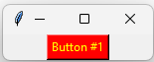

import tkinter as tk
window = tk.Tk()
button = tk.Button(window, text="Button #1",
bg="MediumPurple",
fg="LightSalmon",
activeforeground="yellow",
activebackground="red")
button.pack()
window.mainloop()
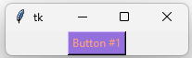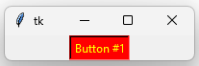

- Label()
import tkinter as tk
window = tk.Tk()
label = tk.Label(window, text = "Little label:")
label.pack()
window.mainloop()

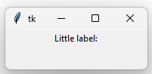
- Frame()
import tkinter as tk
window = tk.Tk()
label = tk.Label(window, text="Little label:")
label.pack()
frame = tk.Frame(window, height=5, width=100, bg="#000099")
frame.pack()
window.mainloop()
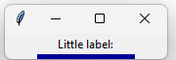

- fill=
import tkinter as tk
window = tk.Tk()
label = tk.Label(window, text="Little label:")
label.pack()
frame = tk.Frame(window, height=30, width=100, bg="#000099")
frame.pack()
button = tk.Button(window, text="Button")
button.pack(fill=tk.X)
window.mainloop()

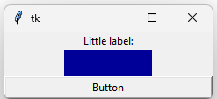

- Checkbutton()
import tkinter as tk
win = tk.Tk()
label = tk.Label(win, text="Little label:")
label.pack()
frame = tk.Frame(win, height=5, width=100, bg="#000099")
frame.pack()
button = tk.Button(win, text="Button")
button.pack(fill=tk.X)
switch = tk.IntVar()
switch.set(1)
checkbutton = tk.Checkbutton(win, text="Check Button", variable=switch)
checkbutton.pack()
win.mainloop()

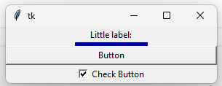

- Entry()
import tkinter as tk
window = tk.Tk()
label = tk.Label(window, text="Little label:")
label.pack()
frame = tk.Frame(window, height=30, width=100, bg="#000099")
frame.pack()
button = tk.Button(window, text="Button")
button.pack(fill=tk.X)
switch = tk.IntVar()
switch.set(1)
checkbutton = tk.Checkbutton(window, text="Check Button", variable=switch)
checkbutton.pack()
entry = tk.Entry(window, width=30)
entry.pack()
window.mainloop()
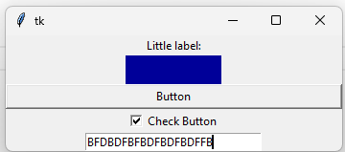

- Radiobutton()
import tkinter as tk
window = tk.Tk()
label = tk.Label(window, text="Little label:")
label.pack()
frame = tk.Frame(window, height=30, width=100, bg="#000099")
frame.pack()
button = tk.Button(window, text ="Button")
button.pack(fill=tk.X)
switch = tk.IntVar()
switch.set(1)
checkbutton = tk.Checkbutton(window, text="Check Button", variable=switch)
checkbutton.pack()
entry = tk.Entry(window, width=30)
entry.pack()
radiobutton_1 = tk.Radiobutton(window, text="Steak", variable=switch, value=0)
radiobutton_1.pack()
radiobutton_2 = tk.Radiobutton(window, text="Salad", variable=switch, value=1)
radiobutton_2.pack()
window.mainloop()
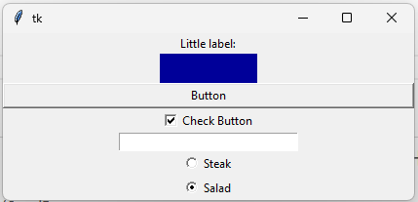

- messagebox.showinfo
import tkinter
from tkinter import messagebox
def clicked():
messagebox.showinfo("info", "some\ninfo")
window = tkinter.Tk()
button_1 = tkinter.Button(window, text="Show info", command=clicked) # "clicked" function defined above is invoked here
button_1.pack()
button_2 = tkinter.Button(window, text="Quit", command=window.destroy)
button_2.pack()
window.mainloop()
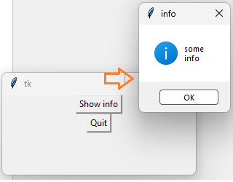

import tkinter as tk
from tkinter import messagebox
def click():
tk.messagebox.showinfo("Click!","I love clicks!")
window = tk.Tk()
label = tk.Label(window, text="Label")
label.pack()
button = tk.Button(window, text="Button", command=click)
button.pack(fill=tk.X) # means it will fill horizontally
frame = tk.Frame(window, height=30, width=100, bg="#55BF40")
frame.pack()
window.mainloop()

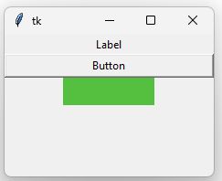

- using x, y, num and type events references to see what occurs behind the scene
def click(event=None):
if event is None:
tk.messagebox.showinfo("Click!", "I love clicks!")
else:
string = "x=" + str(event.x) + ",y=" + str(event.y) + \
",num=" + str(event.num) + ",type=" + event.type
tk.messagebox.showinfo("Click!", string)
window = tk.Tk()
label = tk.Label(window, text="Label")
label.bind("<Button-1>", click)
label.pack()
button = tk.Button(window, text="Button", command=click)
button.pack(fill=tk.X)
frame = tk.Frame(window, height=30, width=100, bg="#55BF40")
frame.bind("<Button-1>", click)
frame.pack()
window.mainloop()

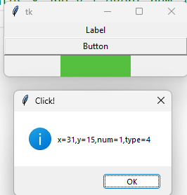

- font
import tkinter as tk
window = tk.Tk()
label_1 = tk.Label(window, text="Quick brown fox jumps over the lazy dog")
label_1.grid(column=0, row=0)
label_2 = tk.Label(window, text="Quick brown fox jumps over the lazy dog", font=("Times", "12"))
label_2.grid(column=0, row=1)
label_3 = tk.Label(window, text="Quick brown fox jumps over the lazy dog", font=("Arial", "16", "bold"))
label_3.grid(column=0, row=2)
window.mainloop()
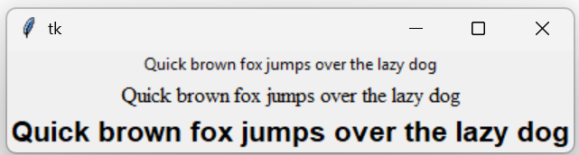

- widget properties
import tkinter as tk
window = tk.Tk()
button_1 = tk.Button(window, text="Ordinary button");
button_1.pack()
button_2 = tk.Button(window, text="Exceptional button")
button_2.pack()
button_2["borderwidth"] = 10
button_2["highlightthickness"] = 10
button_2["padx"] = 10
button_2["pady"] = 5
button_2["underline"] = 1
window.mainloop()
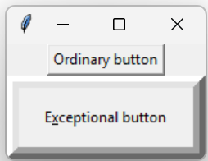

- anchor
import tkinter as tk
window = tk.Tk()
button_1 = tk.Button(window, text="Regular button");
button_1["anchor"] = tk.E
button_1["width"] = 20 # pixels!
button_1.pack()
button_2 = tk.Button(window, text="Another button")
button_2["anchor"] = tk.SW
button_2["width"] = 20
button_2["height"] = 3 # rows
button_2.pack()
window.mainloop()

