I'm going to mark this as resolved as I was able to get past the auto-grader SQL query count check that utilizes time zone difference (3.3.3-2), based on the use of a straightforward/naive (you'll see why I call it naive if you read on) handling of the edge case mentioned in the assignment prompt. However, I'd like to add a little note here in case it benefits anyone else. I struggled for quite some time trying to wrap my head around this, I guess overthinking it in the context of what we need to pass the autograder, but for the sake of technical correctness would like to point it out.
The reason I encountered this early on, and therefore the reason it tripped me up for so long, is simply because I was randomly sampling some data after my transformation to make sure the calculated time zone differences made sense. Especially as we are not given any way to check this until later in the assignment (section 3, Athena). But anyway, I noticed that while my approach worked in most cases, for short flights (e.g. < 60 minutes), where a flight is going "backwards" in time (e.g. FWA [GMT-4] to FWA [GMT-5]), my calculation didn't work. Here is an example from Athena: 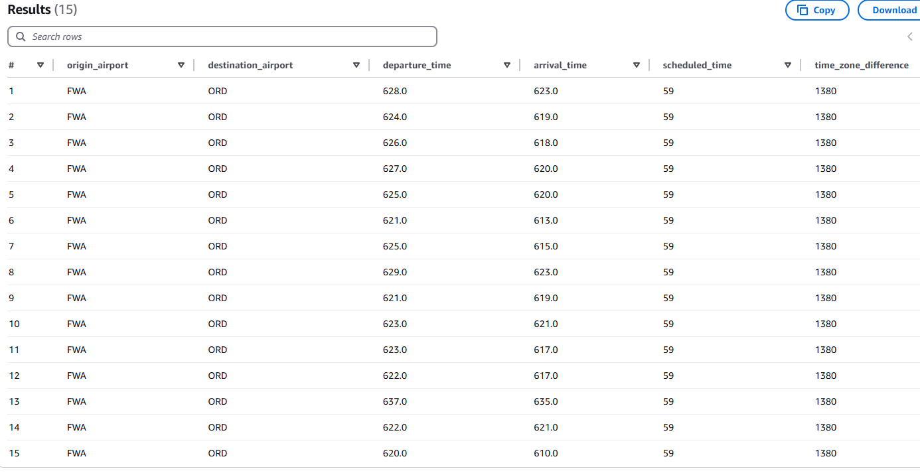Clearly, time_zone_difference is wrong here. However, as stated, I was still able to pass the auto-grader for SQL query two with these incorrect values. Time zone difference on these records shown above should be -60, as you can see.
Now, I started down the road of trying to account for this second scenario which wasn't handled by the simple/naive approach that ended up working for the auto-grader's assessment of SQL query 2 (3.3.3-2). I started trying to incorporate other fields such as day, month, and year into my logic, etc. I was starting to worry about "supersonic" flights that could possibly traverse multiple timezones "backwards" in less than an hour, how these secondary "edge" cases if you will (or "edge cases for handling of the edge case") would play out when also spanning multiple days, and so on...
Like I said, I was overthinking and I pretty much knew it, but it was still frustrating because I clearly saw an issue here with the logic I was using either way (as I initially did try to account for this other situation with the short flights spanning back one time zone) and didn't have a way to verify it until much later in the process, at which point I wasn't sure how much I may have to redo if it was wrong. (Ironically enough, I ended up also having an SQL error that confounded the problem and forced me to redo many of the steps anyway, chasing the wrong issue much of the time again because I wasn't clear on just how completely sound our time_zone_difference calculations needed to be.)
In any case, I did make a run through where at least these particular instances (flights with scheduled time <= 60 minute spanning back one time zone) were corrected to a time_zone_value of -60 (or at least some of them, I'm not sure yet if I got any that happen to span multiple days), and I did still get the same count for SQL query 2, so the difference here does not end up being material to the auto-grader outcome (at least for SQL query 2, see parenthetical note at the end) based on my assessment. Obviously though, it's possibility still threw me off early on, and unless I look at this more rigorously I'm entirely certain there aren't other "edge cases to my edge case handling" that I'm not also missing.
So anyway, hopefully not digressing too much here. The point is, I think the prompt should be more explicit about this. In part 3.3.3 query 2, we are told: I think we need something similar to this for part 3.2.2, where we are explicitly told how/what we need to do to calculate time zone difference if what is expected isn't a perfectly accurate result, and/or it would be nice if we could have some kind of intermediate check at this step, such as being provided an aggregate value for time_zone_difference we could check against to make sure we've calculated this field correctly.
If I have a mistaken thought process here, someone please let me know. Maybe I just haven't slept enough (which is probably true either way). But in any case, hopefully this discussion will help someone else.
(Note I have not yet tried the visualizations, but if I'm thinking of this correctly the outcome here shouldn't be material to these later stages of the autograder, because time_zone_difference and the resulting stop_over_time fields are only used to filter the results, not modify any of the fields we are actually saving off for the viz. I will follow up again once I get past that point if I find I was wrong about that.)

