The aim of the project is to demonstrate obtained knowledge solving the current project tasks. You should follow the steps of the software life cycle: requirements analysis, design, coding, testing and you should represent the results of each step.

**Recommended content of the project:**

Title page

Content table

1. Aim of the project

2. Requirements specification

3. Main body (divided into numbered chapter, subchapters as needed)

3.1 Design

3.2 Implementation

3.3 Testing results

4. Conclusions

5 Attachments

Title page should be as the follow

**FACULTY OF APPLIED INFORMATION TECHNOLOGY**

**Field Of Study: Information Technology**

**Specialty: Programming**

First name Last name

No. of student’s record book: 62831

**PROJECT**

**Course: Introduction to programming**

**Topic:**

**Rzeszow 2022**

**Content table**

1. Aim of the project

2. Requirements specification

3. Main body (divided into numbered chapter, subchapters as needed)

3.1 Design

3.2 Implementation

3.3 Testing results

4. Conclusions

5 Attachments

In the «**Aim of the project**», you should describe the overall setting of the task and the list of tasks that must be solved.

In the «**Requirements specification**» you should present the list of the functional and non-functional requirements for the software under the implementation. To put it simply, functional requirements describe what the program should do, while non-functional requirements place constraints on how the program should do it.

**Functional requirements** (software must do) examples:

1. The system must allow users to choose certain task from the main menu.

2. A user must be able to input data form the keyboard.

**Non-Functional requirements** (how a program operates) examples:

1. The navigation should be provided by main menu and dialog with the user.
2. The inputted data should be validated to prevent the application crashing.

In the «**Main body**» you should present the results of the designing, coding and software testing. Software task should be decomposed and implemented as a set of the functions. Software don’t need to have graphical user interface.

All interaction with the user should be done through the main menu. The program stops working when the user has selected the corresponding menu item. The developed program must be resistant to user errors and not be destroyed due to them.

You should describe the scheme of the dialog between users and your program, Add screens of the user's interaction with your program,

You should describe the results of your program testing with different inputted data

In the **Conclusion** you must justify the effectiveness of the proposed solutions, justify the feasibility of using built-in functions or libraries (if you used them).

The last chapter should be **“﻿﻿Attachments”** please describe the full python code there.

For evaluation, you provide a file with the project and source files in Python.

**TECHNICAL RULES FOR WRITING THE PROJECT**

**I. RULES OF FORMATTING THE TEXT**

- The file with the project should be saved as a Word document (*.doc or *.docx).

- The size of the file cannot exceed 15 MB.

- Do not insert headers or footers with separate text, e.g. chapter's title.

- Every part of the project should begin on a new page.

- Do not put full stops after the headings of particular parts of the project (including chapters/subchapters)

- Page numbers should obligatorily be put in automatically (in the footer, centred, Font Times New Roman, size 12). The first page of the project is the title page and numbering should begin from this very page, but the number should not show on that page.

- The table of contents should be automatic. It should be placed in the third page of the project.

- Font – Times New Roman, size 12, without bolding.

- Standard space between characters (0 points).

- Not more than one space between words.

- Single space between lines.

- Text justified.

- Automatic hyphenation of words.

- If a paragraph should begin on a new page, choose the function of page break (*Ctrl + Enter*).

- Do not leave any single letters or conjunctions at the end of the line. To transfer the conjunction to the next line, press hard space (*Ctrl* + *Shift* + *Space bar*). Hard space should be inserted directly after the conjunction and before the following word (this causes the conjunction to be “attached” to the word).

- Do not use the *Enter* key or soft enter at the end of the line (within a sentence).

- Do not put a space between a word and a punctuation mark following it (comma, full stop, semicolon, colon).

- Words (sentences) written in brackets cannot be separated from the brackets with spaces.

- Enumerations in the text should be done with automatic bulleting or numbering.

- The project must be printed on both sides – in the *File/Page Layout/Margins* menu choose “mirror margins” (inside margin - 2cm, outside, top and bottom margins – 1.5cm each).

**II. FIGURES, GRAPHS, PICTURES, CHARTS**

Graphics included in the thesis should be described as Fig. for figures, maps, graphs, diagrams or pic-tures, and Tab. for tables. They should be numbered sequentially with Arabic numerals (Fig. 1, Tab. 1, etc.).

In the case of Figures*,* the number should be followed with adequate caption (title) and – starting from a new line – information about the source. Figure’s number, its caption and information about the source should be placed below the figure (see example below).



Fig. 5. PolskiBus coach

Source: http://podroze.se.pl/, as of 13.06.2017

For objects marked as Tab., the number and description should be placed above the object (table), and information about the source below the object (see example below).

Tab. 1. Remuneration in insurance sector at different management levels in 2014 (gross in PLN)

|  |  |  |  |  |
| --- | --- | --- | --- | --- |
|  | **Sample size** | **25% earned below** | **median** | **25% earned above** |
| director/mangt | 110 | 9 000 | 14 500 | 25 000 |
| manager | 274 | 5 700 | 8 500 | 12 800 |
| specialist | 964 | 3 400 | 4 960 | 7 700 |
| ordinary employee | 292 | 2 060 | 2 600 | 3 600 |

Source: All-Polish Research on Remuneration (ARR) conducted by Sedlak & Sedlak in 2014

For captions and source information use font Times New Roman, size 10, no bolding or italics.

**III. FORMULAE**

Formulae should be placed centrally, in separate lines, labelled with Arabic numerals in parentheses placed close to the outer margin.

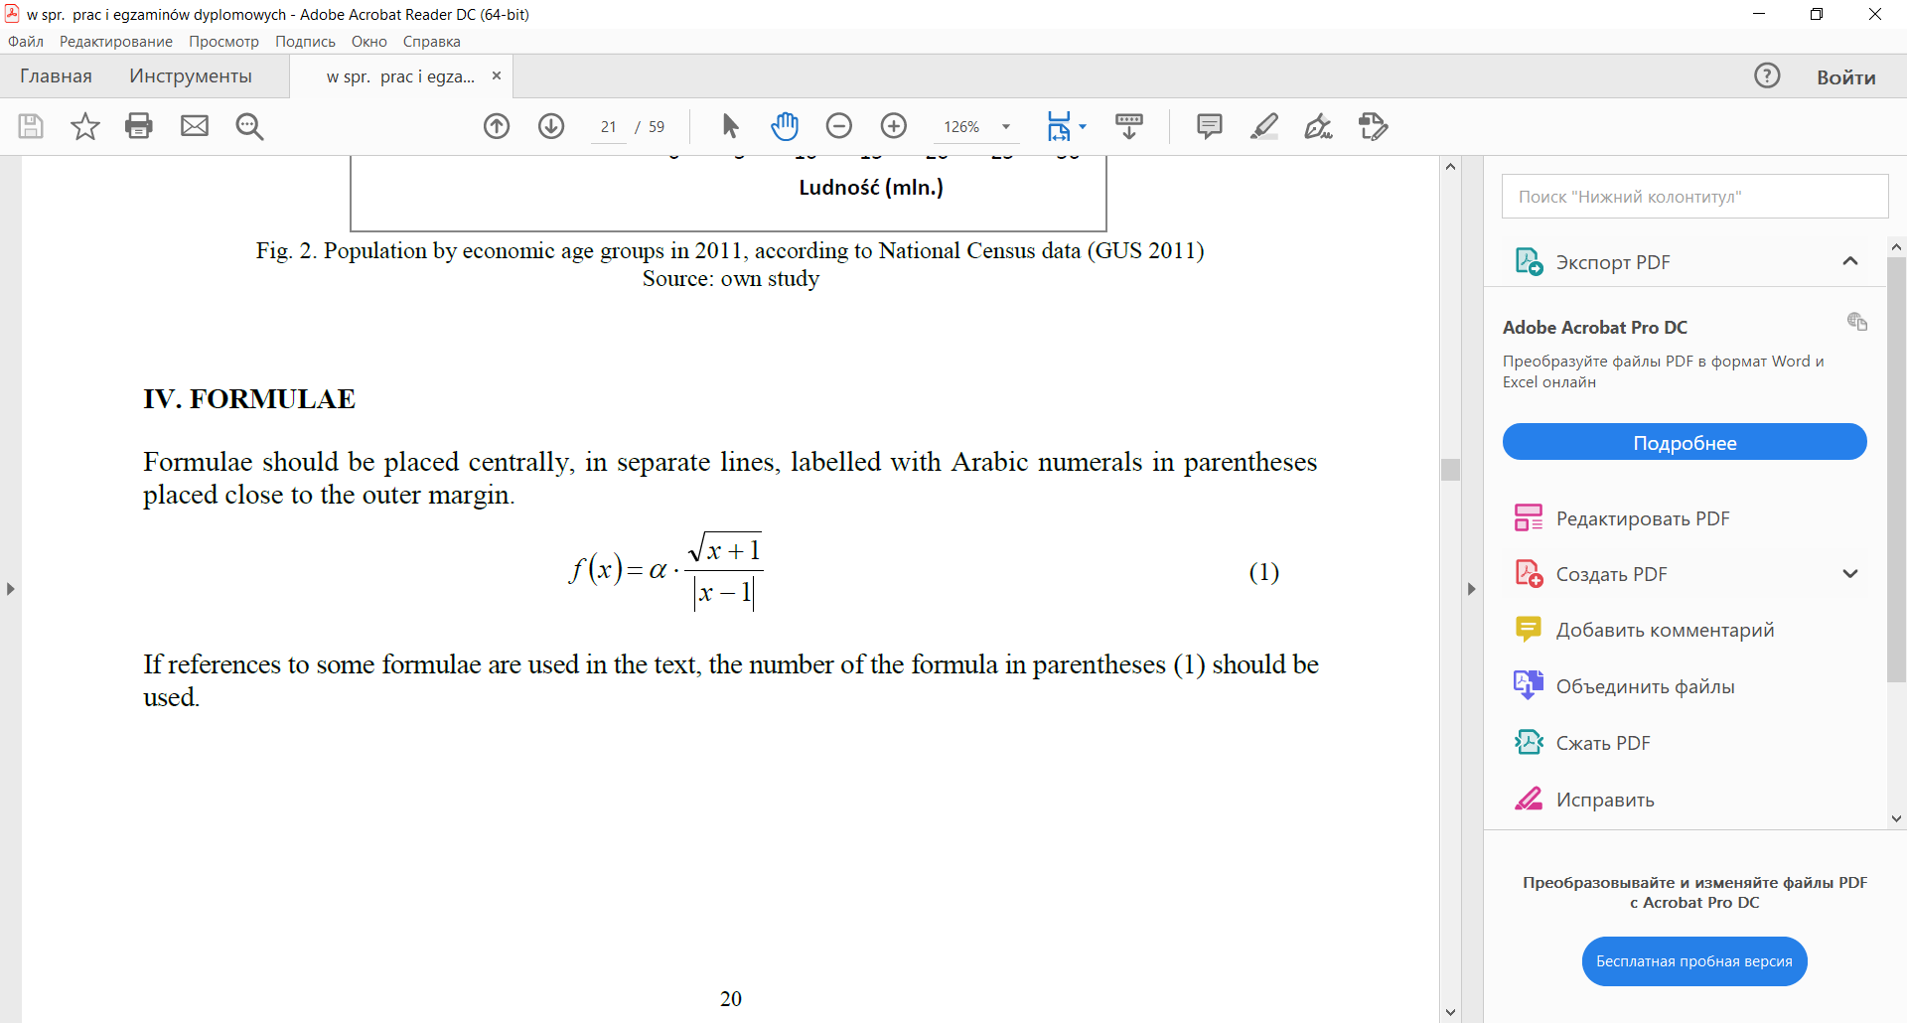 (1)

If references to some formulae are used in the text, the number of the formula in parentheses (1) should be used.