SCIENCE & ACADEMIC ENGLISH (CLIL) ASSESSMENT
Unit: Breath of Life — How Animals Breathe | 7th Grade Life Science | 25 Questions
Student Full Name: _________________________________________ | Date: ___________________________
Class / Section: 7th Grade ( ______ ) Time: 60 minutes | Final Score: _______ / 25 ( _______ % )

PART 1: SCIENTIFIC READING COMPREHENSION — TRUE OR FALSE (Questions 1–6)
Instructions: Read the scientific article below carefully. Then, for statements 1 to 6, write TRUE (T) or FALSE (F) in the answer column based on the text.

READING PASSAGE: The Gift of Breath — One Vital Problem, Many Remarkable Solutions
Every living animal needs oxygen to survive, yet breathing itself is only a delivery service. Inside almost every cell in an animal's body, microscopic structures called mitochondria combine oxygen with digested food to release usable energy. This chemical process is called cellular respiration, and it produces carbon dioxide (CO₂) as a waste gas that the body must remove. The physical act of moving air or water across a respiratory organ is called ventilation, whereas the actual swap of gases happens by diffusion—the natural movement of gas particles from where they are crowded (high concentration) to where they are scarce (low concentration). Because gases can only diffuse across a barrier that is thin and wet, every gas-exchange surface on Earth—whether a lung, a gill, or a skin membrane—must remain thin, moist, and rich in surface area.
Different habitats require completely different respiratory designs. In humans and other mammals, when the dome-shaped diaphragm muscle contracts and flattens downward, air rushes down the trachea and bronchi into 300 to 500 million tiny air sacs called alveoli, which provide roughly 70 square meters of surface area. However, because mammals breathe in and out through the same tubes (two-way airflow), humans extract only about 25% of the oxygen from each breath. In contrast, water holds far less dissolved oxygen than air, so fish use feathery gills covered in microscopic folds called lamellae. Inside the lamellae, blood flows in the opposite direction to the water passing over them. This countercurrent exchange maintains a constant oxygen gradient and allows fish to extract up to 80% of the dissolved oxygen in water.
Other animal groups solve the same problem in surprising ways. Amphibians such as frogs are "triple-threat" breathers: they use gills as aquatic tadpoles, and as adults they combine simple sac-like lungs with cutaneous respiration (breathing directly through their thin, moist skin and mouth lining). Reptiles, covered in thick, waterproof scales for dry land, cannot breathe through their skin and lack a diaphragm; instead, they use rib and body-wall muscles to expand their chest cavity. Finally, insects skip the bloodstream completely for oxygen transport: air enters through tiny side valves called spiracles and travels down branching tracheal tubes into microscopic tracheoles that press directly against individual cells. Because insect blood (hemolymph) does not carry oxygen and gas can only diffuse a short distance down a tube, insects can never grow as large as mammals.

Q# | Comprehension Statement (Based on the Reading Passage) | Write T or F
1. | Cellular respiration takes place inside the mitochondria, where oxygen is combined with digested food to release energy and produce carbon dioxide (CO₂) as waste. | T / F [ _____ ]
2. | Ventilation and diffusion mean the exact same thing: ventilation is the chemical reaction inside cells, while diffusion is the muscular pumping of the ribs. | T / F [ _____ ]
3. | Fish gills extract a higher percentage of available oxygen from water (up to 80%) than human lungs extract from each breath of air (about 25%). | T / F [ _____ ]
4. | In countercurrent exchange, blood inside a fish's gill lamellae flows in the exact same direction as the water passing over the gills. | T / F [ _____ ]
5. | If an adult frog's skin becomes completely dry, cutaneous respiration stops working because gases can only diffuse across a moist surface. | T / F [ _____ ]
6. | Insect blood (hemolymph) is packed with hemoglobin to carry oxygen from the lungs to every cell in the insect's body. | T / F [ _____ ]

PART 2: ANATOMICAL DIAGRAM IDENTIFICATION — THE BIRD'S RESPIRATORY SYSTEM (Questions 7–11)
Instructions: Examine the anatomical illustration of the bird's respiratory system below. Use the Word Bank (A–H) to identify the parts labeled Q7, Q8, Q9, Q10, and Q11. Watch out: there are THREE extra distractor words that do not belong to birds!

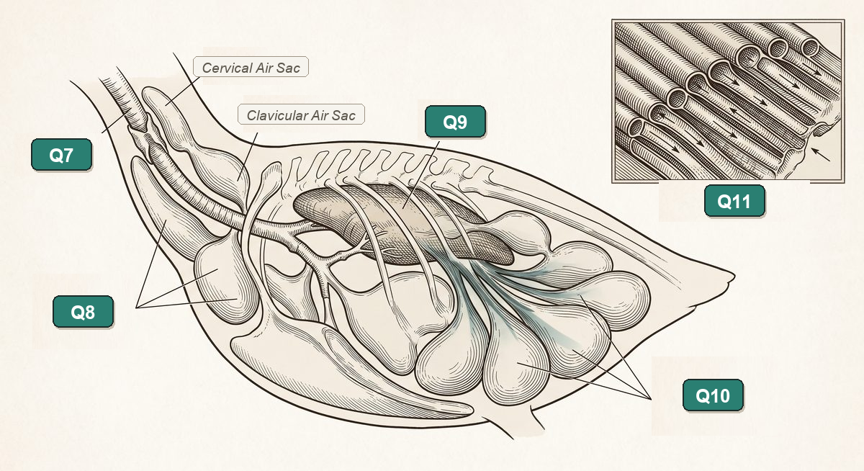
WORD BANK — ANATOMICAL STRUCTURES (Includes 3 Distractors!)
A. Trachea (Windpipe) · B. Anterior Air Sacs · C. Rigid Lung · D. Posterior Air Sacs
E. Parabronchi (Parallel Tubes) · F. Diaphragm Muscle · G. Gill Lamellae · H. Insect Spiracles

Q# | Diagram | Anatomical & Functional Clue | Letter (A–H) & Structure Name
7. | [ Q7 ] | Main tube reinforced with cartilage rings that carries inhaled air from the throat toward the syrinx and air sacs. | Letter: [ ___ ] _____________________
8. | [ Q8 ] | Front group of bellows-like sacs (near the chest) that receive partly used air leaving the lungs before it is exhaled. | Letter: [ ___ ] _____________________
9. | [ Q9 ] | The main gas-exchange organ tucked against the ribs; unlike mammal lungs, it barely changes size as air is pushed through it. | Letter: [ ___ ] _____________________
10. | [ Q10 ] | Rear group of bellows-like sacs that store fresh, incoming air first and push it forward into the lung. | Letter: [ ___ ] _____________________
11. | [ Q11 ] | Microscopic parallel tubes (shown in the magnified inset box) that allow continuous one-way airflow instead of dead-end sacs. | Letter: [ ___ ] _____________________

PART 3: SCIENTIFIC VOCABULARY & ADAPTATION MATCHING (Questions 12–17)
Instructions: Match each respiratory term or adaptation in the left column (Questions 12–17) with its correct scientific definition in the right column (A–G). Write the correct letter in the brackets. One letter is an extra distractor!

Scientific Term (Write Letter A–G) | Function & Biological Description
12. Alveoli [ _____ ] | A. Hard bony flap on each side of a fish's head that covers and protects the delicate gill filaments while helping pump water.
13. Countercurrent exchange [ _____ ] | B. Oxygen-storing protein found in high concentrations inside the muscles of deep-diving mammals like sperm whales and seals.
14. Cutaneous respiration [ _____ ] | C. 300–500 million microscopic air sacs wrapped in blood capillaries inside mammal lungs where oxygen diffuses into the blood.
15. Spiracles & Tracheoles [ _____ ] | D. Gas exchange directly through thin, moist, blood-vessel-rich skin—used by adult frogs and lungless salamanders.
16. Operculum [ _____ ] | E. Valve-like side openings and microscopic air tubes in insects that deliver oxygen straight to body cells without using blood.
17. Myoglobin [ _____ ] | F. Opposite-direction flow of blood and water across fish gill lamellae that maintains a constant oxygen gradient (up to 80% extraction).
(Extra Distractor Definition) | G. The voice box at the base of a bird's trachea that produces complex songs without performing any gas exchange.

PART 4: MULTIPLE CHOICE — COMPARATIVE SYSTEMS & ACADEMIC ENGLISH (Questions 18–23)
Instructions: Read each question carefully and circle or write the letter of the single best answer (A, B, C, or D).

18. How do reptiles such as snakes, lizards, and turtles ventilate their lungs on dry land without a diaphragm?
A) They absorb 90% of their oxygen through their wet, porous scales by cutaneous diffusion.
B) Snakes and lizards expand their rib cage with muscles, while turtles use special muscles near their limbs because their ribs are fused to their shell.
C) They use nine internal air sacs to pump air in a continuous one-way loop through rigid lungs.
D) They pump water across internal gill arches located behind their nostrils.
19. Why can bar-headed geese fly over the Himalayas at altitudes above 7,000 meters, where the air holds only one-third of sea-level oxygen?
A) Their air sacs store air and push it in a continuous one-way flow through the lungs on both inhale and exhale, keeping the lungs full of fresh air.
B) They collapse their lungs before takeoff and breathe exclusively through their feathers.
C) Their alveoli are ten times larger than whale alveoli and use two-way tidal ventilation.
D) They do not perform cellular respiration while flying at high altitudes.
20. Which sequence correctly describes how a frog's respiratory surfaces change from its larval stage (tadpole) to adulthood?
A) Tracheal tubes as a larva → gills and a muscular diaphragm as an adult.
B) Simple lungs only as a larva → feathery external gills only as an adult.
C) Feathery gills for breathing underwater as a tadpole → simple sac-like lungs, moist skin (cutaneous respiration), and mouth lining as an adult.
D) Parabronchi and air sacs as a tadpole → waterproof scaly skin and rib-driven lungs as an adult.
21. Why do deep-diving mammals like seals and sperm whales collapse their lungs during deep ocean dives?
A) Because water enters their bronchi so they can extract dissolved oxygen like fish.
B) In order to avoid decompression sickness (nitrogen bubbles in the blood), relying instead on oxygen stored in their blood and muscle myoglobin.
C) Because their diaphragm stops working below 10 meters of water depth.
D) So that carbon dioxide can diffuse out through their thick blubber and skin.
22. [Academic English — Cause & Effect] Complete the scientific explanation: "Insects cannot grow as large as mammals ___________ oxygen must diffuse down tiny tracheal tubes without help from the bloodstream."
A) whereas
B) despite
C) because
D) although
23. [Academic English — Comparison & Passive Voice] Which sentence is both grammatically correct in academic English and scientifically accurate?
A) Whereas mammal lungs breathe in and out (two-way flow), fresh air is pushed in one direction through a bird's lungs by nine air sacs.
B) Bird lungs are more efficiency than mammal lungs because air are deliver by spiracles.
C) Unlike fish gills, human lungs extracts 80% of oxygen by countercurrent exchange.
D) Because reptiles have a diaphragm, their lungs is more folded that amphibian lungs.

PART 5: BIBLICAL PRINCIPLE & COMPARATIVE SYSTEMS SYNTHESIS (Questions 24–25)
Instructions: Read the Biblical Principle verses below. Answer Questions 24 and 25 in complete English sentences (3–4 sentences each), connecting the scientific mechanics of the two respiratory systems with the Biblical truth.

"Let everything that has breath praise the LORD. Praise the LORD!" — Psalm 150:6 (NKJV)
"For with You is the fountain of life; in Your light we see light." — Psalm 36:9 (NKJV)
24. [Human Lungs vs. Bird Air Sacs + Psalm 150:6] Compare how the HUMAN respiratory system (alveoli and involuntary diaphragm rhythm) and the BIRD respiratory system (nine air sacs and continuous one-way airflow through parabronchi) work. How do both our 20,000 involuntary daily breaths and a bird soaring over 7,000-meter mountain peaks reflect our dependence on God and fulfill Psalm 150:6?
💡 Helpful English Words & Connectors: whereas · diaphragm · alveoli · one-way airflow · air sacs · depend on · Creator · praise the LORD
____________________________________________________________________________________________________________
____________________________________________________________________________________________________________
____________________________________________________________________________________________________________
____________________________________________________________________________________________________________
25. [Fish Gills vs. Insect Tracheal Tubes + God's Wisdom in Creation] Compare how FISH (using gills, lamellae, and countercurrent exchange underwater) and INSECTS (using spiracles and tracheoles to deliver oxygen directly to cells without blood) solve the problem of breathing in completely different habitats. How do these two extraordinary engineering designs show the wisdom and care of the Creator for creatures great and small?
💡 Helpful English Words & Connectors: while · countercurrent exchange · 80% of oxygen · spiracles · tracheoles · divine engineering · habitat
____________________________________________________________________________________________________________
____________________________________________________________________________________________________________
____________________________________________________________________________________________________________
____________________________________________________________________________________________________________

TEACHER'S ANSWER KEY & CLIL GRADING RUBRIC (25 Questions — 4 Points Each = 100%)
Instructions: Complete scoring key for Parts 1–4 and model responses + rubric criteria for Part 5 (Questions 24–25).

PART 1: Reading Comprehension — True or False (Questions 1–6)
1. TRUE (T) — Mitochondria combine oxygen with digested food (cellular respiration) and release CO₂ as waste.
2. FALSE (F) — Ventilation is the physical movement of air/water; diffusion is the passive movement of gases across a membrane.
3. TRUE (T) — Fish gills extract up to 80% of dissolved O₂ via countercurrent exchange, while humans extract ~25%.
4. FALSE (F) — In countercurrent exchange, blood and water flow in OPPOSITE directions.
5. TRUE (T) — Gases can only diffuse across a thin, moist surface; dry amphibian skin cannot exchange gases.
6. FALSE (F) — Insect blood (hemolymph) does not carry oxygen at all; air travels directly via tracheal tubes.
PART 2: Bird Respiratory System Diagram Identification (Questions 7–11)
7. [ Q7 ] → A. Trachea (Windpipe)
8. [ Q8 ] → B. Anterior Air Sacs
9. [ Q9 ] → C. Rigid Lung
10. [ Q10 ] → D. Posterior Air Sacs
11. [ Q11 ] → E. Parabronchi (Parallel Tubes)
*(Distractors Not Used: F. Diaphragm Muscle, G. Gill Lamellae, H. Insect Spiracles)*
PART 3: Scientific Vocabulary & Adaptation Matching (Questions 12–17)
12. Alveoli → C
13. Countercurrent exchange → F
14. Cutaneous respiration → D
15. Spiracles & Tracheoles → E
16. Operculum → A
17. Myoglobin → B
*(Distractor Not Used: G — Syrinx / Bird voice box)*
PART 4: Multiple Choice — Comparative Systems & Academic English (Questions 18–23)
18. B — Snakes/lizards use rib muscles; turtles use limb-area muscles because their ribs are fused to the shell.
19. A — Nine air sacs create continuous one-way airflow through the lungs on both inhale and exhale.
20. C — Tadpole gills underwater → adult simple lungs + moist skin (cutaneous) + mouth lining.
21. B — Collapsing lungs prevents decompression sickness; oxygen is stored in blood and muscle myoglobin.
22. C — 'because' (introduces the scientific cause why insects cannot grow as large as mammals).
23. A — Correct contrast connector ('Whereas') and passive voice ('is pushed') with accurate science.
PART 5: Biblical Principle & Comparative Synthesis — Model Answers & Rubric (Questions 24–25)
24. Model Full-Credit Answer: Whereas humans breathe in and out (two-way airflow) using the diaphragm muscle to pull air into millions of alveoli about 20,000 times a day, birds use nine air sacs to push fresh air in a continuous one-way flow through their parabronchi. Our involuntary human breathing reminds us moment by moment that our life is held in God's hands, while a bird's ultra-efficient lungs allow it to soar over 7,000-meter mountains to declare God's glory, fulfilling Psalm 150:6.
25. Model Full-Credit Answer: While fish extract up to 80% of dissolved oxygen underwater using countercurrent exchange in their gill lamellae, insects need no lungs or blood for oxygen because air enters through spiracles and travels down tracheoles directly to individual cells. Both systems show God's infinite wisdom and purposeful design: whether in the depths of the ocean or in the smallest insect on land, the Creator equips every creature with the breath of life to praise the LORD.

