TARGET VARIABLE= ANS TO BPQ020

**FEATURES**

Alcohol Consumption = ALQ130

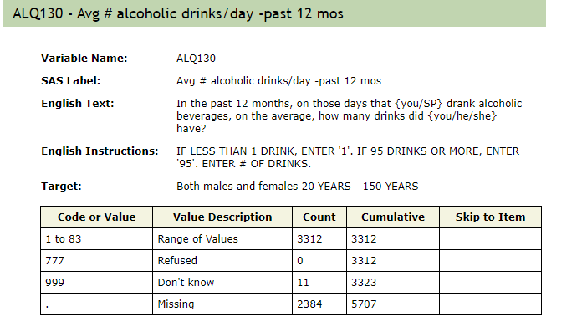

Income = INDFMMPI & INDFMMPC

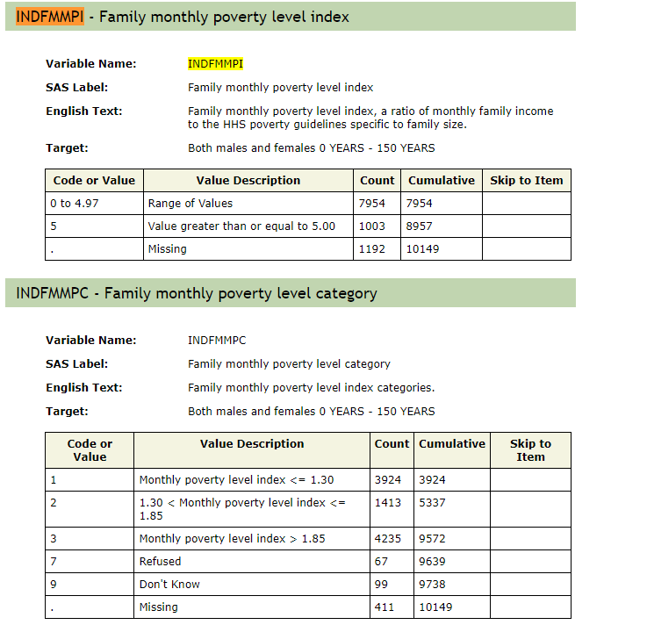

Race = RIDRETH1

Smoke = SMD020, SMD030, and SMDF040

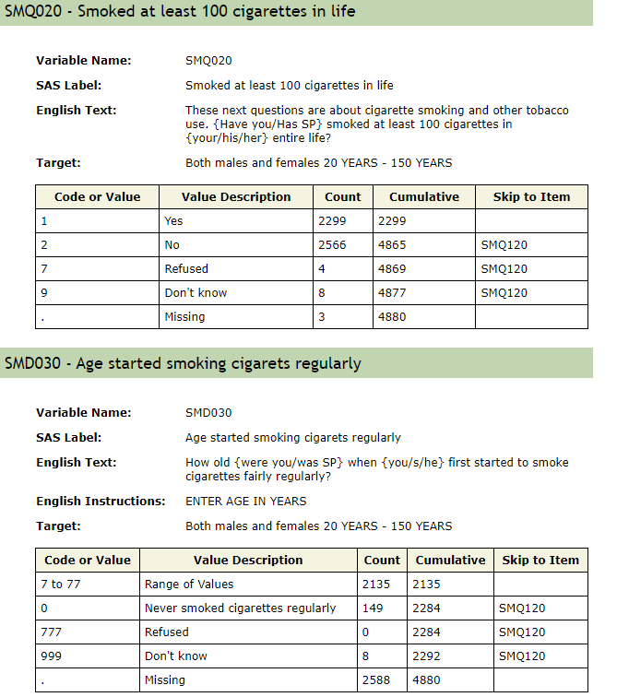

Cholesterol Levels (mg/dL) – LBXTC

Weight – BMXWT

BMI – BMXBMI

Physical activity / Heart Rate = PAQ605, PAQ620, PAQ650, & PAQ665



