SOT Automation Application Setup

# Glossary

List of references used in the steps below

|  |  |  |
| --- | --- | --- |
| References | Meaning | description |
| <Application Path> | Refers to the unzipped application path | Application once unzipped will create a folder named “uhg-sot-automation”.  This refers to the absolute path up until and including “uhg-sot-automation”. |

# Assumptions:

1. The python packages mentioned in the <Application Path>/setup/requirements.txt are available in the server machine, having same or higher version.

Note: In case any package is missing install using below command:-

pip install <package name>

To confirm if the package is already installed use command:-

pip freeze | findstr <package name>

In case pip is not installed on the system follow steps as per below link:-

<https://github.com/BurntSushi/nfldb/wiki/Python-&-pip-Windows-installation>

2. Path variables for java and python are set.

3. port 5000 should be available on server machine to run the app.

# Setup:-

## **Step 1: Setup the Master configuration json.**

Location : <Application Path>/setup

Filename : masterConfig.json

1. Open MasterConfig.json in editor of choice. This opens a file with below format:-

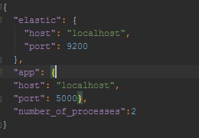

1. "host"(elastic): host ip at which elastic search is running.

This is defaulted to localhost, since the server will be started local to the app server. We will keep this as it is.

1. "port"(elastic): port of the elastic search.

Defaulted to elasticsearch default port 9200. Recommend to keep this as it is unless 9200 is occupied and we need to setup on any other port.

1. “host”(app): host ip at which application is running.

This is defaulted to localhost, since the server will be started local to the app server. We will keep this as it is.

1. "port"(app): port of the application to run on.

Defaulted to port flask default port 5000. Recommend to keep this as it is unless 5000 is occupied and we need to setup on any other port.

1. “number_of_processes”: defaulted to 2.

## **Step 2: running the elasticsearch.**

Location : <Application Path>/ elasticsearch-5.2.0/bin

Filename : elasticsearch.bat

1. Open windows command prompt and navigate to <Application Path>/ elasticsearch-5.2.0/bin
2. type in the command "elasticsearch.bat"
3. Wait for at least 5 minutes. Then check for the url http://localhost:9200 in the browser. If the response is similar to the below:

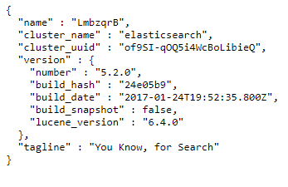

## Then it means that elasticsearch server is up and running and we can proceed to the next step. If not then try to change elasticsearch port with help of admin in both the masterConfig.json and in <Application Path>/ elasticsearch-5.2.0/config/elasticsearch.yml.

## **Step 3: running the app.**

Location : <Application Path>/setup

Filename : run.pyc

1. Open windows command prompt and navigate to <Application Path>/setup
2. type in the command "python run.pyc"

## **Step 3: Test setup is successful**

1. Open browser, type in url http://localhost:5000
2. If the application home page (login Page) loads, the setup is successful.

