**DSC640_2-3_ProjectTask1 Dashboard**

**AIR TRAVEL & SAFETY**

On the discussion point of ‘Air Travel and safety’, recently there are many restrictions imposed by every country because of COVID 19. Even before Corona virus situation, a small incident would cause a lot of media speculations on the reason of the incident. We do see some real incidents happen, recently in 2021 Jan ‘The Sriwijaya Air plane 182 - a Boeing 737 - Indonesia ’ has crashed and raises technical and security safety Issues.

Summary:

Before making any allegations on the overall safety of the airline travel, we need to look at the stats to see how the air travel has increased in volume in terms of number of flights, Air Lines and passengers. This increase in volume gives the confidence of Airline industry for further growth in different places and locations.

Given are the stats of how the number of incidents and fatalities has decreased in the recent times compared to last century, shows us the increase of safety measures implemented over the period of time. When compared to the Road Traffic accidents with air travel the percentage is very less. The increase of the net profit of the airline industry over the period of time, shows the confidence in the people to choose to air travel.

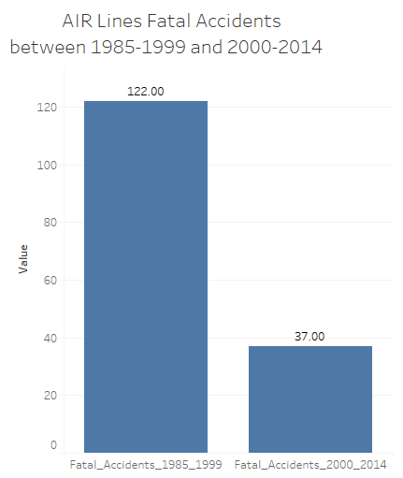 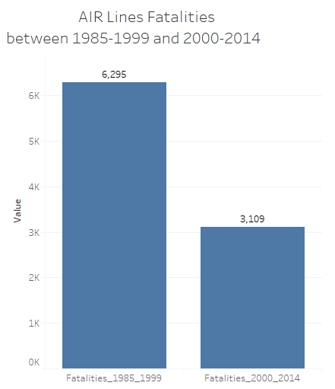 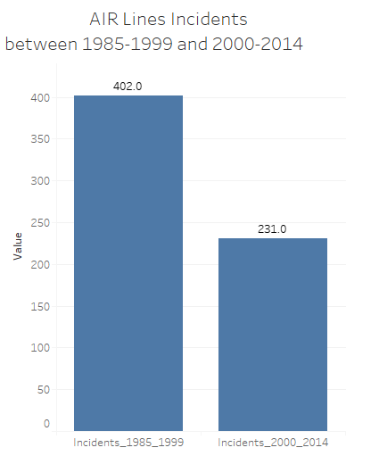

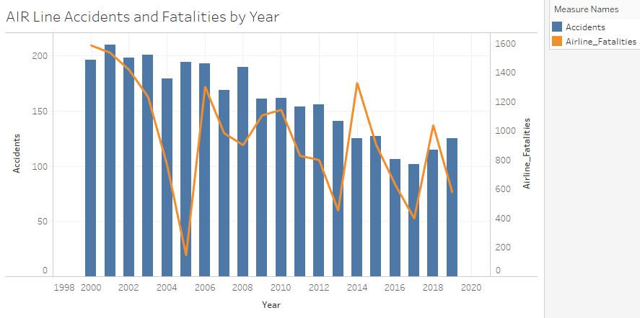 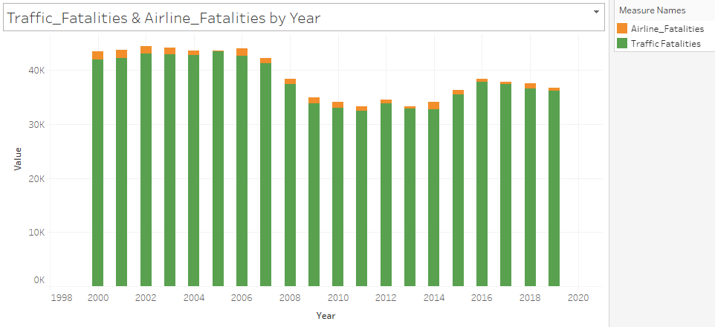

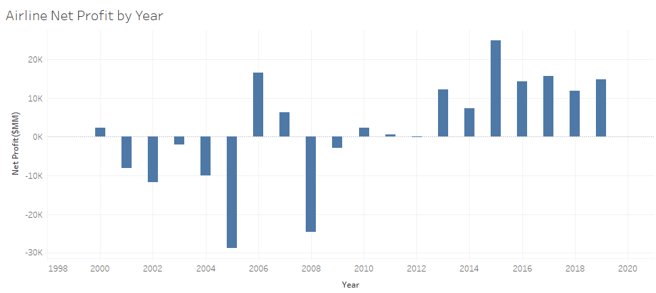

**Reference:**

Airline Safety: <https://github.com/fivethirtyeight/data/tree/master/airline-safety>

Traffic Fatalities: <https://en.wikipedia.org/wiki/Motor_vehicle_fatality_rate_in_U.S._by_year>

<N>et Profit: [https://www.airlines.org/dataset/annual-results-u-s-passenger-airlines/#](https://www.airlines.org/dataset/annual-results-u-s-passenger-airlines/)

Github repo: [bgaggainpali/DSC640_Data_Presentation_And_Visualization (github.com)](https://github.com/bgaggainpali/DSC640_Data_Presentation_And_Visualization)