**DSC640_5-3_Infographic_Supporting_Document**

**AIR TRAVEL & SAFETY**

As an important means of transportation, air travel plays a major role in the international and domestic travel. Where it could take for days and moths on the road and in ships, we can reach the destination in hours, and also making the travel possible to unexplored and not reachable territories through land.

On the discussion point of ‘Air Travel and safety’, recently there are many restrictions imposed by every country because of COVID 19. Even before Corona virus situation, a small incident would cause a lot of media speculations on the reason of the incident. We do see some real incidents happen, recently in 2021 Jan ‘The Sriwijaya Air plane 182 - a Boeing 737 - Indonesia ’ has crashed and raises technical and security safety Issues.

Before making any allegations on the overall safety of the airline travel, we need to look at the stats to see how the air travel has increased in volume in terms of number of flights, Air Lines and passengers. This increase in volume gives the confidence of Airline industry for further growth in different places and locations.

* Air travel has become more reliable with many safety measures implemented in the recent years.
* Fatal Accidents and number of Fatalities has reduced in half compared to last decade.
* While the Airline flight departures has remained fairly consistent, the number of accidents has reduced significantly.
* Airline incidents are very low compared to all other type of incidents with in an year.
* Increase in profit over years proves the people trust in the air travel which is only going to increases in future.

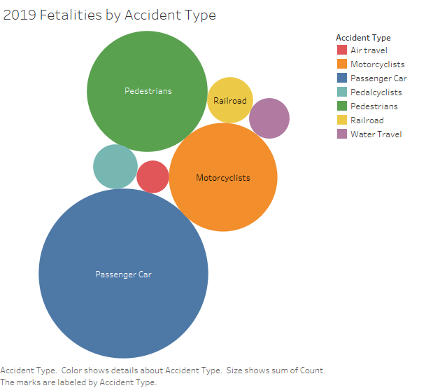 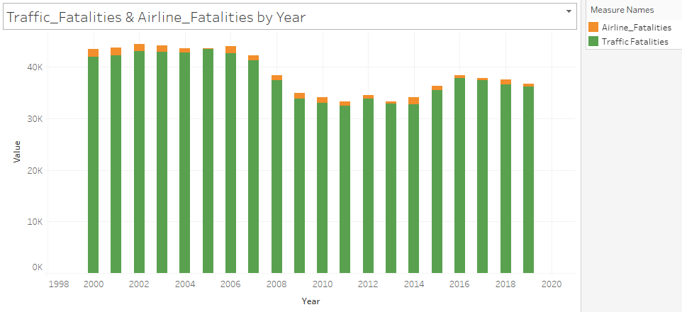

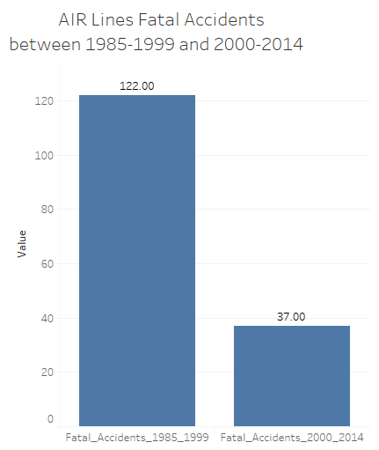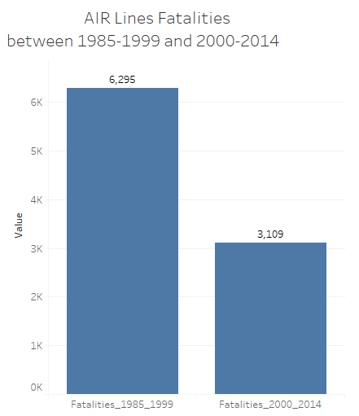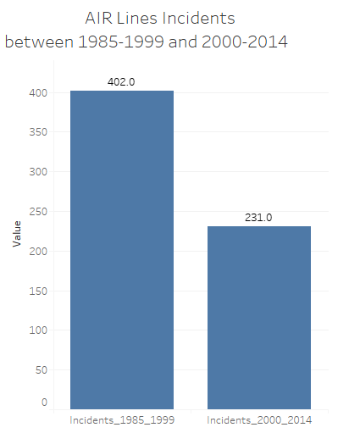

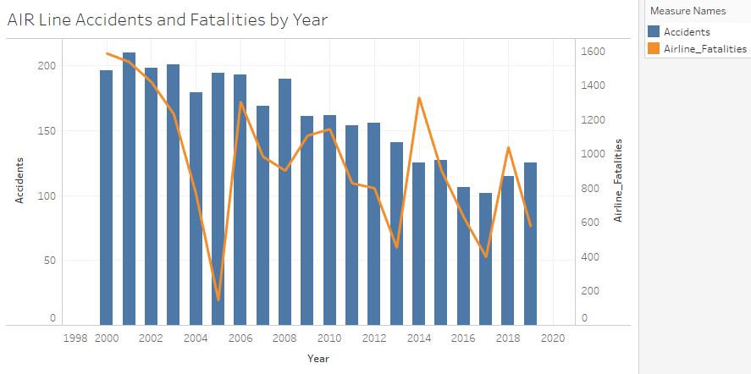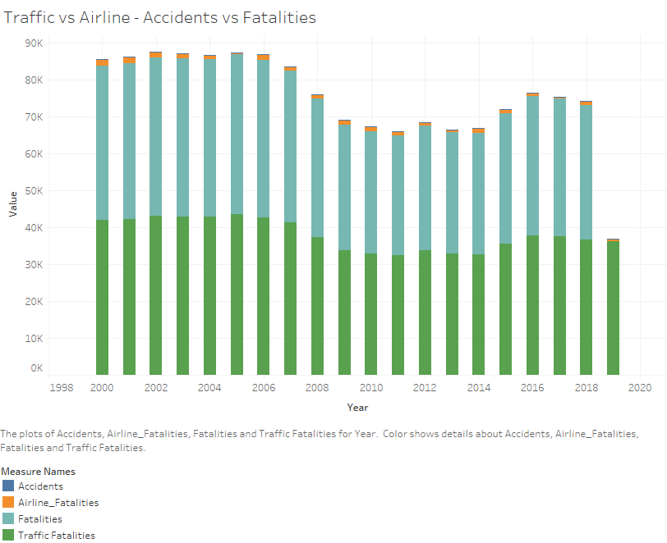

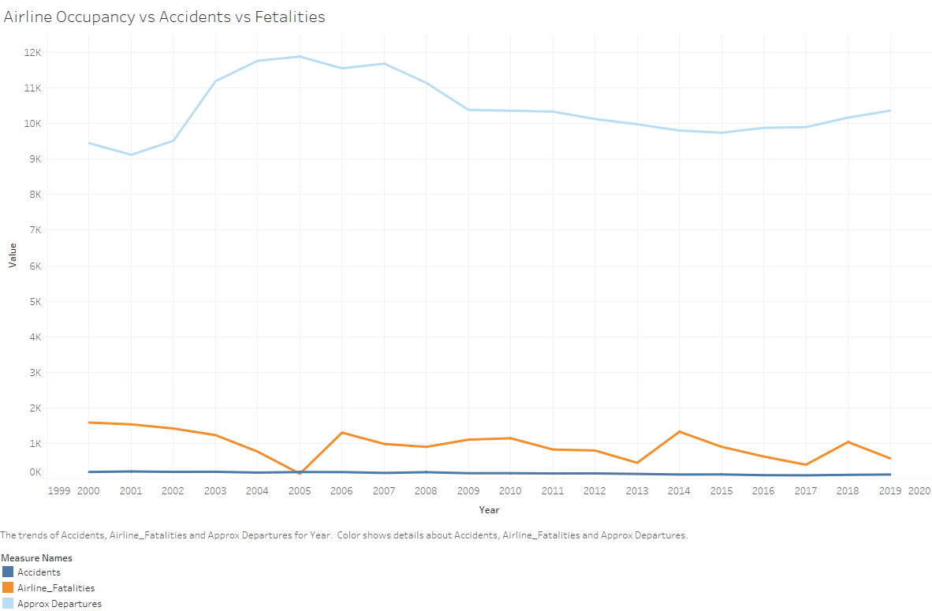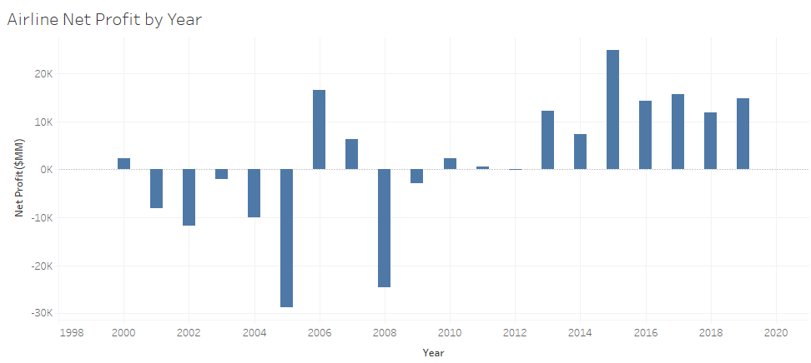

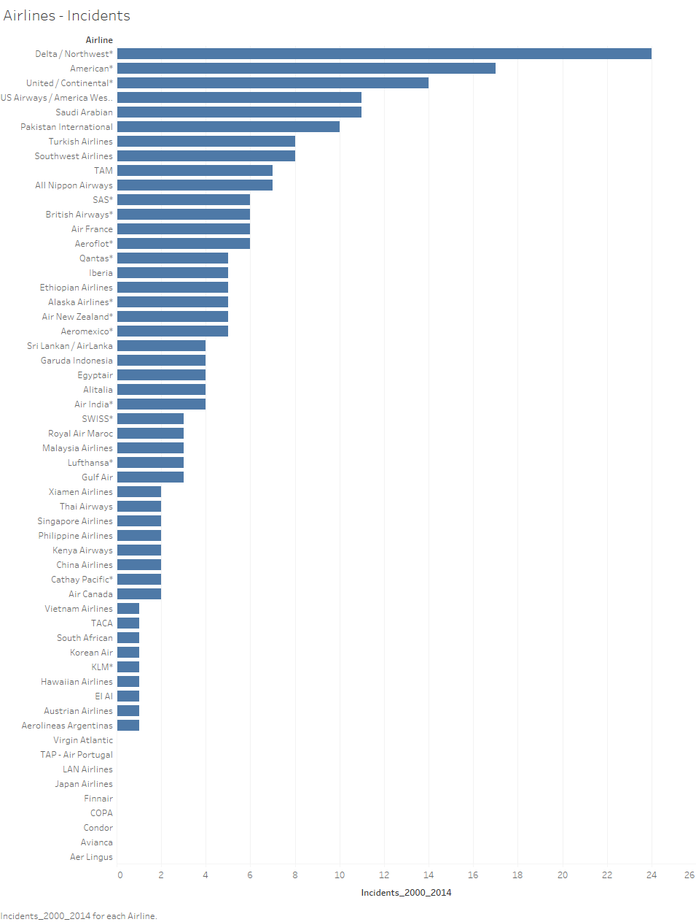

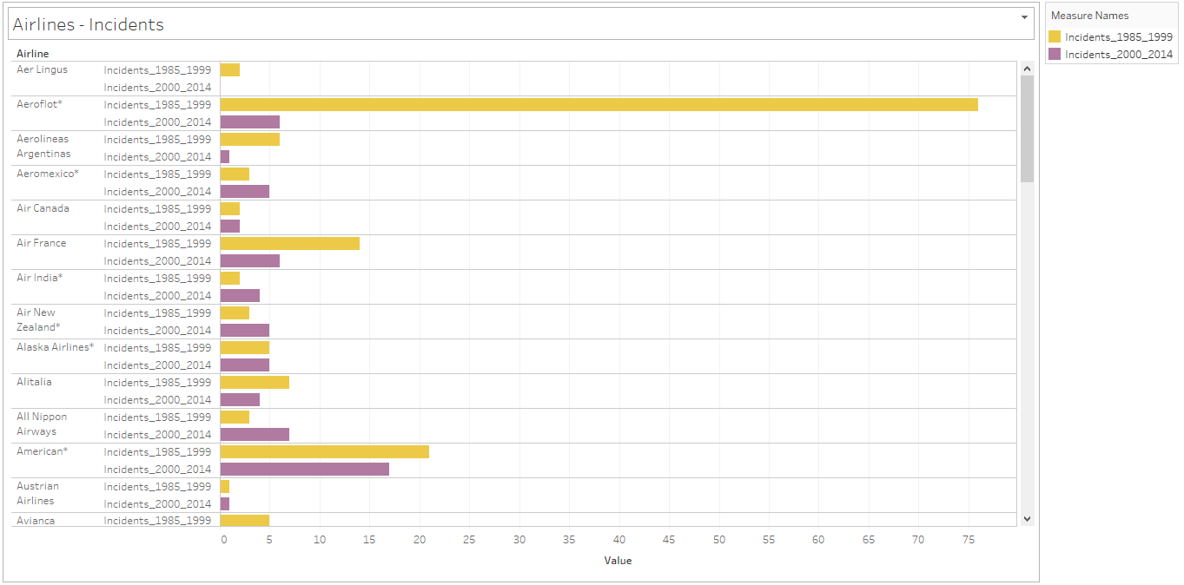

**Reference:**

Airline Safety: <https://github.com/fivethirtyeight/data/tree/master/airline-safety>

Traffic Fatalities: <https://en.wikipedia.org/wiki/Motor_vehicle_fatality_rate_in_U.S._by_year>

<N>et Profit: [https://www.airlines.org/dataset/annual-results-u-s-passenger-airlines/#](https://www.airlines.org/dataset/annual-results-u-s-passenger-airlines/)

Airline Accidents: [List of accidents and incidents involving commercial aircraft - Wikipedia](https://en.wikipedia.org/wiki/List_of_accidents_and_incidents_involving_commercial_aircraft)

Transportation: [Transportation Fatalities by Mode | Bureau of Transportation Statistics (bts.gov)](https://www.bts.gov/content/transportation-fatalities-mode)

Github repo: [bgaggainpali/DSC640_Data_Presentation_And_Visualization (github.com)](https://github.com/bgaggainpali/DSC640_Data_Presentation_And_Visualization)